

CBA Practice model answers
PTX FA2011 Practice Test 2

PTX FA2011 – Practice Test 2
Section 1
Task 1.1
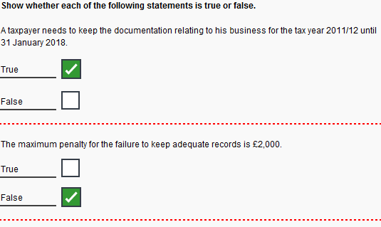
Task 1.2
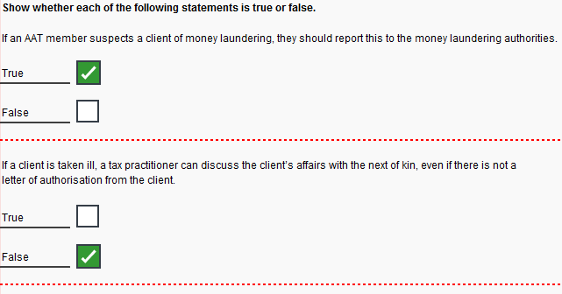
Task 1.3
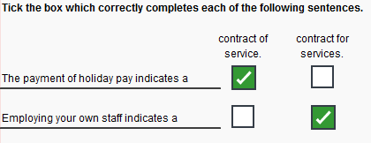
Task 1.4
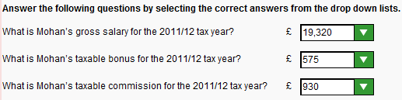
Task 1.5
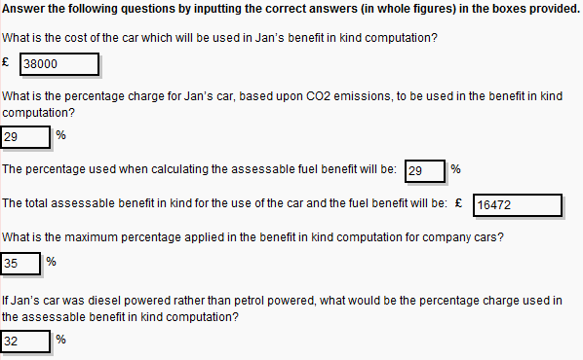
Task 1.6
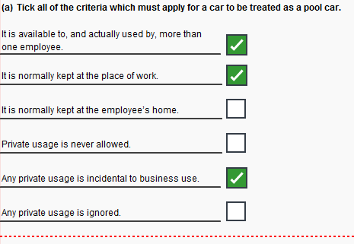

Task 1.6 (continued)
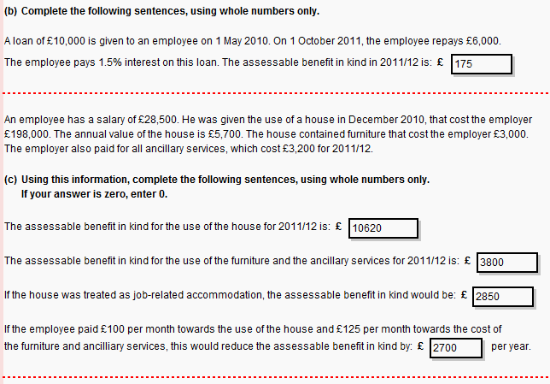
Task 1.7
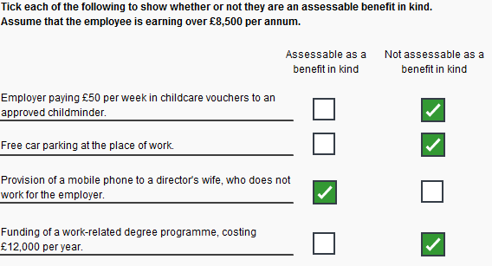
Task 1.8
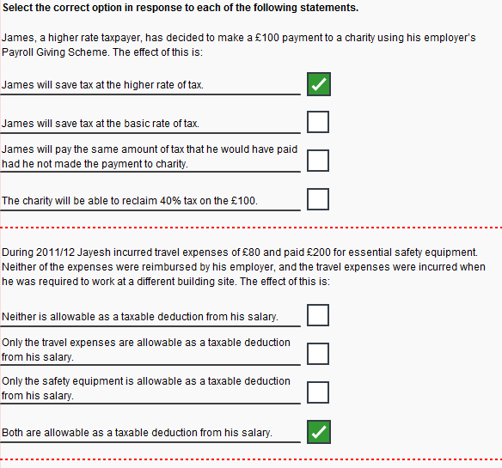
Task 1.8 (continued)
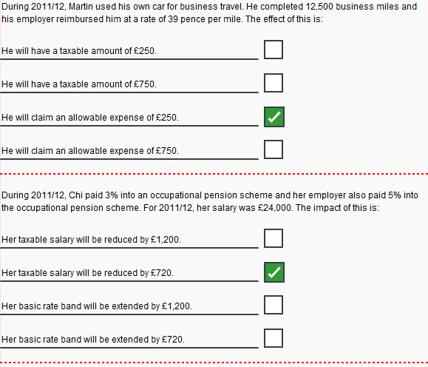

Task 1.9
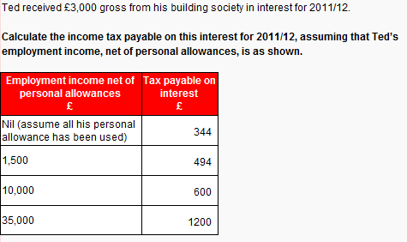

Task 1.10
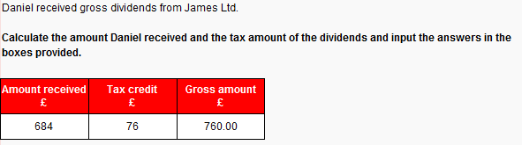
Task 1.11
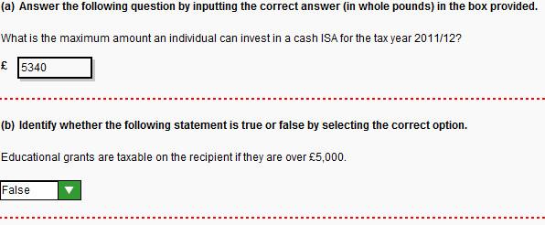
Task 1.12
(a) £
Property income 25,000
Personal allowance:
(9,940 – ([25,000 – 24,000] / 2 9,440
15,560
Tax payable:
15,560 x 20% 3,112

(b) £
Property income 35,000
Personal allowance 7,475
27,525
Tax payable:
27,525 x 20% 5,505

Task 1.13
Late return

Firstly, the return should have been filed by 31 January 2012. Margaret will have received a £100 penalty immediately simply due to the fact that the return is late. As the return is also more than three months late, HMRC may charge a penalty of £10 per day, to a maximum of £900.

Also, as the return is more than six months late, she may incur a penalty which is the higher of £300 and 5% of the tax liability. As 5% of her liability would be £40 (£800 x 5%), then the £300 is the likely penalty.

Late payment

The £800 should have been paid by 31 January 2012. As this payment is over six month late, she would incur a penalty of 10% of the unpaid tax, which would equal £80. In addition, she would be charged interest on the unpaid tax, chargeable on a daily basis from the due date to the date of payment.

2011/12

As the payment for 2011/12 is less than £1,000, payments on account would not be required. Instead the tax for 2011/12 would be due by 31 January 2013.

Task 1.14
Box 18 29,200
Box 22 1,390
Box 23 1,200
Box 24 3,600
Box 34 910
Box 36 22,100
Box 37 6,100
Box 38 16,000

Section 2
Task 2.1
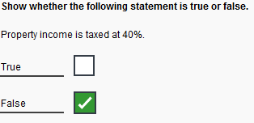
Task 2.2
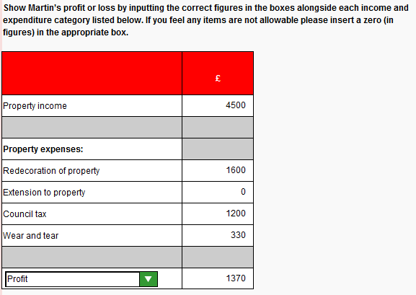
Task 2.3
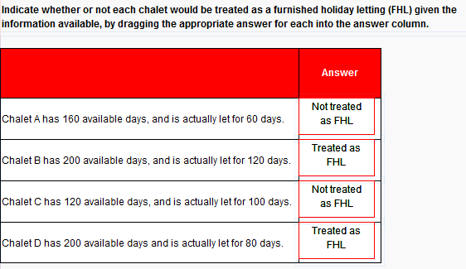
Task 2.4
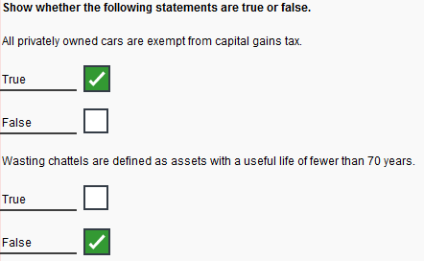
Task 2.5
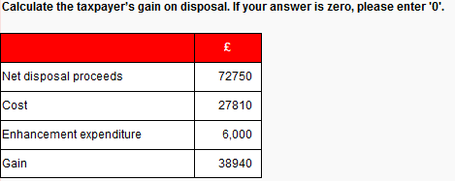
Task 2.6
 | No of  Shares |  | £
March 1998 | 400 |  | 6,000
Bonus issue | 40
 | 440
Rights issue | 55 |  | 550
 | 495 |  | 6,550
October 2011 | 300 |  | 3,970
 | 195 |  | 2,580
Proceeds | 5,700
Cost | 3,970
Gain | 1,730

Task 2.7
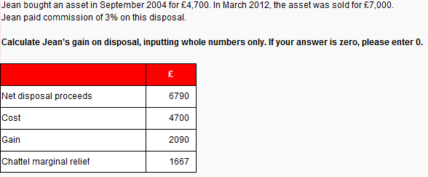
Task 2.8
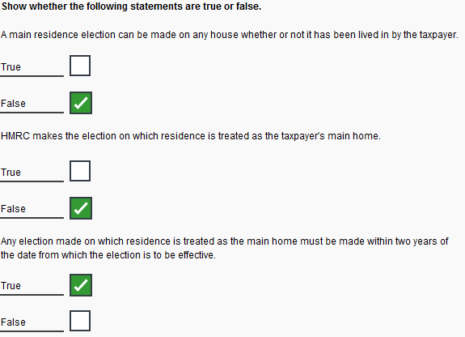
Task 2.9
