

CBA Practice model answers

Personal Tax (PTX) – FA2011

PTX Practice Test – FA 2011
Section 1
Task 1.1
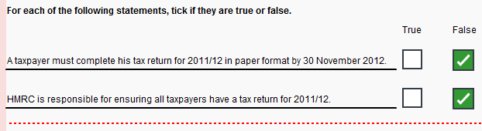
Task 1.2
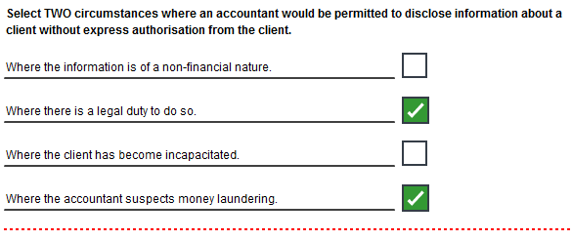
Task 1.3
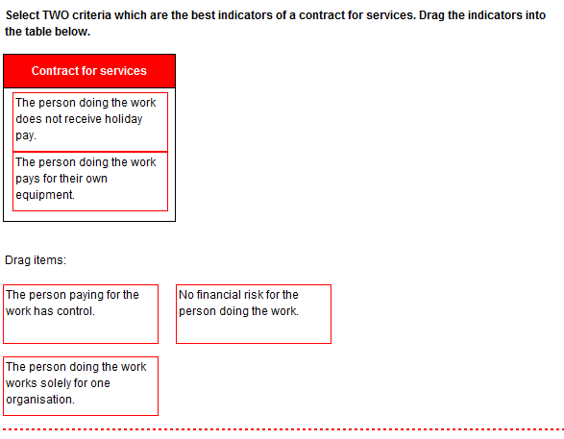
Task 1.4
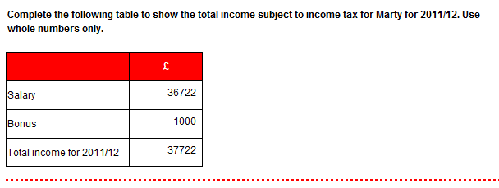
Task 1.5
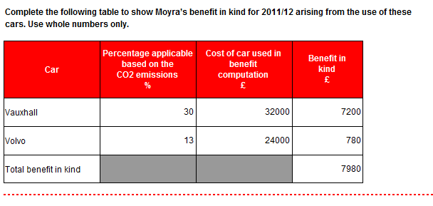
Task 1.6
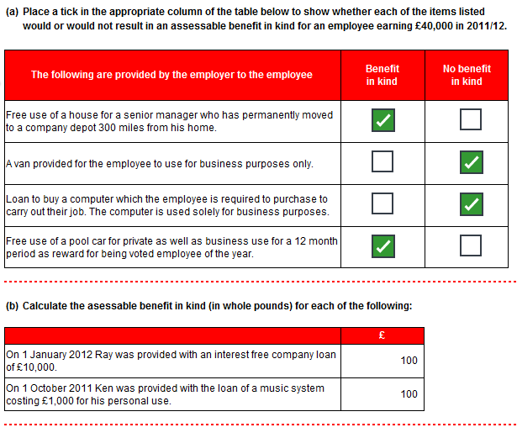
Task 1.7
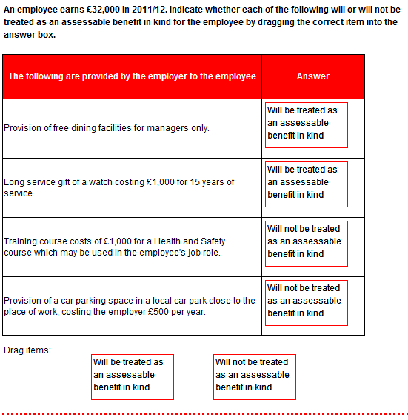
Task 1.8
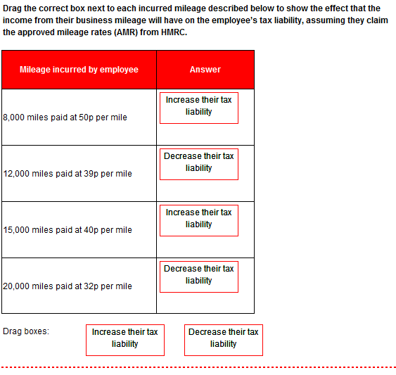
Task 1.9
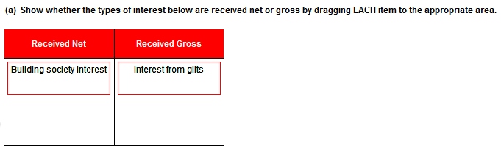
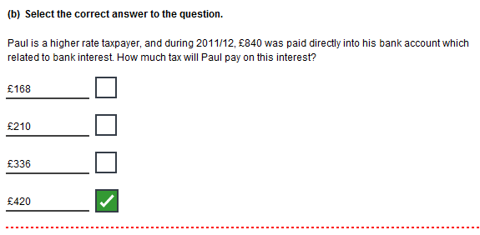
Task 1.10
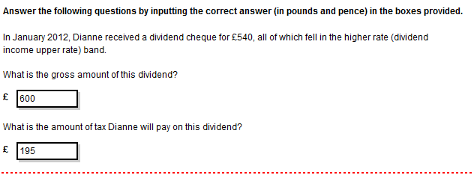
Task 1.11
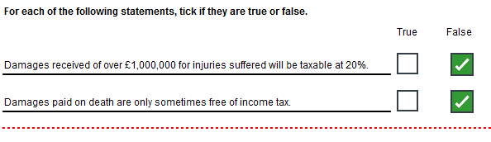
Task 1.12
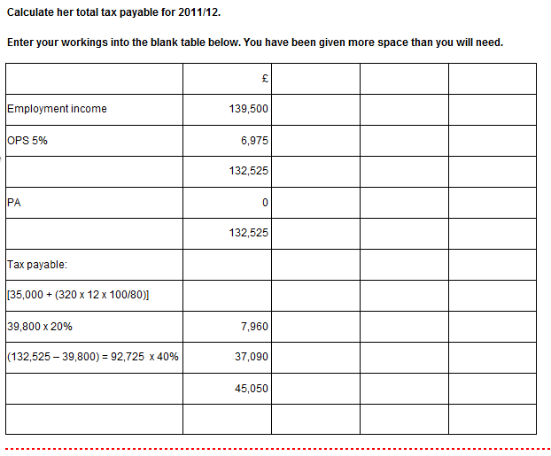
Task 1.13
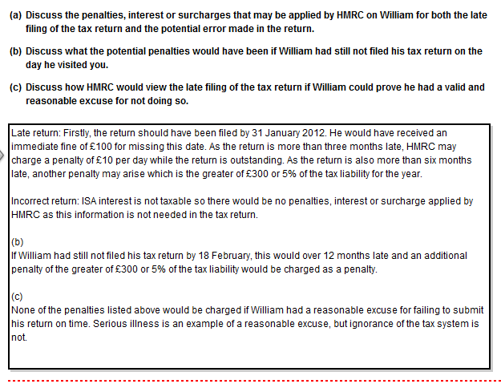
Task 1.14
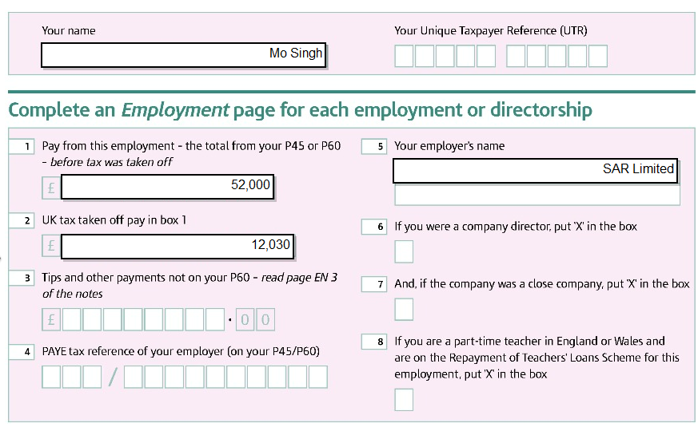
Task 1.14 (continued)
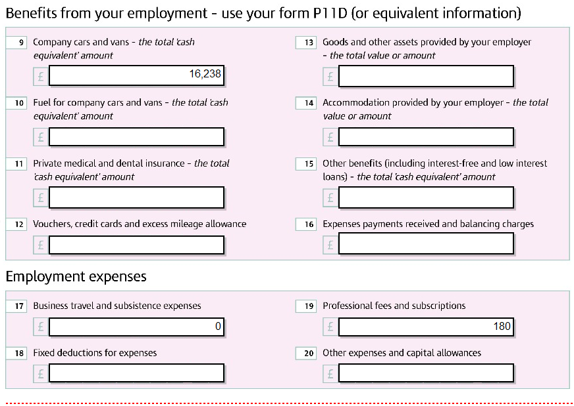
Task 2.1
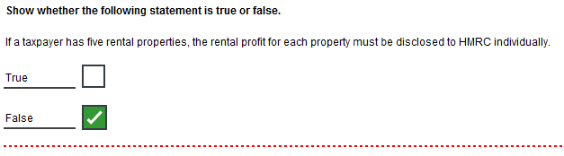
Task 2.2
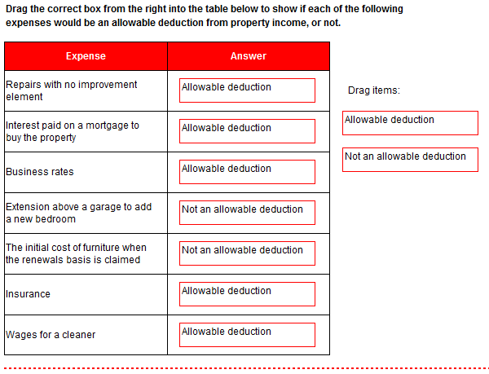
Task 2.3
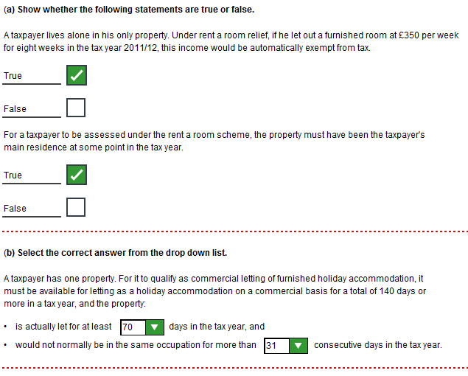
Task 2.4
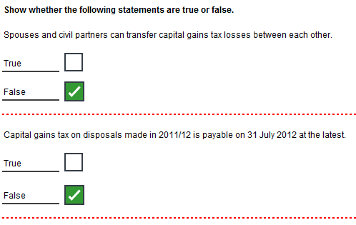
Task 2.5
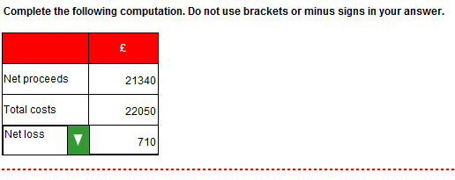
Task 2.6
 |  | £
July 2011
Proceeds – 700 x £25 |  | 17,500
Cost |  | 19,600
Loss |  | 2,100
March 2001 | 900 | 8,800
July 2011 | 100 | 978
 | 800 | 7,822
Proceeds – 100 x £25 |  | 2,500
Cost |  | 978
Gain |  | 1,522

Task 2.7
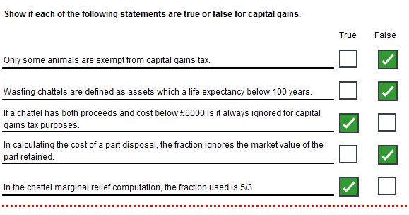
Task 2.8
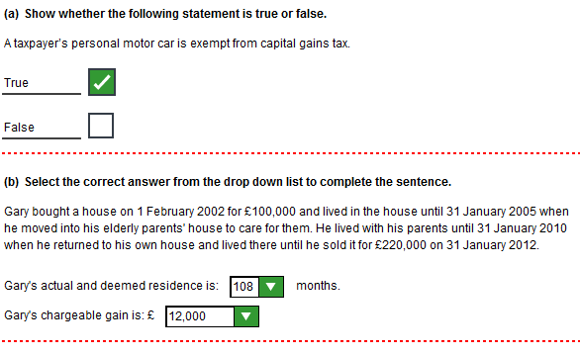
Task 2.9


