

CBT Practice model answers

Personal Tax (PTX) – FA2013

PTX Practice Test – FA 2013
Section 1
Task 1.1
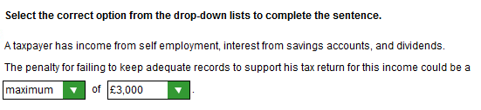
Task 1.2
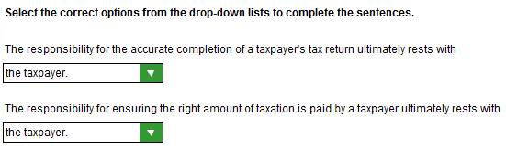

Task 1.3
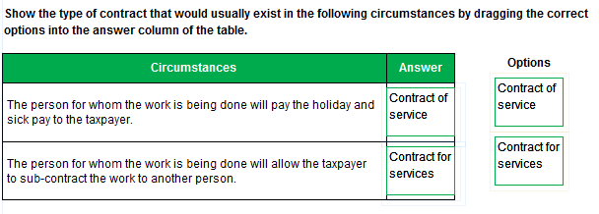
Task 1.4
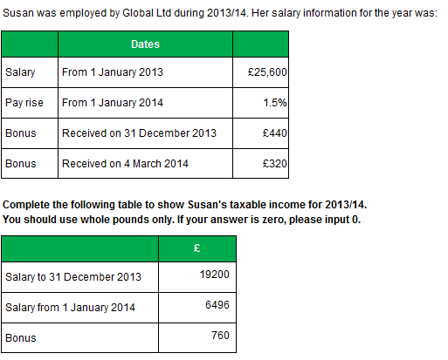
Task 1.5
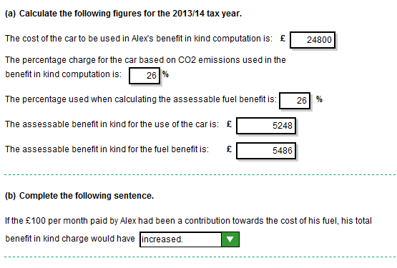
Task 1.6
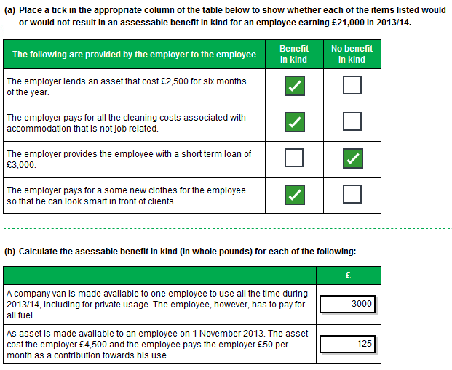
Task 1.7
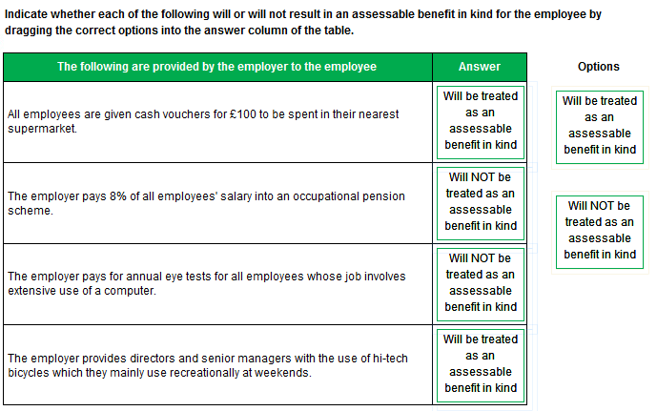
Task 1.8
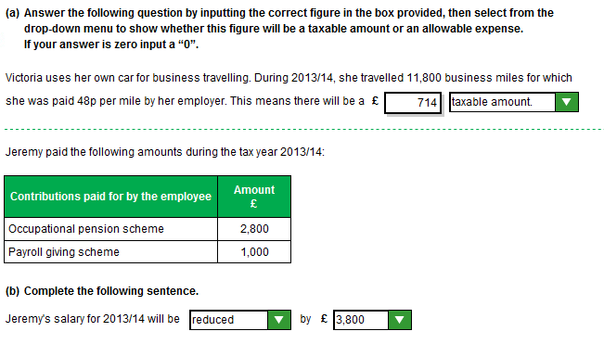
Task 1.9
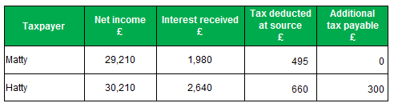
Task 1.10
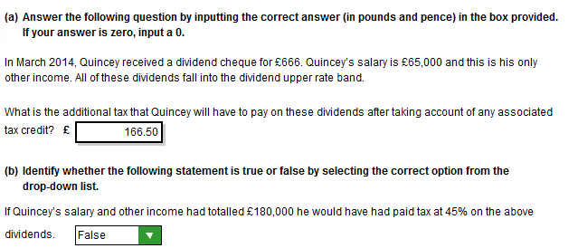
Task 1.11
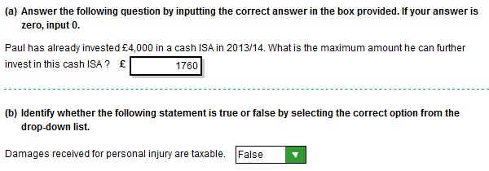
Task 1.12
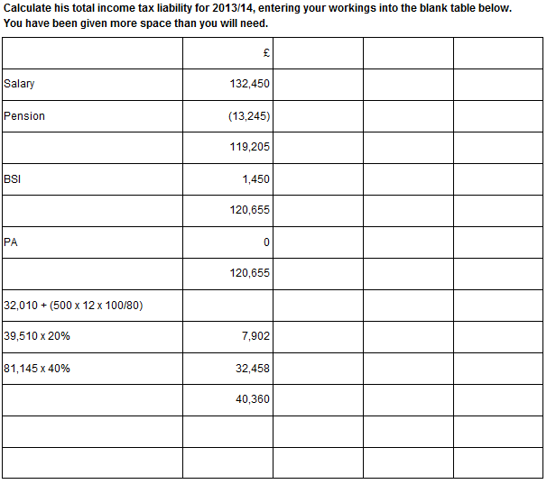
Task 1.13
(a)

The penalties for late payments are as follows:-
- Interest will be charged on any payments on account and balancing payments that are not paid after the due date.
- Interest is charged from the date the tax is due to the day before it is actually paid.
- Penalties are also charged in addition to interest:
- More than 30 days late: 5% of tax overdue.
- More than six months late: further 5% of the tax overdue.
- More than 12 months late: further 5% of the tax overdue.

(b)
31/01/13 | 11,560 | (16,800 – 13,640) + (16,800/2) = 3,160 + 8,400
31/07/13 | 8,400 | (16,800/2)
31/01/14 | 9,120 | (17,280 – 16,800) + (17,280/2) = 480 + 8,640

Task 1.14
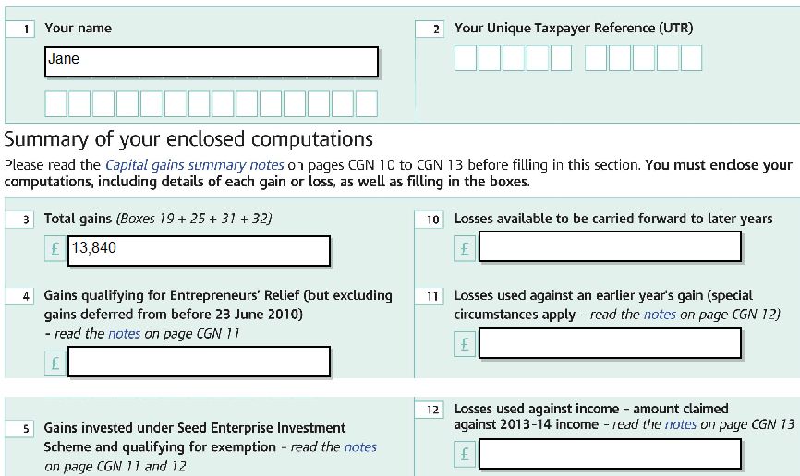

Task 1.14 (continued)
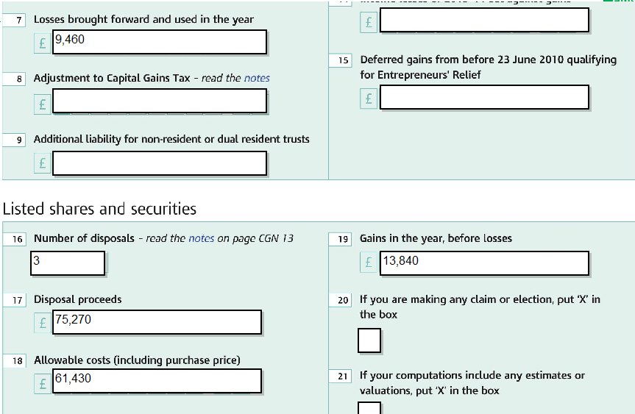
Section 2
Task 2.1
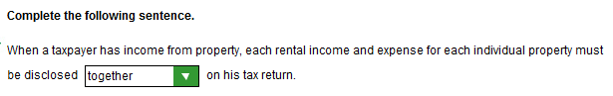
Task 2.2
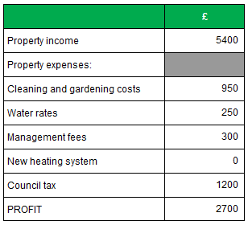
Task 2.3
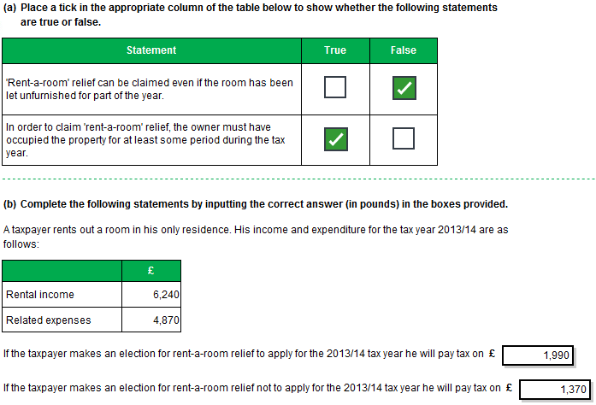
Task 2.4
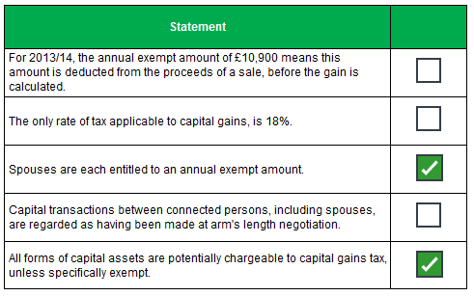
Task 2.5
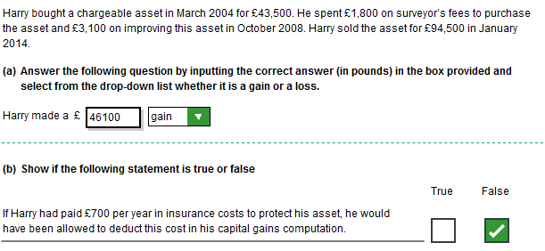
Task 2.6
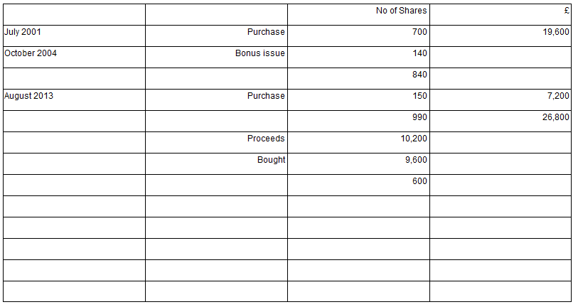
Task 2.7
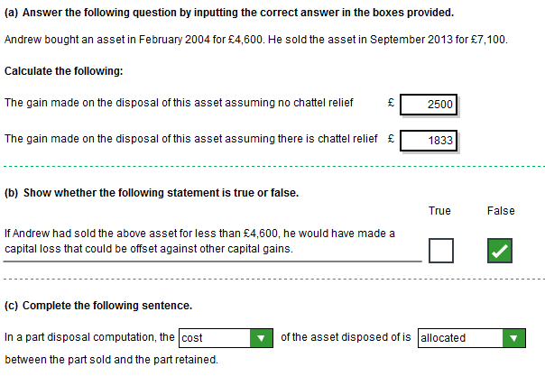
Task 2.8
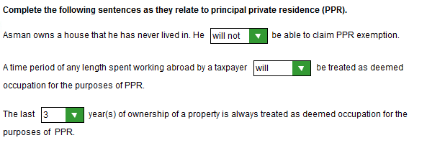
Task 2.9
