

CBT Practice test model answers

Indirect tax (ITX)
Practice assessment 1

Section 1

Task 1.1

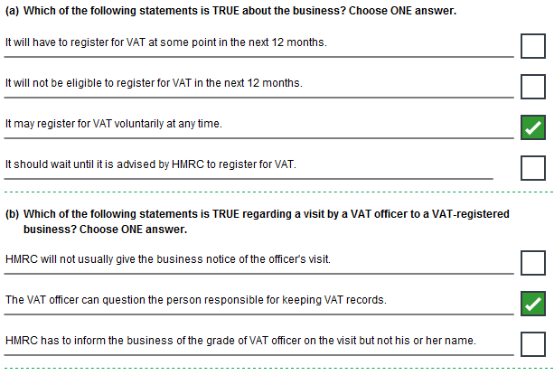
Task 1.2

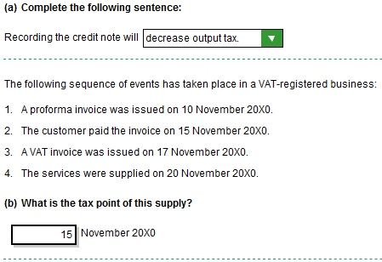

Task 1.2, continued

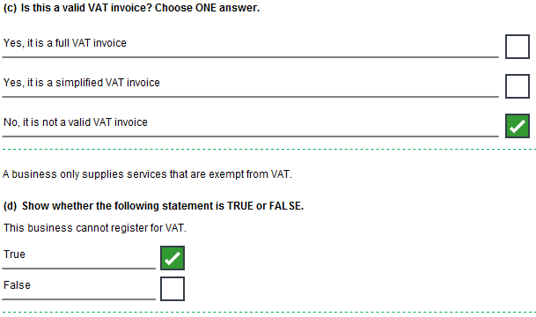
Task 1.3

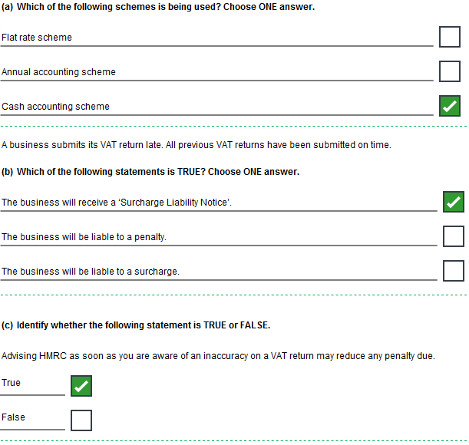
Task 1.4

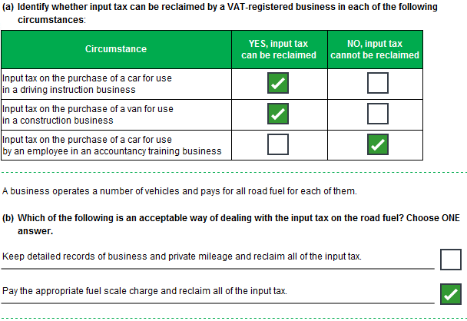
Task 1.4, continued

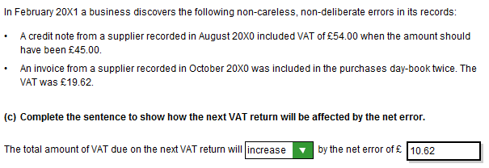
Task 1.5

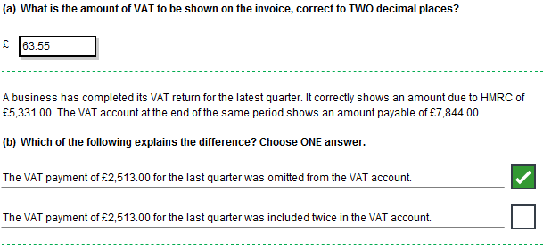
Section 2

Task 2.1

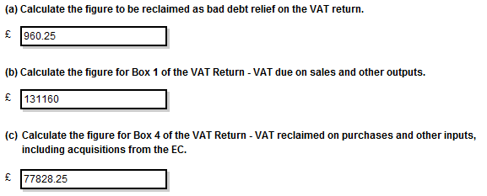
Task 2.2

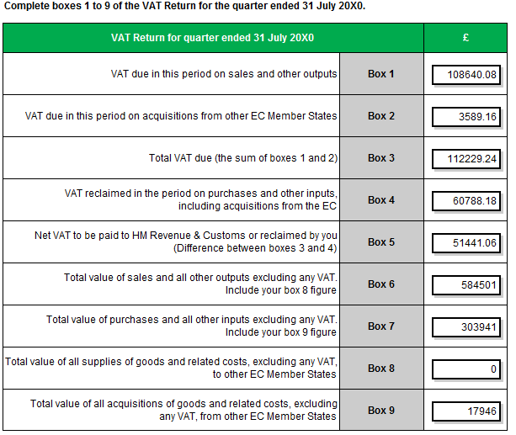
Rounding – Boxes 6-9

This model answer shows the figures in boxes 6-9 rounded up, however figures rounded down are equally valid for the purposes of this assessment.
Task 2.3

