

CBA Practice model answers

Indirect Tax
FA2013 – practice 1

Section 1
Task 1.1

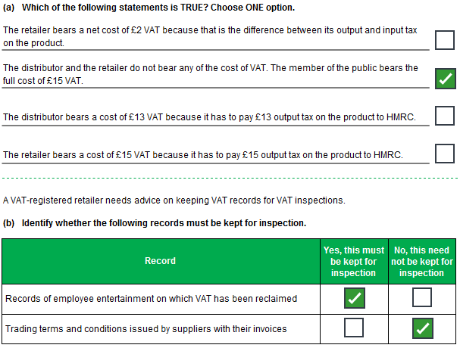
Task 1.2

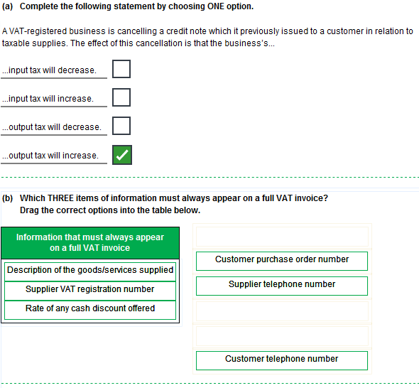
Task 1.2 continued

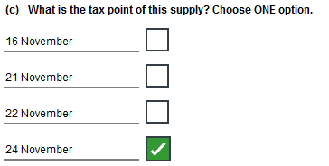
Task 1.3

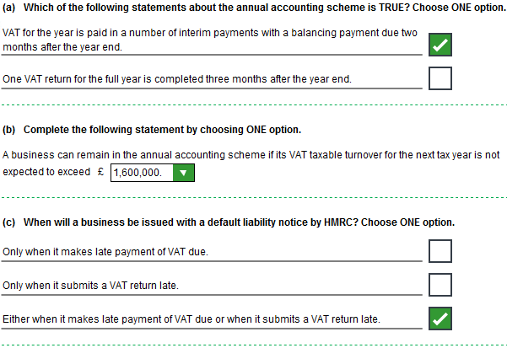
Task 1.4

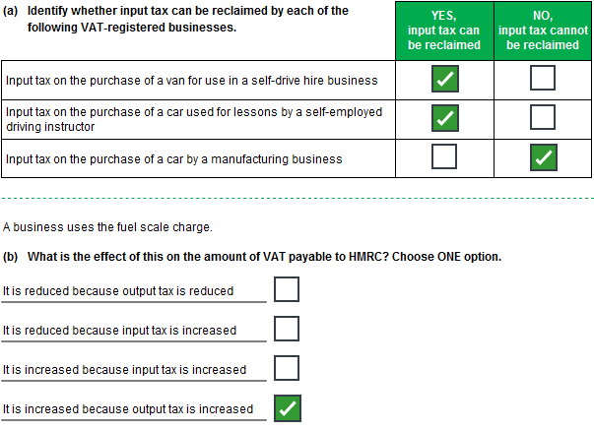
Task 1.4 continued

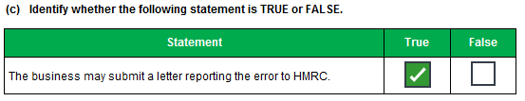
Task 1.5

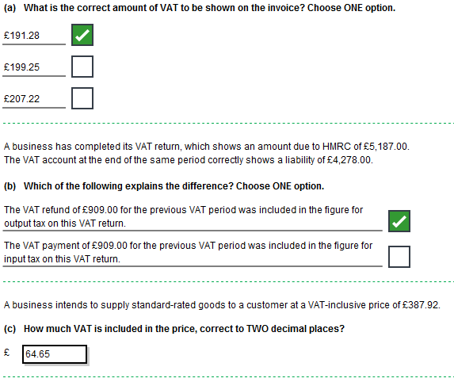
Section 2
Task 2.1

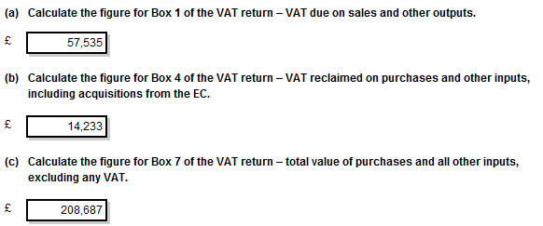

Task 2.2

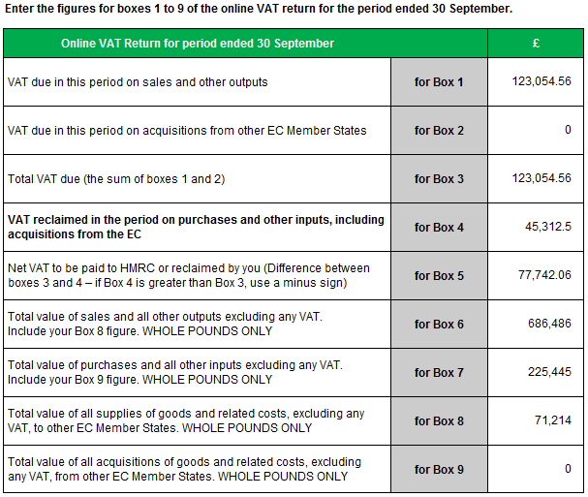
Rounding – Boxes 6-9

This model answer shows the figures in boxes 6-9 rounded down, however figures rounded up are equally valid for the purposes of this assessment.
Task 2.3

