

CBT Practice test model answers

Financial Statements (FNST)
Practice assessment 4
Section 1

Task 1.1

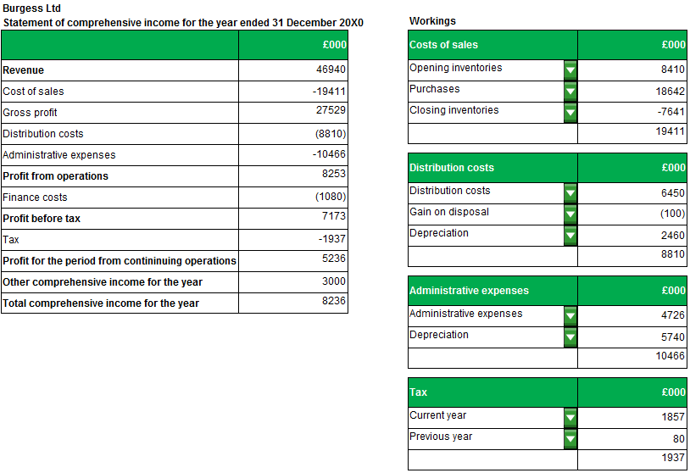

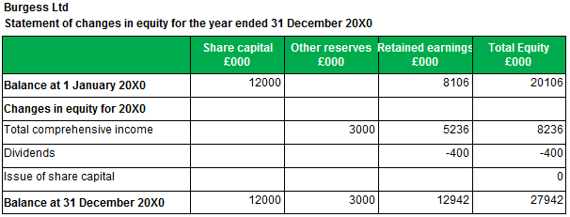
Task 1.2

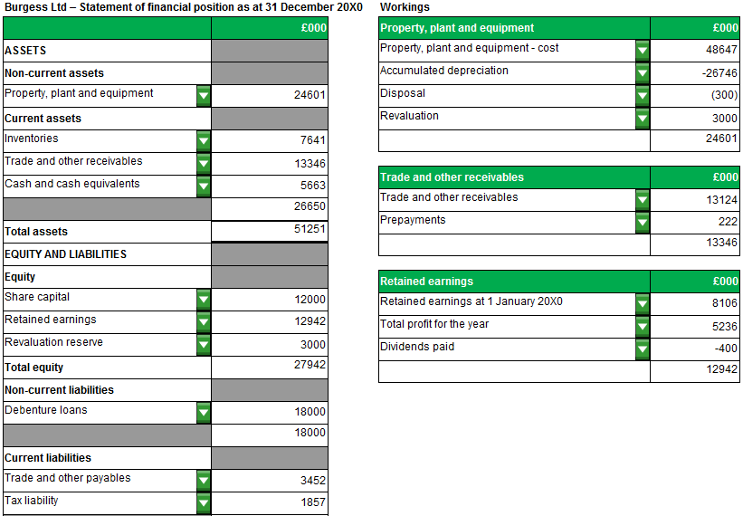
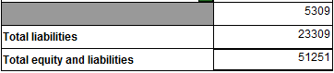

Task 1.3

(a)

Revenue is the gross inflow of economic benefits during the period arising in the course of the ordinary activities of an entity (for example by selling goods or services) when those inflows result in increases in equity (not borrowings which increase liabilities), other than increases relating to contributions from equity participants (issues of shares will not therefore constitute revenue).

[IAS 18 Paragraph 7]

(b)

Revenue associated with the provision of a service should be recognised when all of the following conditions are satisfied:

- the amount of revenue can be measured reliably

- it is probable that the economic benefits associated with the transaction will flow to the entity

- the stage of completion of the transaction at the end of the reporting period can be measured reliably and

- the costs incurred for the transaction and the costs to complete the transaction can be measured reliably

[IAS 18 Paragraph 20]

(c)

The revenue that may be recognised in respect of the contract with the retailer will be based upon the stage of completion of the transaction at the end of the reporting period, 31 December 20X0.

This will be 3/12 x £3,600 = £900.

No revenue may be recognised in respect of the sale of the equipment as this does not arise in the course of the ordinary activities of the company.
Task 1.4

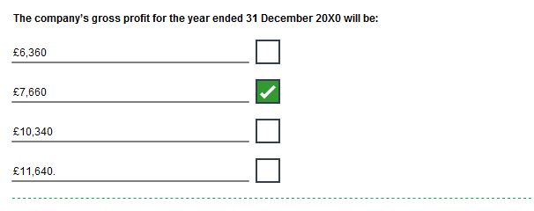
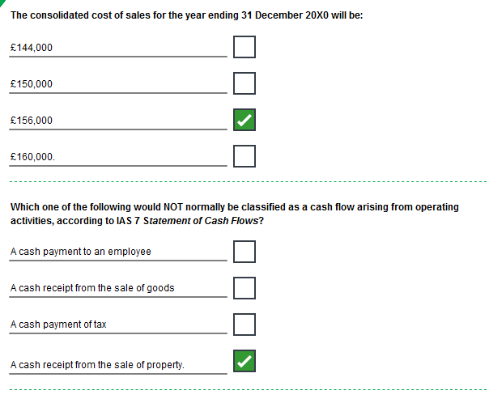
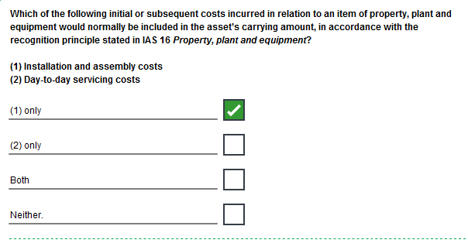

Task 1.4, continued

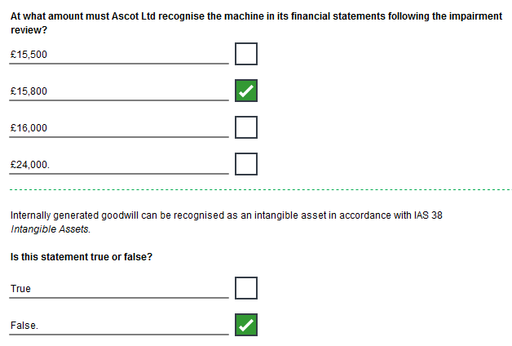

Task 1.5

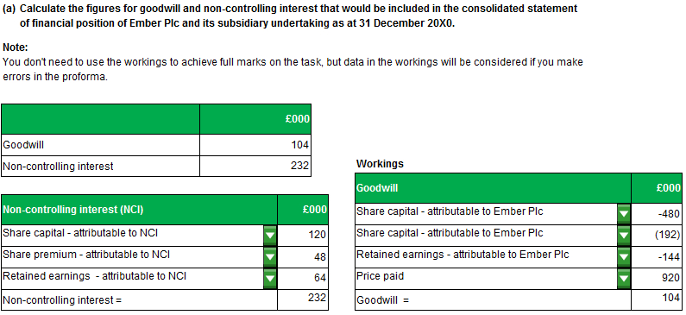

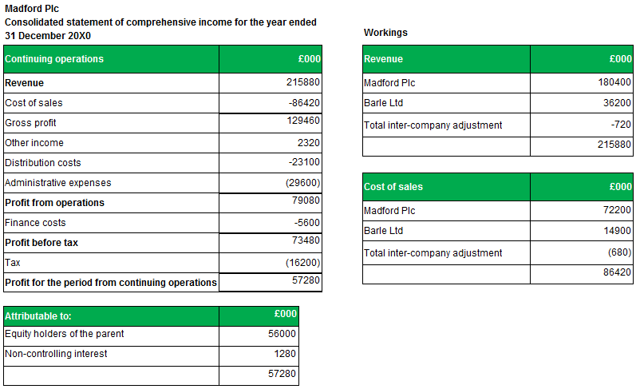

Section 2

Task 2.1

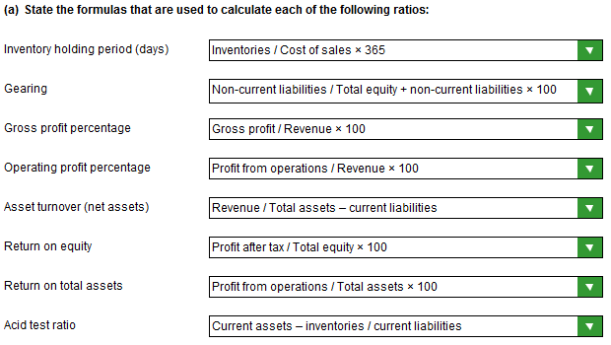

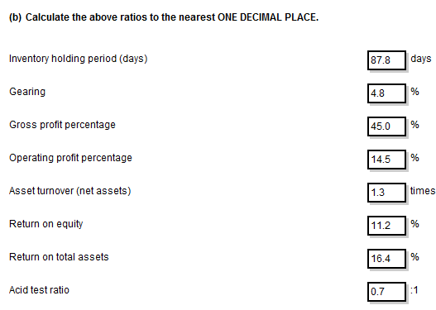
NOTE:
The model answer shows answers rounded down but answers rounded up are equally valid.
Task 2.2

Notes for Sally regarding whether she should keep or sell her shares in Waskerley Plc

(a) Earnings per share is worse.

- Less profit is available for distribution as a dividend in relation to each issued ordinary share/lower rate of return.
- Profits could have been lower, and/or
- Waskerley Plc may have issued more ordinary shares. This is the most likely explanation as the ‘Financing activities’ section of the statement of cash flows is positive.

Asset turnover (total assets) is worse.

- Assets are less efficient at generating sales/revenue.
- Revenue could be lower.
- The company may have purchased some non-current assets. This is supported by the ‘Investing activities’ section of the statement of cash flows which shows a large negative cash outflow.
- Furthermore, the purchase of assets may have been made towards the end of the year, thus giving them less time to generate revenue for Waskerley Plc and/or the assets could have been subject to initial teething troubles.
- The performance of the assets may improve in later years as they bed in.
- There could also have been a revaluation upwards of assets.
- The fall could also indicate the presence of surplus cash following the raising of the finance (as there was an increase in cash and cash equivalents), old/obsolete inventories or that the company is not collecting in its trade receivables efficiently.

Interest Cover is worse.

- Waskerley Plc is more risky/ there is less profit to meet interest payments.
- It may be more difficult to obtain finance in the future and there is likely to be a greater volatility of profits for ordinary shareholders.
- This could be caused by lower operating profits and/or
- higher interest payments.
- Waskerley Plc may have taken out more loans during the year. This is the most likely explanation as the ‘Financing activities’ section of the statement of cash flows is positive.

(b) Sally should be advised to sell her shares as she is receiving a lower rate of return/the company is more risky. The EPS, interest cover and asset turnover ratios have all declined.

Alternatively, it could be argued that Sally should keep her shares as it appears that money has been raised to finance the acquisition of assets which should hopefully improve the performance of the company and return in future years.
Task 2.3

(a)

Purpose

- assist the Board of IASB in the development of future International Accounting Standards and in its review of existing International Accounting Standards;
- assist the Board of IASB in promoting harmonisation of regulations, accounting standards and procedures relating to the presentation of financial statements by providing a basis for reducing the number of alternative accounting treatments permitted by International Accounting Standards;
- assist national standard-setting bodies in developing national standards;
- assist preparers of financial statements in applying International Accounting Standards and in dealing with topics that have yet to form the subject of an International Accounting Standard;
- assist auditors in forming an opinion as to whether financial statements conform with International Accounting Standards;
- assist users of financial statements in interpreting the information contained in financial statements prepared in conformity with International Accounting Standards; and
- provide those who are interested in the work of IASB with information about its approach to the formulation of International Accounting Standards.
(b)

Comparability
Information about a reporting entity is more useful if it can be compared with similar information about other entities and with similar information about the same entity for another period or another date.

Consistency, although related to comparability, is not the same. Consistency refers to the use of the same methods for the same items, either from period to period within a reporting entity or in a single period across entities. Comparability is the goal; consistency helps to achieve that goal.

Comparability is not uniformity. For information to be comparable, like things must look alike and different things must look different.

Verifiability
Verifiability means that different knowledgeable and independent observers could reach consensus, although not necessarily complete agreement, that a particular depiction is a faithful representation.

Verification can be direct or indirect.

Direct verification means verifying an amount or other representation through direct observation, for example, by counting cash.

Indirect verification means checking the inputs to a model, formula or other technique and recalculating the outputs using the same methodology.

[Paragraph QC 26 – 28]

Timeliness
Timeliness means having information available to decision-makers in time to be capable of influencing their decisions.

Generally, the older the information is the less useful it is so current information is more meaningful.
However, some information may continue to be timely long after the end of a reporting period because, for example, some users may need to identify and assess trends.

[Paragraph QC 29]

Understandability
Classifying, characterising and presenting information clearly and concisely makes it understandable.

Some phenomena are inherently complex and cannot be made easy to understand.
Excluding information about those phenomena from financial reports might make the information in those financial reports easier to understand. However, those reports would be incomplete and therefore potentially misleading.

Financial reports are prepared for users who have a reasonable knowledge of business and economic activities and who review and analyse the information diligently.

At times, even well-informed and diligent users may need to seek the aid of an adviser to understand information about complex economic phenomena.

[Paragraph QC 30-32]

