

CBT Practice test model answers

Financial Statements (FNST)
Practice assessment 3
Section 1

Task 1.1

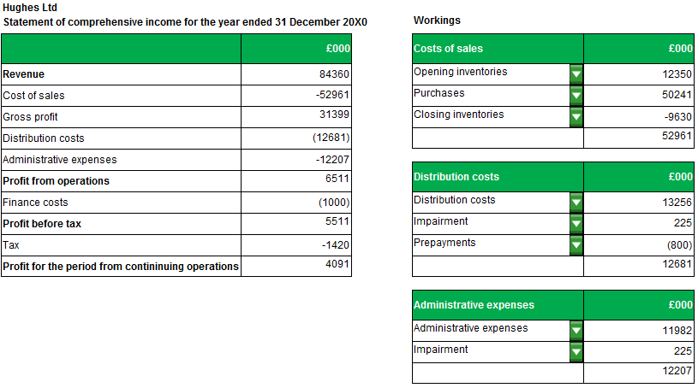

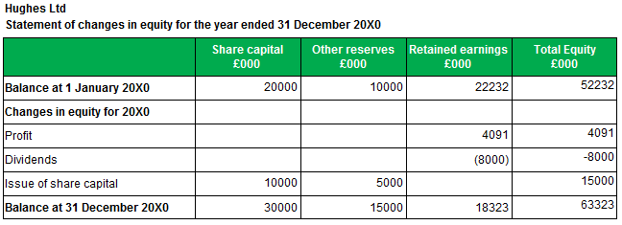
Task 1.2

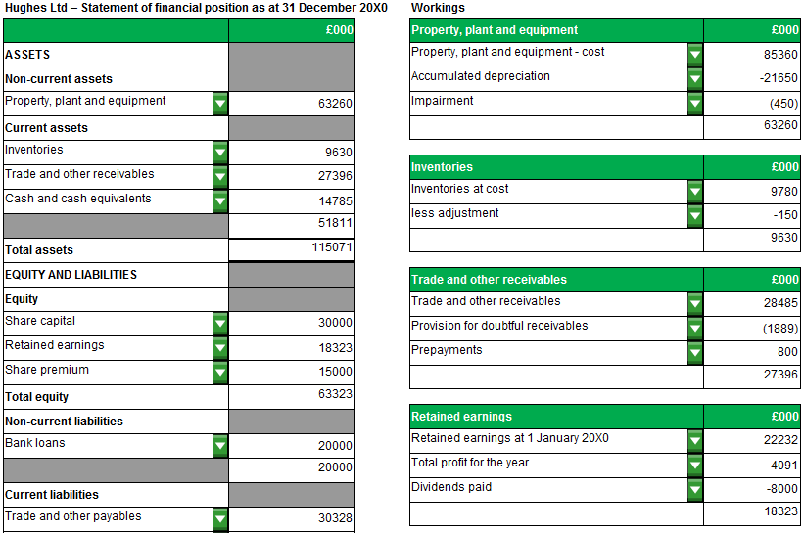
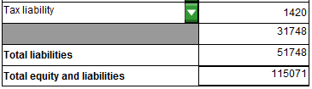

Task 1.3

- The revalued asset should be carried at its revalued amount, which is the fair value of the asset at the date of the revaluation less any subsequent accumulated depreciation and subsequent accumulated impairment losses.

Fair value is the amount for which the asset could be exchanged between knowledgeable, willing parties in an arm's length transaction. This will usually be determined from market-based evidence, which in the case of land and buildings will usually be provided by a professionally qualified valuer.

- Revaluations should be made with sufficient regularity to ensure that the carrying amount does not differ materially from that which would be determined using fair value at the end of the reporting period.

Items of property, plant and equipment which experience significant and volatile changes in value may need to be revalued annually, otherwise it may only be necessary to revalue an item every three or five years.

- Companies are unable to be selective as to which particular assets should be revalued. If an item of property, plant and equipment is revalued, the entire class of property, plant and equipment to which that asset belongs must be revalued, in order to avoid the reporting of amounts in the financial statements that are a mixture of costs and values as at different dates.

- If an asset's carrying amount is increased as a result of a revaluation, the increase must be recognised in other comprehensive income in the statement of comprehensive income and in total equity under the heading of revaluation surplus in the statement of financial position.

However, the increase must be recognised in profit or loss (not in other comprehensive income) to the extent that it reverses a revaluation decrease of the same asset previously recognised in profit or loss as an expense. The amount of the increase in excess of the amount previously written off as an expense would then be recognised in other comprehensive income in the statement of comprehensive income and as a revaluation surplus in total equity in the statement of financial position.

If an asset's carrying amount is decreased as a result of a revaluation, the decrease must be recognised as an expense in profit or loss.

However, the decrease must be recognised in other comprehensive income (as a negative amount) to the extent of any credit balance existing in the revaluation surplus in respect of that asset. The decrease recognised in other comprehensive income reduces the amount recognised in equity under the heading of revaluation surplus in the statement of financial position.

[IAS 16 Paragraphs 31-33, 36, 39-40]
Task 1.4

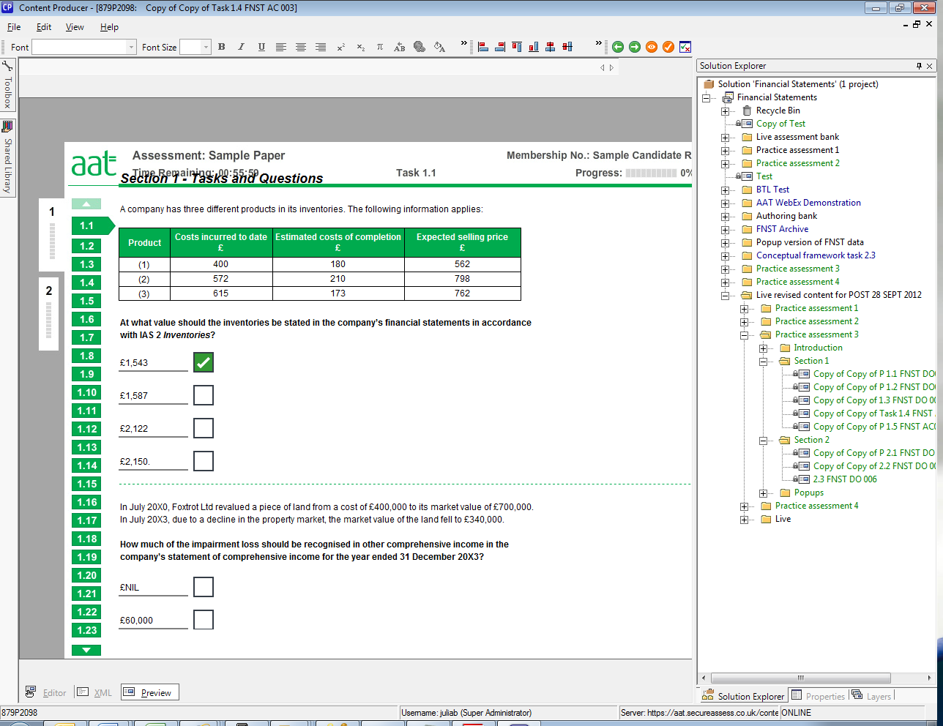
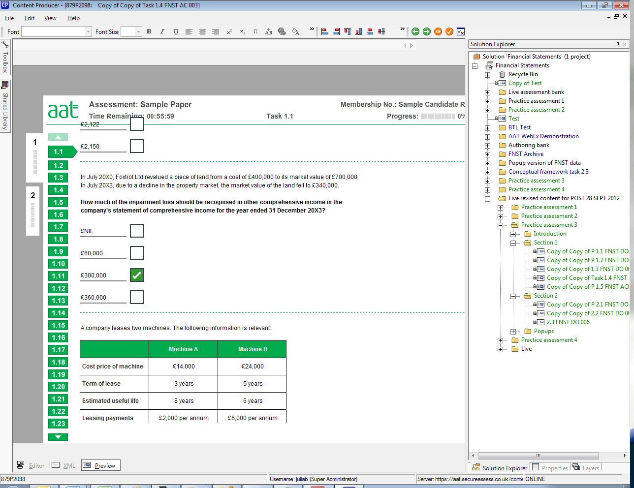
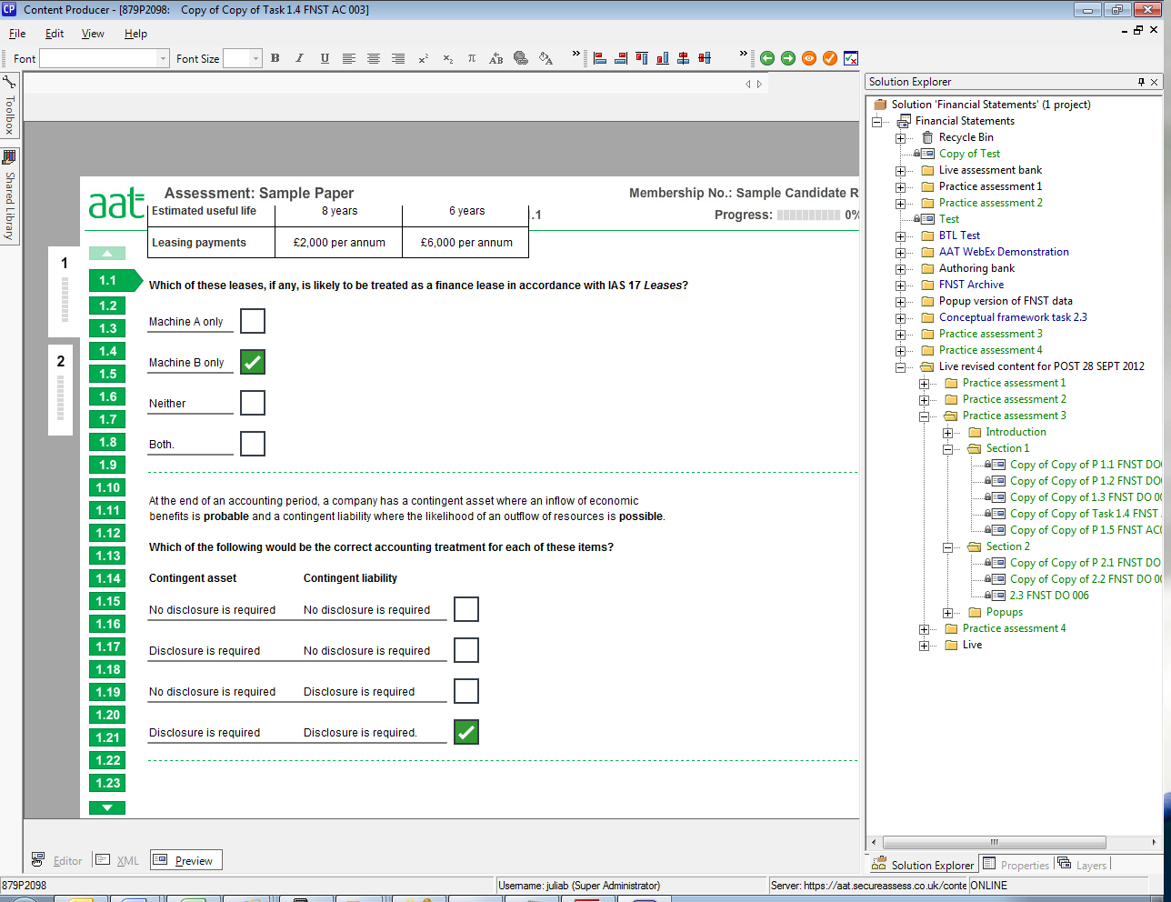
Task 1.4, continued

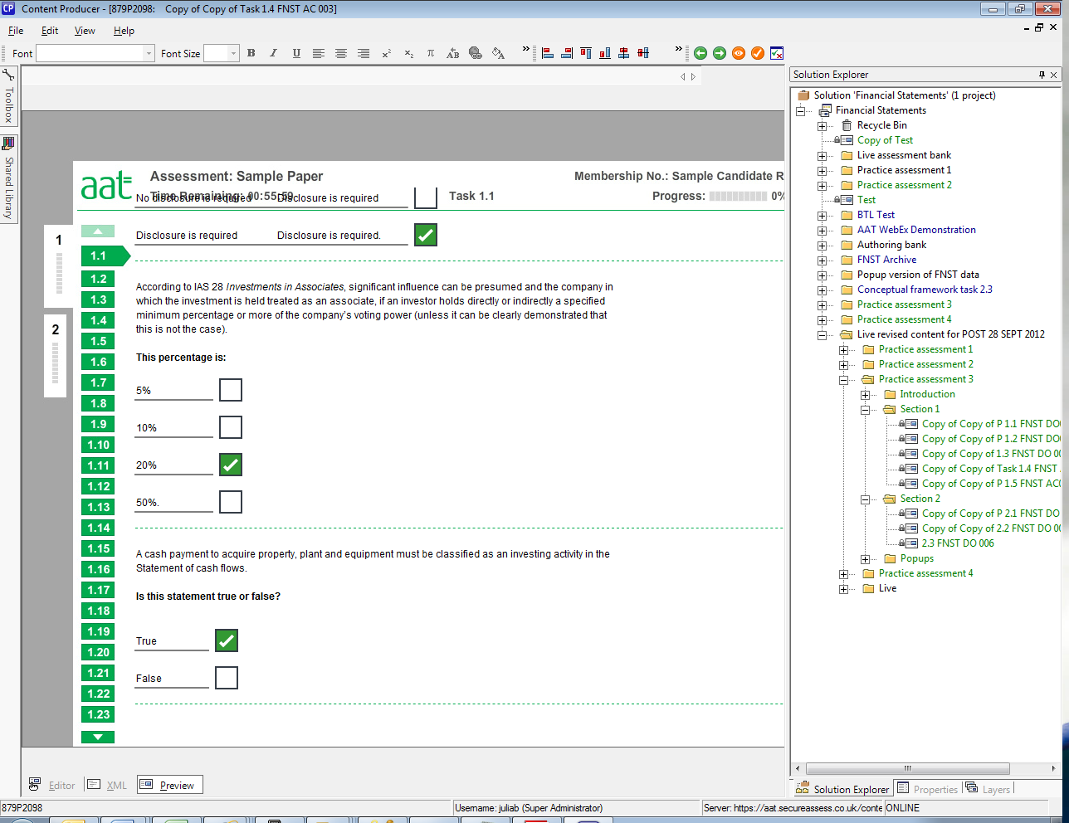

Task 1.5

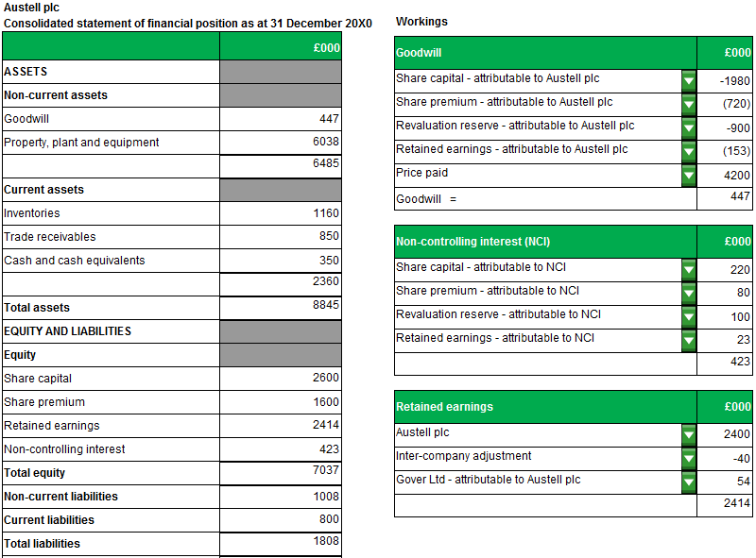
Section 2

Task 2.1

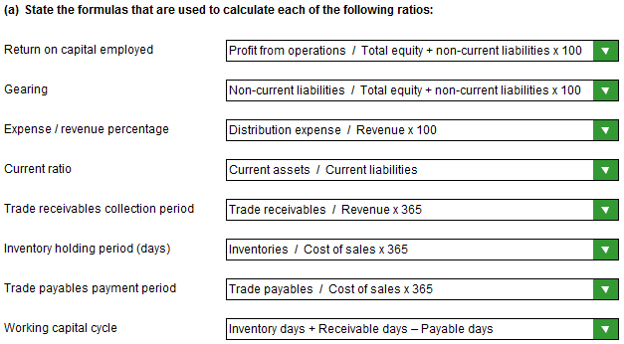

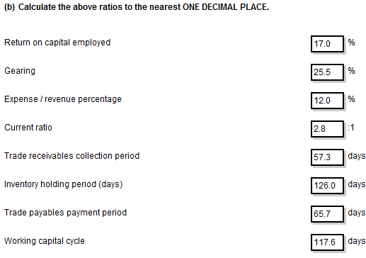

NOTE:
The model answer shows answers rounded down but answers rounded up are equally valid.

Task 2.2

(a) Notes for the Financial Director of Alston Ltd regarding use of the company’s cash resources

The inventory turnover ratio is better than the industry average.

- Alston Ltd sells its inventories more quickly (holds less inventories) than the
industry average.
- Alston Ltd may have lower selling prices.
- Alston Ltd may have more effective stock management systems/better
marketing.

The trade receivables collection period is worse than the industry average.

- Alston Ltd is taking longer to collect debts.
- Bad for cash flow.
- Alston Ltd may be offering longer credit terms to boost sales or
- credit control procedures may be lax.

The trade payables payment period

- Alston Ltd is paying its trade payables sooner.
- Bad cash flow.
- Good for supplier goodwill.
- Alston Ltd may have negotiated additional settlement discounts with suppliers
or Alston Ltd’s suppliers may have dictated shorter payment terms.

The asset turnover (total assets) is better than the industry average.

- Alston Ltd is using its total assets more efficiently to generate extra
revenue, i.e.making better use of its assets.
- It may have more revenue/sales.
- Less assets, or other companies may have newer assets that are not yet
working efficiently in terms of generating revenue, or they may have revalued
their assets.
- The company may carry less inventories (see inventory turnover ratio), lower receivables (although the trade receivables collection period is worse), and/or a lower cash balance.

(b) Recommendations

The trade receivables collection period could be improved by:

- Credit collection procedures could be improved, e.g. telephone reminders,
sending reminders out promptly.
- Shorter credit terms could be given to customers.
- Introduce settlement discounts to customers to encourage early payment; add
interest on overdue payments; ultimately, court action.
- Consider debt factoring.
- Credit checks could be introduced
- Impose/reduce credit limits

Task 2.3

Financial performance reflected by accrual accounting
Accrual accounting depicts the effects of transactions and other events and circumstances on a reporting entity's economic resources and claims in the periods in which those effects occur, even if the resulting cash receipts and payments occur in a different period.

This is important because information about a reporting entity's economic resources and claims and changes in its economic resources and claims during a period provides a better basis for assessing the entity's past and future performance than information solely about cash receipts and payments during that period.

[OB 17]

Financial performance reflected by past cash flows
Information about a reporting entity's cash flows during a period also helps users to assess the entity's ability to generate future net cash inflows.

It indicates how the reporting entity obtains and spends cash, including information about its borrowing and repayment of debt, cash dividends or other cash distributions to investors, and other factors that may affect the entity's liquidity or solvency.

Information about cash flows helps users understand a reporting entity's operations, evaluate its financing and investing activities, assess its liquidity or solvency and interpret other information about financial performance.

[OB 20]

