
CBA Practice test model answers
Financial Statements (FNST) 2

Task 1.1

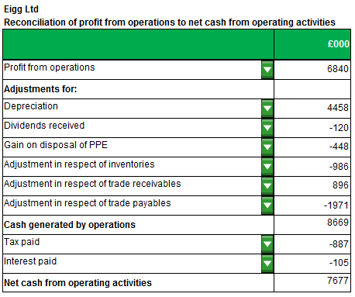

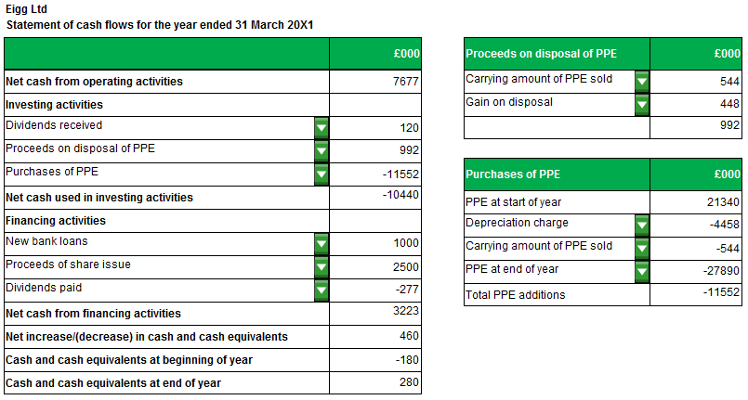

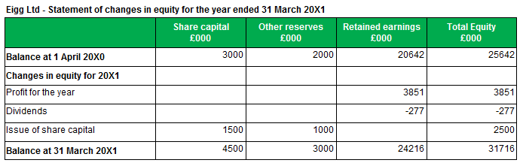
Task 1.2

Task 1.3
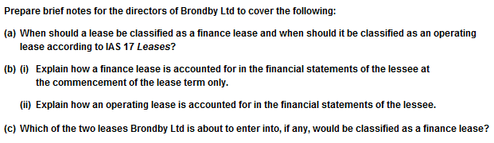
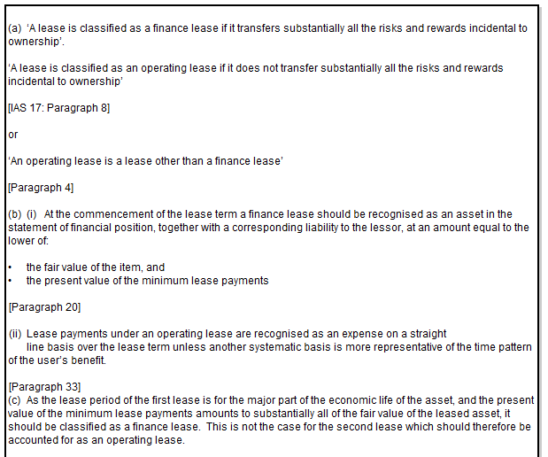

Task 1.4
Task 1.4

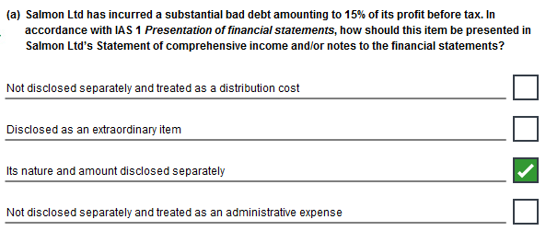
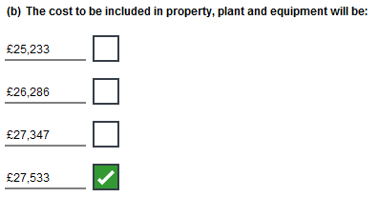

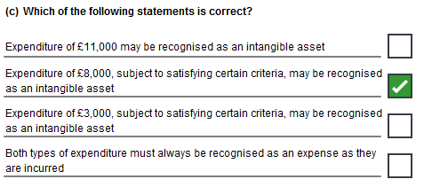

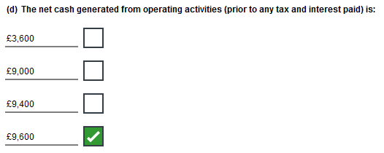

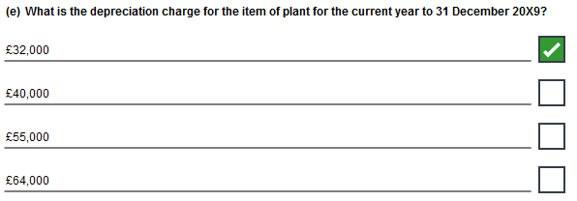

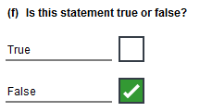
Task 1.5
Task 1.5

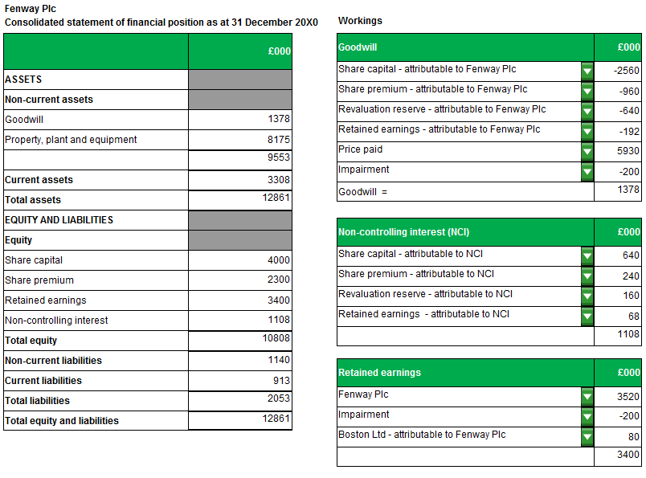

Task 2.1
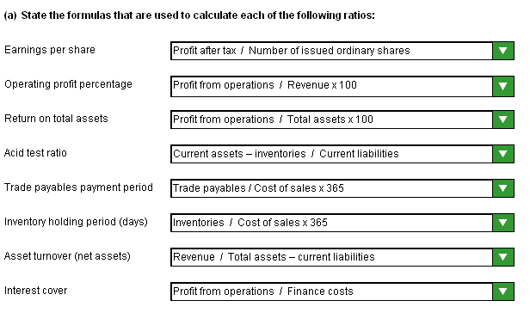

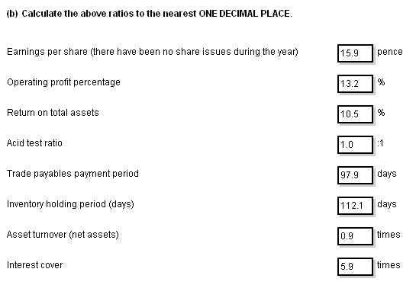

NOTE:
The model answer shows answers rounded down but answers rounded up are equally valid.
Task 2.2

Mike,

As requested I have analysed the working capital of Humber Limited by means of computing four accounting ratios for the company and comparing these to industry averages. My analysis is as follows:

(a)
- Current ratio is better

- Humber Ltd has more current assets available to meet its current liabilities/more solvent
- However, looks to be too high/ indicates less efficient management of working capital
- It may have higher levels of receivables, inventories or cash & cash equivalents/
lower payables.

(ii) Inventory holding period is worse

- Humber Ltd is selling its inventories less quickly than the industry average
- Could be due to old/obsolete stock/ less demand from customers /poor stock management systems.

(iii) Trade receivables collection period is worse

- Humber Ltd is taking longer to collect debts
- Bad for cash flow
- Could be due to poor credit control procedures
- May just be offering longer credit terms to boost sales
- Could indicate the presence of bad debts.

- Trade payables payment period may be considered to be better
(if linked to supplier goodwill) or worse (if linked to cash flow).

- Humber Ltd is paying its trade payables sooner [6 days quicker]
- Bad for cash flow
- Good for supplier goodwill
- It may have negotiated additional settlement discounts with suppliers/ suppliers may have dictated shorter payment terms.
(b) Suggestions to improve the management of working capital

- Increase turnover of inventory/reduce inventory levels e.g. improve stock control procedures, reduce
selling prices, better marketing.
- Collect debts more quickly/reduce trade receivable days e.g. improve debt collection procedures,
reduce credit periods.
- Increase the length of time taken to pay trade payables/increase trade payable days e.g. negotiate
extended credit terms, improve payment procedures.

Task 2.3
