
CBA Practice paper model answers
Financial Statements (FNST) practice test 1

Task 1.1

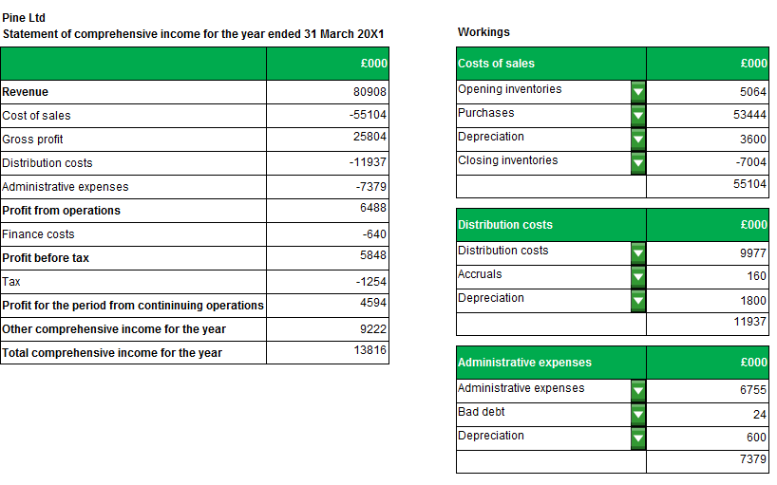

Task 1.1 continued

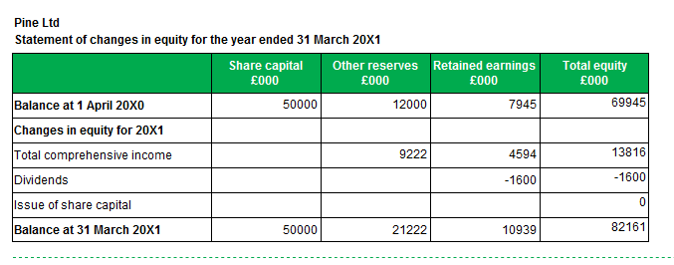
Task 1.2
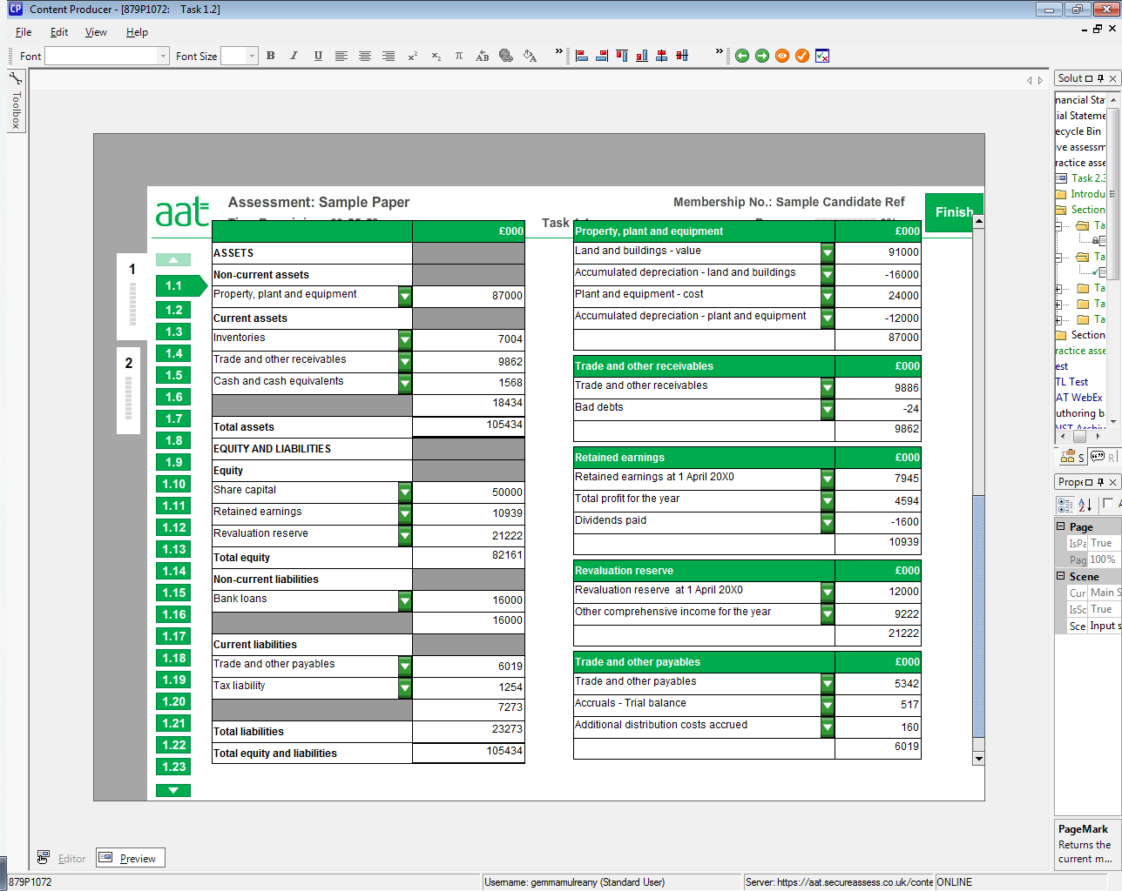

Task 1.3

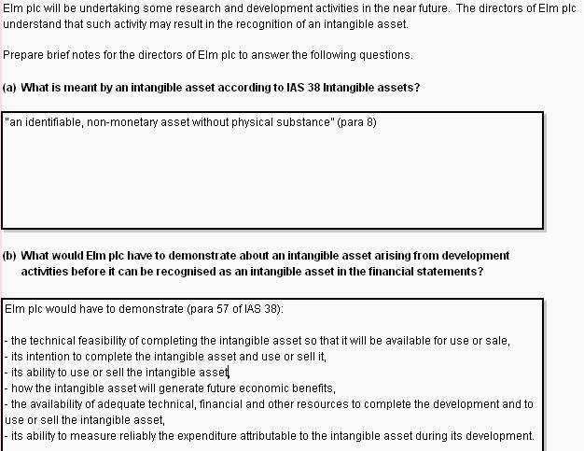
Task 1.4

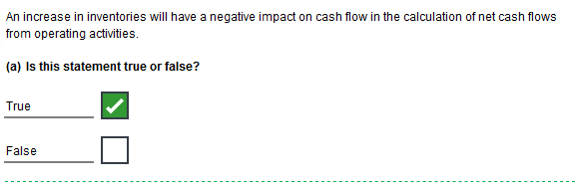

Task 1.4 continued

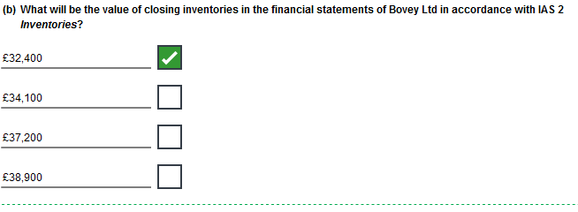

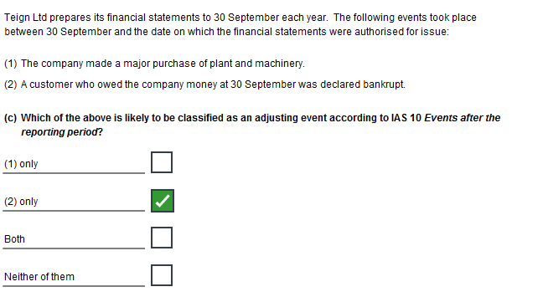
Task 1.4 continued

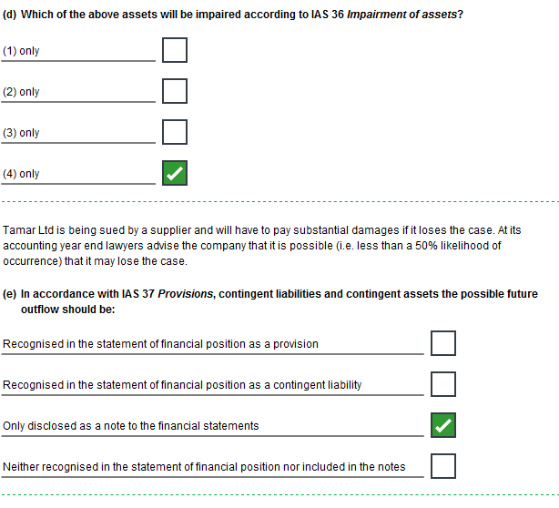
Task 1.4 continued

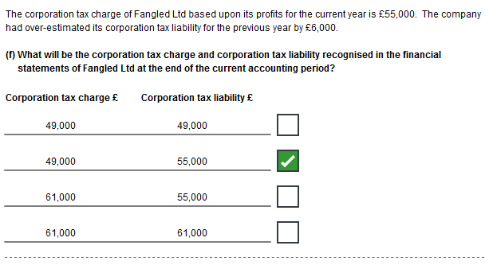

Task 1.5

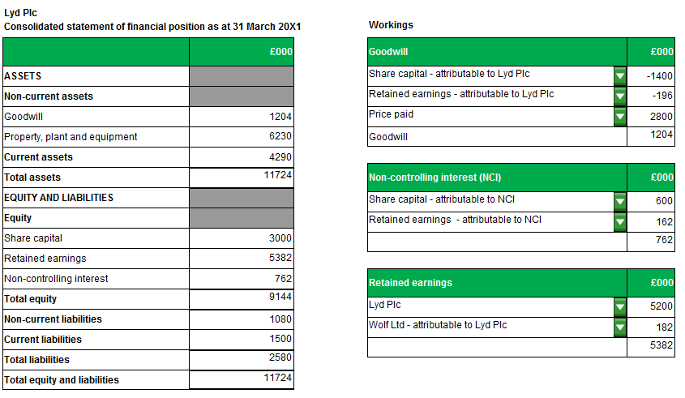

Task 1.5, continued

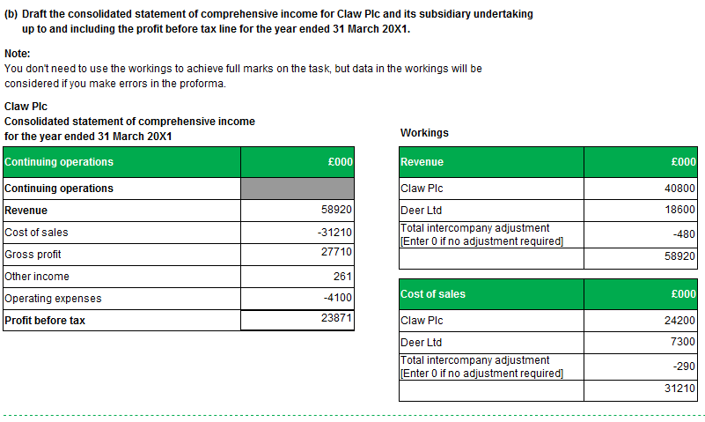
Task 2.1

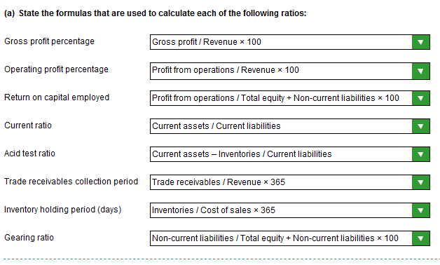

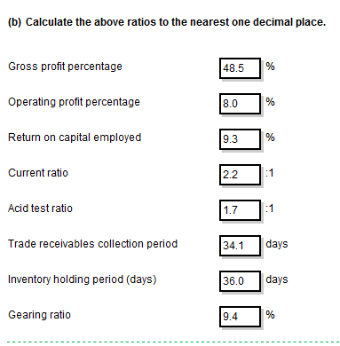

NOTE:
The model answers show figures rounded down (with the exception of the first two answers which do not require rounding).
Answers rounded up are equally valid (e.g. 9.4 an equally valid response for ‘Return on capital employed’).

Task 2.2

Notes for Nancy Charlton regarding a possible investment in Limden Ltd

(a)
(i) | The gross profit ratio has improved.
 | More gross profit is being generated by sales/gross profit margin on sales.
 | Improvement may be due to increasing its sales price or decreasing the cost of sales or both.
 | Could have been a change in the product mix.
(ii) | The operating profit ratio has deteriorated.
 | Less operating profit is being generated from sales.
 | Either a decrease in the sales margins or an increase in expenses, or both.
 | As the gross margins have improved, must be the result of an increase in expenses.
(iii) | The return on equity has deteriorated.
 | Less net profit is being generated from equity.
(iv) | The gearing ratio has deteriorated.
 | Could cause problems obtaining loans in the future
 | More risky
 | May have taken out additional loans during the year
(v) | The interest cover ratio has deteriorated.
 | Less operating profit to cover interest payments.
 | More risky
 | Caused by lower operating profits/higher interest payments
 | Higher interest payments could be due to new loans taken out during the year.
(b) | Nancy should be advised not to invest since only the gross profit percentage has improved whilst overall profitability has deteriorated and any investment would be risky.
Task 2.3

