

CBT Practice test model answers

Financial Performance (FNPF)
Practice assessment 3

Section 1

Task 1.1

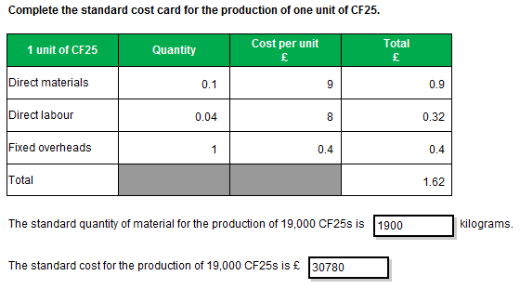

Task 1.2

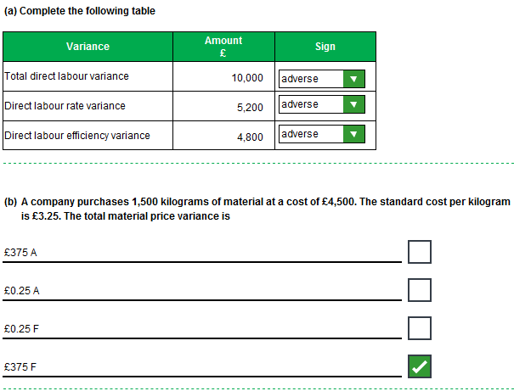

Task 1.2, continued

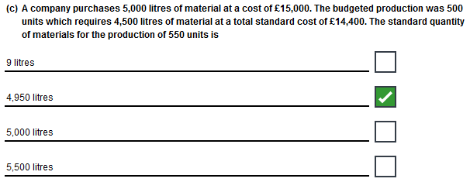
Task 1.3

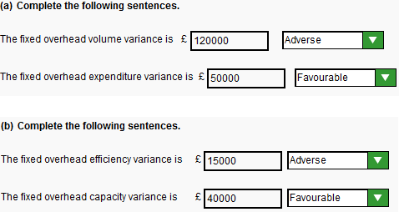

Task 1.4

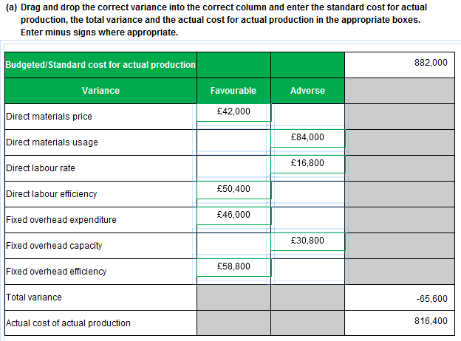

Task 1.4, continued

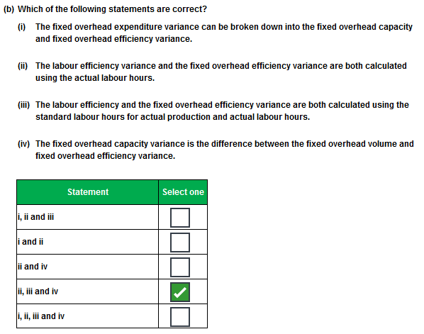

Task 1.5

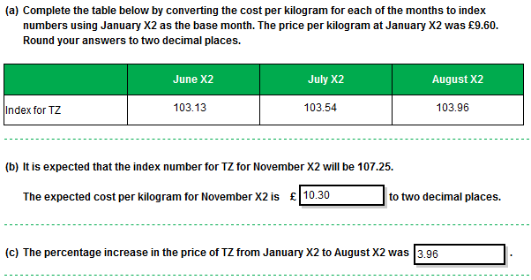

Task 1.6

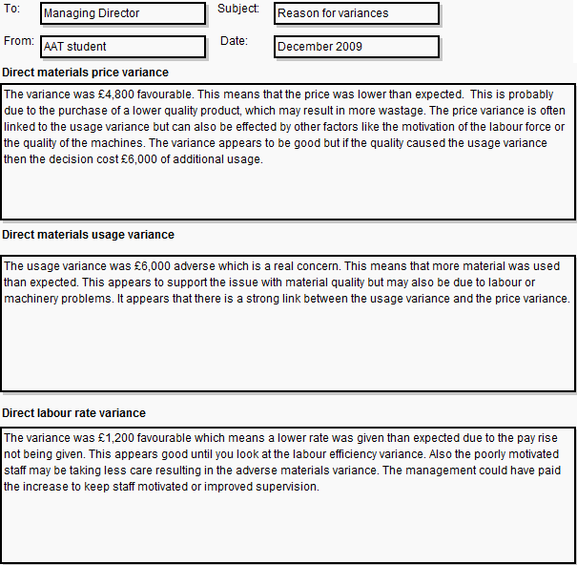
Task 1.6, continued

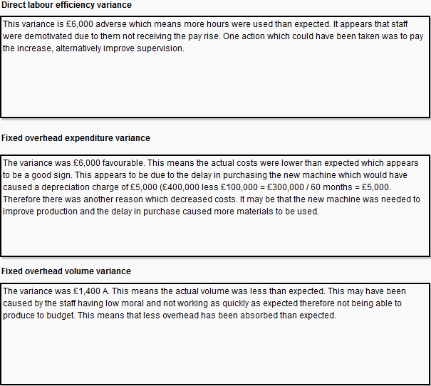

Section 2

Task 2.1

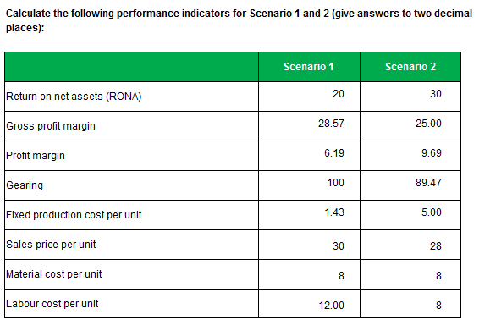
Gearing:
The answer shown in the gearing row of the given model answer is calculated as:
- Debt/Equity x 100% = 100 and 89.47 for Scenario 1 and Scenario 2 respectively.
However, the gearing may also be calculated as:
- Debt/(Debt plus Equity) = 50 and 47.22 for Scenario 1 and Scenario 2 respectively.

Both approaches are considered valid for the purposes of this assessment and will mark as correct.

Task 2.2

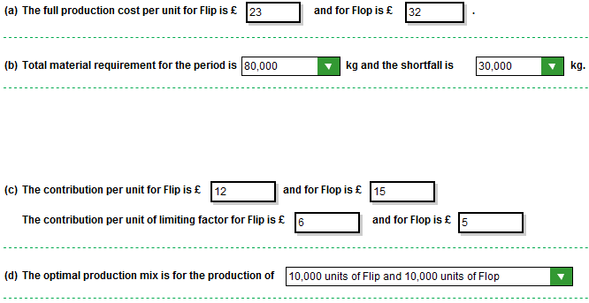
Task 2.3

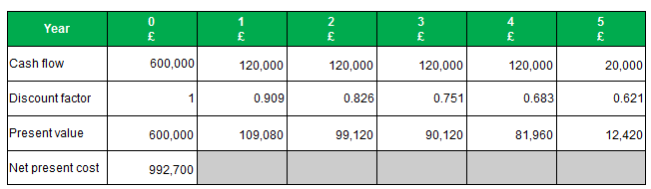

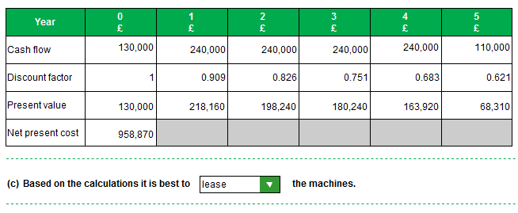

Task 2.4

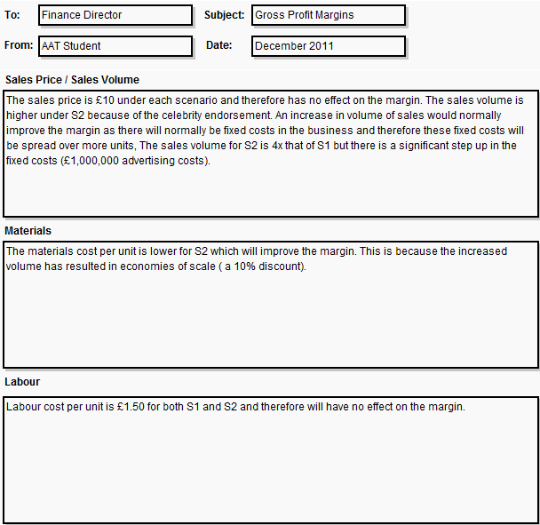
Task 2.4, continued

