

CBT Practice test model answers

Financial Performance (FNPF)
Practice assessment 1

Section 1

Task 1.1

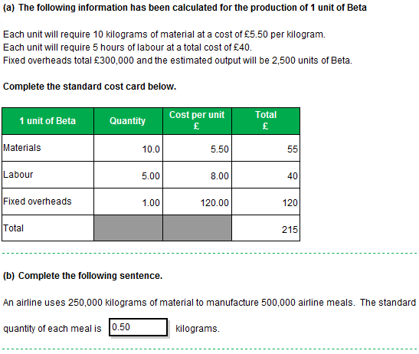
Task 1.2

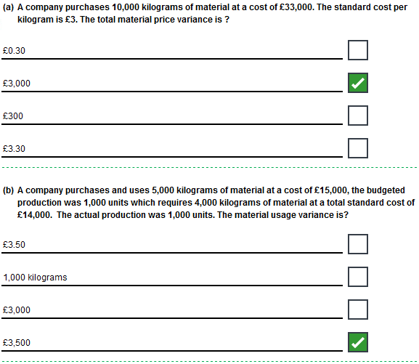
Task 1.2, continued

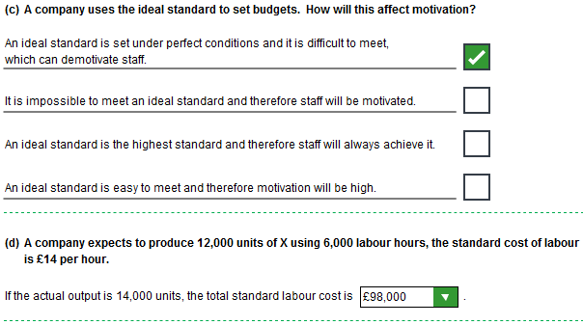
Task 1.3

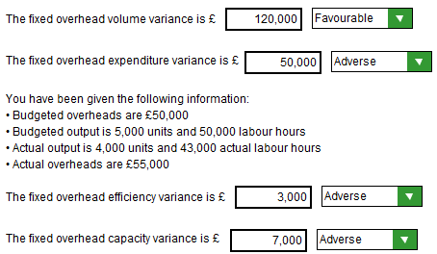
Task 1.4

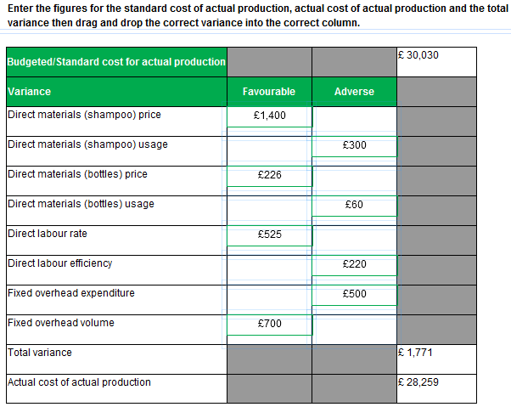
Task 1.5



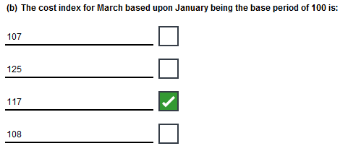

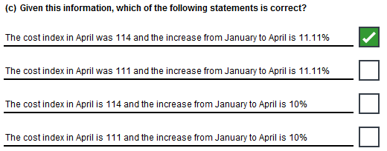
Task 1.6

To: Production Director Subject: Reason for variances

From: AAT student Date: December 2009

- Possible reasons for the variances

Direct materials (Arabica) price variance

The price variance for Arabica beans is £800 adverse. This is due to the market price of beans increasing due to the poor harvest, meaning there is lower supply, therefore the price increases. The company could not have taken any action as the market sets the price.

Direct materials (Arabica) usage variance

The usage variance for Arabica beans is £2,250 favourable. This has been caused by the mixing process making an error and adding a greater amount of Robusta beans to the mix. The result is that the company has saved money because they have used less Arabica beans per kilogram of production, but the mix is outside of the range recommended to produce an acceptable quality blend. Therefore the customers may be unhappy.

The company could have secured the maintenance personnel by paying a market rate.

Direct materials (Robusta) price variance

The price variance for Robusta beans is £600 favourable. This is due to the market price of beans decreasing due to a good harvest meaning there is a larger supply, therefore the price reduces. The company could not have taken any action as the market sets the price.

Direct materials (Robusta) usage variance
The usage variance is £1,875 adverse because the company used more beans than expected. This was because of the mixing machine breaking down.

- Action which could have been taken

Quality of beans – no action is necessary as the quality was as expected; no action could be taken as quality is dependent on the harvest.

Machines breakdown – the information states that the low pay rise meant that maintenance staff left. Therefore one option would be to pay more to retain maintenance staff or outsource to a reliable company.

Section 2

Task 2.1

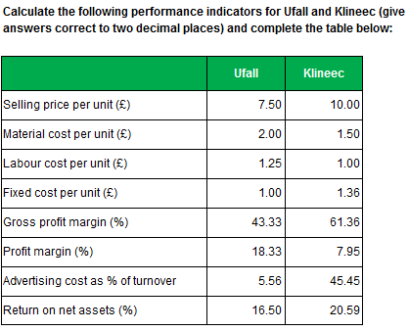
Task 2.2

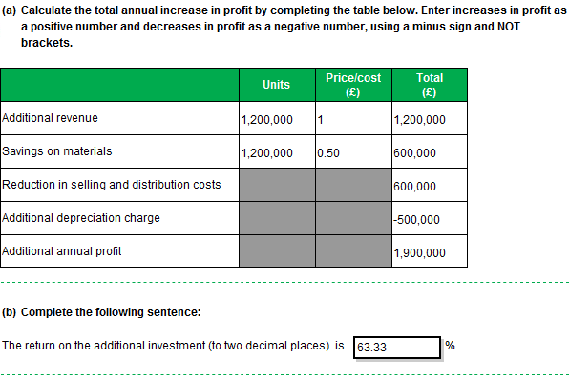

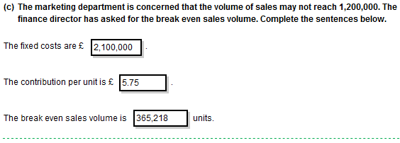
Task 2.3

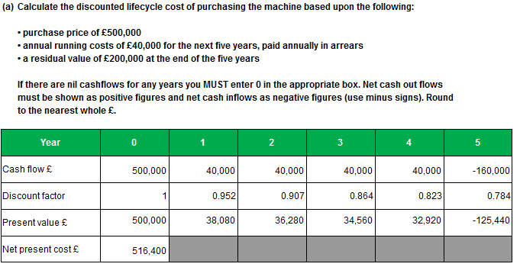

Task 2.3, continued

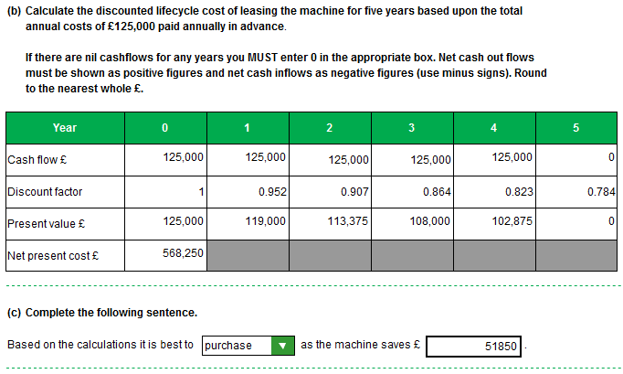

Task 2.4

To: Finance Director Subject: Various

From: AAT student Date: December 2012

- Why are the gross profit margins different?

- Sales Price / sales volume
The sales price is higher under Scenario 1 which will result in an increase in the gross profit margin. However, the sales volume is half that of Scenario 2, which will reduce the margin if there are fixed costs because the fixed cost per unit will be higher.

- Materials
The materials cost per unit is constant and therefore does not affect the gross profit margin. There is no economy of scale.

- Labour
Labour cost per unit is £1 for Scenario 1 decreasing to £0.80 for Scenario 2. The more units that are produced, the lower the labour cost per unit. This will improve the margin for Scenario 2. It may be because of economies of scale in production or the learning effect.

- Fixed costs
Fixed costs are constant in total. Therefore, as the volume of production increases, the fixed cost per unit reduces. This will increase the margin.

- Which is the dominant factor and why?

Scenario 2 sells twice as many units as Scenario 1, has the same material cost per unit, lower labour cost per unit, and lower fixed costs per unit. All of these would increase Scenario 2’s margin. However the margin is lower. This is due to the lower sales price per unit which is the dominant factor.

- Why are the net profit margins different?

The net profit margins are different due in part to the reduction in gross profit for Scenario 2 and in part due to the increased sales and distribution costs in Scenario 2.

- Recommendation, with reasons, as to which course of action to take

Based purely on the forecast information, Scenario 1 is the best option creating the largest return. However, the sales volume is lower than Scenario 2 and therefore the market share is lower. It may be worth setting the price lower to gain market share. Alternatively, could the price be set at, say, £8 per unit, and what would be the demand at this price?

