
CBT Practice test model answers

External Auditing (EXA)
Practice assessment 4

Section 1
Task 1.1

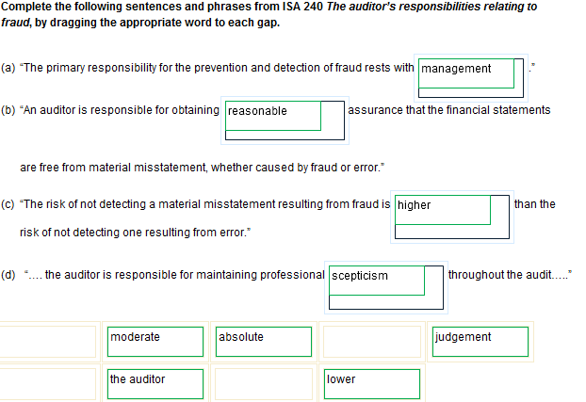
Task 1.2

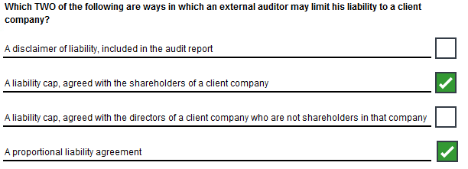

Task 1.3

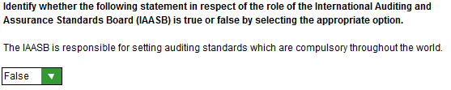

Task 1.4

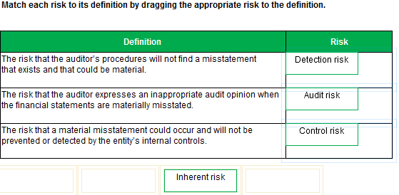
Task 1.5

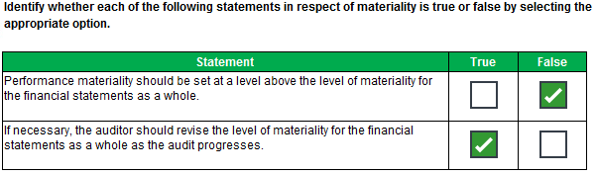

Task 1.6

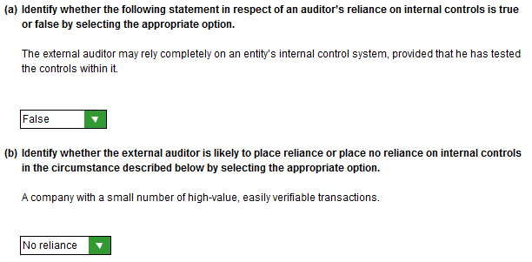
Task 1.7

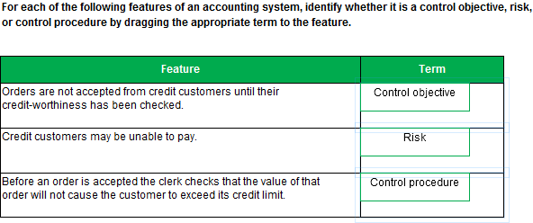
Task 1.8

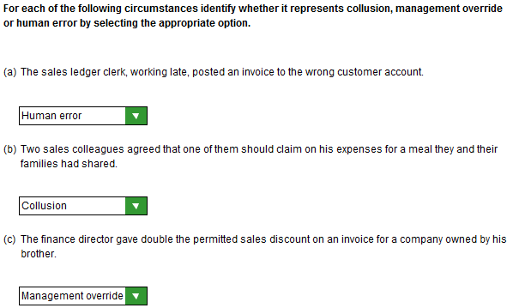
Task 1.9

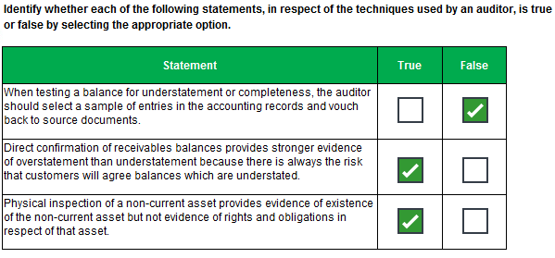

Task 1.10

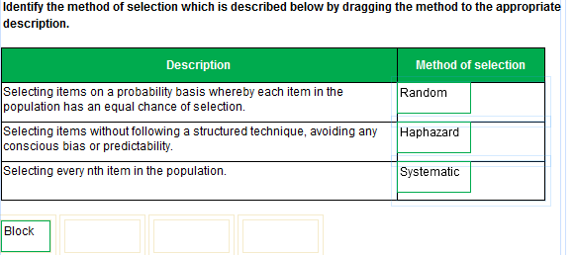
Task 1.11

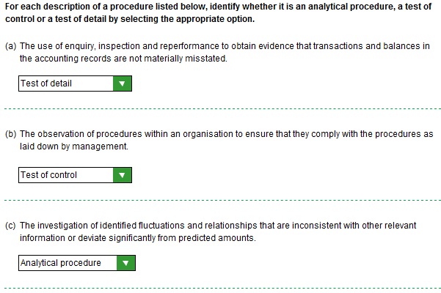
Task 1.12

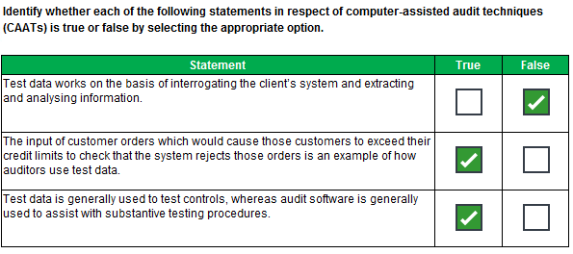

Task 1.13

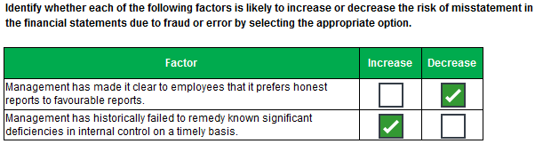

Task 1.14

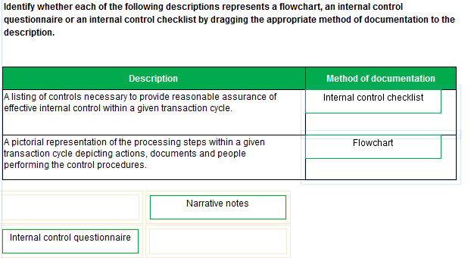
Task 1.15

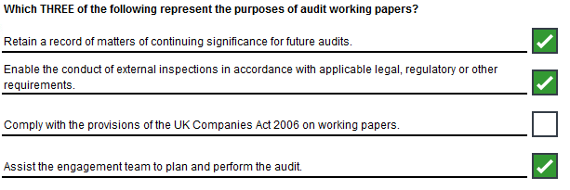

Section 2
Task 2.1

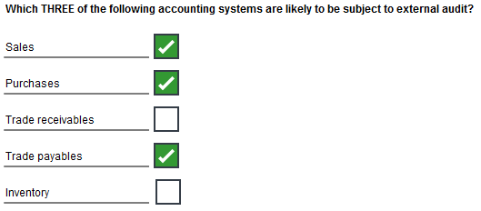

Task 2.2

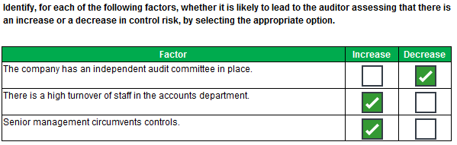

Task 2.3

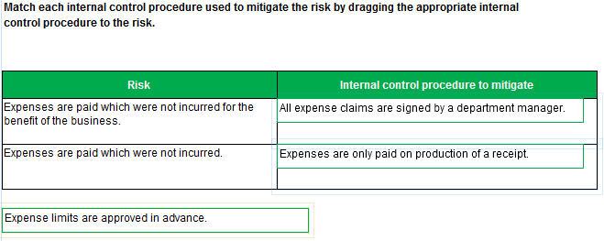

Task 2.4

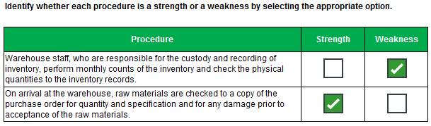

Task 2.5

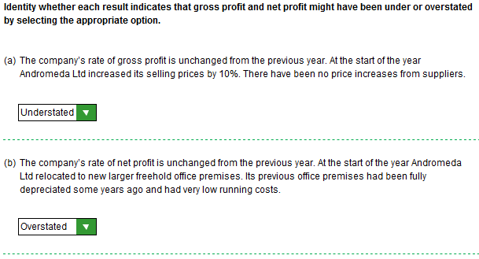

Task 2.6

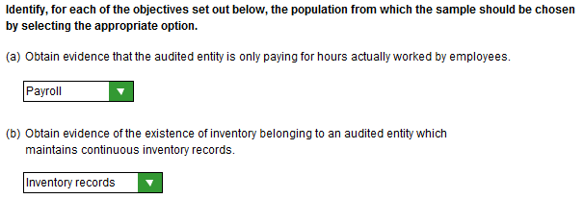
Task 2.7

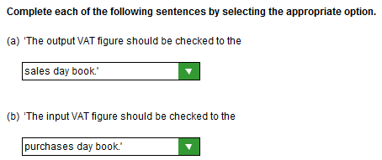
Task 2.8

(i) Risks

- The cost of additions may be misstated or may relate to items that should have been expensed (eg training costs wrongly capitalised).
- Additions may be incomplete.
- Additions could be wrongly classified (eg as plant and equipment instead of motor vehicles).
- Not all disposals (including any plant scrapped) may have been recorded.
- The amount taken out of cost for disposals may not be the original cost, especially if items have been fully depreciated.
- The opening cost figure may not have been correctly brought forward from the previous year.
- Assets may not exist.
- The movement on cost may not be correctly disclosed in the financial statements.
- Assets may not be owned by Gremlin Ltd.
- The cut-off of additions and disposals could be incorrect.

(ii) Procedures

- Agree the opening cost figure to last year’s final financial statements.
- Obtain a schedule of additions and disposals.
- Select a sample of additions and vouch the cost to purchase invoices/finance lease agreements to ensure correctly capitalised and title obtained.
- Review purchase invoices/ repairs and maintenance account/minutes for items that should have been capitalised.
- Compare additions/disposals to budgeted additions/disposals.
- Review minutes of meetings/scrappings notes/invoices for sale of plant and ensure all items actually disposed of during the year are reflected on the schedule of disposals.
- Select a sample of disposals and confirm original cost to the non-current asset register/Periodic review of cost account to equipment with differences reported and investigated.
- Review invoices relating to non-current assets around the year end to ensure that additions and disposals are recorded in the correct period.
- Select a sample of assets from the asset register and physically verify.
- Ensure the note to property plant and equipment properly discloses the above movement on cost.

Task 2.9

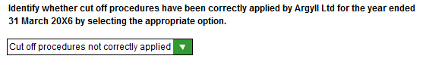

Task 2.10

- Select a sample of individual net pay amounts from both the weekly and monthly payrolls and:
  - agree hours worked to printout of hours worked (weekly payroll)
  - agree pay rates to personnel files (weekly payroll)
  - agree salary to personnel files (monthly payroll)
  - agree deductions to personnel files (including tax coding notices)
  - reperform calculations
  - seek out employee to verify existence
- Verify payments to employees and to tax authorities to bank statements
- Trace a sample of postings from the payroll to the nominal ledger
- Check nominal ledger figures to the financial statements
- Carry out analytical procedures utilising relationships between numbers of staff and average pay rates and average percentages of deductions for tax etc
- Compare with previous year and budget and obtain plausible explanation for movements out of line with expectations
- Ensure the payroll has been signed as approved by someone in authority
- Check swipe card system to ensure recording hours correctly (test of control)
- Identify starters and leavers by comparing the payroll at two different points in time and ensure names added to/deleted from payroll at appropriate dates
- Review bank transfer details for completeness and duplicate names
Task 2.11

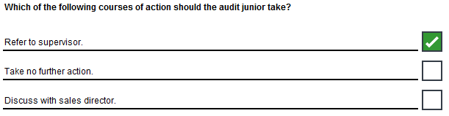

Task 2.12

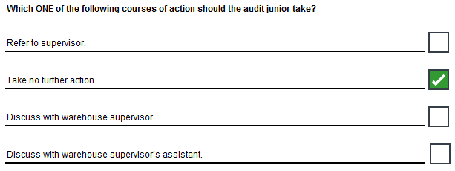

Task 2.13

- Consequences
- Bank reconciliations may not be performed.
- Errors in writing up the cash book may not be discovered/Cash may be misstated.
- Bank errors may not be discovered.
[As alternative to above two points] – No one has looked at reconciling items.
- Entries made by the bank may not be accounted for on a timely basis/bounced cheques may not be spotted, which could impact on cash management/May fail to identify that overdraft limit has been exceeded.
- Delays in despatching cheques to suppliers may not be discovered and such delays could damage the company’s relationship with its suppliers.
- Fraud/teeming and lading could go undetected.

(ii) Recommendations
- Unpresented cheques in the reconciliation should be traced to the first few days of the next bank statement.
- Uncleared lodgements in the reconciliation should be traced to the first few days of the next bank statement.
[As alternative to above two points] – Uncleared items are cleared/investigated and the items annotated with when presented/cleared at the bank.
- The reconciliation should be reviewed by the financial controller and signed as evidence of his review.
- Entries on the bank statements but not in the cash book should be accounted for promptly.
- Errors discovered should be corrected promptly and the reason for making those errors investigated.
- Monitoring of procedures to ensure compliance.

Task 2.14

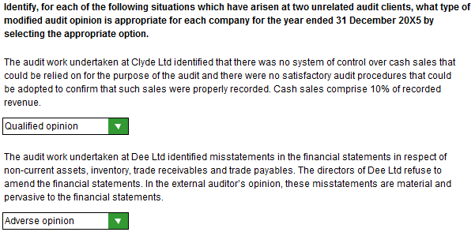

Task 2.15

