
CBT Practice test model answers

External Auditing (EXA)
Practice assessment 1

Section 1
Task 1.1

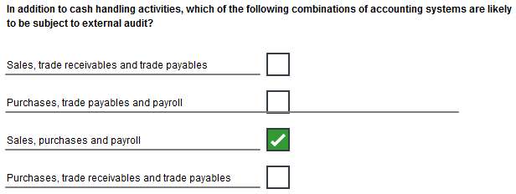
Task 1.2

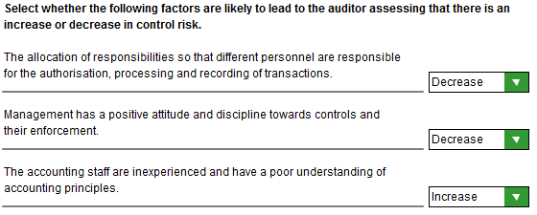
Task 1.3

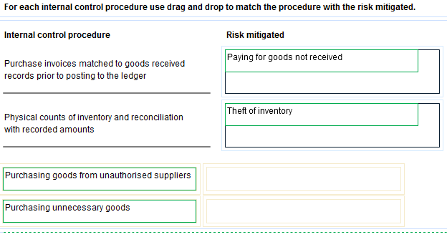
Task 1.4

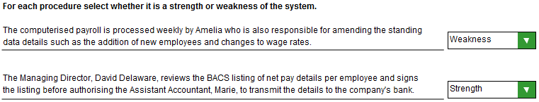
Task 1.5

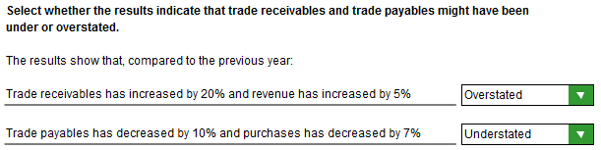

Task 1.6

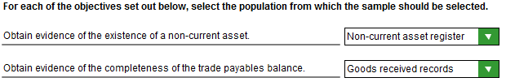

Task 1.7

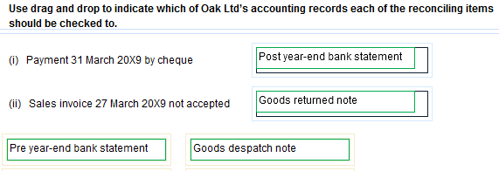
Task 1.8

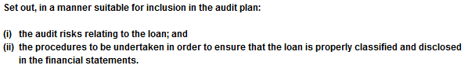

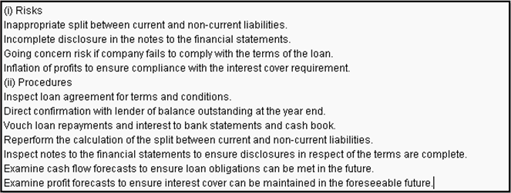

This task will not be marked in the practice assessment.
Task 1.9

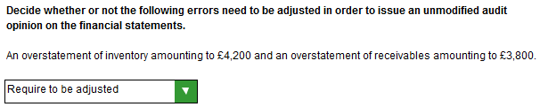

Task 1.10

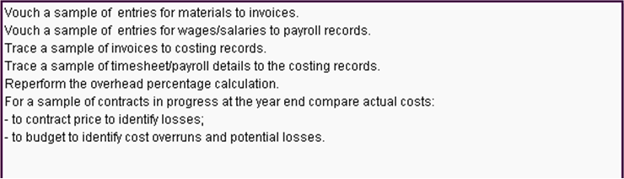

This task will not be marked in the practice assessment.
Task 1.11

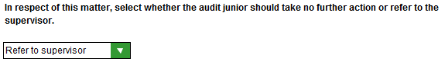
Task 1.12

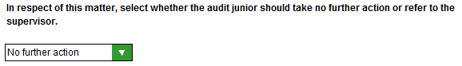
Task 1.13

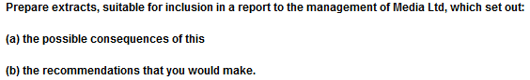

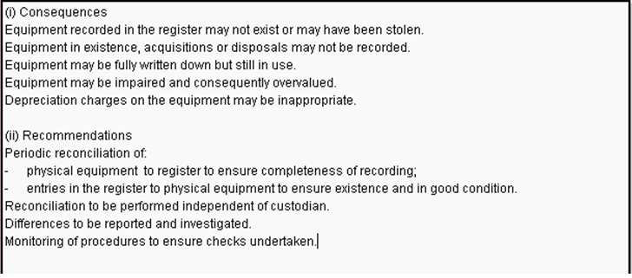

This task will not be marked in the practice assessment.
Task 1.14

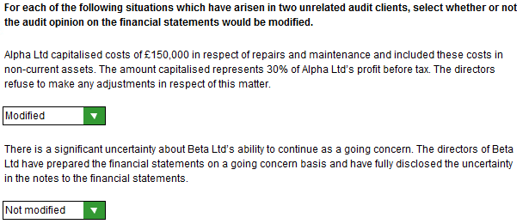

Task 1.15

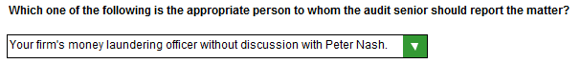

Section 2
Task 2.1

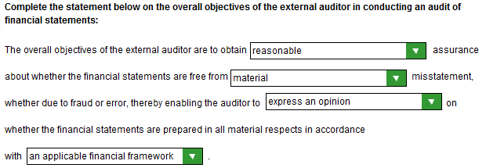
Task 2.2

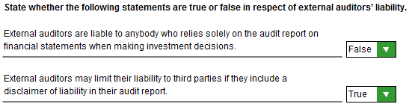

Task 2.3

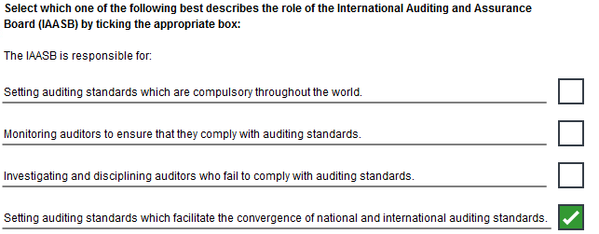

Task 2.4

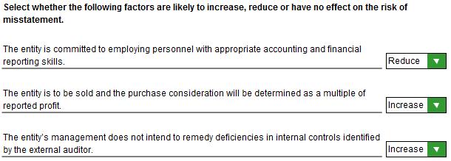
Task 2.5

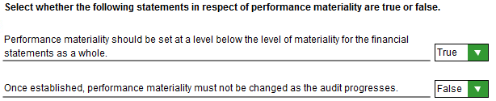

Task 2.6

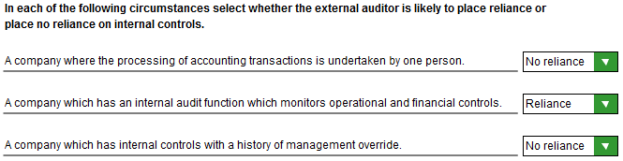

Task 2.7

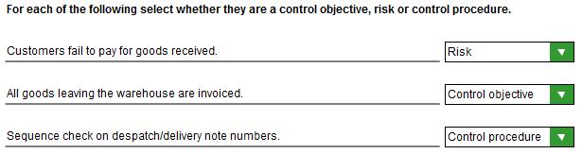
Task 2.8

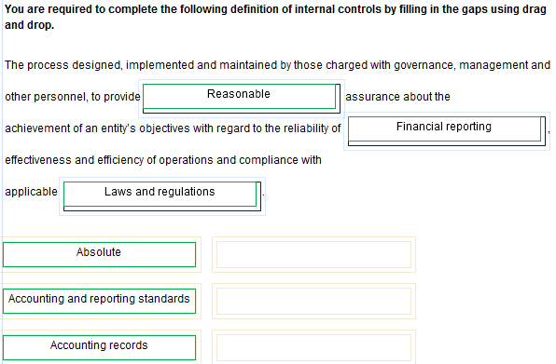

Task 2.9

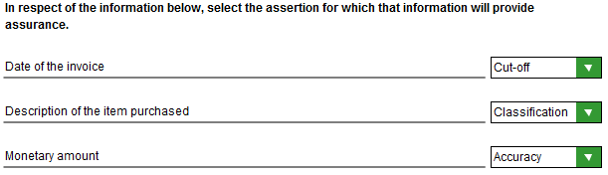

Task 2.10

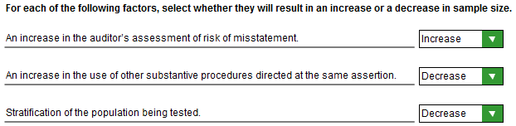

Task 2.11

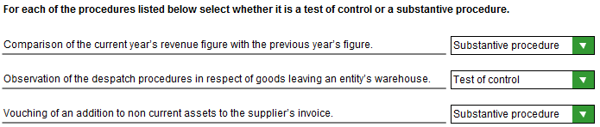

Task 2.12

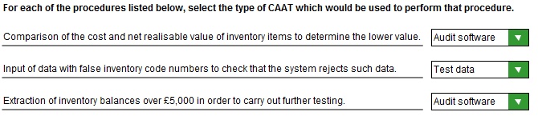

Task 2.13

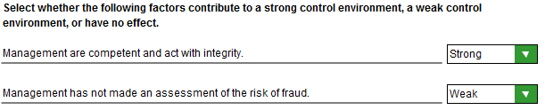

Task 2.14

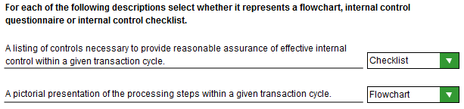

Task 2.15



