

CBT Practice test model answers

Costs and Revenues (CRS)
Practice assessment 3

Section 1
Task 1.1

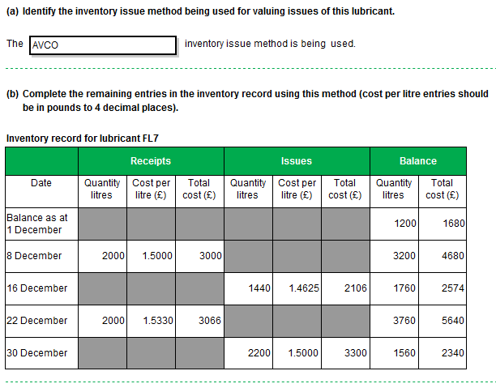

Task 1.2

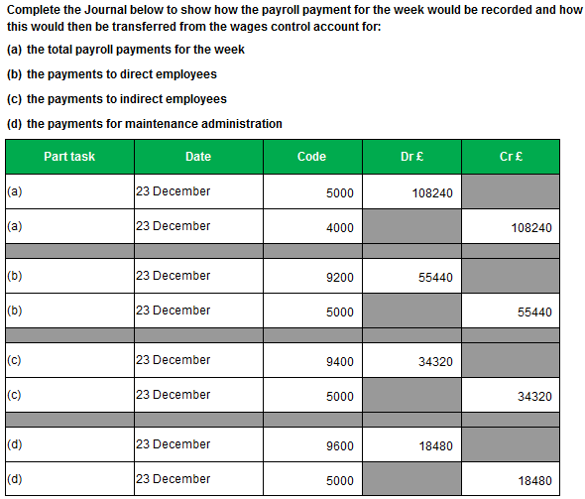

Task 1.3

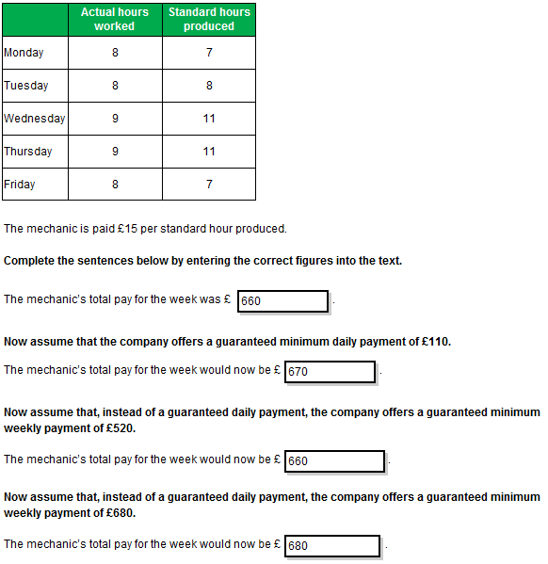
Task 1.4
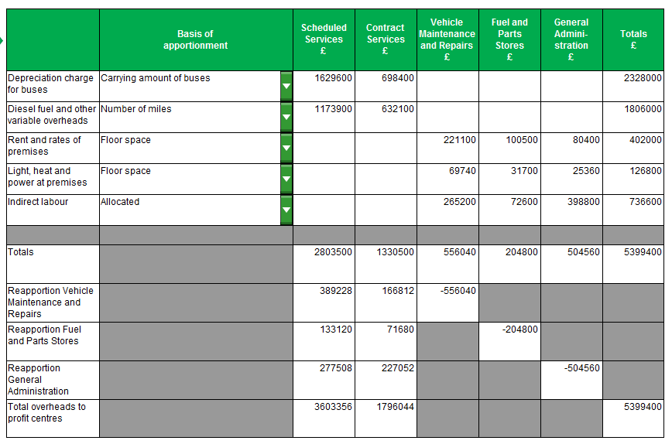

Task 1.5

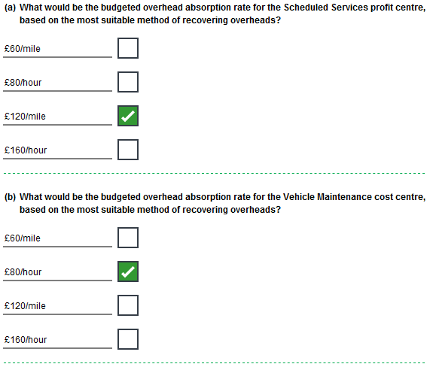

Task 1.5, continued

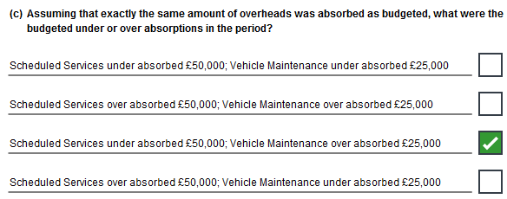

Section 2
Task 2.1

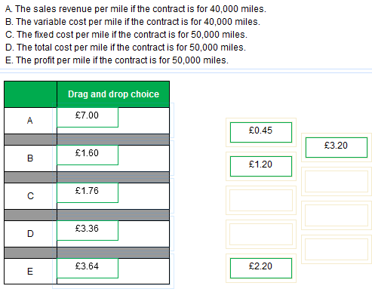

Task 2.2

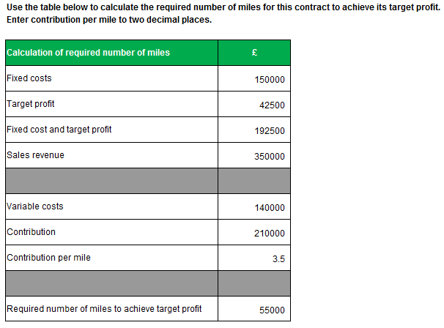

Task 2.3

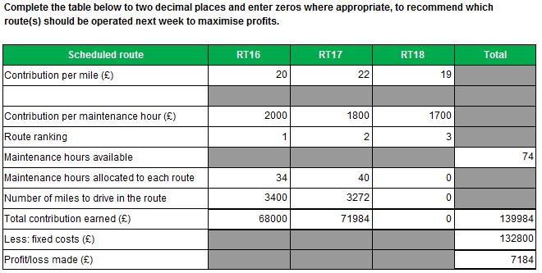

Total contribution earned

In this task the ‘Total contribution figure’ for RT17 may also be entered as 72,000 as per the table given in the task. Please note that if using this approach the ‘Total’ column would also need to be updated accordingly.
This approach is considered equally valid as that shown in the model answer above.

Task 2.4

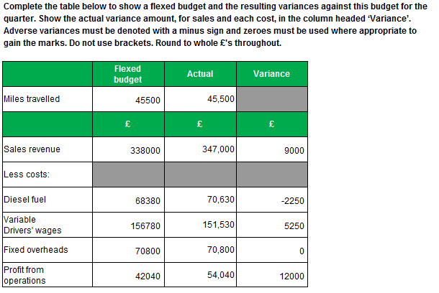

Task 2.5

