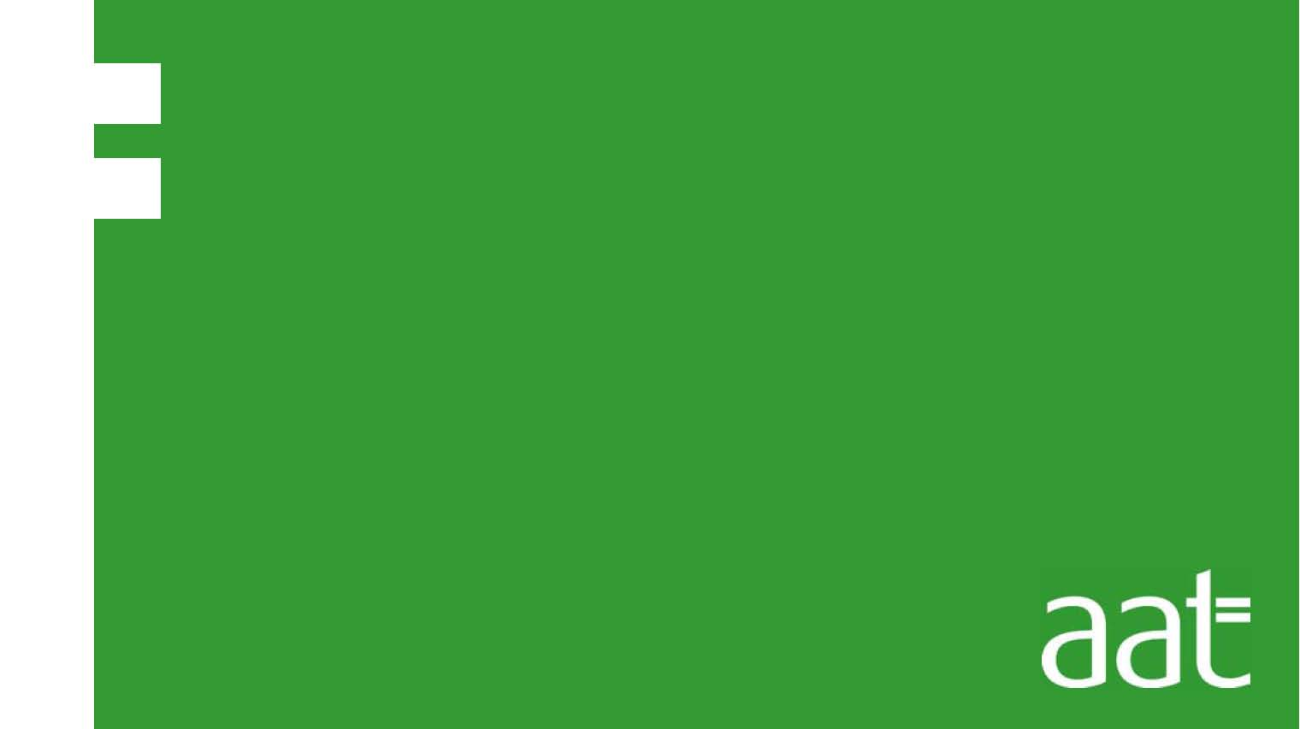

CBT Practice test model answers

Costs and Revenues (CRS)
Practice assessment 2

Section 1

Task 1.1

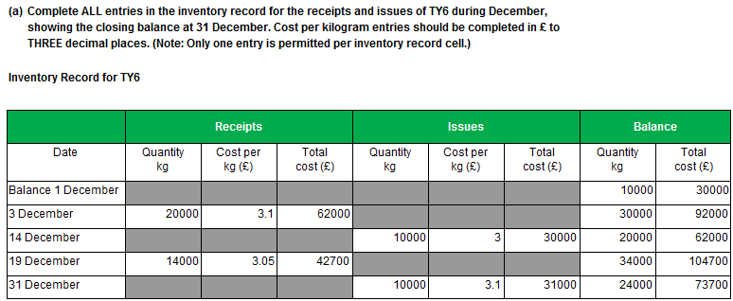

Task 1.1, continued

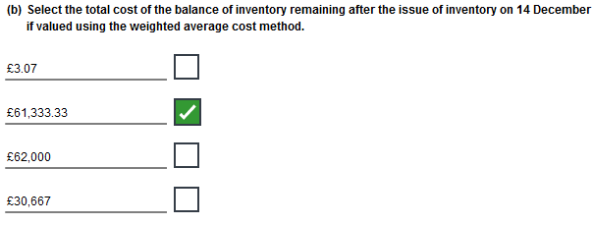

Task 1.2

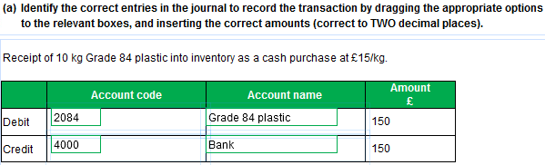

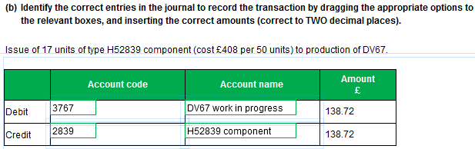

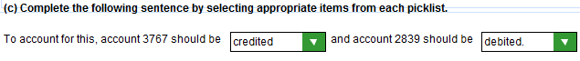

Task 1.3

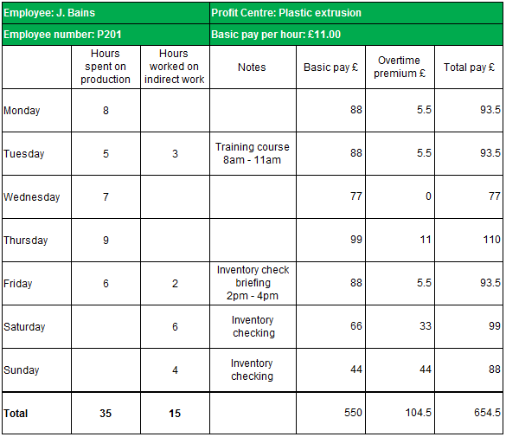
Sunday hours

The figures for Sunday hours in this task may be entered as 4 hours of double time made up of either:

- £44 basic pay plus £44 overtime premium (as shown in the model answer); or
- £0 basic pay and £88 overtime premium, viewing all of the hours on Sunday as overtime premium.
Both methods are equally valid for the purposes of this assessment.

Please note that the figures in the Total row will need to be duly adjusted if using the second method.

Task 1.4

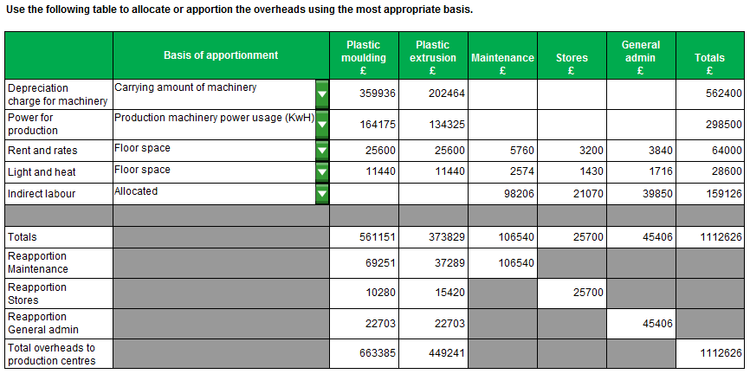

Task 1.5

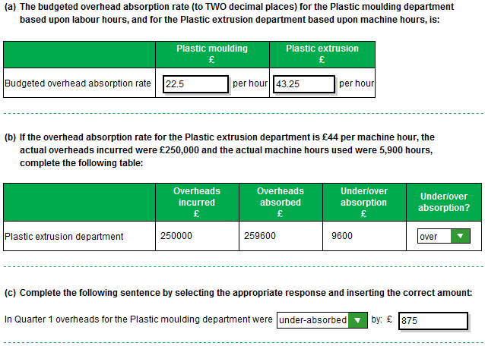

Section 2

Task 2.1
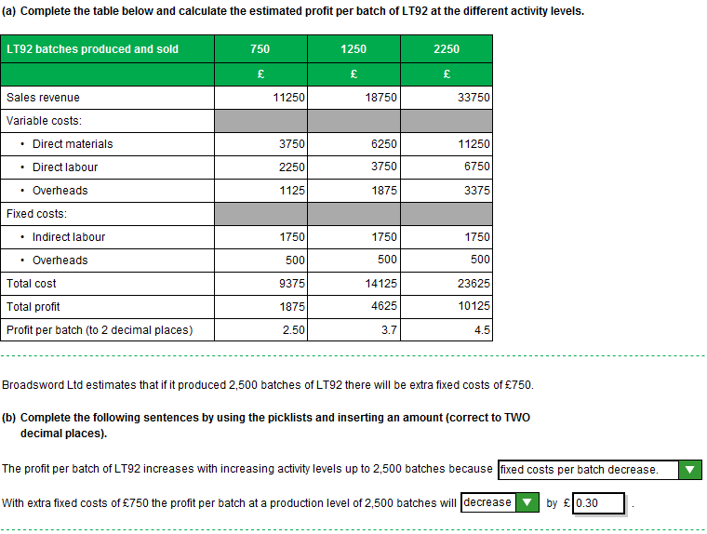
Task 2.2

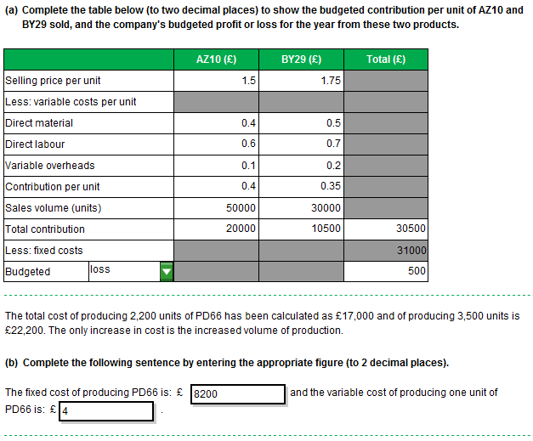

Task 2.3
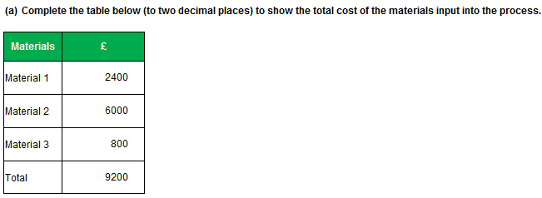

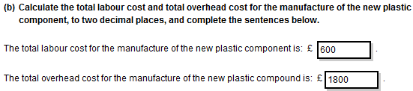

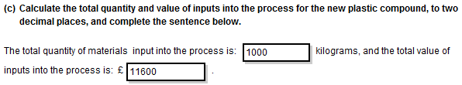

Task 2.3, continued

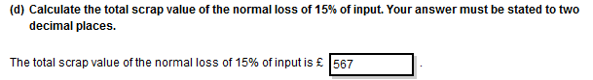

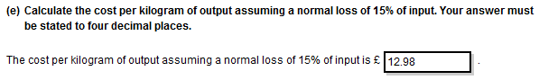

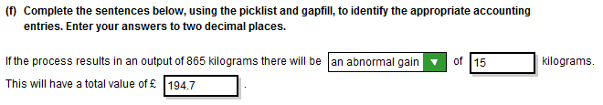
Task 2.4

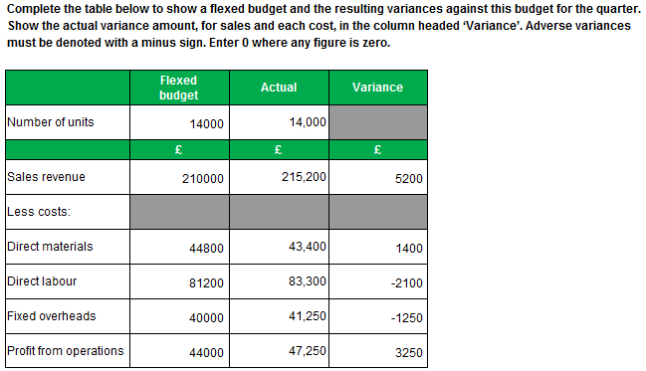

Task 2.5

