
CBT Practice test model answers

Business Tax (BTX)

Practice assessment 2 FA 2010(2)

Section 1

Task 1.1

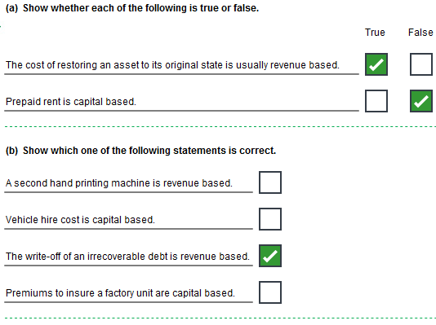
Task 1.2

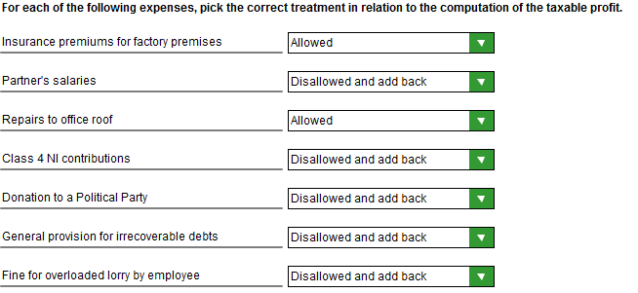
Task 1.3

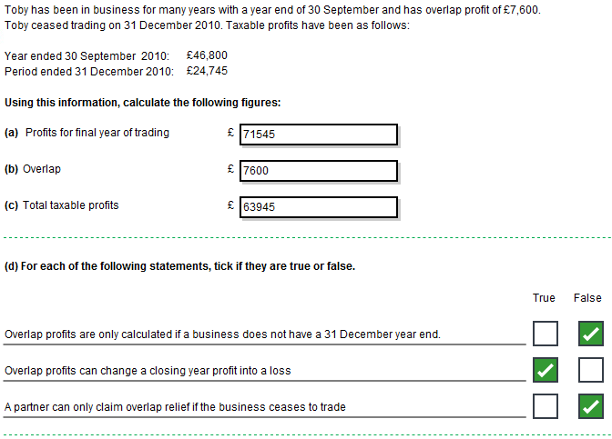
Task 1.4

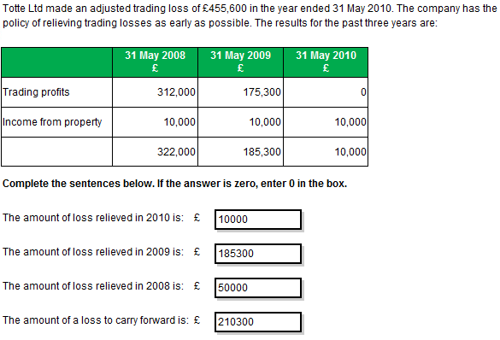
Task 1.5

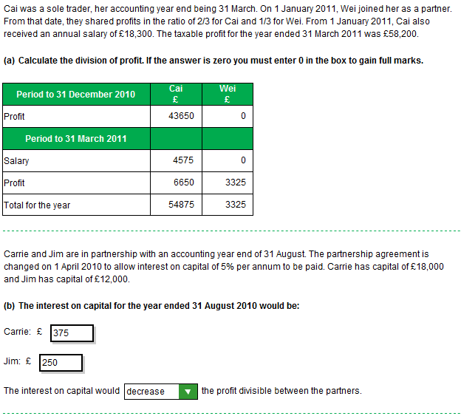
Task 1.6

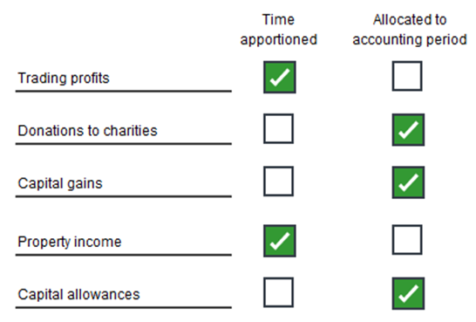
Task 1.7

 | AIA /  FYA |  | General pool |  | Nissan  car |  |  | Total allowances
b/fwd |  |  | 108,700
Non-AIA additions |  |  | 17,400
 |  |  | 126,100
 |  |  |  |  | 21,700
Disposals |  |  | (15,800) |  | (18,900)
Balancing allowance |  |  |  |  | 2,800 |  |  | 2,800
 |  |  | 110,300
WDA @ 20% |  |  | 22,060 |  |  |  |  | 22,060
 |  |  | 88,240
FYA addition | 25,080
100 % | 25,080 |  |  |  |  |  |  | 25,080
AIA additions | 37,000
 | 19,700
 | 56,700
AIA - maximum | 50,000 |  |  |  |  |  |  | 50,000
 | 6,700
 | 2,680 |  | 4,020 |  |  |  |  | 2,680
 |  |  |  |  |  |  |  | 102,620
 |  |  | 92,260

Section 2

Task 2.1

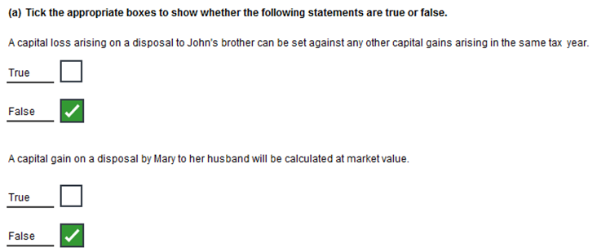
Task 2.2

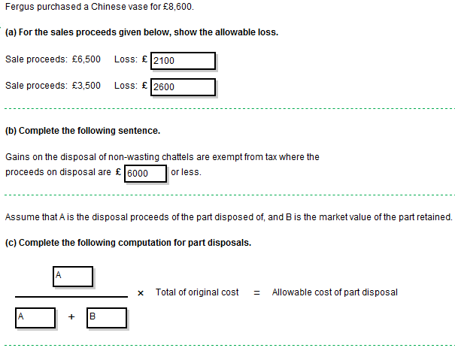
Task 2.3

 | No of  shares | £ | £
December 2001 | 6,000 | 18,000 | 18,000
IA June 2004 .077 |  |  | 1,386
 |  |  | 19,386
RI | 1,000 | 4,000 | 4,000
 |  |  | 23,386
IA Jan 2011 22.6 |  |  | 5,285
 | 7,000 | 22,000 | 28,671
Sold | 7,000 | 22,000
Proceeds | 35,000
Cost | 28,671
Gain | 6,329

Task 2.4

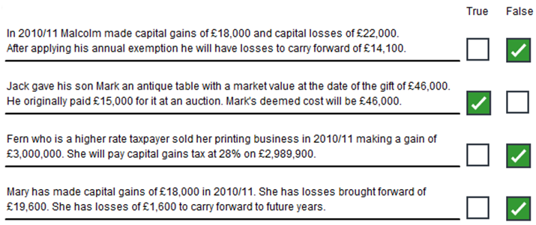
Task 2.5

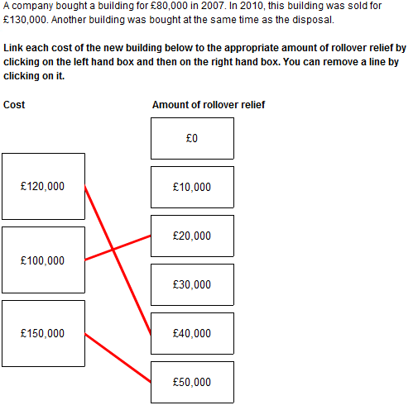
Task 2.6

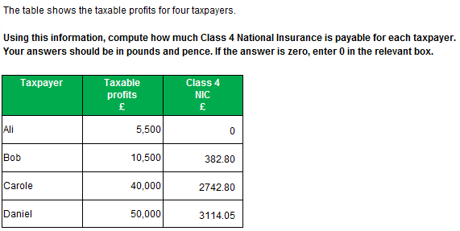
Task 2.7

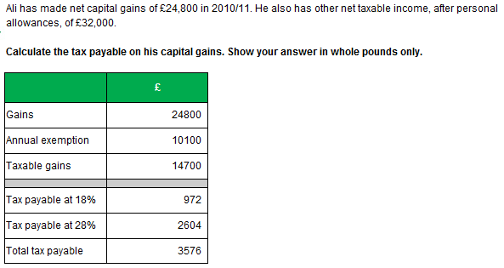
Task 2.8

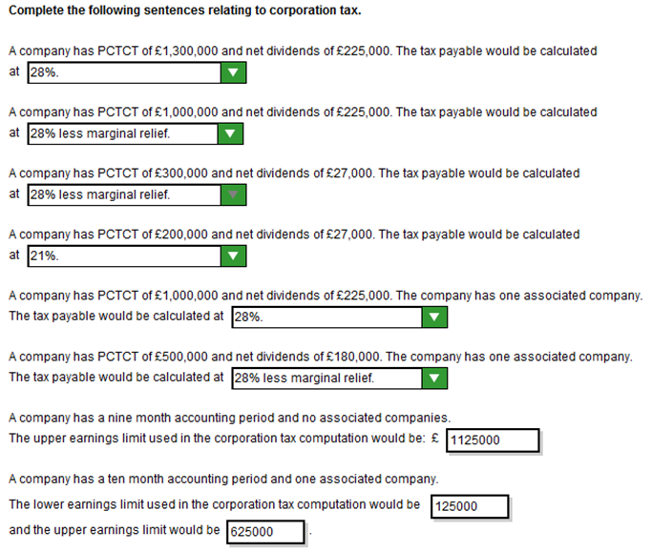
Task 2.9

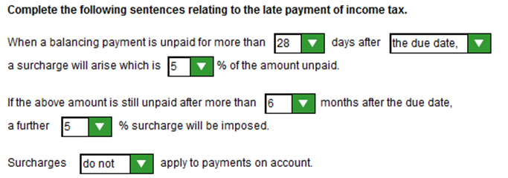
Task 2.10

