

CBT Practice test model answers
Business Tax (BTX)
Practice assessment 2 FA 2011
Section 1
Task 1.1

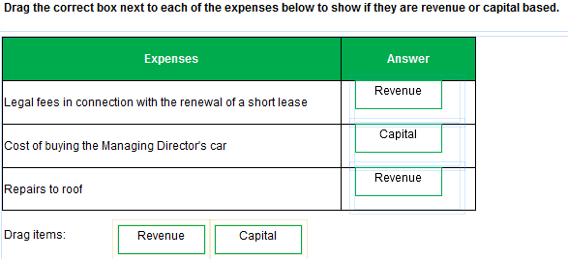

Task 1.2

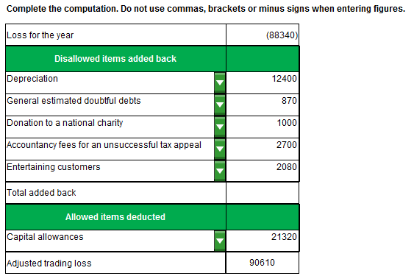
Task 1.3

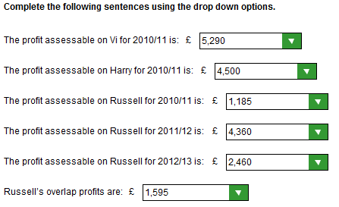

Task 1.4

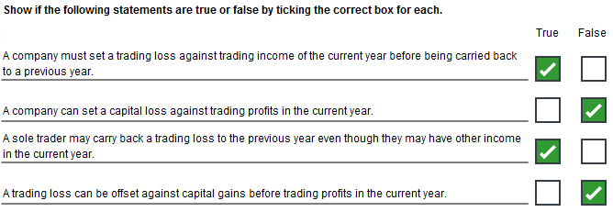
Task 1.5

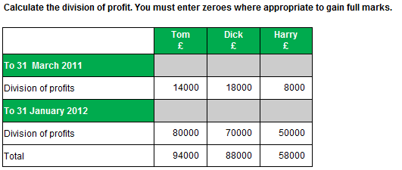

Task 1.6

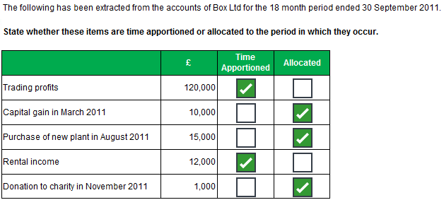
Task 1.7
 |  | General Pool | Marcus’ Car (PU) | Special pool | Allowances
Brought forward |  | 97,400 | 9,100
Disposals |  | 10,100 | 7,700
 |  | 87,300
Balancing allowance |  |  | 1,400 |  | 980
Car – 100% |  |  |  |  | 16,400
Special rate car |  |  |  | 27,930
Private usage car |  |  | 21,020
AIA:
Acquisitions | 117,000
AIA | 100,000 | 17,000 |  |  | 100,000
 |  | 104,.300
WDA – 20% |  | 20,860 |  |  | 20,860
WDA – 20% |  |  | 4,204 |  | 2,943
WDA – 10% |  |  |  | 2,793 | 2,793
Balances to carry forward |  | 83,440 | 16,816 | 25,137
Total allowances |  |  |  |  | 143,976

Section 2
Task 2.1

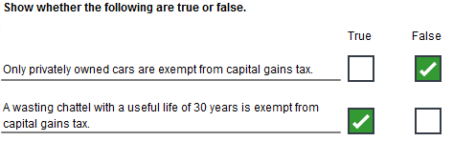
Task 2.2

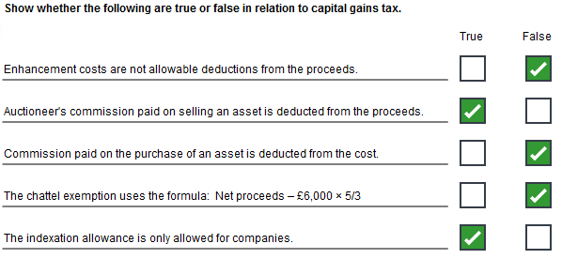
Task 2.3
 | Number of shares |  | Cost  £
October 2011
Proceeds 2,000 x £33 |  |  | 66,000
Cost 2,000 x £29 |  |  | 58,000
Gain |  |  | 8,000
Pool:
July 2000 | 4,000 |  | 80,000
Rights issue | 400 |  | 4,800
 | 4,400 |  | 84,800
Disposal | 1,000 |  | 19,273
 | 3,200 |  | 65,527
Proceeds 1,000 x £33 |  |  | 33,000
Cost |  |  | 19,273
Gain |  |  | 13,727

Task 2.4

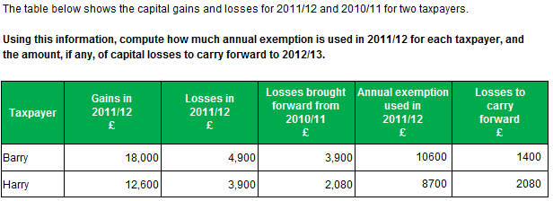
Task 2.5

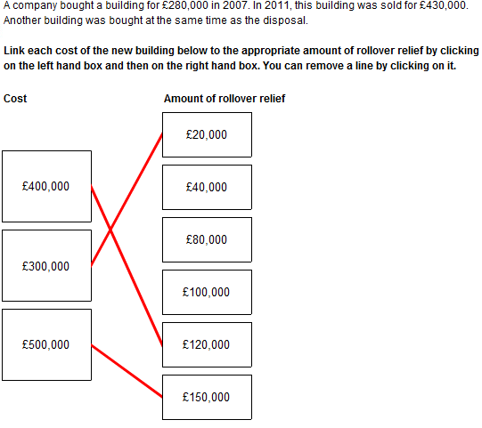
Task 2.6

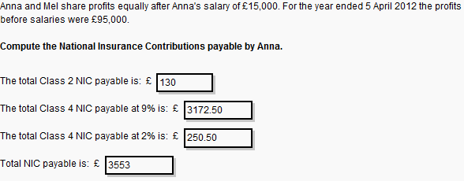
Task 2.7

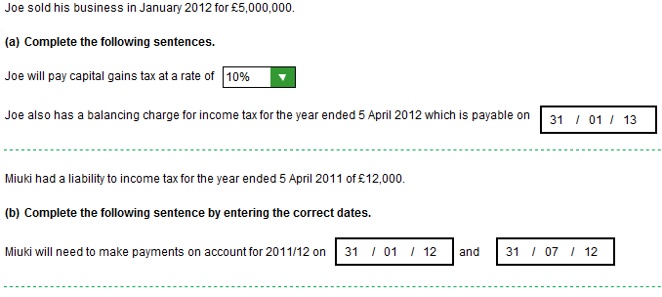

Task 2.8

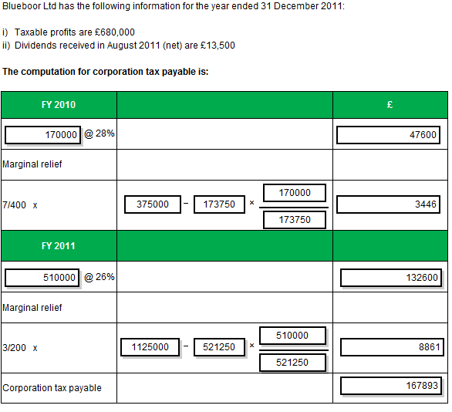
Task 2.9

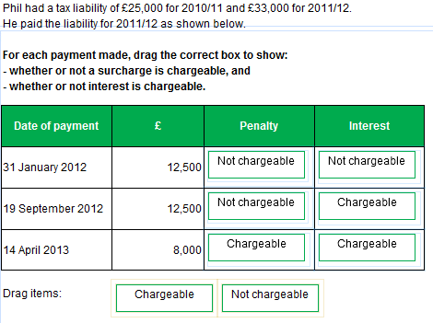
Task 2.10

Box 11 = 86,500
Box 22 = 350
Box 24 = 1260
Box 25 = 70
Box 29 = 2000

