

CBA Practice model answers
BTX FA2012 – Practice Test 1
Section 1
Task 1.1
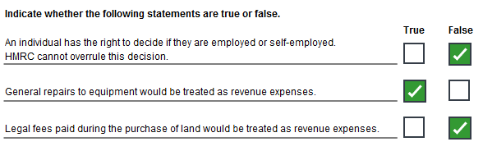
Task 1.2
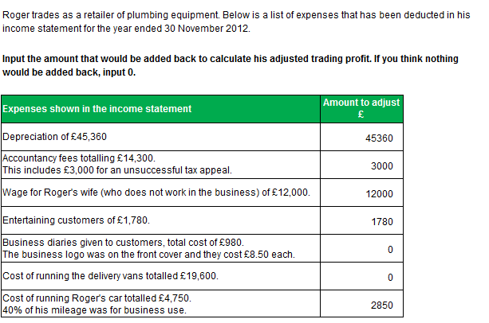
Task 1.3
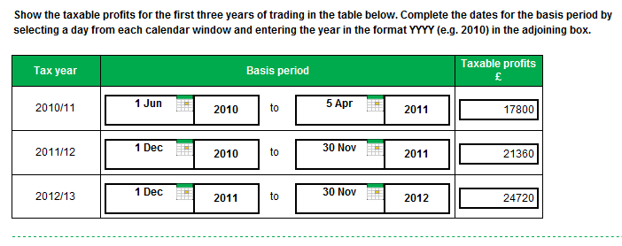
Task 1.4
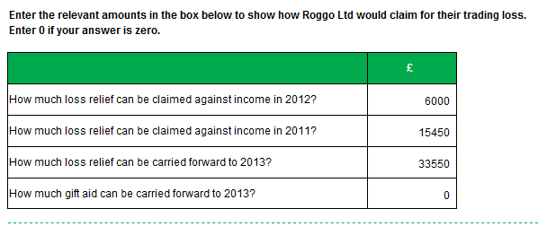
Task 1.5
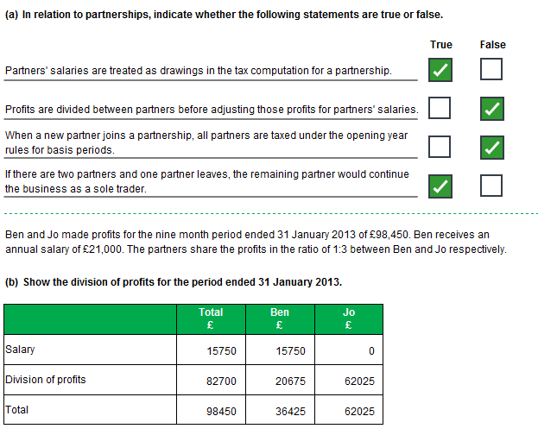
Task 1.6
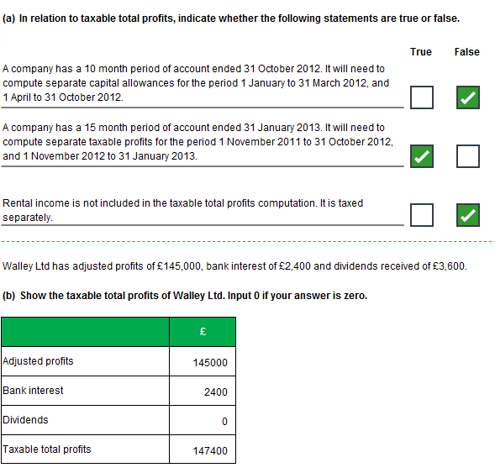
Task 1.7
a)
(100,000 x 4/12) + (25,000 x 8/12) = £50,000
(20 x 4/12) + (18 x 8/12) = 18.67%
(10 x 4/12) + (8 x 8/12) = 8.67%

b)
 |  | General  Pool £ |  | Car  Pool £ |  | Allow  £
B/fwd |  | 107,500 |  | 36,560
100% FYA:
Plant |  |  |  |  |  | 8,645
Car |  |  |  |  |  | 22,020
AIA:
Plant | 28,040
AIA (OF) | 28,040 |  |  |  |  | 28,040
Disposals |  | 11,250 |  | 15,400
 |  | 96,250 |  | 21,160
WDA 18.67% / 8.67% |  | 17,970 |  | 1,835 |  | 19,805
 |  | 78,280 |  | 19,325
 |  |  |  |  |  | 78,510
Section 2
Task 2.1
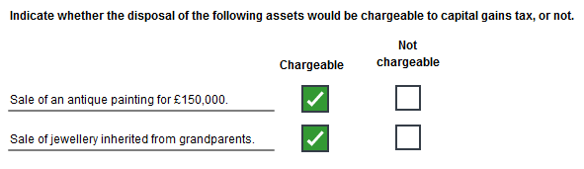
Task 2.2
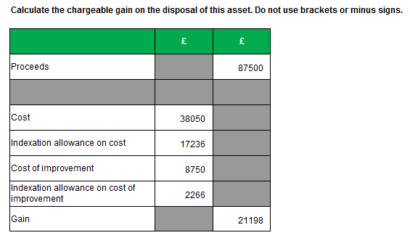
Task 2.3

 | No of  Shares |  | Cost £
June 1999 | 300 |  | 12,450
February 2004 | 60 |  | 1,020
 | 360 |  | 13,470
October 2012 | 120 |  | 4,490
Balance | 240 |  | 8,980
Proceeds | 200 |  | 13,660
Cost from Nov 2012 | 80 |  | (5,232)
Cost from pool | 120 |  | (4,490)
Gain |  |  | 3,938

Task 2.4
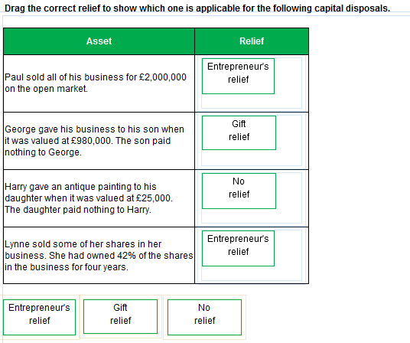
Task 2.5
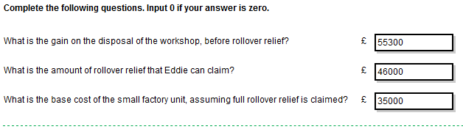
Task 2.6
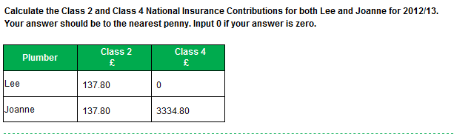
Task 2.7
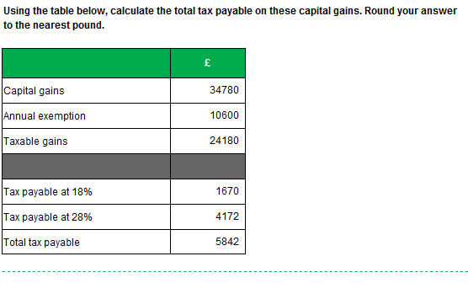
Task 2.8
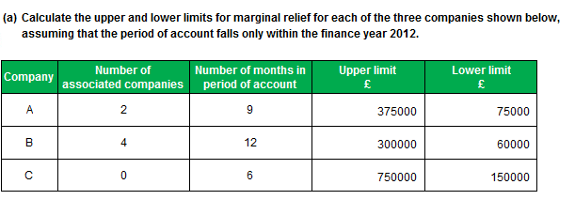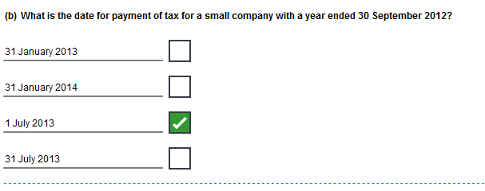
Task 2.8 continued
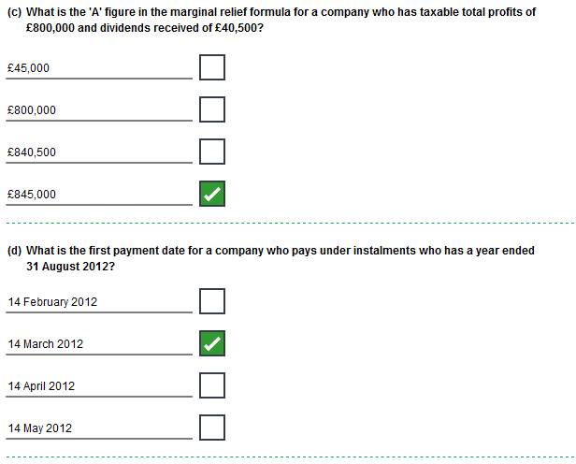
Task 2.9
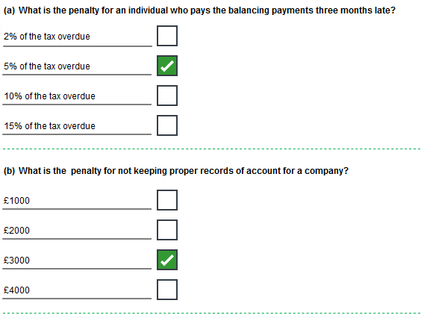
Task 2.9 continued
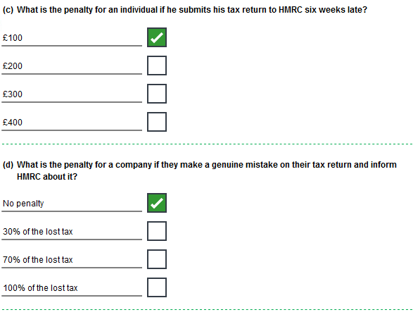
Task 2.9 continued
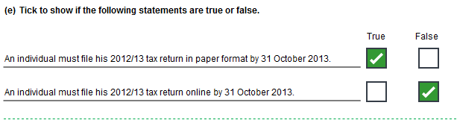
Task 2.10
Box 38: 50,500
Box 39: 2
Box 43: 2012
Box 44: 1,380,000
Box 45: 24
Box 46: 331,200

