

CBT Practice test model answers

Budgeting (BGT)
Practice assessment 3
Section 1
Task 1.1

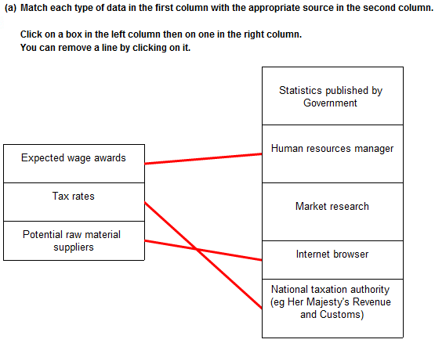

Task 1.1, continued
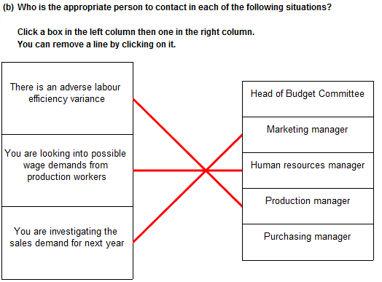

Task 1.1, continued

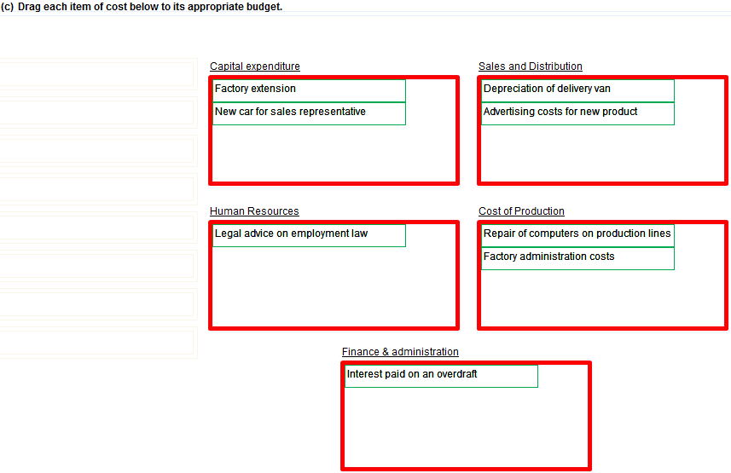
Task 1.1, continued

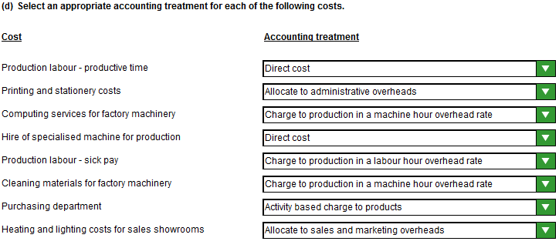
Task 1.2

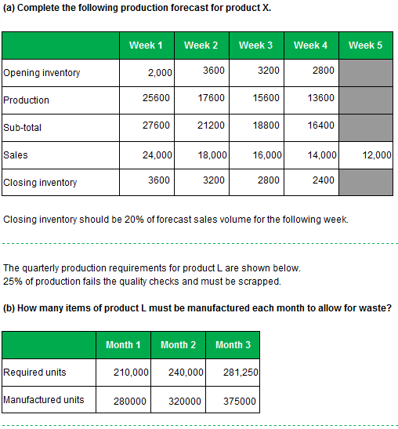

Task 1.2, continued

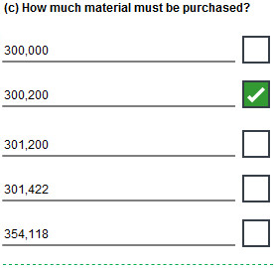

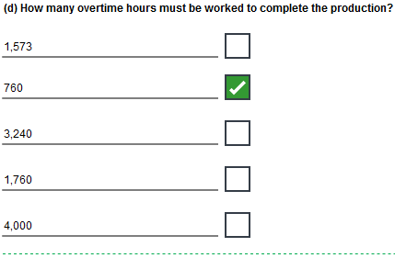
Task 1.2, continued

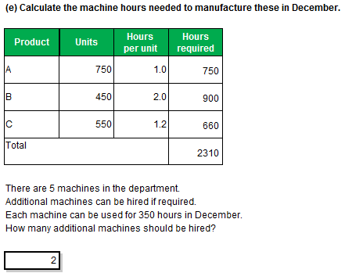
Task 1.3

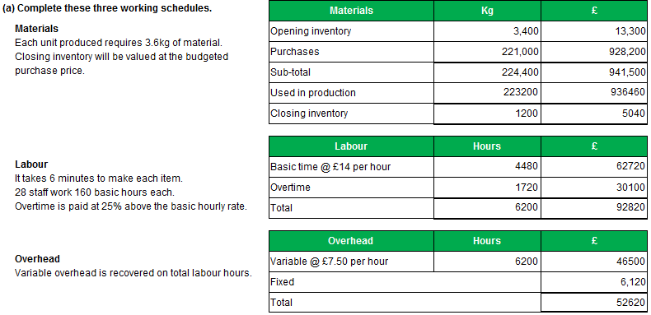

Task 1.3, continued

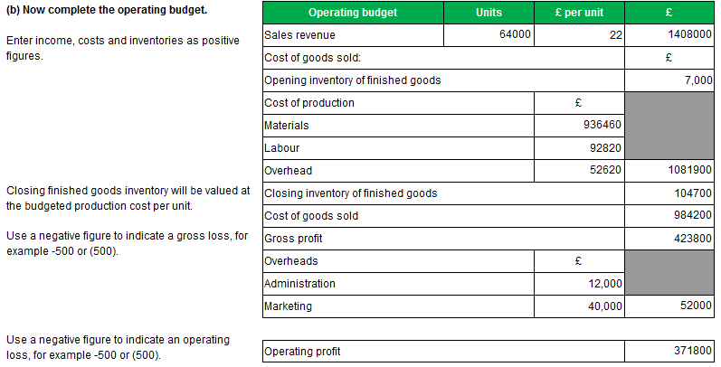
Task 1.4

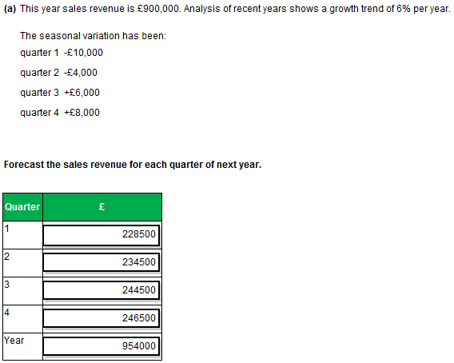
Task 1.4, continued
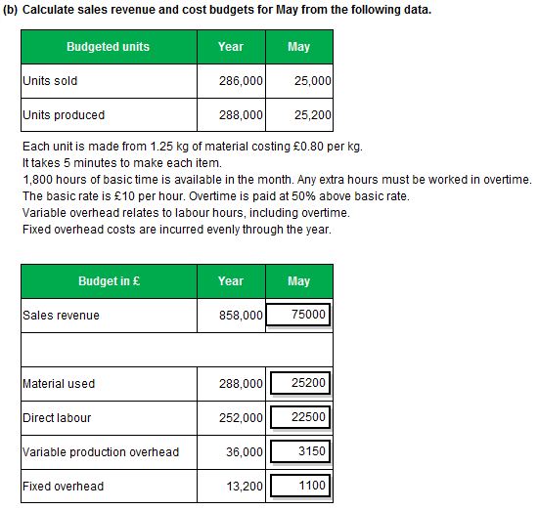

Task 1.4, continued

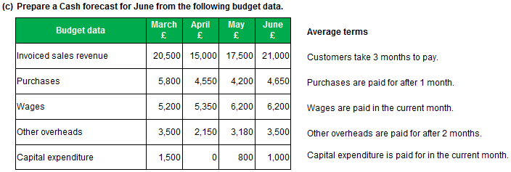

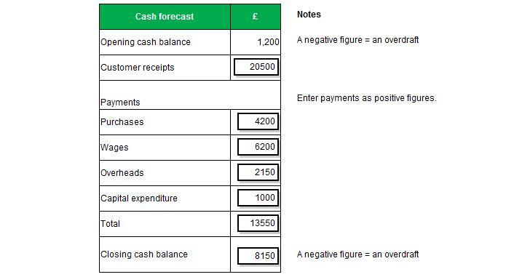

Task 1.5

To: Budget Committee
From: Budget Accountant
Date: xx/xx/xxxx
Draft Production Budget

Budget submission

I attach the proposed production budget for next year for your consideration and approval. This is based on the approved sales volume budget and forecasts provided by the production manager.

Sales are forecast to increase to 886,000 units. The production manager has forecast a 2,000 unit increase in finished inventory to give a requirement to produce 888,000 saleable items. He proposes to reduce wastage levels by slowing the production. Although this will increase the labour hours it should produce savings in material costs.

Please let me know if you need any further information.

Links to forecasts

As explained, this budget is built up from four forecasts: sales volume, closing inventory, production efficiency and wastage. Clearly the sales forecast is critical to all aspects of our budget and will be monitored closely. This will also influence the level of inventory we need to carry.

The forecasts of production efficiency and wastage are also linked. We need to put performance measures in place to check whether the expected benefits are achieved and are cost effective.

Budget Accountant
Task 2.1

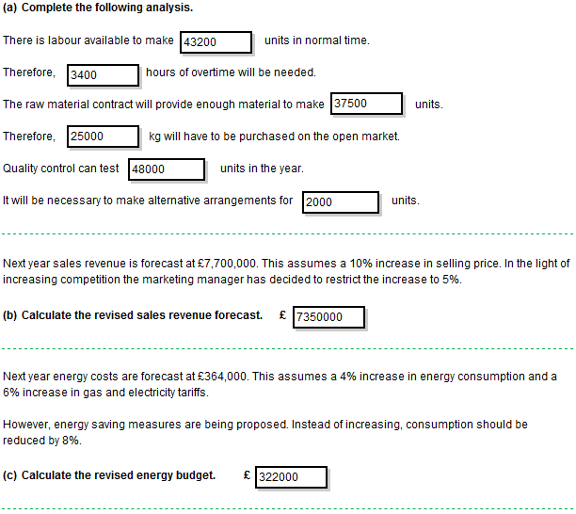
Task 2.2

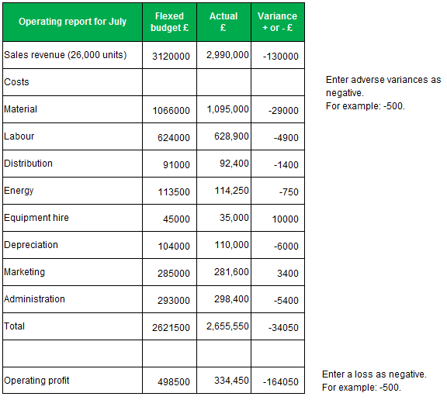
Task 2.3

To Chief Executive Date (Today)
From Budget Accountant Subject Review of Operating Statement

(a) Reasons for variances

I have reviewed the results for the period. There was an operating profit of £240,000 compared with the flexed budget profit of £278,000.

Problems with the production machinery caused significant adverse cost variances.

Material costs were 7% above budget (£12k), even though an expected 7.5% price increase had not occurred. This indicates a material usage variance of around 15%. This appears to be due to machinery breakdowns which spoiled work in progress.

Similarly, labour costs were 13% above budget (£31k). This will also have been due to the disrupted production and the need to replace scrapped work in progress. The additional work might have required overtime working at premium rate.

Variable power costs were 33% above budget (£10k). Again this was due to the disruption and additional production requirement. However the variance percentage is higher than material and labour and needs investigating. The consultants’ recommendation of standard costing possibly indicates that the data available for budget setting was inaccurate.

Equipment hire was 25% above budget (£15k). This will also have been affected by the disruption and additional production requirement. The scale of the variance suggests that the equipment hire rates may have increased for machines required at short notice.

(b) Standard costing

Standard costing and budgetary control are powerful management tools that can be used separately but naturally combine into a seamless system of planning and control. They share the approach of setting targets, measuring actual performance, analysing variances and initiating management action to correct or improve future performance and set new targets.

Standard costs provide the ‘per unit’ data that is required to construct the variable elements of the production cost budget. This data just needs to be multiplied up by the production budget volumes.

The variance analysis that is performed in standard costing provides an explanation of the variances arising in budgetary control.

This is particularly effective for companies with a number of products.

