

AQ2016 SAM mark scheme

Level 4 Synoptic Assessment
SAM 1
Task 1 (10 marks)
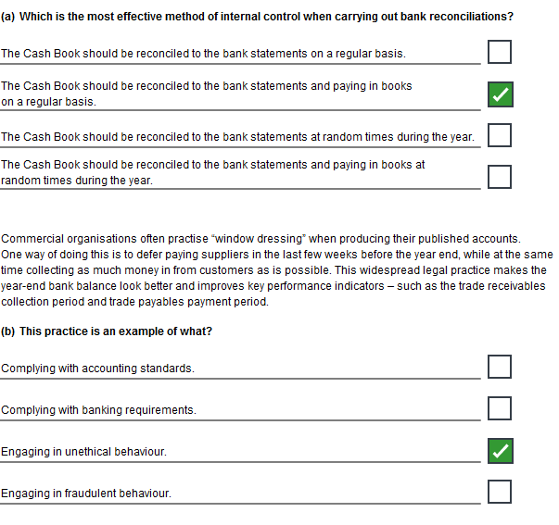
Task 1 (continued)
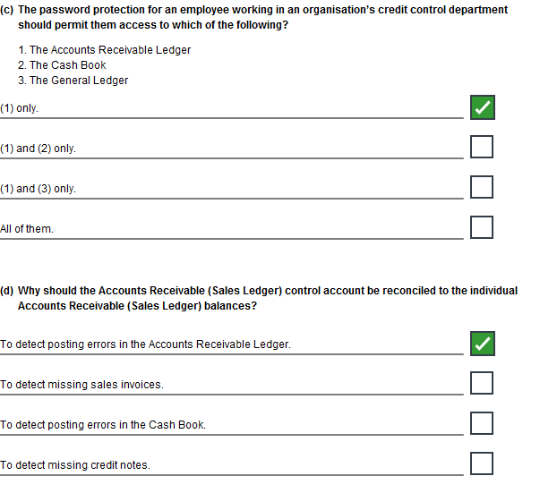
Task 1 (continued)
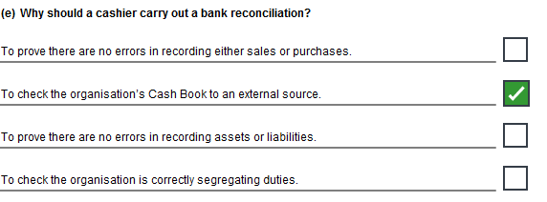

Task 2 (20 marks)

NB: The suggested answer below includes more points than are necessary to gain full marks. This has been done in order to demonstrate a broader range of the types of responses a candidate could give.

(a) The layout and presentation of the Operating Statement
The design of this statement is poor. It is not possible for the reader to make a valid comparison of actual and budgeted results.
It is stated in the commentary that the budgeted profit has been achieved but this is not the case. The material and labour elements of the budget have been revised upwards by about £25,000. The original profit budget was approximately £194,000. We should not lose sight of this.
The impact of the 4.2% shortfall in sales volume has not been identified in the statement. This means that movements in unit revenues and unit costs are not clear. It requires analysis to discover that the average selling price of £142 was £2 higher than budget. Similarly the material, labour and production overhead costs per unit were above budget.
Although variances are shown there is no indication of whether they are favourable or adverse or of their significance.
My recommendations are:
- If a budget revision is approved, the original budget should also be shown on the operating statement
- The impact of volume changes should be highlighted. This can be done either by flexing the variable elements of the budget (revenue and variable costs) or by adding two columns to the statement to show the budgeted and actual revenue and variable costs per unit.
- A further refinement would be to separate variable and fixed costs and show contribution.
- Each variance should be identified as favourable or adverse.
- It would also be helpful to highlight large variances or to show each variance as a percentage of its budget.

(b) The effectiveness of the budget committee

It is not clear that the budget committee has been effective.
The expenditure review identified that material and labour costs were increasing. The only action noted was to increase the budget.

The favourable variance on marketing has only been achieved by deferring the advertising campaign until after the financial year end. Will it be budgeted for again in the following year? And what impact might the delay have on sales revenue?
The depreciation saving is merely an accountancy adjustment. The correction to previous year’s charges should probably be reported separately as an unbudgeted windfall. Regarding the current year, it is inconsistent to revise the budget for material and labour but not for depreciation.
The savings in administration are very small and not explained.
The budget committee have provided for £21,000 bonus payable to themselves. It is not clear how this has been authorised. Certainly, it was not budgeted.
My recommendations are:
- The committee must be properly constituted to be representative of the organisation. Finance, marketing and the chief executive need to be involved.
- Procedures need to be developed to ensure that stretching but achievable budgets are agreed by all concerned.
- Changes to accounting policy and procedures must be agreed with yourself and where necessary cleared with auditors etc.
- The committee should meet regularly to monitor results.

(c) The advantages and disadvantages of linking remuneration to budget achievement

There are many ways of designing schemes to link remuneration to budget achievement. Managers can be targeted on their own budgets, on overall profitability or on a range of performance measures, such as a balanced score card.

The advantages of a well-designed scheme can be:
- It promotes budget ‘ownership’ by giving managers a vested interest in ensuring that budgets are realistic and properly coordinated
- It motivates managers to achieve their own budget targets
- It motivates managers to work together to achieve or exceed the organisation’s goals
- Over time it can encourage greater loyalty among managers and their staff

However, there are also potential disadvantages, particularly if schemes are poorly designed or not carefully supervised:
- Schemes that are narrowly based on each manager’s own budget achievement can encourage unhelpful rivalry between managers
- Similarly, such schemes tend to encourage selfish behaviour and actions which may not be to the benefit of the organisation or its customers
- On the other hand, broadly based schemes, linked to many performance measures or to overall profitability may be ineffective because managers feel that most of the elements are beyond their individual control
- Where performance measures are used there is a danger that managers will attempt to manage the measures rather than the performance. In other words, they will look to find ways of merely making the results look better.
- There is an increased risk of managers trying to inflate their budgets to make them more easily achievable
- Managers may even be tempted to make unnecessary expenditure in order to fully utilise their budgets, believing that this will give their next budget bid credibility
- There may be pressure, as we have seen with B & Co Ltd, to manipulate accounting policies and procedures to improve results

My recommendations are:
- Any bonus scheme must be designed with careful attention to the points that I have made above
- The scheme needs to be independently assessed by a non-beneficiary, such as myself, and authorised by our remunerations committee.
- The remuneration committee should authorise any payments made under the scheme
- The remuneration committee should have the power to adjust the payment calculation to exclude the impact of unforeseen events such as windfall profits or accounting adjustments
Task 6 (15 marks)

NB: The suggested answer below includes more points than are necessary to gain full marks. This has been done in order to demonstrate a broader range of the types of responses a candidate could give.

(a)
Tony Clark, the company Purchasing Manager, has too much individual authority to negotiate prices that can tie the company into a large supplier for up to 3 years. There should be a mechanism for senior management to review and approve contracts over a certain value. Since the supplier base has contracted from 50 to a much smaller number each individual contract is likely to be of significant value.

Tony should not be the only individual to check that invoice prices are as agreed – since they have been agreed by him in the first place. There is, obviously, the potential for Tony to collude with a supplier to inflate process in return for a bribe. Another member of staff (probably the Accounts Payable clerk or Tony’s boss) should check that the invoiced prices are as agreed.

Suppliers’ invoices should be sent to the Accounts Payable clerk not the Purchasing Manager. They can then be entered onto the system before Tony is asked to approve them. This provides both a more secure audit trail and a better segregation of duties.

All company cheques and BACS authorities should be signed by more than one signatory from amongst the authorised signatories (the directors and the Chief Accountant). Allowing payments against just one single signature leaves the company open to mistakes or fraud.

(b)
One method of evaluating the internal controls is a SWOT analysis.
This examines the strengths, weaknesses, opportunities and threats embedded in the existing purchases control method.

Strengths
- What advantages do our internal controls have?
- What do they achieve that is better than the alternatives?
- Consider our strengths from both an internal perspective, and from the point of view of our suppliers.

Weaknesses
- What could we improve?
- Again, consider this from an internal and external basis: Do our suppliers perceive weaknesses that we don't?

Opportunities
- What opportunities are there to improve our internal controls?
- What new developments in internal controls could be adopted?

Threats
- What obstacles do we face?
- Is changing technology making our existing controls out of date?
- Could any of our weaknesses seriously threaten the business?

