
CBT Sample assessment model answers

Professional Diploma Synoptic (PDSY)
Sample assessment 2
Task 1 (15 marks)

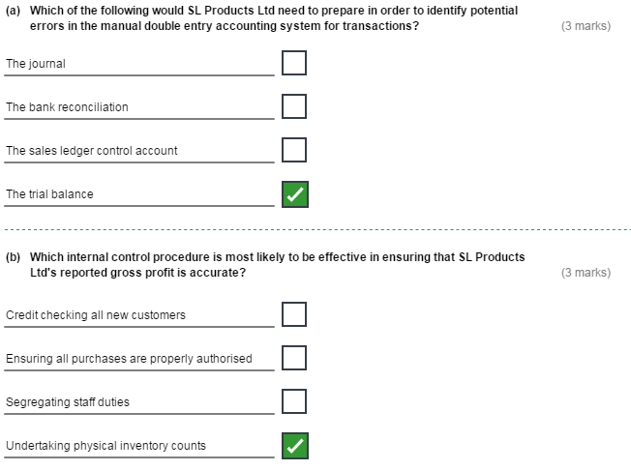

Task 1, continued
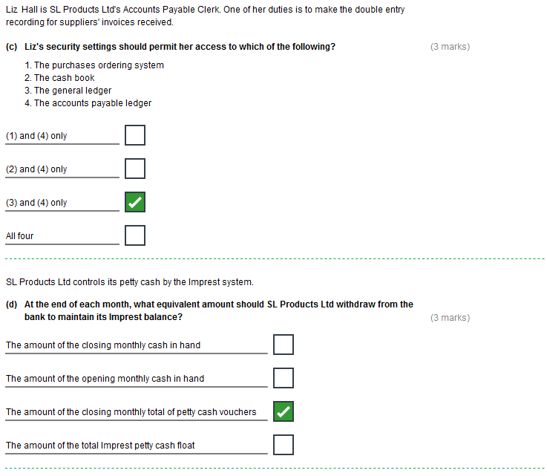
Task 1, continued

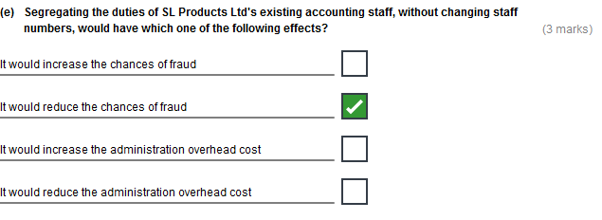
Task 2 (15 marks)

- The long term planning procedure.
Suggested commentary:

The length of the long term plan, at 5 years, is a realistic planning horizon, and is in keeping with typical commercial practices.

The long term plan is a fixed one, and it has not been changed to reflect the large increase in sales volume experienced in all three of the first years of the plan.

One reason for producing a fixed plan may have been that it takes less time and effort. It is, therefore, less costly to produce.

This has led to the sales volume budgets for both 20X5 and 20X6 being unrealistic.

A rolling five-year plan would be better where such major changes occur. This would mean that at the end of each year of the original five-year plan, a new fifth year plan would be added in, reflecting changes in the business environment. The advantages of rolling plans are that they encourage management to be forward-looking, and keep the plan in line with current conditions A disadvantage is that they may take up a disproportionate amount of management time .

(b) The 20X6 budgetary procedure.
Suggested commentary:

The budget is a fixed one; meaning it has not been flexed for the 20% increase in activity.
A fixed budget is a budget where the variable costs are not changed in line with the change in activity.

A flexible budget is one where the turnover and variable costs are changed in line with the change in activity. In this case they would be increased by 20%. Fixed costs remain unchanged from the original budget.

The advantage of fixed budgeting is that it is takes less time, and is, therefore, less costly to produce; the disadvantage is that variances are less meaningful and, therefore, control is effectively reduced. The advantage and disadvantage of flexible budgeting are the opposite of this.
Flexible budget calculations: Turnover 1,890.0; direct materials 453.6; direct labour 283.6; production overhead 378.0; selling & distribution costs
189.0; (fixed costs 73.8 (unchanged); total costs 1,378.0; operating profit 512.0).

The budgeted cost figures have been derived just as a % of the budgeted turnover; for example direct materials are 24%; direct labour is 15%; production overheads are 20%; and selling & distribution costs are 10%.This is a top-down approach and it has the advantage of improved communication of plans and co-ordination of activities; but the disadvantage of reduced commitment and motivation of lower management.

The cost figures would be far more accurate if budgeted bottom-up by lower management building up the relevant costs.

Task 2, continued

(c) The internal controls used to try and achieve the 20X6 budget.

Suggested commentary:

The company is using variance analysis. This involves comparing the budgeted and actual costs and revenues to produce the differences – or variances .Where turnover is less than budget or costs are higher there will be adverse variances. These should be investigated and corrective action taken. Where the opposite applies there will be favourable variances. These should also be investigated with a view to further exploiting the factors causing them to arise.

However, the variances are meaningless since they are produced against a fixed budget. The budget should be flexed to provide a more valid comparison.

Merville Ltd's management seems to be using the fact that the budget has not been flexed to disguise their poor control over direct labour – since this is still adverse if the budget were flexed.

Direct material has, as management claim, been well controlled, as there is a favourable variance against a flexed budget. The same is true of selling and distribution costs.

Direct labour, however, has been badly controlled, as there is an adverse variance against a flexed budget. This has also resulted in an adverse variance for production overheads.

Task 3 (15 marks)

Note: There are more suggested answers shown below than are required to be given in the task.

The company is operating with two payrolls.
This increases costs by effectively doubling the amount of work involved both in running both payrolls; and by increasing the time taken to make extra RTI submissions to HMRC.

Use of non-standard payroll software.
This does not link to the main accounting systems, so causing the General Ledger entries to have to be posted using journal entries – taking time and incurring additional costs and adding to the risk of errors occurring.
Using non-standard software could also result in operational difficulties if the payroll clerk were absent, as other members of staff may be unable to use it.

Paying some employees in cash could be a major weakness.
This involves time to organise and collect from the bank; time to produce manual pay packets and fill these with cash; and then there is the risk of theft as the cash is brought back from the bank, and kept in the safe overnight. In addition there is the (avoidable) cost of employing a part time member of staff to help deal with the cash payment procedures.

Employees are permitted to collect other colleagues’ pay packets.
This puts the company at risk of compensation claims if pay does not actually reach the employee – particularly since the practice is against stated company procedures.

Backing the payroll up only weekly.
Although the payrolls are only run weekly they will be regularly updated during the interim for changes in employees' details (such as tax codes and addresses). This information could be lost (before the system is next backed up).

Backing up data on a memory stick (rather than say using cloud computing) could be a weakness.
The memory stick could be lost or corrupted.

There is no reference to the payroll being checked and authorized or to the BACS authority being authorized. If these are not being done, then this is a weakness. Failures in checking and authorizing could lead to non-compliance and/or missed errors and/or potential fraud.

There is a lack of segregation of duties.
Jane both runs the payroll, and makes up and distributes the pay packets. This could lead to missed errors and/or potential fraud.

There is no reference to the pay packets being signed for. If this is not being done then it is a further weakness.
It could lead to employees claiming that they never received their pay.

Task 4 (20 marks)

- BRIEFLY discuss the validity of each of the three directors' views on how the final decision should be made as to which products to discontinue.
Suggested commentary:
The Managing Director is basing his decisions on the reported profits of each product.
The reported operating profits include an arbitrary allocation of fixed costs that undermines their credibility.
Fixed costs are irrelevant to the decision as they are by definition unavoidable regardless of the decision.
This is misleading since the four products all have different sales volumes. A product such as SL66 which has twice the number of units sold as its competitor M66 will usually have a higher contribution and reported operating profit. The variable production overhead is recovered on a different basis in each company. These costs are also much higher per unit for Merville Ltd than for SL Products Ltd. This makes comparisons at the contribution level difficult.

The Sales Director is basing her decisions on the reported contributions of each product. This approach has the same weaknesses outlined in the last two points above. It does, however, avoid considering the arbitrary allocation of fixed costs. A better approach might be to use throughput. Throughput measures the difference between output (ultimately sales) and material input into the product.

The Production Director is basing his decisions on the contribution per unit. This approach gets around the problem of different sales volumes. It also avoids the arbitrary allocation of fixed costs. But the variable production overhead is recovered on a different basis in each company. It is the correct approach if there are no limiting factors, such as KC9 sometimes being in short supply. Where there are limiting factors the correct approach is as outlined in b) below.

You are now required to consider what effect material KC9 should have in making the decision.
(b) BRIEFLY explain, with reasons, which of the substitute products should be continued and which should be discontinued if KC9 is in short supply. Provide any supporting calculations.
Suggested commentary:
A limiting factor is anything that constrains the output of the business – in this case the supply of KC9.
As the supply of KC9 makes is a limiting factor, it would constrain the output of the business.
Where there is a limiting factor the correct approach is to rank the four products in order of their contribution per unit of it. Here this means per kg.of KC9 used.

The decision to discontinue a product is long term and strategic. Therefore, even though KC9 may not be in short supply now we know that it sometimes is. Accordingly it should be considered.
The contributions per kg of KC9 are:
SL65 £800
SL66 £400
M65£1,000
M66 £500
This implies that M65 should be continued with and SL65 discontinued (£1,000 is better than £800). Also that M66 should be continued with and SL66 discontinued (£500 is better than £400).
Task 5 (20 marks)
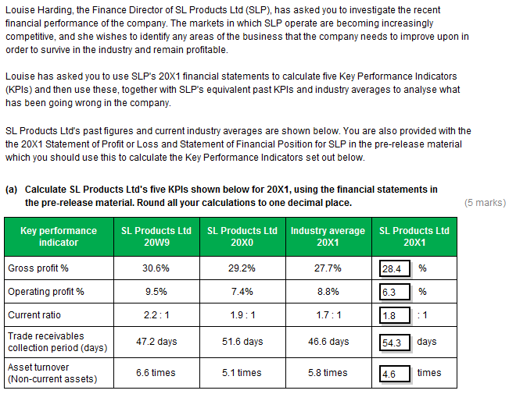

Task 5, continued
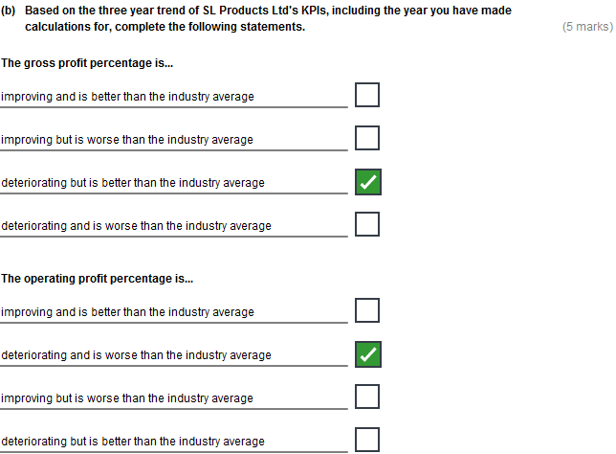

Task 5, continued

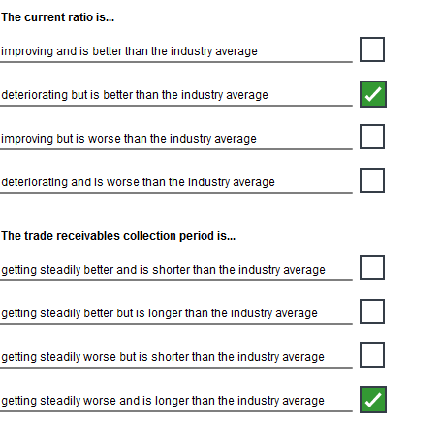

Task 5, continued

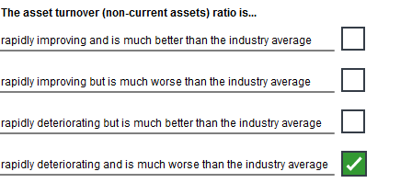

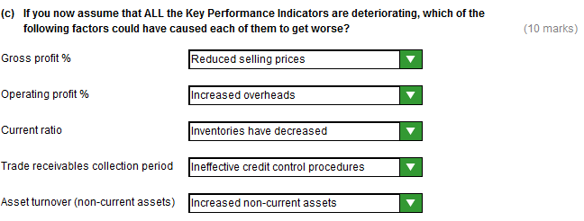

Task 6 (15 marks)
- Identify TWO weaknesses in the company’s systems, practices and internal controls in respect of each of the following procedures:
- Purchasing
- Accounts payable
- Internal reporting.
Purchasing:
There is no effective segregation of duties in the purchasing procedures.
The Purchasing Manager is, without any restrictions, able to:
- Identify and approve suppliers
- Negotiate new contracts
- Agree any subsequent price increases
- Agree any subsequent changes to payment terms.

There is also the risk that, as he has been in this role for six years, he may have developed a relationship that is too close with suppliers. Also he has had a very close working relationship with Ruth Holmes for at least 6 years.

There is, obviously, the potential for the Purchasing Department to collude with a supplier (such as Loebid Ltd) to award apparently fair contracts and then subsequently change their terms in return for a bribe.
Accounts Payable:
The weekly pre-list of approved supplier payments is unnecessary.
Paying a quarter of suppliers by cheque, rather than by BACS, could be a weakness.
Cheque processing is costly in terms of both the time involved and bank charges.
It is also more prone to errors and cheques can be easily lost in the post and possibly misappropriated.
The pre-list itself, using a spreadsheet, is a possible source of error due to staff making mistakes in entering data.
Internal Reporting:
The internal reporting of material price variance (MPV) is too limited. It only calculates the total MPV.
This means that detailed price variances by supplier, and product line are not being reviewed.
There may well be significant adverse variances that are not being investigated because they are netted off against other favourable variances in arriving at the total MPV.This is the case in this specific task.

Task 6, continued
- For each of the three procedures listed above, make a recommendation to improve ONE of the weaknesses you have identified.

Purchasing:
Senior management should review and approve all contracts and orders over a certain value .
Senior management should also approve any subsequent significant changes in prices or payment terms.
Someone outside of the Purchasing Department should do the financial stability checks on suppliers – probably Liz Hall.
There should be a defined central policy, probably set by the board, for the criteria to use in selecting suppliers.
There should be an independent check that purchase prices and goods are as agreed. Tony and Ruth should not be the only individuals checking that invoices are as agreed. Another member of staff (probably the Accounts Payable clerk or Tony’s boss) should sample check that the invoiced prices and goods are as agreed. Suppliers’ invoices should be sent to the Accounts Payable clerk not the Purchasing Department. They can then be entered onto the system before Tony is asked to approve them. This provides both a more secure audit trail and a better segregation of duties.

Accounts Payable:
Invoices should be passed for Accounts Payable posting on a daily basis as approved.
All suppliers should, if possible, be paid by BACS.
If the company decides to continue using a pre-list it should be derived electronically from the Accounts Payable ledger.

Internal Reporting:
Price variances should be calculated by: supplier and product line.
Accounts Department staff should then investigate all significant adverse variances to enable appropriate remedial action to be taken.
Significant favourable variances should also be investigated so as to further exploit any opportunities this shows up.
Any improvements involve some financial outlay.
- Identify and BRIEFLY discuss the analytical method of evaluating whether it would be worthwhile to improve the internal controls in this area. Note: You are NOT required to produce the analysis - you only need to identify and discuss it.
The analytical method of evaluating whether it would be worthwhile to improve the internal controls in this area is a Cost Benefit analysis.
This examines the costs incurred in making improvements, and the benefits arising from this cost outlay.
Costs include those for changes to procedures, software, and staff roles and training.
Benefits include more efficient controls, less risk of errors and reduced risk of fraud.
Whilst most costs can be quantified the benefits are difficult to measure in monetary terms. However, some attempt should be made to do this.
For the improvements to be worthwhile the benefits must outweigh the costs.

