
CBT Sample assessment model answers

Professional Diploma Synoptic (PDSY)
Sample assessment 1
Task 1 (15 marks)

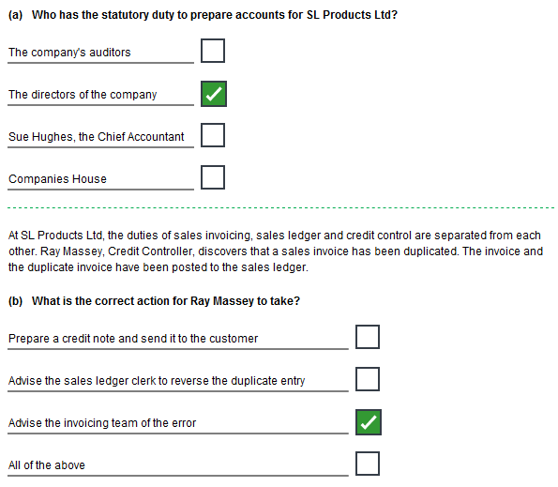

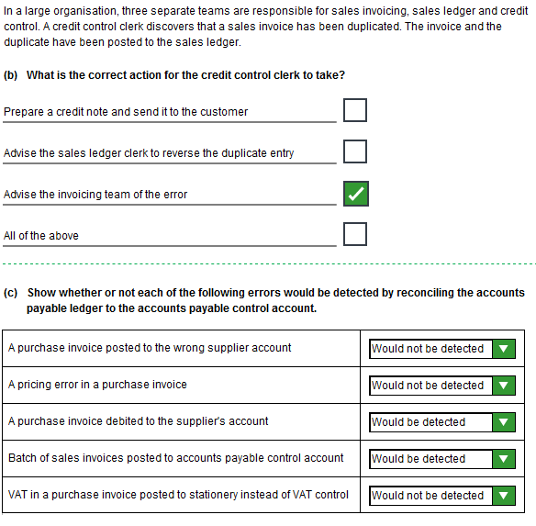
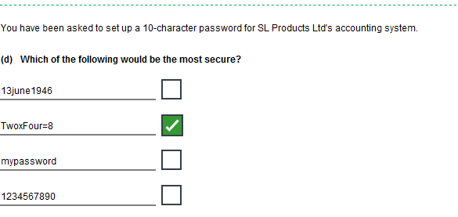
Task 1, continued
Task 1, continued

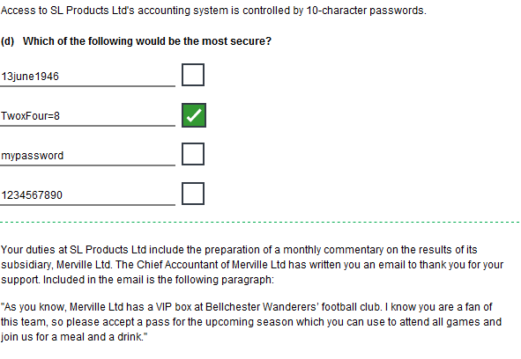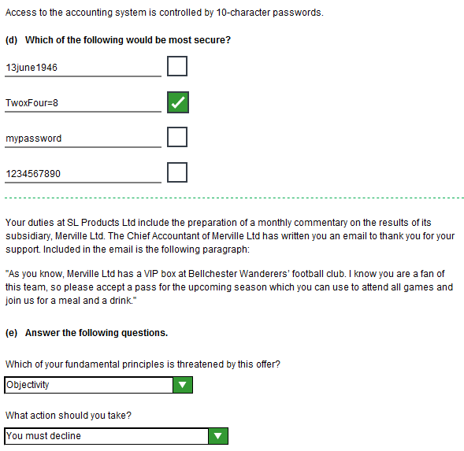
Task 2 (15 marks)

- Examine the planning assumptions and calculations in the proposed budget and identify any weaknesses.

The draft budget is based on the assumption of 10% growth in sales volume. No justification is offered for this round figure assumption. I suggest that we need to review recent trends in Merville Ltd's products; look at the potential for the anticipated new products and estimate the likely additional business generated from our own customers. With only 50 current products, this should not be difficult.
The assumption that sales revenue will only grow relative to sales volume is probably pessimistic. Although we are told prices can never be raised, new products should command a healthy margin when launched, particularly as they are patent protected.
All costs have been increased by 12.5% in the draft budget (2.5% for inflation and 10% for growth). There is no reason why fixed costs should increase by more than an appropriate rate for inflation. Each line of costs needs to be considered carefully according to its cost type (variable, fixed, etc) and its own cost pressures.
In particular, agreement is required about the management bonus. This has been accrued at £21,000 for 20X2 and, in effect, budgeted at £23,625 for 20X3. This has not yet been approved.

- Explain how costs and profitability should be managed in an organisation that manufactures multiple products.

In a multi-product manufacturing organization it is essential that costs and profitability are reviewed by product. Therefore, a costing system needs to be in place.

A standard costing system has particular advantages in that it is based on calculations of what the costs should be - called standard costs. This is useful for control as variances from these standards can be reported and investigated.

The standard cost of each product can be compared with its selling price to identify profitability.

Standard costs can be calculated for planned new products to inform price setting.

- Give your opinion, with reasons, on how well the budget would motivate managers to create sustainable, profitable growth.

Budgetary control can be a powerful tool to encourage managers and staff to create sustainable, profitable growth. To do this, budgets need to be stretching but achievable.

The proposed Merville Ltd budget has been prepared by its own directors who have a vested interest, in the form of the management bonus, in ensuring that it is easy to achieve. They have not provided sufficient supporting data to enable us to verify that the sales volume and pricing assumptions are stretching.

Increasing all costs, fixed and variable, by 12.5% cannot be justified and creates significant budgetary slack.

I do not believe that this draft budget would motivate Merville Ltd to create sustainable, profitable growth.

Task 3 (15 marks)

Note: There are more suggested answers shown below than are required to be given in the task.

No. | Weakness | Potential problem
1 | The Purchasing Manager appears to have very little involvement in day to day purchasing, apart from negotiating terms with new suppliers. | Failures in the system and system abuses could go unnoticed.
2 | No apparent security for order stationery. | Potential for anyone to commit fraud by making purchases for their own use in the company's name.
3 | Budget holders and the warehouse manager can raise orders and sign that the goods or services have been received. | There is a potential for fraud as there does not appear to be any check that these purchases are necessary, or even, for business use.
4 | The procedures do not include any mention of checking that goods and services of the correct standard have been received. | If this is not happening the company could be paying for unsatisfactory supplies.
5 | There is no cash limit to purchase orders provided that they are within the approved budget. | Without a second signature on large purchases, there is scope for errors, poor judgement or fraud to be very costly.
6 | Orders can be placed without agreeing a price. | The company is in a weak position to negotiate price after the goods or service have been received.
7 | Lack of authorisation of new accounts. | There should be a policy for choosing new suppliers. Potential for fraud through collusion with suppliers.
8 | The terms agreed by Tony Clark are not countersigned. | Potential for fraud through collusion with suppliers.
9 | Only one signature is required on purchase orders. | Potential for fraud through collusion with suppliers.
10 | Liz Hall checks, clears and arranges payment of invoices. | Potential for fraud through collusion with suppliers.
11 | Tony Clark and Liz Hall control all aspects of purchase accounting. | Potential for fraud through collusion.
Task 4 (20 marks)

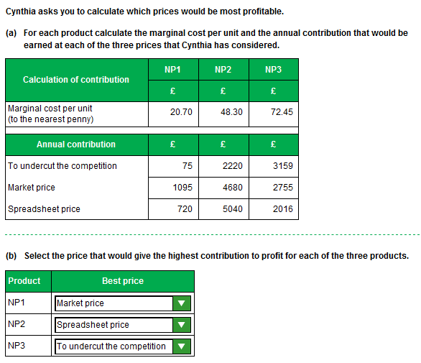

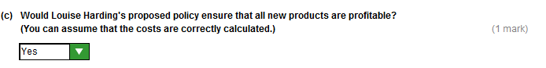

Task 4, continued

- Explain your answer to (c).

In theory, any price that is higher than marginal cost will make a contribution and therefore increase profits. The policy generates prices which are greater than total unit cost, including an apportionment of fixed costs. Therefore they should be profitable at any volume of sale.

- Explain how Louise Harding’s proposed policy could be damaging to the business.

The pricing policy does not allow the sales director to respond to market conditions and find the combination of profit and volume that will optimise contribution.
SLP is in a price competitive business. If new products are not priced competitively they will only sell in small volumes. As ageing products decline they must be replaced by innovative new ones.
The business will go into decline if the product range is not refreshed.

Task 5 (20 marks)

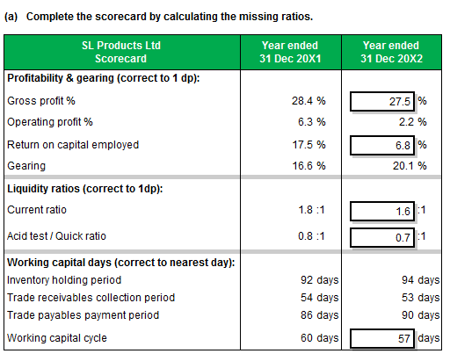
Task 5, continued

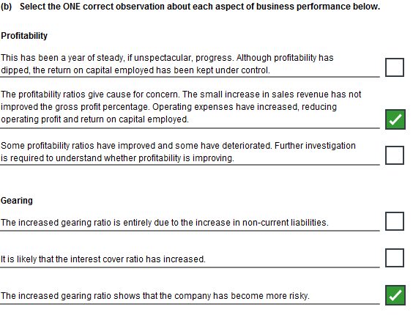
Task 5, continued

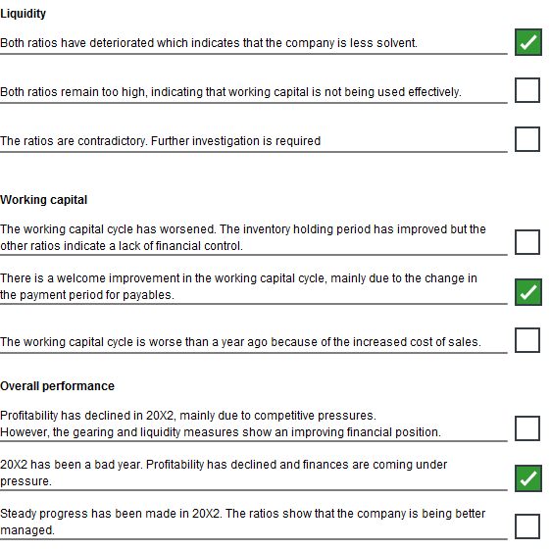

Task 6 (15 marks)

- Identify one strength in these procedures. Explain how the business benefits from this.

Effective credit control is in place. New applicants for accounts are credit checked and there is routine credit control. This minimises bad debt and assists cash flow.

- Identify one weakness in these procedures. Explain how this damages the business and suggest a remedy.

It is not easy for new customers to place orders, particularly from overseas. The requirement to apply for credit terms or to send a cheque through the post is an obstacle to trade and is probably sending potential customers elsewhere. Only 5% of sales are made against cleared cheques.
The account opening procedure needs to be performed electronically. Customers should be able to apply on line for a small initial credit limit which can be immediately checked with a credit reference agency. Alternatively, a facility to pay on-line by credit or debit card when placing an order would be attractive to small businesses and those with a poor credit record.

- Identify an opportunity to improve the procedures. Explain how the procedure should be changed and how the business could benefit.

There appears to be an opportunity to improve relations with customers. Printed catalogues are expensive to produce and distribute and not as effective as targeted electronic communications. Customers could be sent daily electronic mail shots tailored to their own buying records and browsing history. The catalogue could be updated daily.
This could save money and should boost sales.

- Identify one threat to the effectiveness of these procedures. Explain how this could damage the business and suggest an action that would reduce the risk.

We operate in a competitive environment. 80% of our sales are made to just 840, or so, customers and consist mainly of repeat orders for established products. We are vulnerable if our competitors offer new or cheaper products to these customers.
We must protect this business by ensuring that we develop or buy the best available products at competitive prices.

