
CBT Sample assessment model answers

Management Accounting: Decision and Control (MDCL)
Sample assessment 2
Task 1 (16 marks)

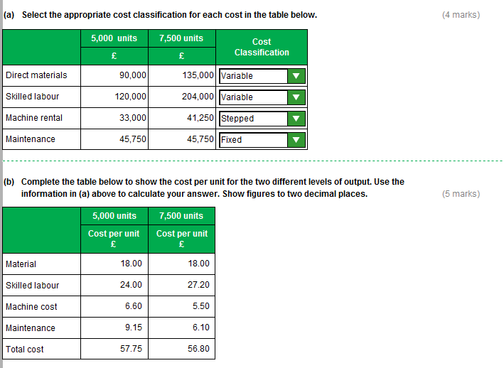

Task 1, continued

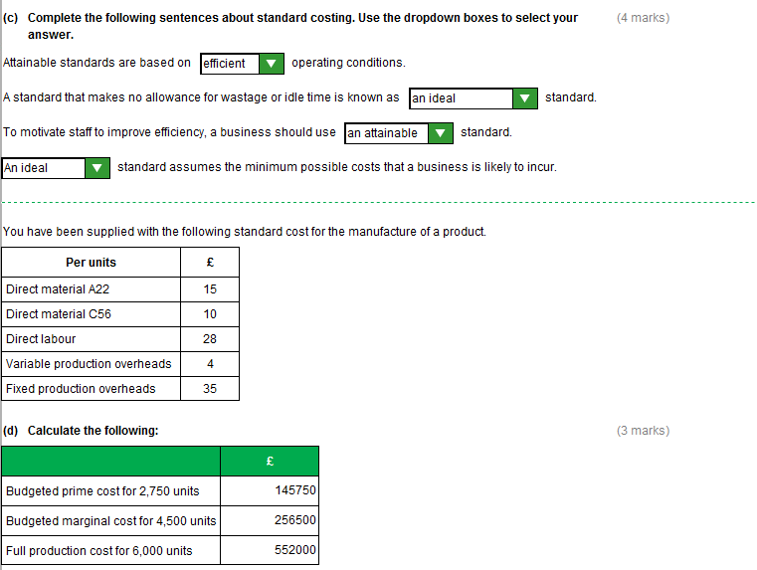

Task 2 (12 marks)

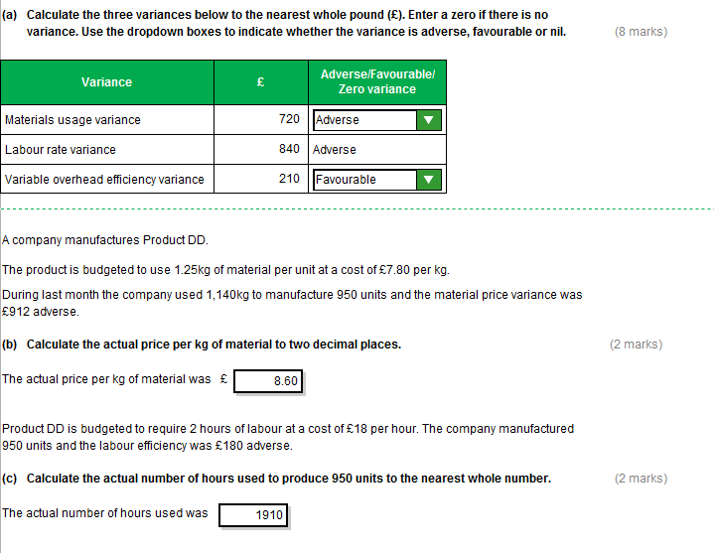

Task 3 (12 marks)

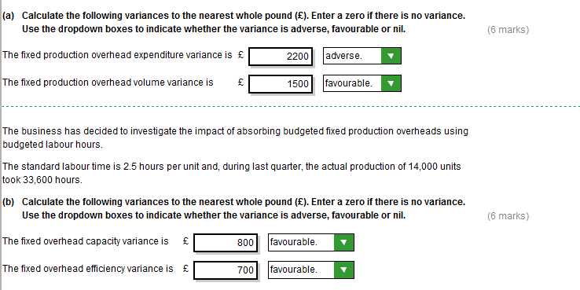

Task 4 (12 marks)

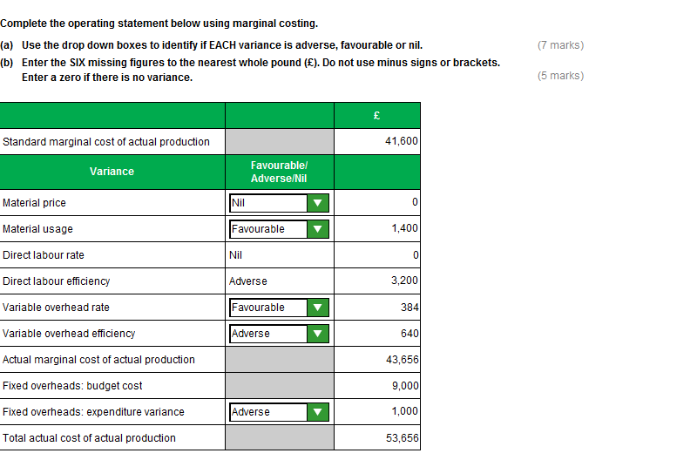

Task 5 (12 marks)

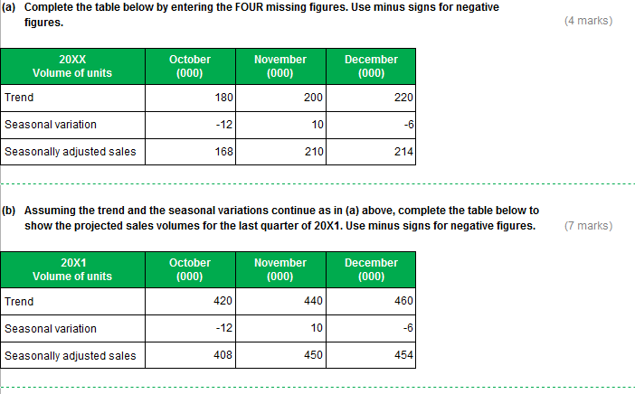

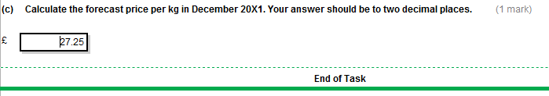

Task 6 (24 marks)

Part (a) (4 marks)
Ideal standards – maximum 2 marks
These are standards that assume perfect operating conditions with no wastage, idle time or machine down time.
They are impossible to achieve
Basic standards – maximum 2 marks
These are standards that are left unchanged over long periods.
They are likely to be out of date and based on historic costs.
Part (b) (i) (4 marks)
The ideal standard for material may have positive benefits as it gives workers something
to strive for.
However since normal wastage runs between 2% and 7%, zero wastage may be impossible to achieve.
Instead of seeing the standard as aspirational, this may demotivate employees and lead to a frustrated workforce.
The basic standard for labour is too easily achievable, so it does not give the workers anything to strive for and is therefore unlikely to result in improvements.
It is out-of-date and needs revising to reflect current operating conditions.
The current approach may result in managers being held responsible for variances which are a result of inappropriate standards rather than decisions they have taken.
Alternatively it may result in variances being entirely attributed to poor standard setting and the consequences of decisions taken by managers may be overlooked or hidden.
e.g. In a month when wastage is 7%, this may partly reflect normal operating conditions and partly a decision by the purchasing manager to buy lower quality ingredients.

Part (b) (ii) (4 marks)
The material usage variance is likely to always be adverse as there will almost certainly be some wastage.
The labour efficiency variance is likely to be favourable as current production is more efficient than the standard allows for.

Part (c) Revised standards including calculations (6 marks)
Standards should be updated/ revised to reflect normal operating conditions.
Material:
Using average wastage rate of 5% of all production: revised standard should be
£2.00/0.95 = £2.105
Note: this assumes that individual chocolates are spoiled and that there is no wastage of the packaging.
Revising the standard for the average wastage means that variances will highlight excess levels (7%) or very low levels (2%) which can then be investigated.

Task 6, continued

Labour
There have been improvements of productivity by 20% so £1.50 labour would now be sufficient to generate 1.2 boxes of chocolates.
Revised standard should be £1.50/1.2 = £1.25 per box
This may encourage further efficiency gains.
Overall prime cost would become: 2.105 + 0.50 + 1.25 = £3.855

Part (d) (6 marks)
Goal congruence issues:
This situation highlights the conflict between:
(i) short and long term:
The reduction in maintenance may help the business achieve its budget in the short term.
But have adverse consequences in the long term – if the machine breaks down or is inefficient .

(ii) the personal interests of the manager and those of the business.
The impact may depend on the extent to which the maintenance is delayed (just until the next accounting period or more permanently?)

Ethical issues:
The manager faces a conflict of interest
between his personal interest (the bonus) and what is right for the business.
The way the bonus is calculated is likely to compromise their Objectivity
There is also the question of Integrity/Transparency
Since the bonus is based on net variance, technically the manager may not be doing
anything wrong.
However, would the manager want others knowing the information behind the net variance?

Task 7 (18 marks)

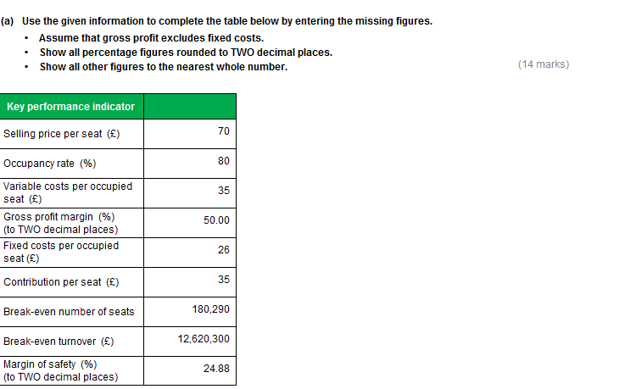

Task 7, continued

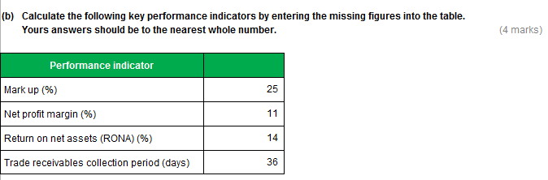

Task 8 (15 marks)

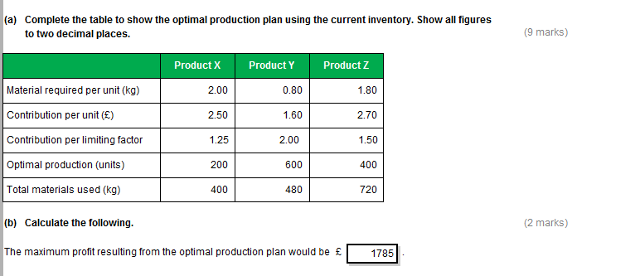

Task 8, continued

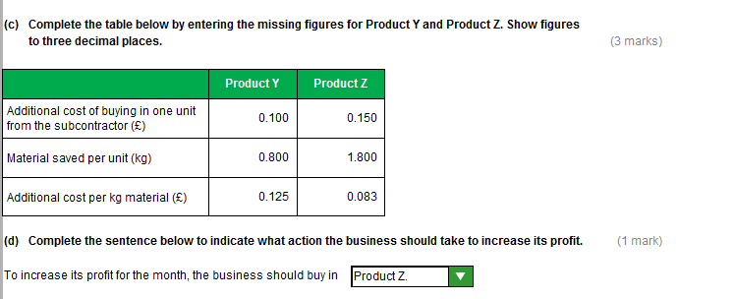
Task 9 (15 marks)

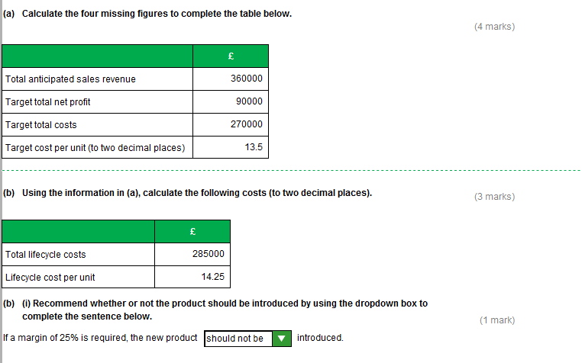
Task 9, continued
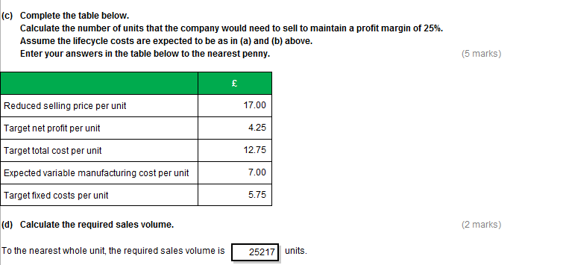
Task 10 (24 marks)

The notes below cover a range of possible points that you may include in your written response.
These examples are not intended to be exhaustive and other valid comments may be relevant.

(a) 16 marks
Sales revenue
Brand B’ revenue is expected to increase by 81% over the period,
whilst Brand A’ revenue is expected to decline by 52.5 %.
The changes in revenue are caused by both price and volume,
and reflect the fact that the two products are at different points in their lifecycle.
There is a growing market for Brand B, hence sales volumes are expected to increase by 67%,
despite an increase in selling price from £23 to £25.
Meanwhile, demand for Brand A is in decline, with sales volumes expected to decline by 50%,
despite a reduction in selling price from £20 to £19.
Gross margin
The variable cost per pair for the two products is the same and constant at £12 per pair.
So the difference in the gross profit margins is entirely due to differences in selling prices
As the market for Brand A has reached maturity, there will be further pressure on selling price.
This is reflected in the lower contribution per pair for Brand A (£8 actual/ £7 forecast, compared to Brand B (£11 actual / £13 forecast).
Overall profitability
The profitability of the two divisions is partly a function of their gross profit margins.
When the higher sales volumes of Brand B are taken with the higher contribution per pair, this means that Brand B generates significantly more contribution to easily cover the fixed costs.
This is despite the fact that Brand B’ fixed costs are higher and increasing, which is likely to reflect the increased marketing to boost sales of the product.
As sales volumes of Brand A fall, spare capacity increases and fixed costs per pair increase.
This is reflected in their falling net profit margin (30% to 17%).

(b) 8 marks
Outsourcing production allows the business to keep more of the business costs variable.
This is useful if the amount of demand and the length of time that additional capacity will be required is unknown.
However the supplier would normally build a profit margin into the cost.
There will need to be checks on quality to ensure outsourced suppliers are up to standard
Other options to increase capacity within the business include: Investment by the Brand B division in new production equipment.
This will require finance and will increase the fixed costs of the business.
This could be sensible if demand is expected to remain high for some years to come which will depend on the length of the product lifecycle.
Investigate the extent to which Brand B can be produced by the Brand A division.

