
CBT Sample assessment model answers

Management Accounting: Decision and Control (MDCL)
Sample assessment 1
Task 1 (16 marks)

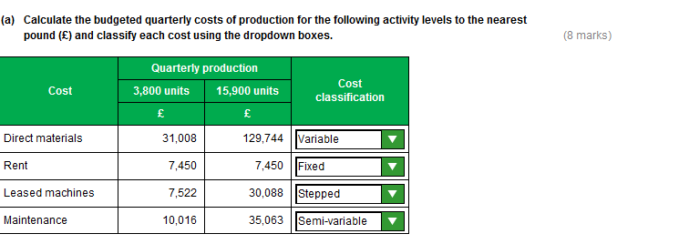

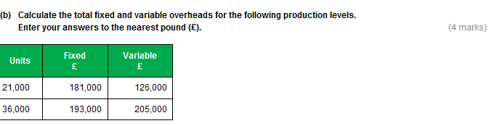

Task 1, continued

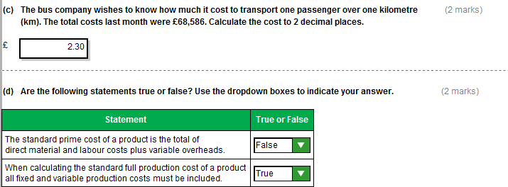

Task 2 (12 marks)

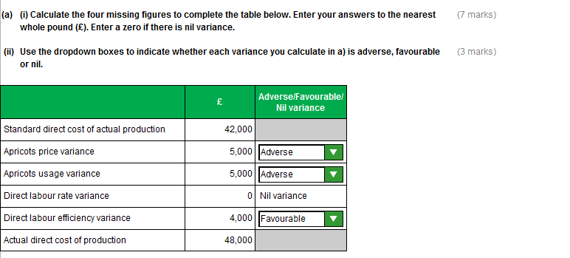

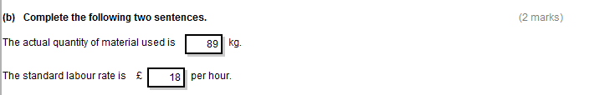

Task 3 (12 marks)

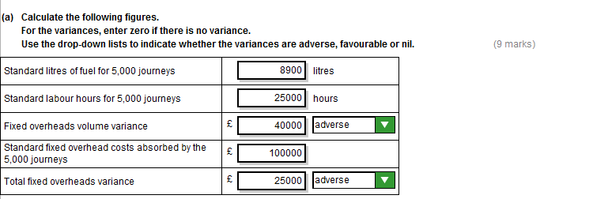

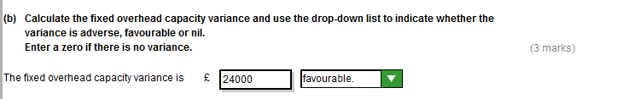

Task 4 (12 marks)

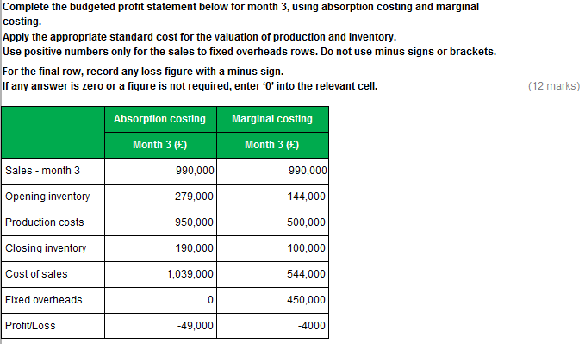

Task 5 (12 marks)

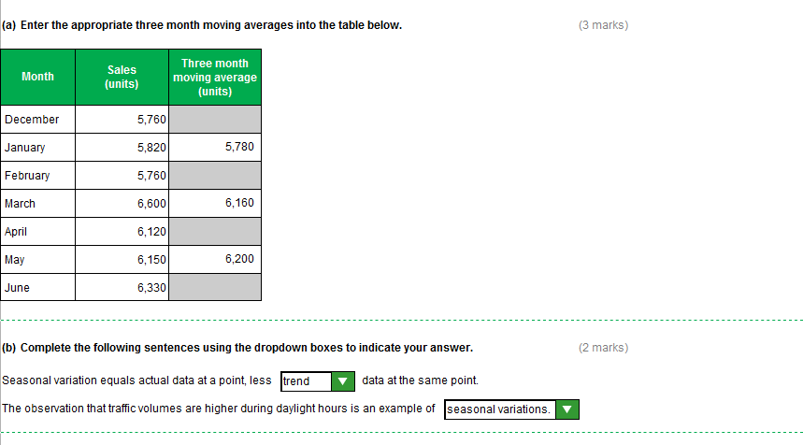

Task 5, continued

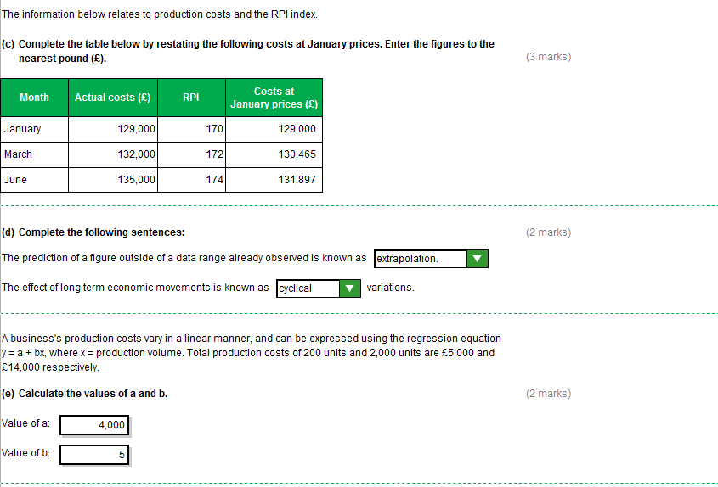
Task 6 (24 marks)

The notes below cover a range of possible points that you may include in your written response.
These examples are not intended to be exhaustive and other valid comments may be relevant.

(a) (i) (12 marks)
A max of 4 marks per event.

STORAGE FACILITIES
The reduction in rent would have reduced fixed overhead expenditure
and is reflected in the favourable fixed overhead expenditure variance.
MACHINERY
The new machinery was more efficient and should lead to favourable labour efficiency
And favourable fixed overhead efficiency variances.
The increased depreciation however, will increase fixed overhead expenditure.
STAFF UPGRADE
The higher skilled staff - probably responsible for the favourable labour efficiency variance.
They are also likely to have led to the favourable materials usage variance
If fixed overheads are absorbed on a labour hours basis
then this would also be the reason for the favourable fixed overhead efficiency variance.
However, the new staff would have caused the adverse labour rate variance
as they are likely to be on a much higher wage rate per hour.
Any overtime worked by the new staff could have led to the favourable capacity variance.

(a) (ii) (6 marks)
The fixed overhead standard cost should be amended to incorporate the saving in rent on the storage facilities
The changes to efficiency and the increase in depreciation will need to be incorporated into the labour efficiency, fixed overhead efficiency and fixed overhead expenditure standards when the performance and expense figures are known.
If new staff are permanent - standard labour rate & hours should be updated.

(b) (6 marks)
Mention of Integrity, Objectivity, and Professionalism
Self- interest versus goal-congruence
Laying off of unskilled staff versus retraining
Hiring expensive staff rather than retaining cheaper staff

Task 7 (18 marks)

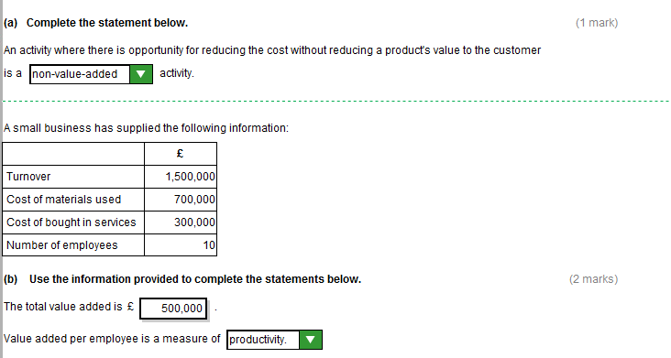

Task 7, continued

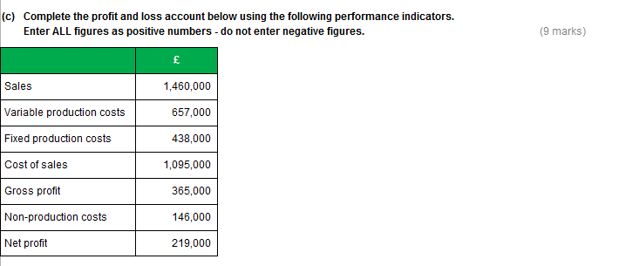
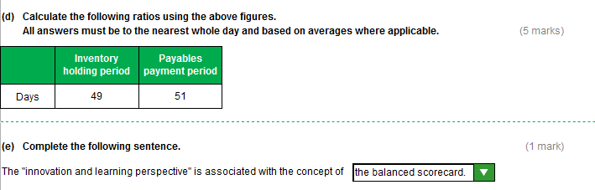
Task 8 (15 marks)

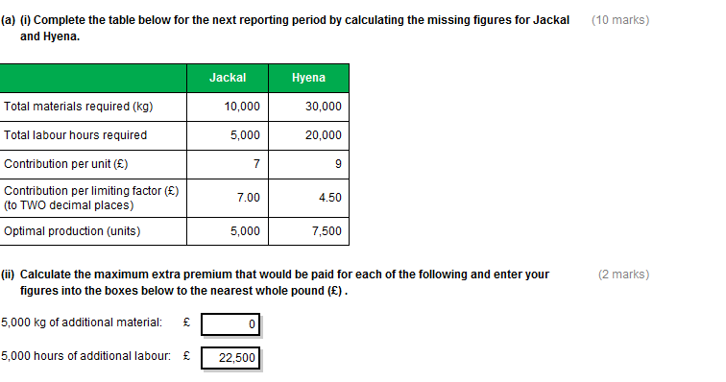
Task 8, continued

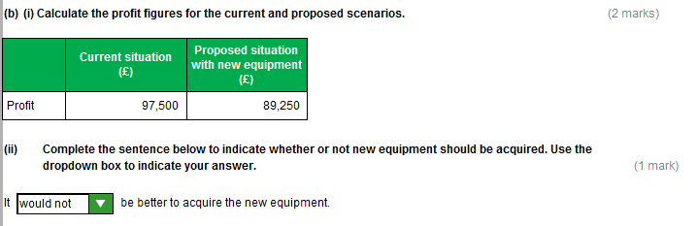
Task 9 (15 marks)

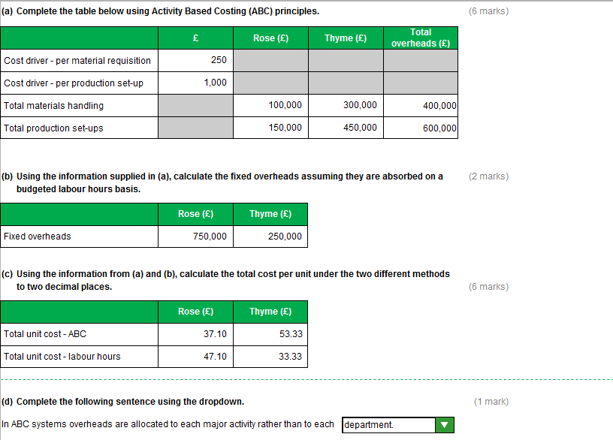
Task 10 (24 marks)

The notes below cover a range of possible points that you may include in your written response.
These examples are not intended to be exhaustive and other valid comments may be relevant.

Contributions

The main reason is because of the much higher variable costs in Charlie/lower variable costs in Delta.
On an initial reading this might look much better for Delta because it has the higher contribution.
Mention of difference in operating gearing
The selling price has no effect on the differing contributions as it is the same for both products.

Break-even points

Despite lower contribution per unit Charlie has a lower break-even point
because of less fixed costs.
This means Charlie has enough contribution to easily cover the fixed costs.
This means Charlie doesn’t have to sell as many units to cover the fixed costs/
Delta would have to sell many more units (6,500 more) than Charlie.

Margins of safety

Charlie has a much higher margin of safety at 50%
Delta margin of safety is only 20%
For 2 main reasons, firstly it has a much higher sales volume
And secondly has a lower break-even point
and thus can suffer a bigger drop in volume (2 marks) before breaking-even.
Delta’s volume only needs to fall by 6,000 less units before it breaks-even and faces the prospect of losses.

(b) Risk analysis and how to reduce it. (Max 10 marks)

From a risk perspective Charlie is the safer option.
Its sales volume would have to fall by half before it hit problems.

Delta is the riskier option because:
Its fixed costs are 67% of its sales revenue

Task 10, continued

It has a lower margin of safety than Gamma

Ways of reducing the risk include,
cutting back on fixed costs,
reducing variable costs
or increasing sales price/volume.
Mention of outsourcing (conversion of FC to VC)
Delta is the riskier option and would need further investigation but
Delta would be much more profitable if sales increased significantly.

