
CBT Sample assessment model answers

Management Accounting: Budgeting (MABU)
Sample assessment 2
Task 1 (20 marks)

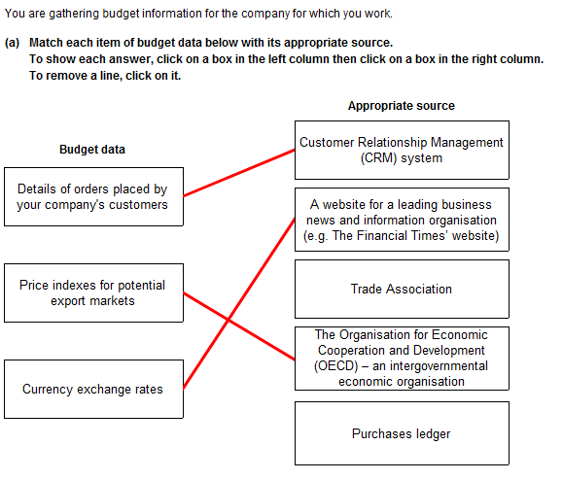
Task 1 (continued)

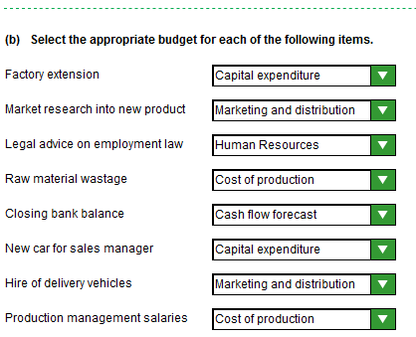

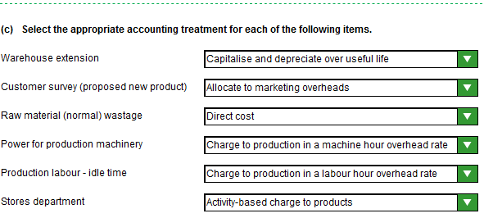
Task 1 (continued)

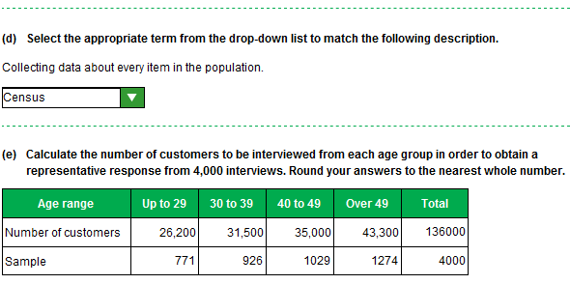

Task 2 (20 marks)

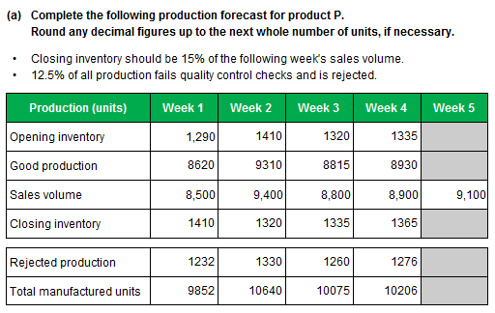
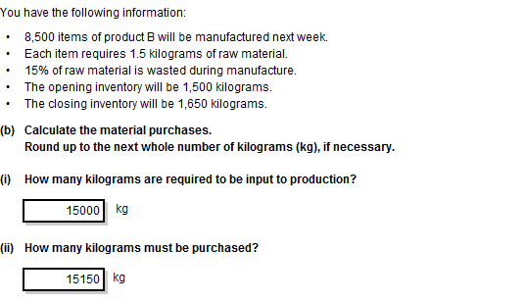
Task 2 (continued)
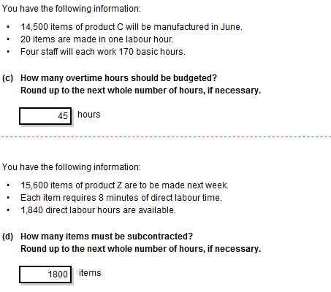
Task 2 (continued)

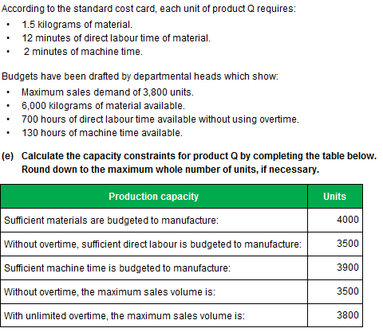

Task 3 (20 marks)

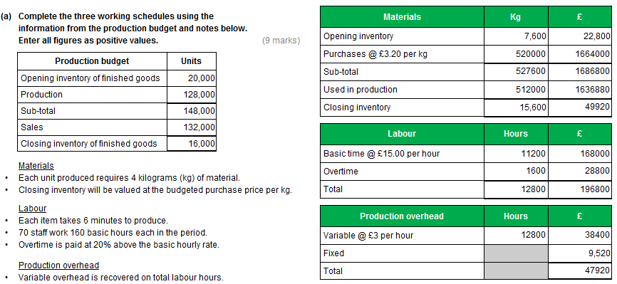

Task 3 (continued)

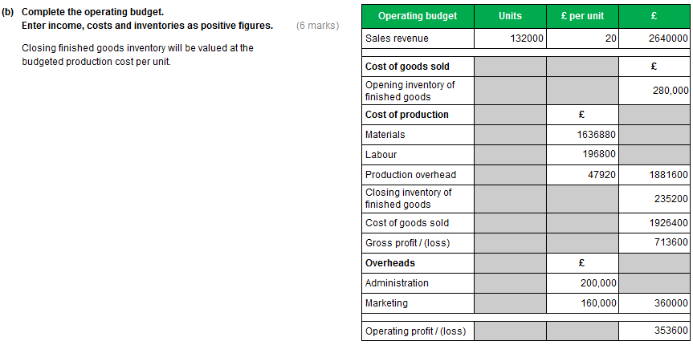

Task 3 (continued)

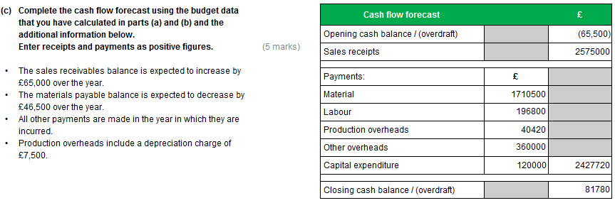

Task 4 (20 marks)

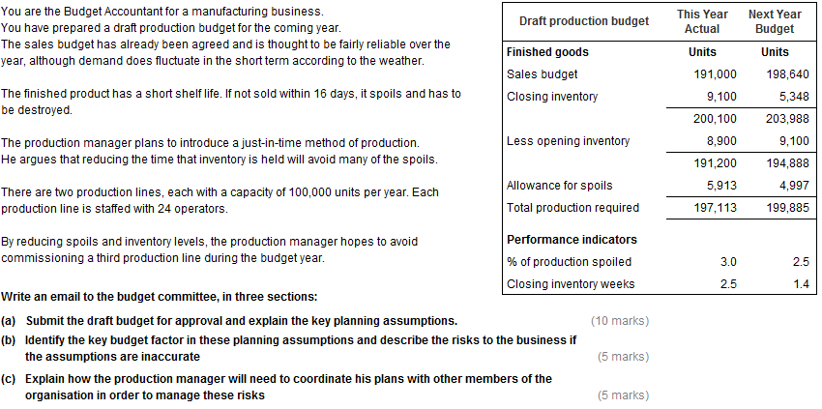

Task 4 (continued)

To: Budget committee Date: xx/xx/xxxx
From: Budget accountant Subject: Draft production budget

- Budget submission
I attach the draft production budget for your consideration and approval. This is calculated from the agreed sales volume budget, which shows a 4% increase over this year. Demand tends to fluctuate with the weather but, over the year, the sales budget is thought to be quite accurate.
The production manager is planning to reduce the average inventory of finished goods from 2.5 weeks average sales to 1.4 weeks. This just-in-time approach should significantly reduce spoils as our product has a shelf life of only 16 days. The production manager expects spoils to be cut by 0.5% to 2.5%.
The inventory reduction will also give a once-only reduction in the production requirement.
Despite 4% higher sales, we are budgeting for an increase in production units of only 1.4%.

- Key budget factor
Each of our production lines has an annual capacity of 100,000 items. The budget production level is within half of one percent of the capacity of the two lines.

We know that demand fluctuates in the short term. With the planned reduction in inventory levels it will be extremely difficult to meet peaks in demand. During slack periods there may be idle time. Furthermore, with an underlying growth rate of 4% pa, it seems inevitable that demand will exceed capacity in the latter part of the budget year. Capacity will be the key budget factor.

When demand exceeds capacity, the consequence will be lost sales, unless alternative production arrangements can be made such as overtime, shift working, sub-contracting or installing a third production line. All of these options will come at a cost.

- Coordination
The production manager will need to coordinate his plans very carefully with his colleagues in order to avoid losing sales or incurring heavy extra costs. In particular, he will need to:
- work closely with the marketing team to ensure that he is aware of the latest order position and sales forecasts
- review pricing policy with the senior marketing manager to optimise revenue from the available capacity
- communicate with his staff or their representative to ensure maximum operational flexibility including overtime working, etc, if possible
- with engineering or technical specialists, develop an expansion ready for when it is needed
- keep the human resource manager appraised of his plans to ensure that staff contracts are appropriate to production needs and to create a recruitment programme.

Budget Accountant

Task 5 (20 marks)

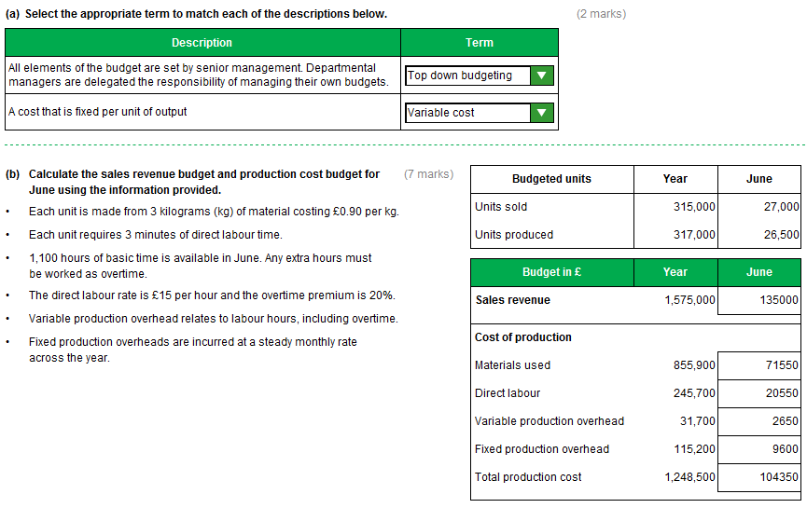

Task 5 (continued)
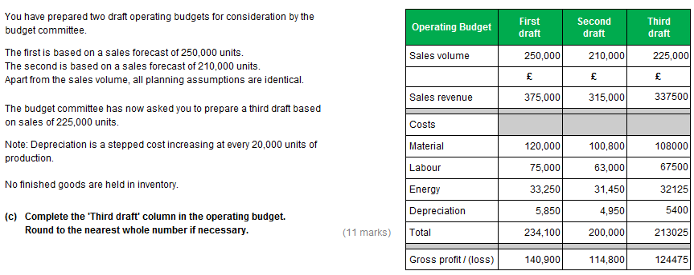

Task 6 (20 marks)

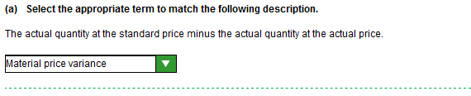

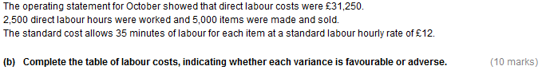

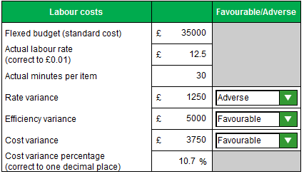

Task 6 (continued)

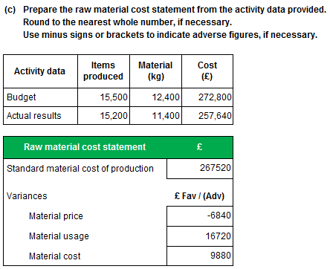
Task 7 (20 marks)

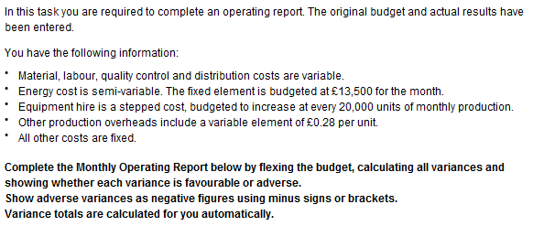

Task 7, continued

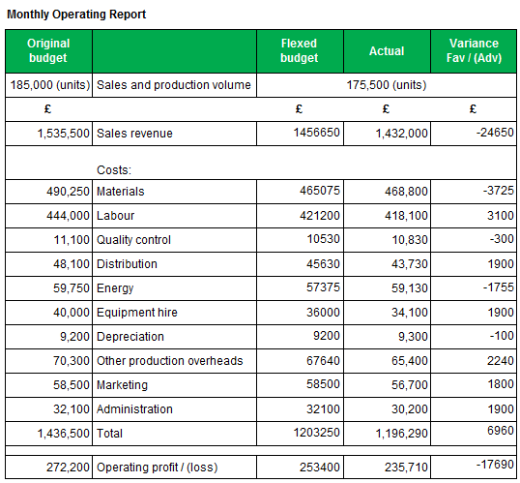

Task 8 (20 marks)

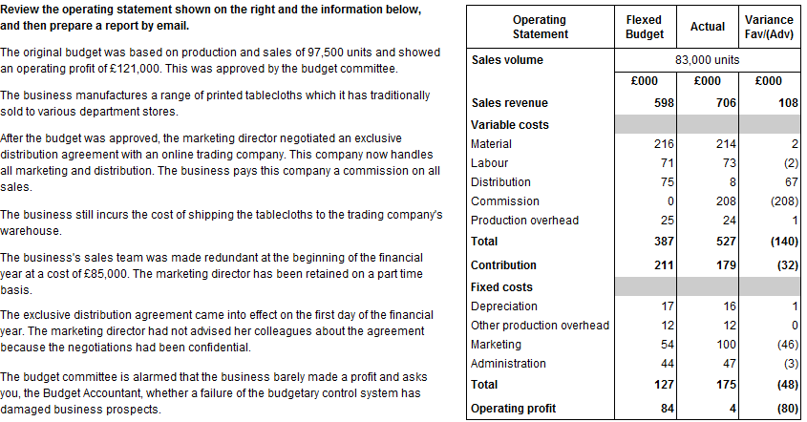

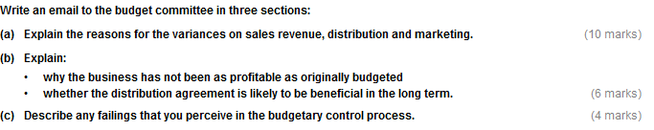

Task 8 (continued)

To: Budget committee Date: xx/xx/xxxx
From: Budget accountant Subject: Performance review

- Reasons for variances
The operating statement shows a profit of only £4,000. Profit was originally budgeted at £121,000. Even when the budget is flexed for lower than anticipated sales volume the expected profit is £84,000. It should be noted that the budget was set before we entered into the exclusive distribution agreement and has not been revised to reflect this. Consequently, there are a number of significant variances from the flexed budget.
Sales revenue shows a very favourable variance of £108,000 (18%) which is due to price. We now sell direct to consumers rather than department stores and this allows us to set prices at retail levels. It should be noted, however, that we have paid an unbudgeted sales commission of £208,000 (£2.50 per item).
There is also a favourable variance of £67,000 (89%) on distribution costs as we no longer have to ship the products to the department stores. The actual expense of £8,000 is the cost of shipping in bulk to the distributor.
Marketing costs were £46,000 (85%) above budget. We no longer need to market our products and have laid off the sales team incurring redundancy costs of £85,000. The marketing director is now a part time employee. Cost, apart from the redundancies, was £15,000.
- Profitability
Profit was originally budgeted at £121,000 but we only achieved £4,000; a shortfall of £117,000.
Sales volume was 15% below the original budget. This might be expected in the first year of a new distribution arrangement or could be a sign of a longer term problem. The flexed budget calculation indicates that we would expect this volume drop to hit profit by £37,000.
There is a once-only redundancy cost of £85,000 which was not budgeted.
The volume decline and redundancy cost more than explain the fall in profit.
Apart from these variances it can be seen that the benefits from the distribution agreement are sales (price) variance of £108,000, savings in distribution of £67,000, savings in marketing of £39,000 (£54,000 - £15,000), totalling £214,000. The commission cost was £208,000. The net benefit was £6,000.
Looking forward, the key issue for the business is sales volume. If it recovers to previous levels or exceeds them it could be argued that the distribution agreement will be beneficial. If not, we appear to have made a major error.
- Budgetary control
It does not appear that the distribution agreement was either evaluated or approved. It was a major departure from the original budget and the budget should have been revised and authorised.
If the proposal had been properly appraised by the management team the risk of a decline in sales volume could have been assessed and the one-off costs estimated. A revised budget would then have provided a valid basis for monitoring performance. The original budget was no longer relevant.
Budget Accountant

