
CBT Sample assessment model answers

Financial Statements of Limited Companies (FSLC)
Sample assessment 2
Task 1 (24 marks)

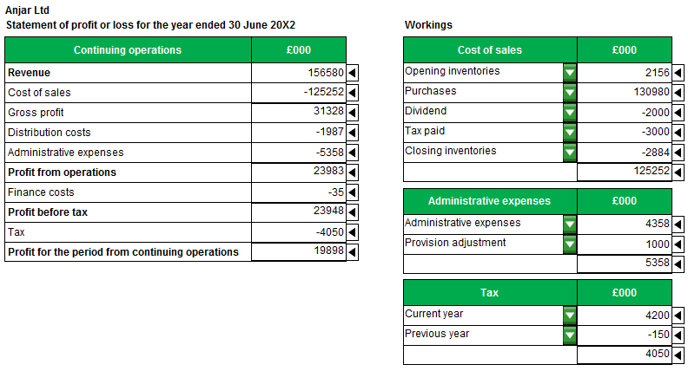

Task 1, continued

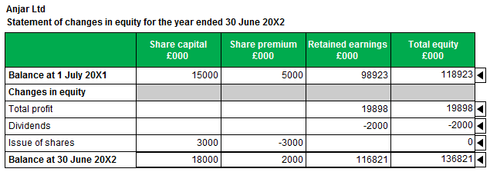

Task 2 (16 marks)

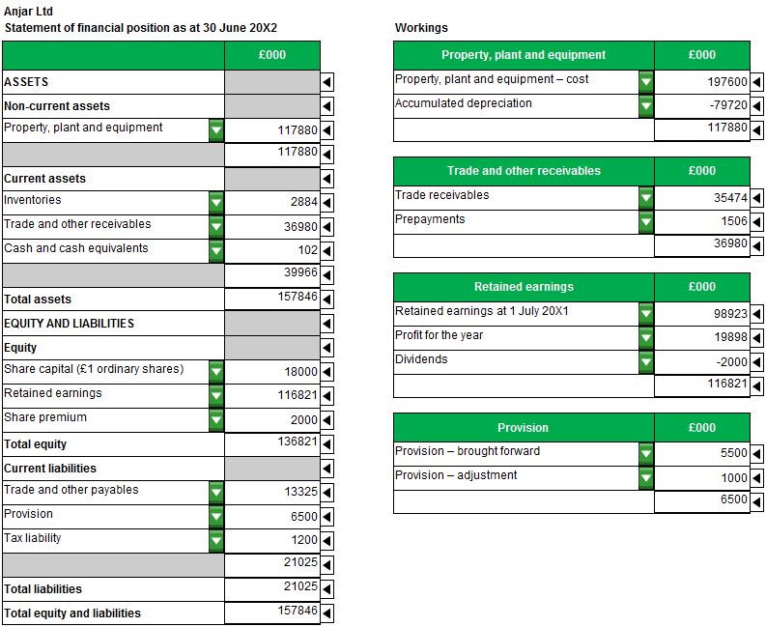
Task 3 (10 marks)
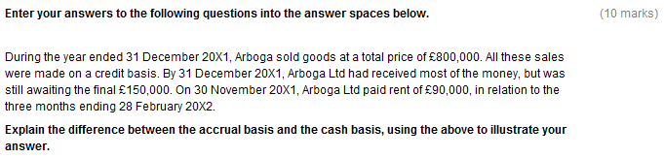
Under the accrual basis transactions are recognised when they occur, not when the related cash flows into or out of the entity.

Therefore under the accrual basis revenue/sales for the year would be £800,000, with trade receivables at the year-end of £150,000. Only that portion of the rent paid which relates to the period would be included on an accrual basis. So rent of £30,000 (£90,000 x 1/3) would be shown as an expense, with the remaining £60,000 recognised as a prepayment.

Under the cash basis only the cash impact of a transaction is recorded. Therefore revenue/sales for the year would be £650,000 and rent would be £90,000

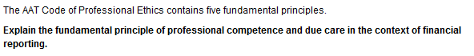

Professional competence and due care means that a professional accountant must:
Maintain professional knowledge and skill at the level required
Act diligently and in accordance with applicable technical and professional standards
For example, keeping up to date with accounting standards/undertaking CPD

Task 4 (12 marks)

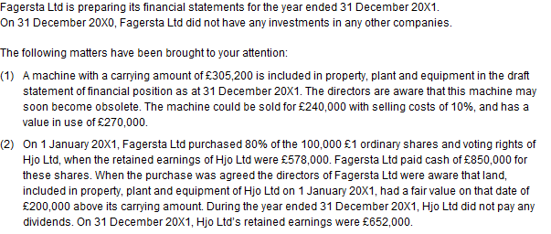

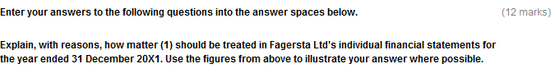
An asset is said to be impaired when its carrying amount exceeds its recoverable amount.
The recoverable amount is the higher of the fair value less costs of disposal/£216,000 and the value in use/£270,000.
The recoverable amount therefore equals £270,000.
The asset’s carrying amount (£305,200) should be reduced to its recoverable amount (£270,000) as the recoverable amount is less than the carrying amount/carrying amount higher than recoverable amount.
An impairment loss of £35,200 (305,200 – 270,000) should be recognised as an expense.
Task 4, continued
In the individual financial statements of Fagersta Ltd the cost of £850,000 should be included as an investment, within non-current assets.
In the consolidated financial statements 100% of Hjo Ltd’s assets and liabilities and income and expenditure should be combined with those of Fagersta Ltd.
A non-controlling interest should be calculated. In the consolidated statement of financial position this will be their share/20% of the fair value of Hjo Ltd’s net assets at 31 December 20X1 and in the consolidated statement of profit or loss this will be their share/20% of Hjo Ltd’s profit for the year.
Non-controlling interest in the consolidated statement of financial position will be £190,400
(20% x (100,000 + 652,000 + 200,000)) and in the consolidated statement of profit or loss £14,800 (20% x (652,000 – 578,000)).
Goodwill should be calculated as the difference between the fair value of the consideration paid/cost of investment/cash paid and the fair value of the net assets acquired . Goodwill will therefore be £147,600 (850,000 – (80% x (578,000 + 100,000 + 200,000)).

Task 5 (15 marks)

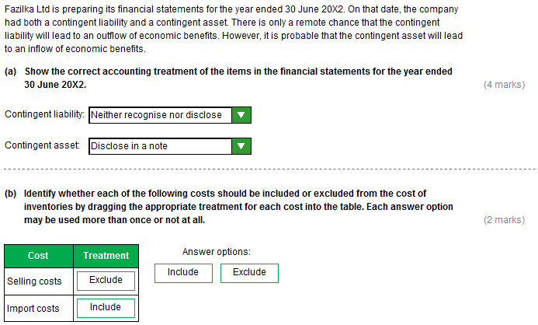

Task 5 (continued)
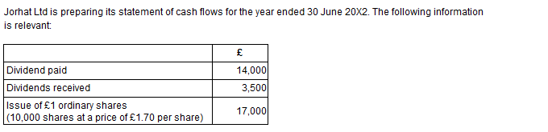
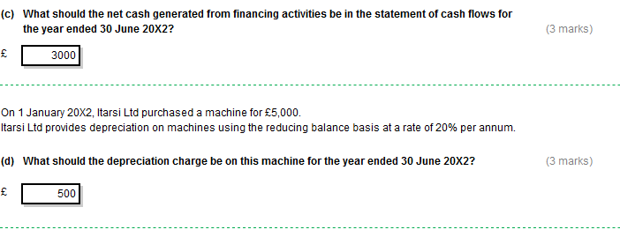

Task 5 (continued)

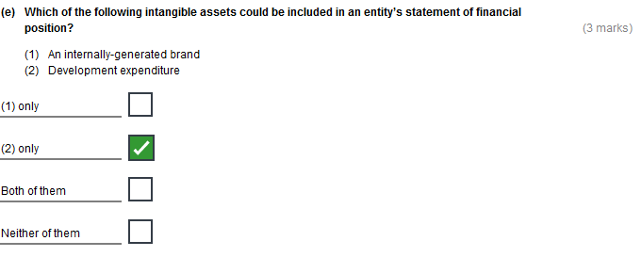
Task 6 (30 marks)

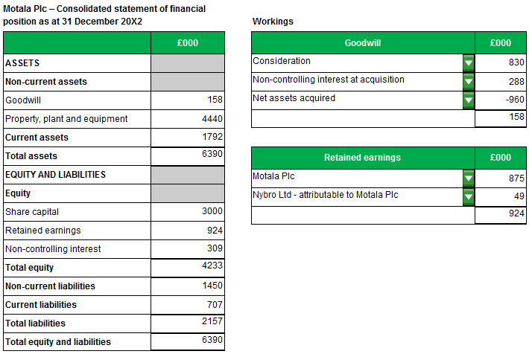
Task 6, continued
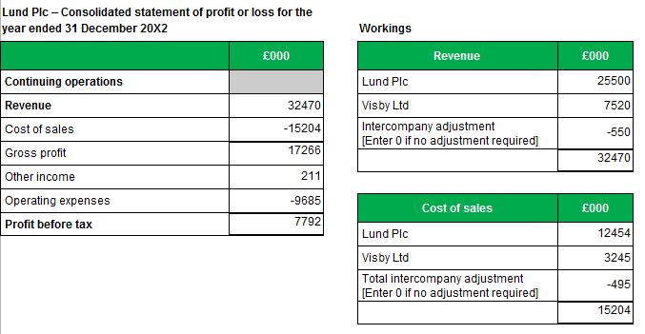

Task 7 (20 marks)

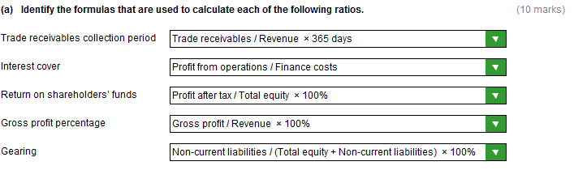

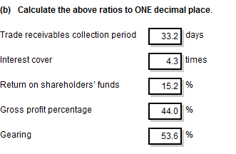
Task 8 (23 marks)

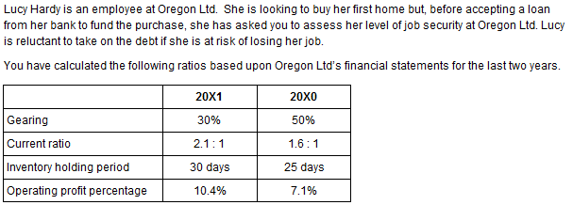

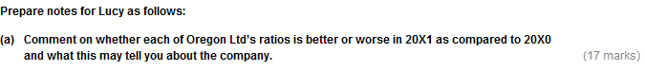

Gearing is better.
The company is therefore less risky.
It may find it easier/cheaper to raise finance in the future.
This could be due to lower debt /paid off loans.
Higher equity.

Current ratio is better.
Sufficient current assets to cover its current liabilities.
More liquid/solvent/less risky.
They may have higher levels of current assets.
Lower current liabilities.
The rise is most likely due to a rise in inventories as the inventory holding period has increased.
Task 8, continued
Inventory holding period is worse
Inventories are taking longer to sell.
Oregon Ltd may have increased prices – an increase in price would be consistent with the increase in the operating profit percentage
This also could be due to lower marketing expenditure – lower marketing expenditure would be consistent with the increase in the operating profit percentage.
Management of inventories may have been poorer. This could lead to higher risk of inventory obsolescence and higher storage costs.
Finally, Oregon Ltd could be stockpiling inventory in order to meet a large customer order.
Operating profit percentage is better.
More operating profit is being generated from sales (more profitable).
This could be due to a higher selling price or lower purchase costs/cost of sales.
The increase could also be due to lower overhead costs (expenses)
There could also be a different product mix.

I advise for you to apply for the loan.
The gearing ratio is better (less risky/debt is a lower proportion of the total finance of the company).
The current ratio is better (more solvent/more able to cover short term debts/liquidity does not appear to be a concern/less risky).
The inventory holding period is worse (taking longer to sell inventories/managing inventories less well)/ but this could be due to a large order in the pipeline.
The operating profit percentage is better (more operating profit is being generated from sales).

