
CBT Sample assessment model answers

Financial Statements of Limited Companies (FSLC)
Sample assessment 1
Task 1 (32 marks)

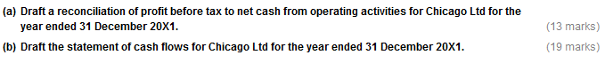

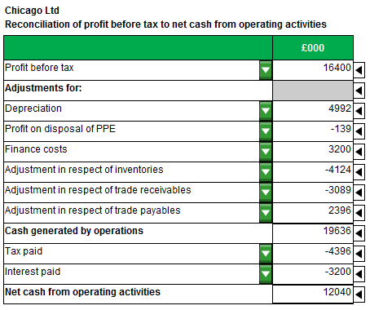

Task 1 (continued)

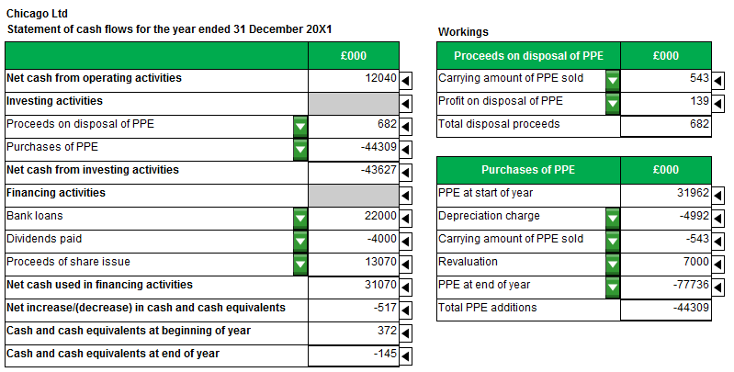

Task 2 (8 marks)

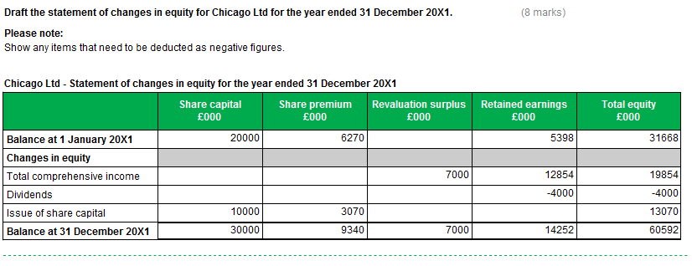

Task 3 (10 marks)

Matter 1
Explain to the directors why inventories should be recognised as an asset in the statement of financial position:
Inventories are recognised as an asset in the statement of financial position because:

- they meet the definition of an asset – they are resources controlled by the entity as a result of past events and from which future economic benefits (cash flows, inflows, revenue, profits, income) are expected to flow to the entity; and

- they satisfy the recognition criteria – it is probable that future economic benefits will flow to Kansas Ltd and the inventories have a cost or value that can be measured reliably.

Identify the TWO measurement bases which should be used to determine the amount at which the inventories should be recognised in the financial statements:
Historical cost and (net) realisable value.

Matter 2
Identify and explain the relevant fundamental principle in accordance with the AAT Code of Professional Ethics:

The relevant fundamental principle is confidentiality.
A professional accountant must:
- not disclose information to third parties without proper specific authority unless there is a legal or professional right or duty to disclose.
- not use confidential information to their personal advantage or to the advantage of third parties.
Task 4 (12 marks)

(1) A provision of £20,000 should be recognised as a liability in the statement of financial position, with a corresponding expense shown in the statement of profit or loss.

This is because Fitnflexi Ltd has a present obligation as a result of a past event.

It is probable that an outflow of resources embodying economic benefits will be required to settle the obligation; and a reliable estimate can be made of the amount of the obligation.

(2) The lease is an operating lease because:
  - the lease term is not for a major part of the economic life of the asset;
  - at the inception of the lease, the present value of the minimum lease payments does not amount to at least substantially all of the fair value of the leased asset.
The lease payments should be recognised as an expense on a straight-line basis over the lease term.
Lease payments of £1,000 (£1,500 × 2 × 2/6) should therefore be recognised in the statement of profit or loss for the year ended 31 December 20X1.
Task 5 (15 marks)

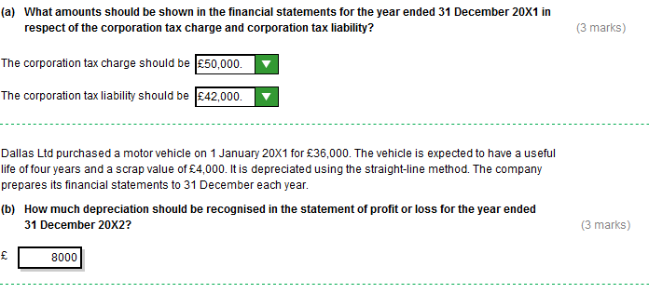
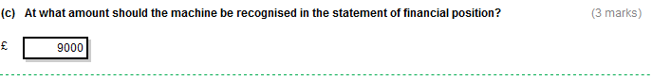
Task 5 (continued)
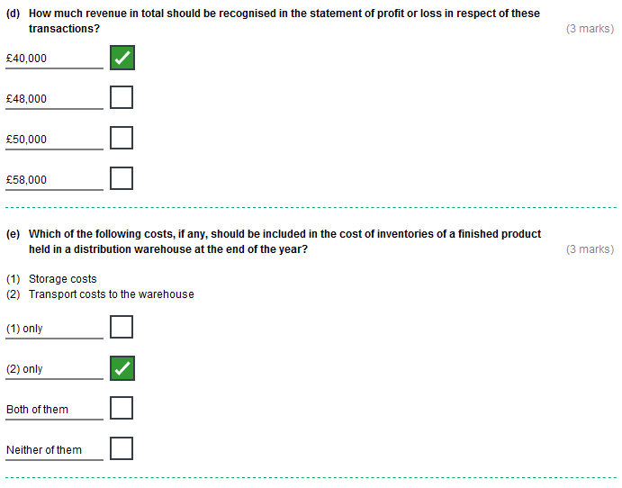
Task 6 (30 marks)
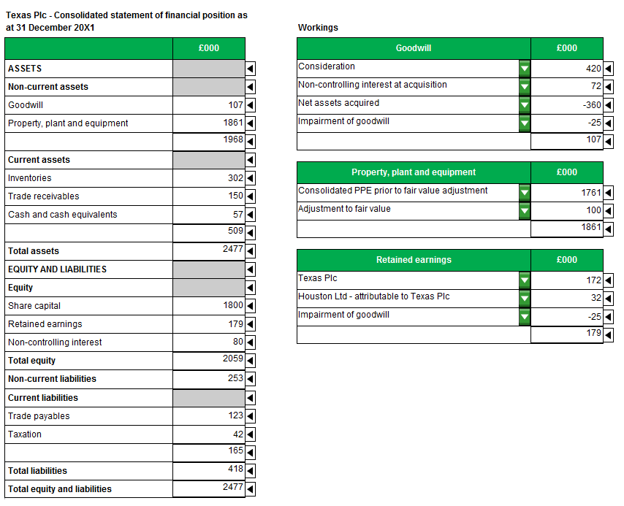
Task 7 (20 marks)

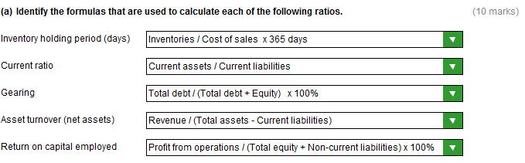

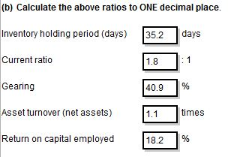

Task 8 (23 marks)

- Comments (17 marks)
Return on capital employed is worse.
Capital is working less efficiently in terms of generating profits (less profit being generated by capital employed).
This could be due to…
- lower profits
- higher equity (higher share capital / higher retained earnings / revaluation surplus)
- also higher non-current liabilities
…which is consistent with the worsening of the interest cover ratio.

Working capital cycle is better.
Working capital / cash is tied up for a shorter period / circulating at a faster rate / good for cash flow.
Inventories may be turning over at a quicker rate (better / shorter inventory holding period / sold sooner / holding less inventories), collecting debts sooner (trade receivables collection period may be better / shorter), or paying its creditors later (longer trade payables payment period).

Quick ratio/Acid test ratio is worse.
More risky / less solvent / liquidity issues.
Unable to cover short term debts (current assets less inventories are less than current liabilities).
This could be due to…
- lower trade receivables or cash and cash equivalents
- higher current liabilities (also allow trade payables, bank overdraft, tax liability)
…which would be consistent with the shortening of the working capital cycle.
Interest cover is worse.
Less profit is available to meet interest payments / more risky.
May be caused by lower operating profits.
May be caused by higher interest payments / higher interest rates.
May have more debt / loans / gearing ratio may be higher.
Could be more difficult to obtain finance in the future.
(b) Advice (6 marks)
Advice is not to buy shares
Only the working capital cycle is better, but this could be due to taking longer to pay suppliers.
Return on capital employed is worse (capital working less efficiently in terms of generating profits).
Quick/Acid test ratio is worse (less solvent / less able to cover short-term debts / liquidity could be a concern).
Interest cover is worse (more risky).

