
CBT Sample assessment model answers

External Auditing (ETAU)
Sample assessment 2
Task 1 (2 marks)

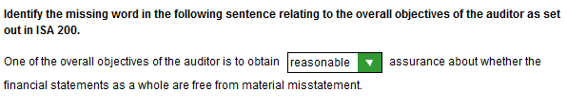

Task 2 (3 marks)

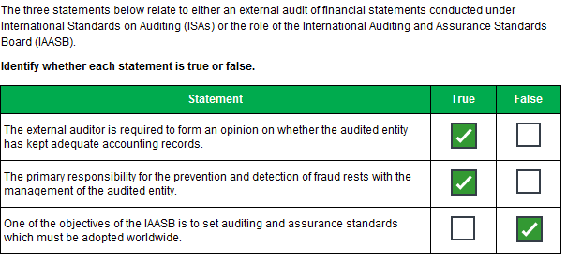
Task 3 (3 marks)

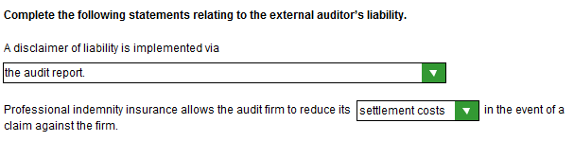

Task 4 (4 marks)

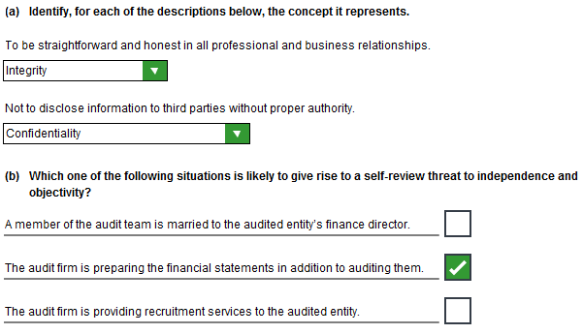

Task 5 (2 marks)

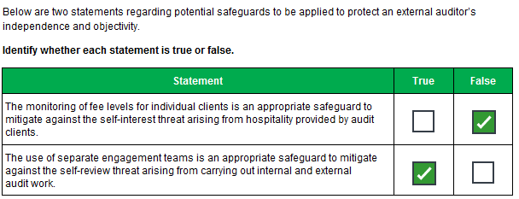

Task 6 (3 marks)

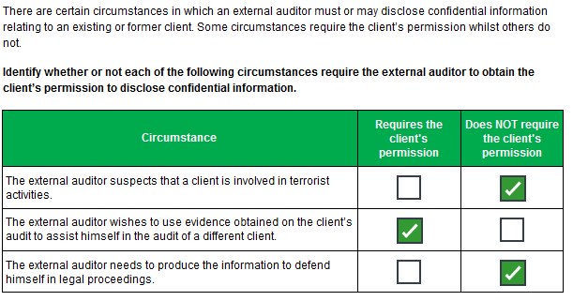
Task 7 (3 marks)

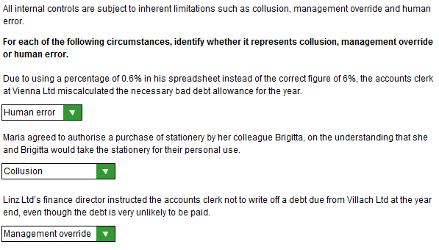

Task 8 (3 marks)

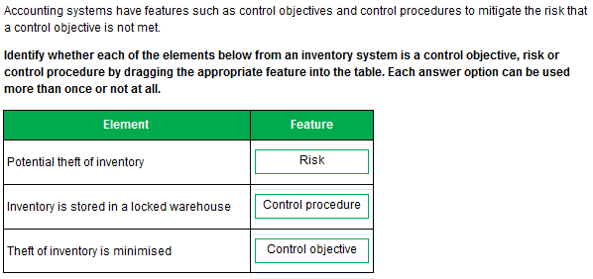

Task 9 (5 marks)

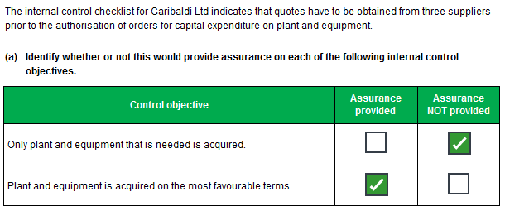

Task 9, continued

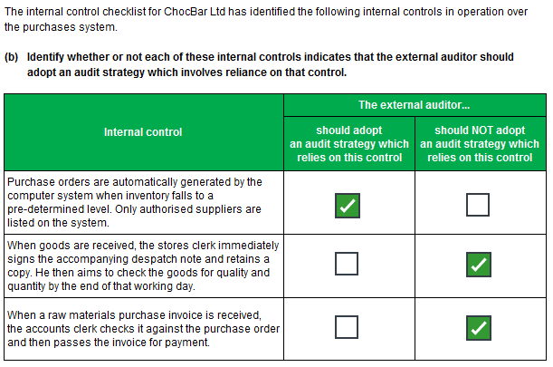
Task 10 (4 marks)

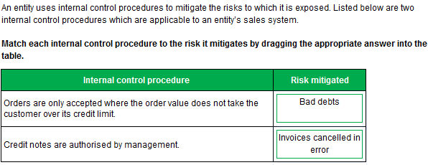

Task 11 (4 marks)

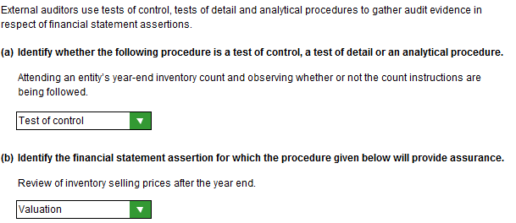
Task 12 (2 marks)

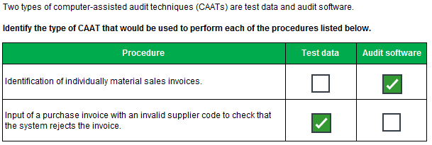

Task 13 (4 marks)

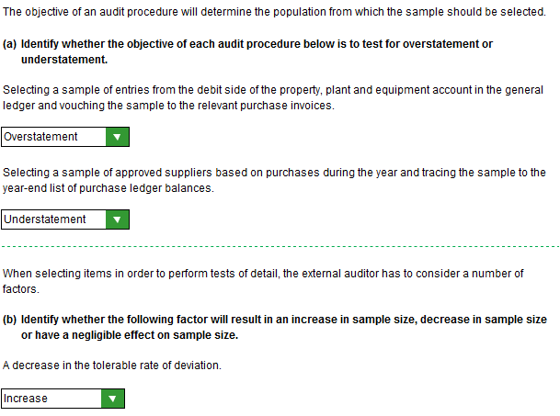
Task 14 (3 marks)

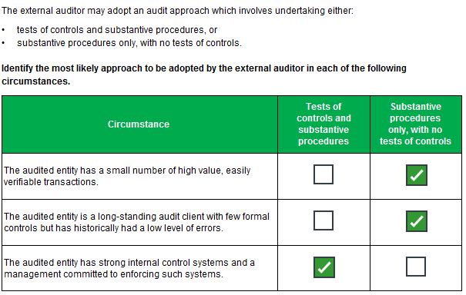
Task 15 (2 marks)

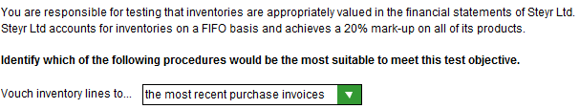
Task 16 (10 marks)

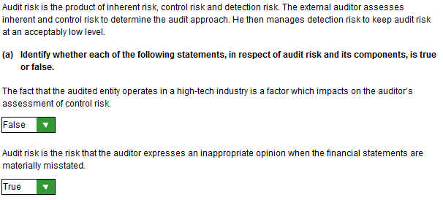

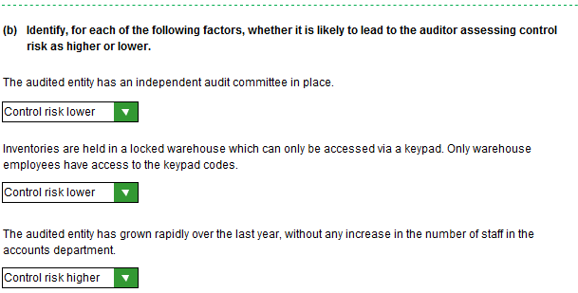
Task 16, continued

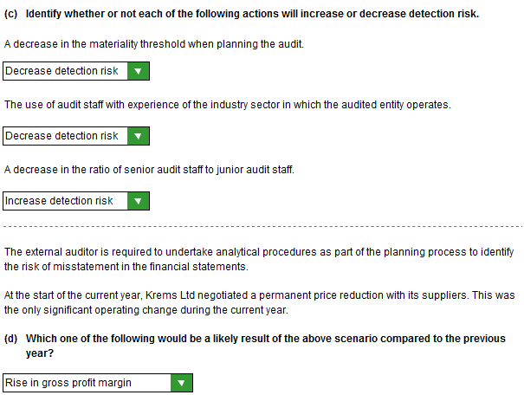
Task 17 (3 marks)

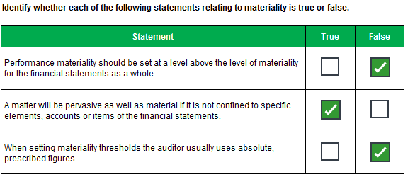

Task 18 (10 marks)

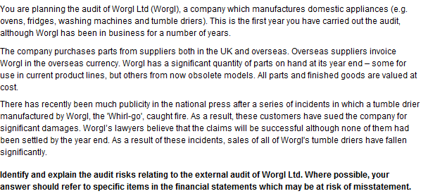

Task 18, continued
Worgl Ltd is a new client which means there are the following risks:
- lack of knowledge and understanding of the business
- increased detection risk
- failure to identify events and transactions which impact on the financial statements/spot errors
- opening balances may be misstated

The company pays for part for in overseas currency which means there is a risk of inappropriate exchange rates/translation errors in purchases, payables and inventory.

Inventory has been overstated for parts for obsolete models and for parts for the Whirl-go.
Possibly also for other tumble driers, finished goods of the Whirl-go and other finished tumble driers.
The Net Realisable Value (NRV) may be lower than cost

The unsettled claims for damages mean that there are the following risks:
- incomplete disclosure of the facts regarding the claims
- provision may not be fairly stated
- going concern risk (if claims are huge)

There has been a drop in sales of other tumble driers/adverse publicity which mean there is:
- a going concern risk, as mentioned above.
- a lack of disclosure re going concern risk, or
- a risk of an inappropriate basis of preparation of the financial statements

Task 19 (10 marks)

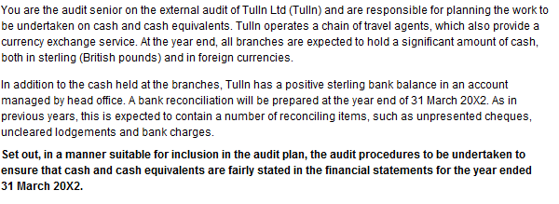
- Attend (a sample of) branches on 31 March 20X2
- Count the cash (or a sample of it)
- Trace cash held at (a sample of) branches through to cash book/financial statements, ensuring amounts held in forex are translated at correct closing exchange rate, by referencing a source such as the Financial Times and by checking the calculations performed

- Obtain a bank letter directly from Tulln’s bank.
- Agree the balance as per the bank letter to the bank statement and bank reconciliation
- Agree the cash book balance to the bank reconciliation
- Reperform the bank reconciliation and trace unpresented cheques to April 20X2 bank statement. If any cheques do not clear in April, enquire as to why this is.
- Review paying-in books and bank statements to confirm uncleared lodgements paid in pre year-end
- If any uncleared lodgements do not clear in April, enquire as to why this is.
- Ensure cash book has been adjusted for any pre year-end bank changes/other items not known about

Task 20 (3 marks)

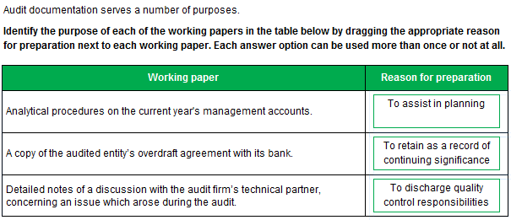
Task 21 (3 marks)

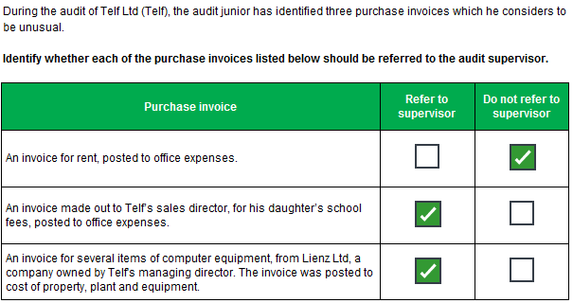
Task 22 (10 marks)

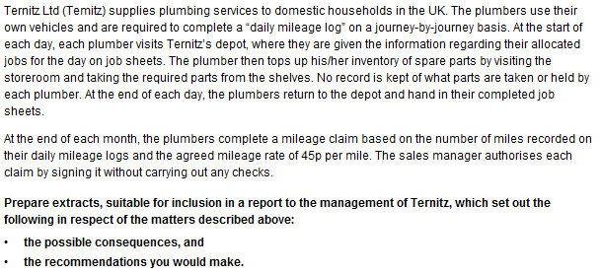

Possible consequences:
- The mileage might not relate to company business/false claims for mileage might be made/some sort of fraud
- Errors might be made in calculating mileage due
- Spare parts might be taken for personal use/use on “private” jobs
- Ternitz Ltd may run out of inventory/experience stockouts
- There may be an adverse impact on cash flow and on profits

Recommendations:

- The mileage per each plumber’s vehicle should be recorded at the beginning and end of each day and be independently verified
- The Sales manager should sign each day’s mileage log
- After checking that the day’s mileage is reasonable for the locations visited
- The monthly mileage should be calculated by the accounts department
- A requisition form should be completed for parts required that day and be signed by the sales manager, with reference to that day’s job sheets and the parts already held by that plumber
- A record should be kept of parts held by each plumber/inventory records maintained and regularly updated for parts issued and used
- Ternitz LTd should communicate the company policy to staff/train staff and procedures should be monitored to ensure compliance
There should be disciplinary procedures for failing to comply with company policy

Task 23 (4 marks)

