
CBT Sample assessment model answers

External Auditing (ETAU)
Sample assessment 1
Task 1 (2 marks)

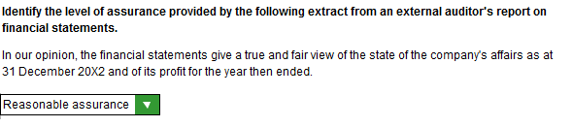

Task 2 (3 marks)

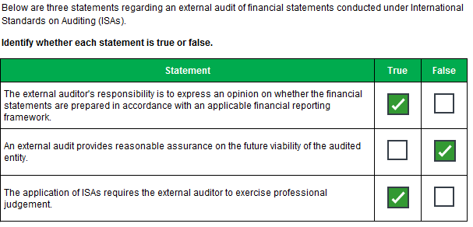
Task 3 (3 marks)

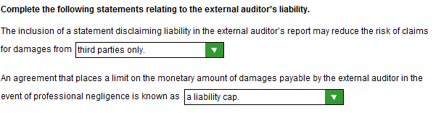

Task 4 (4 marks)

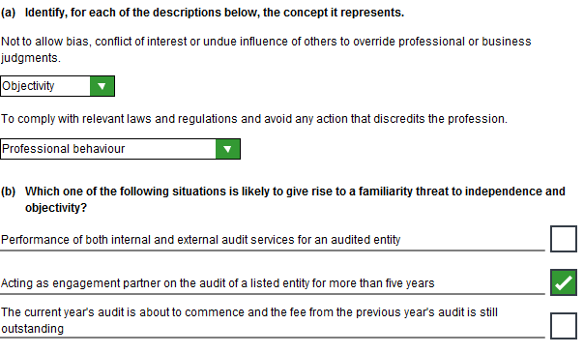

Task 5 (2 marks)

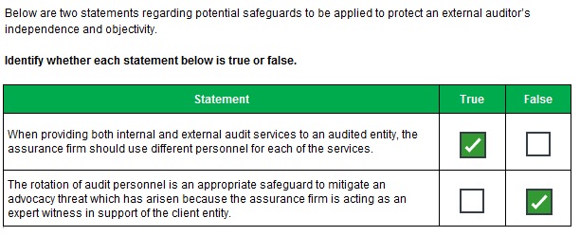

Task 6 (3 marks)

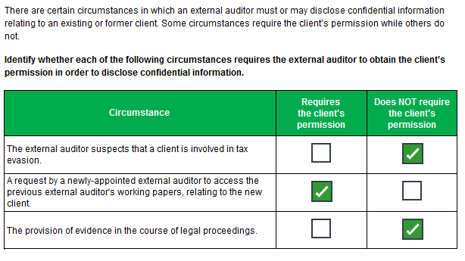
Task 7 (3 marks)

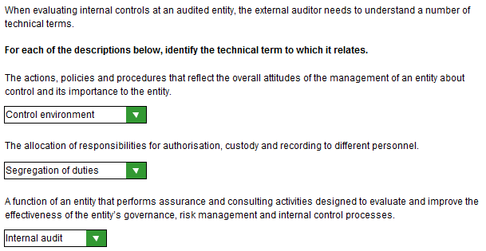

Task 8 (3 marks)

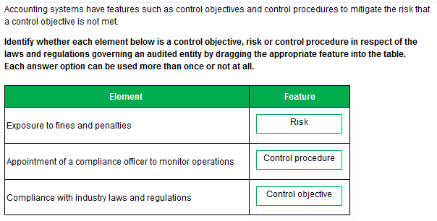

Task 9 (5 marks)

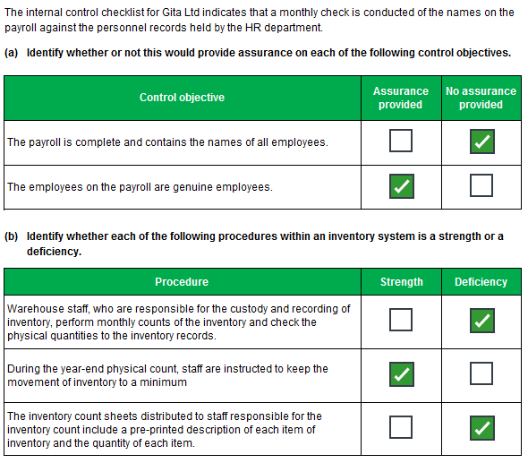
Task 10 (4 marks)

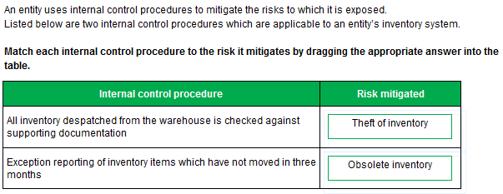
Task 11 (4 marks)

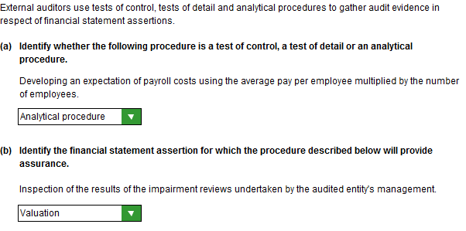
Task 12 (2 marks)

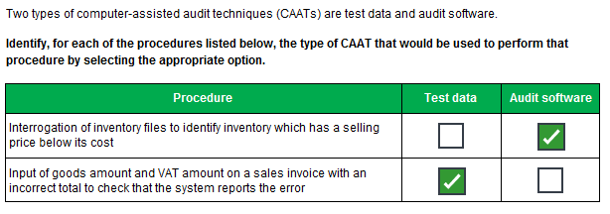

Task 13 (4 marks)

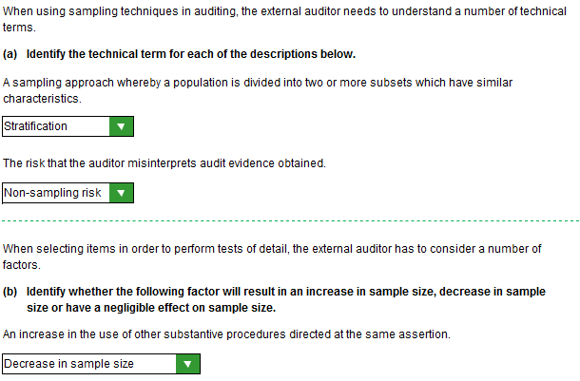
Task 14 (3 marks)

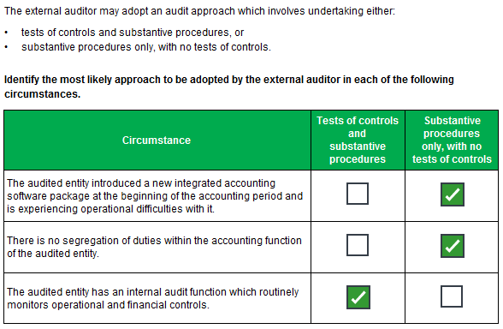
Task 15 (2 marks)

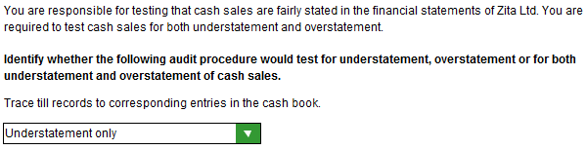

Task 16 (10 marks)

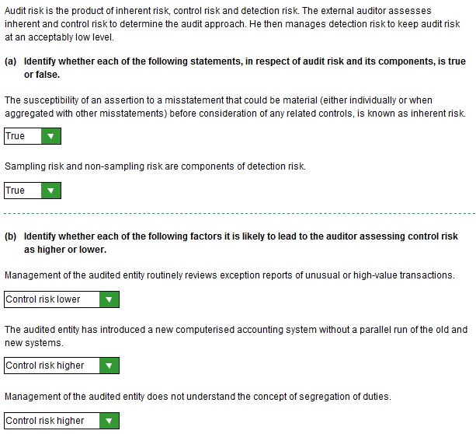
Task 16, continued

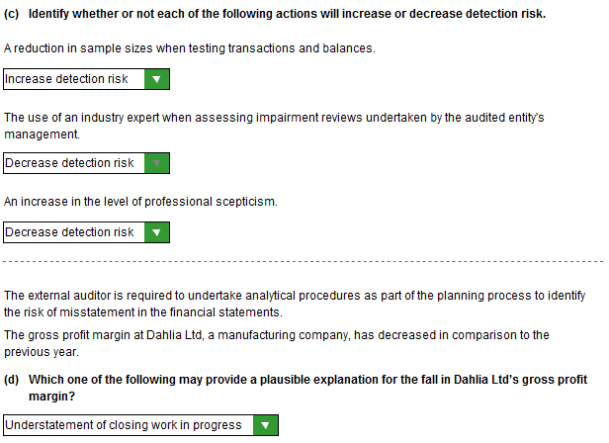
Task 17 (3 marks)

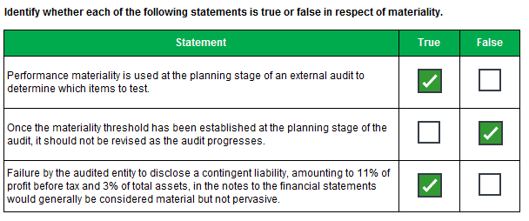
Task 18 (10 marks)

Identify and explain the audit risks relating to the external audit of Gear Ltd. Where possible, your answer should refer to specific items in the financial statements which may be at risk of misstatement.

Fashion goods:
- subject to obsolescence
- NRV may be lower than cost
- inventory may be overstated

Clothing and accessories paid for in US dollars:
Risk of inappropriate exchange rates/translation errors in:
- purchases
- payables
- inventory

Overdue receivables:
- potential irrecoverable debts
- overstated receivables and profit
- understated bad debt allowances

New computer system:
- increased risk of errors due to
- lack of familiarity
- lack of parallel running
- unproven track record of software company
- lack of external auditor involvement

Backlog of work:
- increased risk of errors
- in particular, risk of cut-off errors at year end

Bookkeeper solely responsible for input of data:
- lack of segregation of duties
- increased risk of misstatement due to fraud or error
Task 19 (10 marks)

Attend the year-end inventory count
Evaluate procedures, in particular:
- counting in pairs
- use of sequentially numbered count sheets
- independent supervision
- marking items once counted
- movements kept to a minimum
- damaged items noted

Perform test counts
- floor to sheet
- sheet to floor

For a sample of cost records:
- vouch component costs back to purchase invoices
- re-perform translations from foreign currency and
- check the exchange rate to a reliable source
- ensure completeness of included components by discussion with employees
- check the time taken to assemble by observation/discussion with employees/timesheets
- vouch hourly rate to payroll records
- re-perform the overhead calculation and ensure
- = 20% of direct costs
- production costs per management accounts/direct costs per management accounts = 20%
- ensure overheads are productive in nature/no selling or administrative costs included
- ensure overheads based on normal level of activity/enquire into any idle time

Review selling prices after year end to ensure above cost

Review movements after year end to identify slow-moving/obsolete items

Task 20 (3 marks)

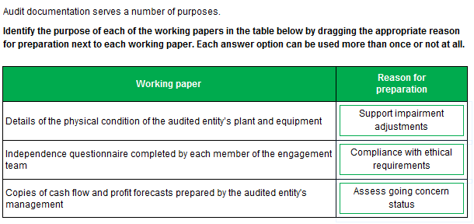
Task 21 (3 marks)

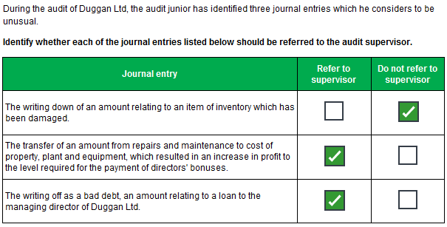
Task 22 (10 marks)

Consequences
Obsolete inventory
Costs incurred if products have to be scrapped/destroyed
Adverse impact on cash flow
Adverse impact on profits
Expired products may be sold
Leading to loss of customer goodwill/business
Or food poisoning
Giving rise to legal claims
Investigated by Regulator (Environmental Health) resulting in
- fines or
- possible closure

Recommendations

Specific

Regular checks of sell-by dates to be made during inventory counts
Introduce process in warehouse to ensure inventory despatched on a FIFO basis
Record sell-by dates on inventory system and regularly check not expired
Check dates on all products before despatched to customers
Expired inventory should be immediately destroyed
Exception reporting of items close to sell-by date
Discount items approaching sell-by date in order to sell inventory with short life

General
Communicate policy to staff/train staff
Monitor procedures to ensure compliance
Disciplinary procedures for failing to comply with company policy
Task 23 (4 marks)

