
CBT Sample assessment model answers

Cash and Treasury Management (CTRM)
Sample assessment 1
Task 1 (8 marks)

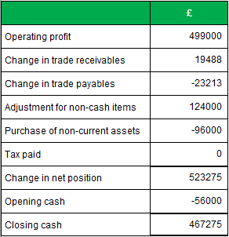

Task 2 (8 marks)

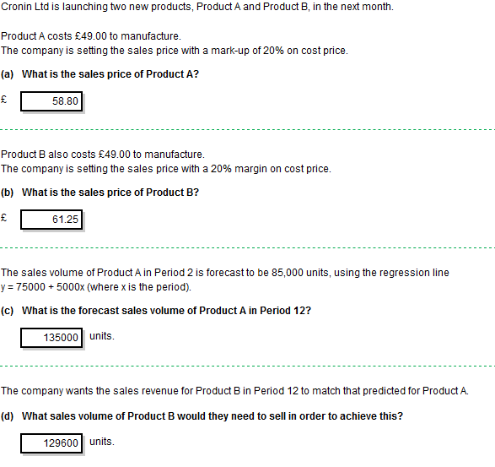
Task 3 (10 marks)

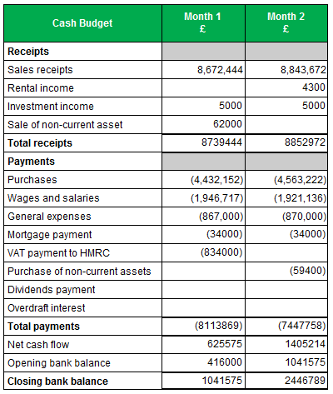
Task 4 (10 marks)

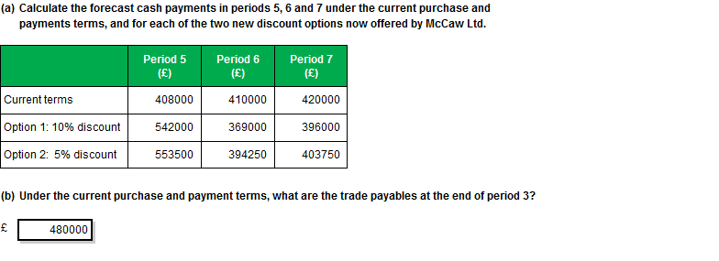

Task 5 (12 marks)

The notes below cover a range of possible points that you may include in your written response.
These examples are not intended to be exhaustive and other valid comments may be relevant.

Cash sales from driving theory tests

- The cash sales from driving theory tests have decreased by £675,000 and this equates to a variance of 15.00%.
- The cash sales have decreased because there has been a price reduction from £33 to £30 and this has not been budgeted for.
- Downturn in sales volumes.
- Possible timing difference, the volume might improve in future months.
- Inaccurate forecasting
- The remedy would be to amend future budgets taking into account price reduction.
- Public awareness campaign

Cash receipts from vehicle testing sales

- The cash receipts from Slot Sales are £1,275,000 under budget and this equates to a variance of 24.88%.
- The reason for this is due to the new system which has been unavailable for a number of days in the period and therefore sales could not be taken.
- No remedy may be needed as future months should fall back in line with budget if the system is available.
- Inaccurate forecasting
- Downturn in volumes
- The remedy would be to monitor for next two months if system is available, next month may see a spike in sales to catch up but the following month should be back to normal.

Investment income

- Receipts from investment income are £19,500 below budget and this equates to a variance of 28.68%.
- This is due to a drop in the bank base rate from 1.75% to 1.25% which has affected the rate of interest of the investment.
- Inaccurate forecasting The remedy would be to amend future budgets until the rate changes again.
- Research other investments for a better return

Wages and salaries

- Wages and Salaries are overspent by £263,000 and this equates to a variance of 22.87%.
- This is due to the new slot sales system where we have used a large amount of contingent labour.
- There is also the possibility that overtime has been used to catch up on the backlog when the system was unavailable.
- Inaccurate forecasting
- The remedy would be to increase the budget if the contingent labour workforce is still in place.

IT Costs

- IT Costs are overspent by £1,300,000 and this equates to a variance of 27.08%.
- This is due to the new slot sales system where the project has over-run resulting in additional IT charges.
- Inaccurate forecasting
- The remedy would be to increase the budget if these increased costs are set to continue.
- Obtain up to date information from the project manager as to the future costs.

Banking Charges

- Banking Charges are under budget by £4,000 and this equates to a favourable variance of 19.05%.
- This could be due to the downturn in slot sales and the fact that the transactional volumes costs have reduced as a result of this.
- Inaccurate forecasting
- The remedy would be to review the company’s cash receipts from slot sales for the next two months and you would expect transactional volumes to come back in line with budget.

Task 6 (32 marks)

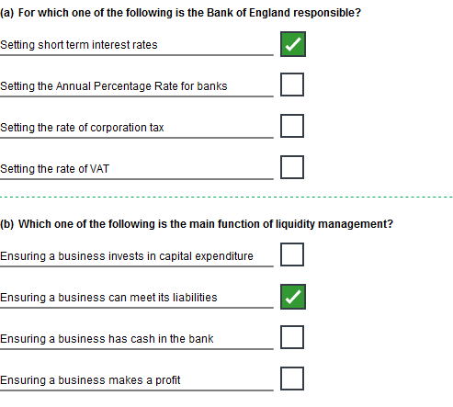
Task 6 (continued)

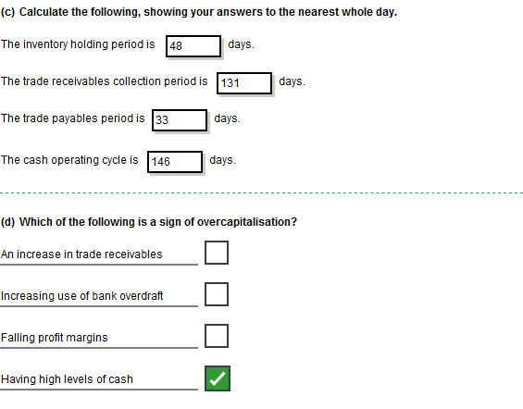

Task 6 (continued)

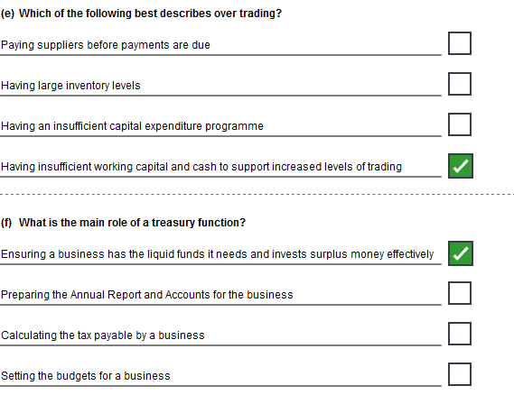
Task 6 (continued)

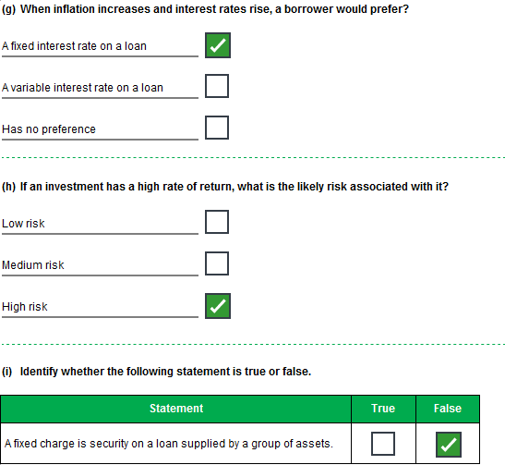
Task 6 (continued)

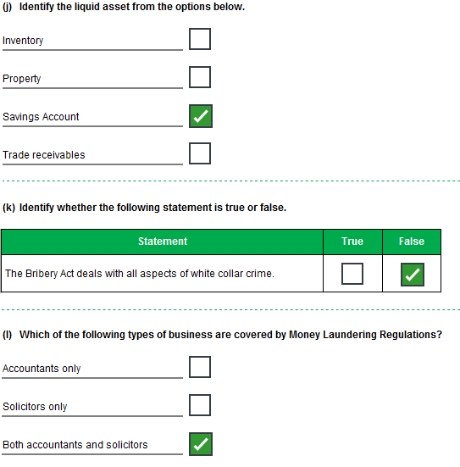
Task 7 (22 marks)

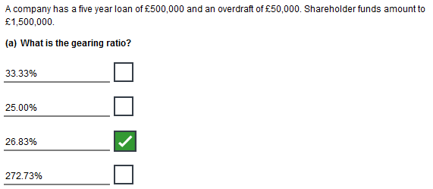
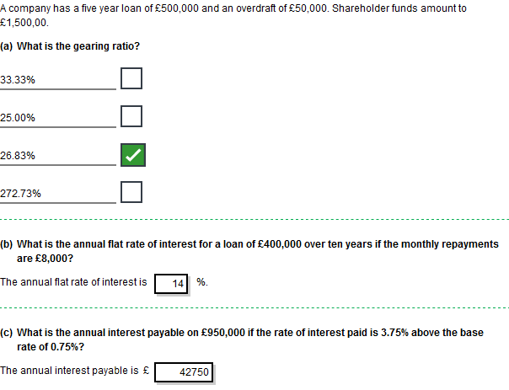

Task 7, continued

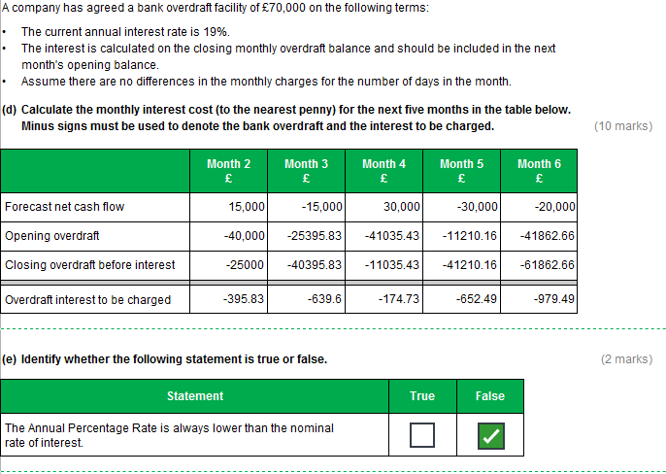
Task 7, continued

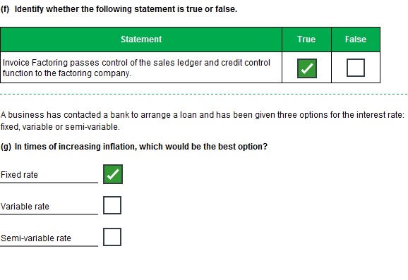
Task 8 (18 marks)

The notes below cover a range of possible points that you may include in your written response.
These examples are not intended to be exhaustive and other valid comments may be relevant.

Option 1 - Bank Loan
This will increase non-current asset levels by £3m in the Statement of financial position.

Cost of Loan:
Set Up Cost £3,000,000 x 1.75%= £52,500
Annual Interest £3,000,000 x 9%= £270,000
Total Interest £270,000 x 3=£810,000
Total Cost of Loan £862,500
Monthly repayment is £3,810,000/36 = £105,833
1st Month is £105,833 + £52,500 = £158,333

Advantages of Loan:
Generally loans can be tailored to suit the business e.g period, repayment schedule and interest rates
Generally lower interest rates than other finance options
The repayments are fixed so good for budgeting purposes
Payment holidays may be allowed

Disadvantages of Loan:
Interest charged on the initial loan balance so no account taken of payments made.
Penalties for early repayment
Security may be needed
Covenants may be needed
Charge may be placed on asset or asset(s)

Accounting Treatment:
The set-up fee and interest for year 1 will be charged to the statement of profit or loss in year 1 and the interest for years 2 and 3will be charged to the statement of profit or loss in years 2 and 3.
The credit rating may suffer
The balance of the loan will be split between current and non-current liabilities in the statement of financial position.
Only the current liability amount will have a bearing on the liquidity ratio.
The total amount of the balance outstanding on the loan will be included in the gearing calculation.
The gearing of the company will increase which could affect the company’s ability to raise additional finance.

Option 2 - Hire Purchase Agreement
This will increase non-current asset levels by £3m in the Statement of financial position.

Cost of HP Agreement:
Total Interest £651,083
35 monthly repayments of £98,679 = £3,453,765
Option to Purchase Fee £197,318
Total Cost of HP Agreement £3,651,083
35 Monthly repayments of £98,679 approx.
This is the cheapest option

Advantages of HP Agreement:
As the interest is an APR it is calculated on a reducing balance
Therefore the interest paid is less than the bank loan
The company gets possession of the goods without paying the full price for them at the outset.
The repayments are fixed so good for budgeting purposes

Disadvantages of HP Agreement:
The company is only hiring the machine until the option to purchase fee is paid
If the company misses one monthly payment then the non-current asset can be seized
Generally an expensive way to purchase goods
Finance company owns the non-current asset until the option to purchase fee is paid

Accounting Treatment:
The non-current asset will be shown in the SOFP of the Company
The interest for year 1 will be charged to the statement of profit or loss in year 1 and the interest for years 2 and 3 will be charged to the statement of profit or loss in years 2 and 3.
The amount of credit will be split between current and non-current liabilities in the SOFP
Only the current liability amount will have a bearing on the liquidity ratio.
This could result in a lower credit score.
The total amount of the HP credit will be included in the gearing calculation.
The gearing of the company will increase which could affect the company’s ability to raise additional finance.

Option 3 - Operating Lease
Cost of Operating Lease:
Annual lease rental payments £1,500,000
Monthly repayment is £1,500,000/12 = £125,000
Total Costs is £4,500,000 over the 3 years
This is the most costly option.
The lease term is not given and therefore the total costs are unknown. However as the asset is an operating lease it implies there is a useful economic life of the asset post lease term.

Advantages of Operating Lease:
Off balance sheet
No effect to gearing or liquidity

Disadvantages of Operating Lease:
Possibility of paying for asset twice and therefore costs the business more
No ownership of asset
Commitment to make payments over lease term
Risk and reward remains with lessor

Accounting Treatment:
The lease rental of £1.5m per annum will be charged to the statement of profit or loss.
There will be no entries in the statement of financial position for the operating lease but has to be shown in a note detailing the non-cancellable annual commitments
The operating lease is off balance sheet and the gearing will be unaffected.
Therefore the total debt on the balance sheet will be unaffected by the lease but a competent credit risk analyst will consider the size of the lease commitment and estimate a revised gearing position including the operating lease as finance.
There will be no entry in current liabilities and the liquidity will be unaffected.

Task 9 (22 marks)

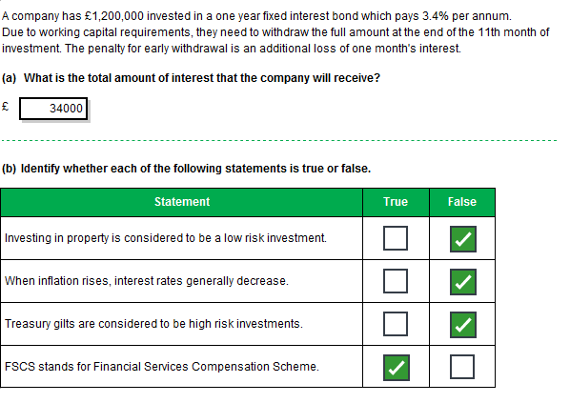
Task 9 (continued)

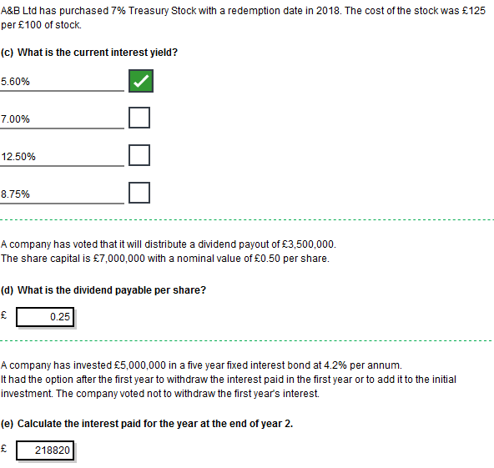
Task 9 (continued)

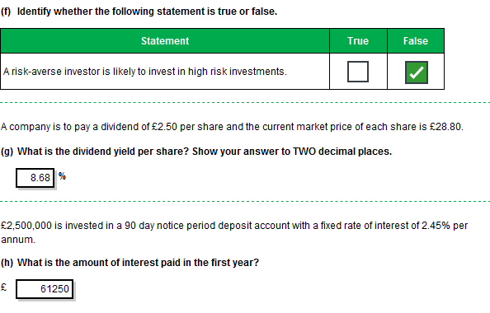
Task 10 (18 marks)

The notes below cover a range of possible points that you may include in your written response.
These examples are not intended to be exhaustive and other valid comments may be relevant.

Diamond Mine in Central Africa:
This is a very high risk investment
No definitive evidence to support how rich the mine is
Obtain a copy of the research article and review
However there is a potential of a large return if the mine is successful and shares rise
Is this a FTSE100 company?
If so shares can be easily traded
If not risk increases
Total investment could be totally lost
Review company history and previous results
Does the company usually distribute dividends?
Could be reputational damage if child labour being used
Could be reputational damage if poor H&S record and a disaster occurs
A visit to the mine would be appropriate given the size of the possible investment.
Investing in Central Africa is very risky with political uncertainty and high levels of corruption.
Not unknown for African governments to seize foreign assets
Uncertain inflation
What is the company attitude to risk

Local Company
This is also a high risk investment
Is this a FTSE100 company – probably not
If so shares can be easily traded
If not risk increases
Look at company profile and results
Total investment could be totally lost
Could be helping the local community re-generate
Creating 250 local jobs
If local economy rejuvenates then more disposable income for community to spend
What is the company attitude to risk
Discounted shares could rise in value
However if they do rise what will the chances of selling them be
Maybe stuck with them
Share value could drop
Company could become insolvent due to a number of factors
Will the consequence of the expansion increase the trade for Payne ltd, directly or indirectly

Five-year fixed rate bond with a High Street Bank
It is difficult to identify the risk on this investment as the interest rate is fixed and the return is guaranteed.
Historically banks were seen as safe investments.
However, that has changed and although governments have bailed out banks some may still fail
Traditionally fixed rate accounts were seen as risk free from the perspective of the loss of capital value.
However in light of the global financial crisis there is a risk of loss of capital value if the deposit is not covered by a government backed guarantee scheme
There is a risk that early redemption penalties may be imposed but this is usually a couple of month’s interest and there is no risk to the capital.
The return is 5% per annum.
This return should be guaranteed assuming it is a large UK bank which will be supported by the UK government
The liquidity will be dependent on the terms of the investment. The investment is for a fixed period, however it may be possible to redeem the investment early with a small interest penalty
Therefore the investment is readily available.
May be possible to sell the bond before maturity.

