
CBT Sample assessment model answers

Credit Management (CDMT)
Sample assessment 1
Task 1 (18 marks)

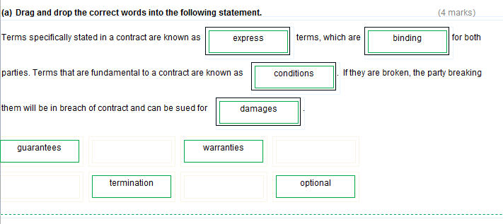
Task 1 (continued)
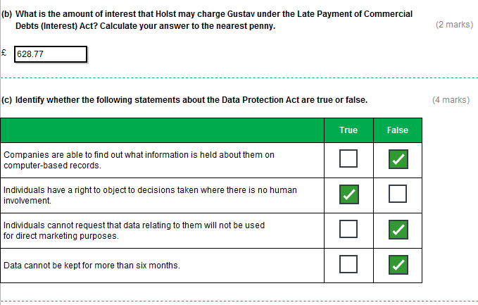
Task 1 (continued)
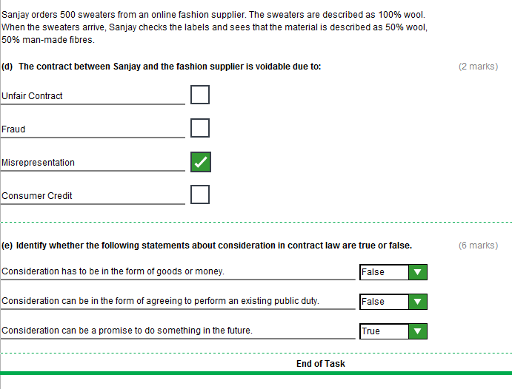
Task 2 (24 marks)

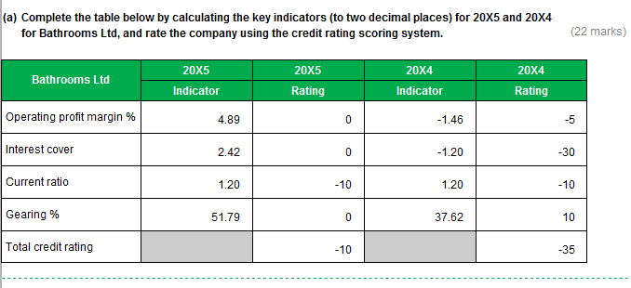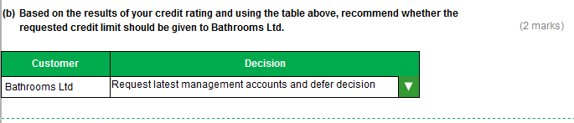
Indicators

This model answer uses the appropriate negative figures to indicate negative operating profit margin percentages, and zeros to indicate negative interest cover figures. This reflects industry preference.

However, for the purposes of this assessment, students may enter zero or the appropriate negative figure for both negative operating profit margins and negative interest cover.

Task 3 (30 marks)

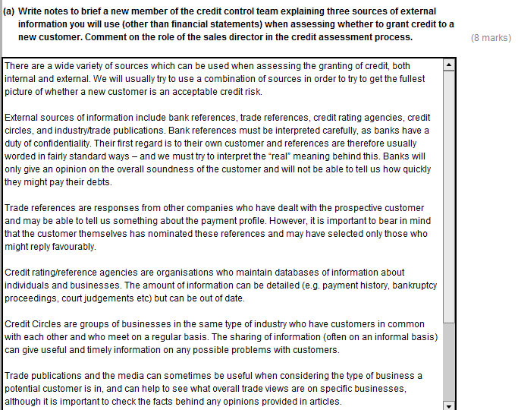

Task 3 (continued)

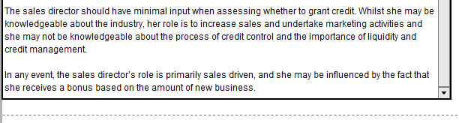

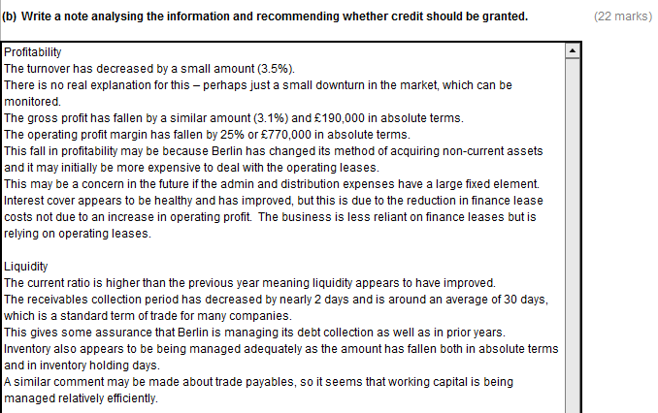
Task 3 (continued)
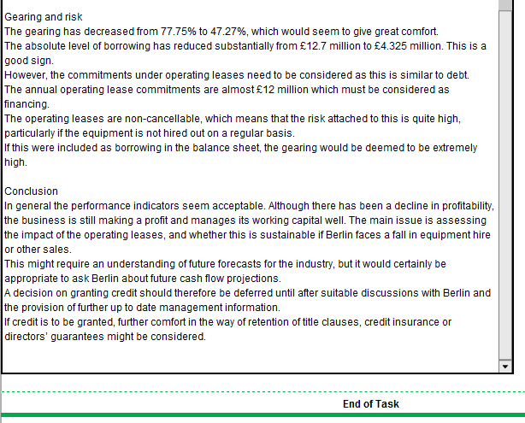

Task 4 (20 marks)

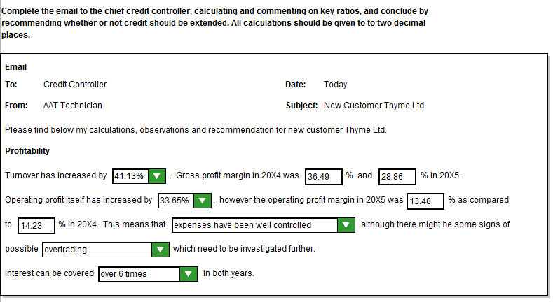
Task 4 (continued)

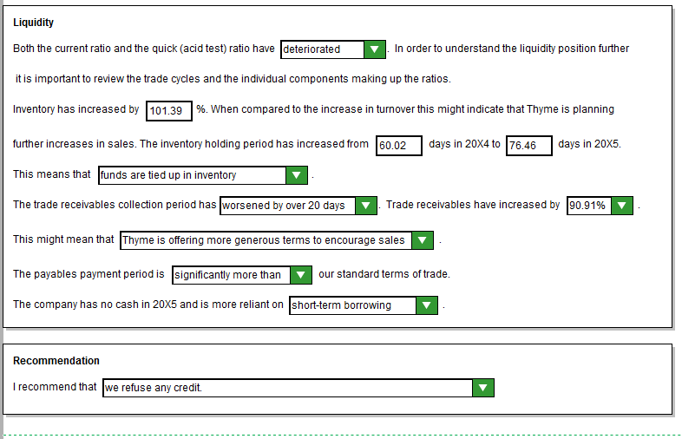
Task 5 (22 marks)

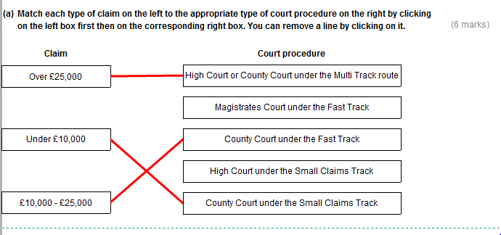

Task 5 (continued)

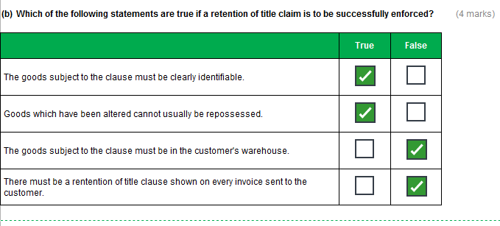
Task 5 (continued)
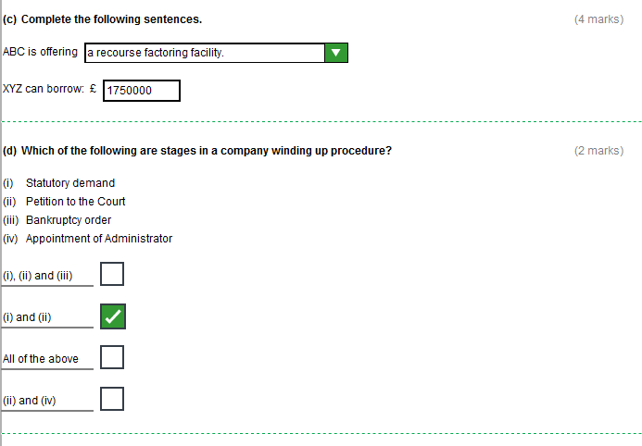
Task 5 (continued)

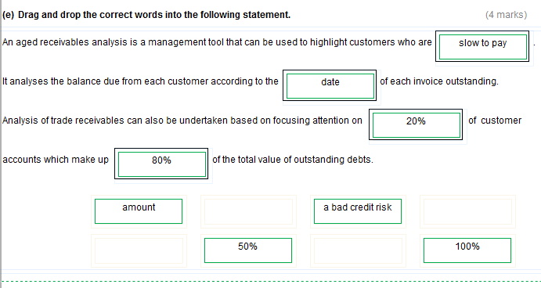
Task 5 (continued)

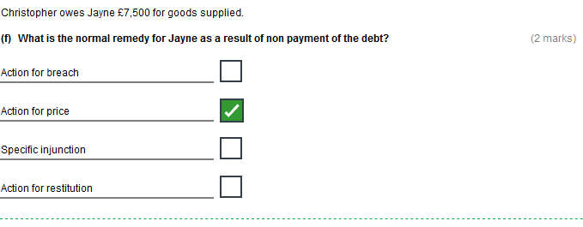
Task 6 (16 marks)

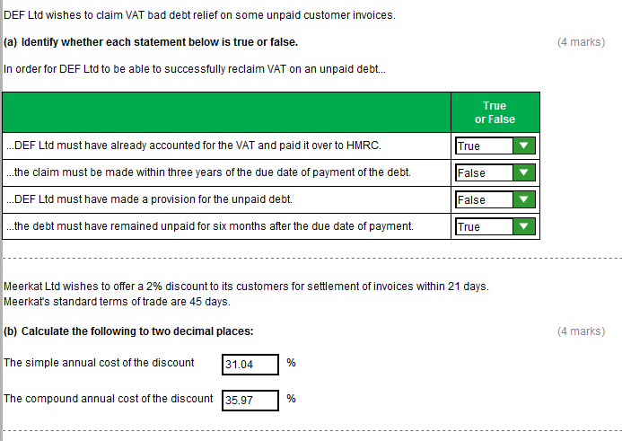
Task 6 (continued)

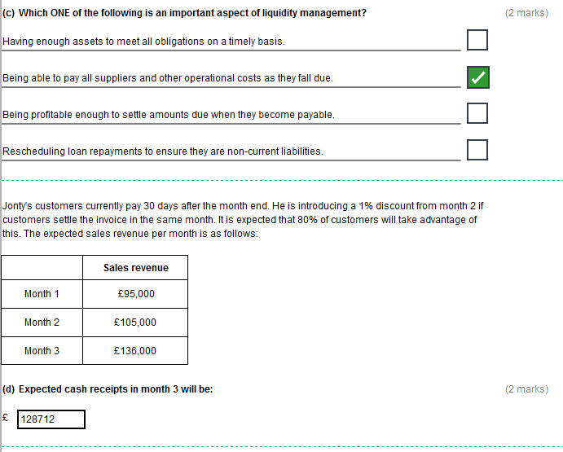

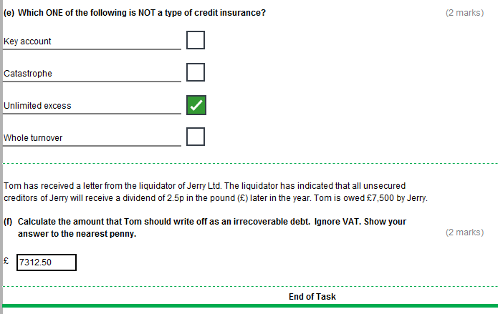
Task 7 (20 marks)

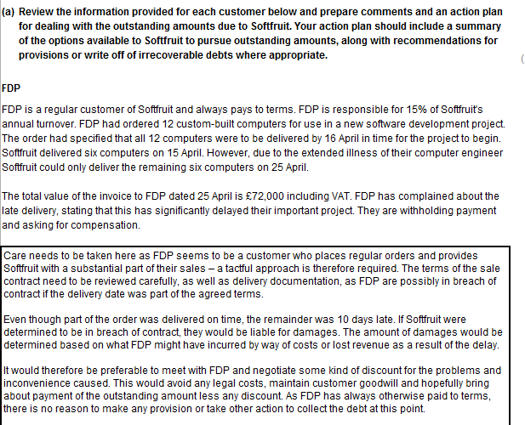
Task 7 (continued)

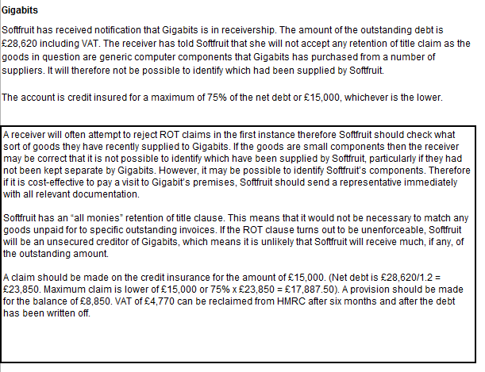
Task 7 (continued)

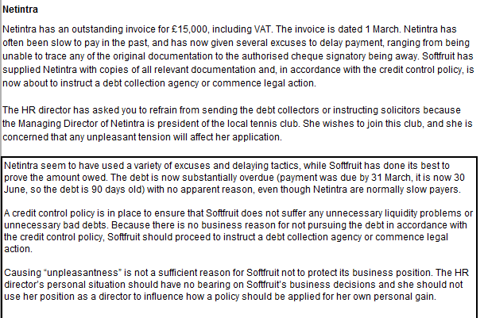

(b) Megachips

 | May | June
 | £ | £
Opening balance | 65,000 | 37,600
Invoice | 26,400 | 16,920
Credit note | (3,840) | (2,100)
Interest charge | 250 | 0
Closing balance | 37,600 | (2,100)
Payments received | 50,210 | 54,520

