

AQ2016 SAM mark scheme

Level 3 Synoptic Assessment
SAM 1
Task 1 (15 marks)
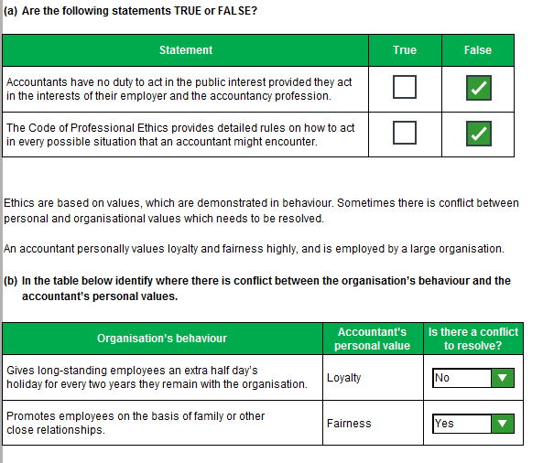
Task 1 (continued)
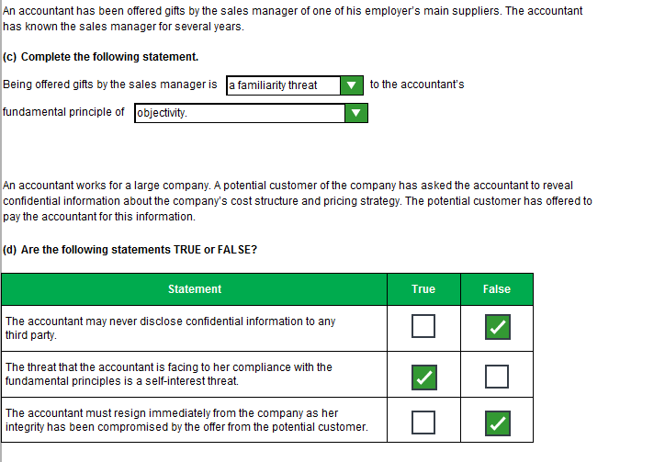
Task 1 (continued)
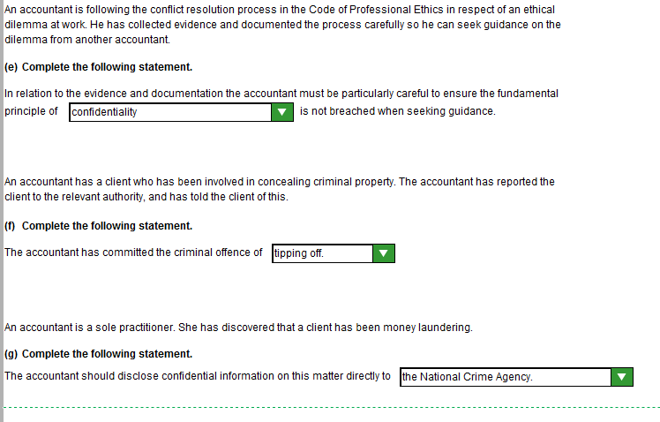

Task 3 (14 marks)
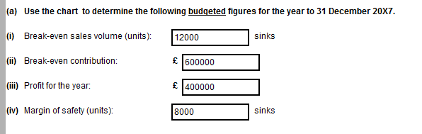

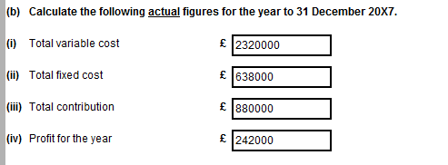
Task 3 (continued)

To: Lakmani Moore <Lakmani.Moore@BLMCo.co.uk>; Brian Moore <Brian.Moore@BLMCo.co.uk>
From: Sam Jones <Sam.Jones@BLMCo.co.uk>
Date: 31/1/X8
Subject: Performance of BLM & Co in 20X7

1. The budgeted profit for the year was £400,000, whereas the actual profit achieved was only £242,000.

2. The revised break-even volume, using the actual figures, is 14,500 units.

Working:
Contribution per unit = £880,000/20,000 units = £44 per unit
Break-even sales volume = Fixed costs/Contribution per unit: £638,000/£44 = 14,500 units

3. The actual profit is much lower than expected, even though the budgeted volume of 20,000 units was achieved.

The actual break-even point of 14,500 units is higher than budgeted at 12,000 units and has been affected by the following changes compared to the budget:

(i) Increased fixed costs, which have risen from £600,000 to £638,000

(ii) Reduced contribution per unit has increased the break-even volume required. Budgeted contribution per unit was £600,000/12,000 units (or £600,000 FC + £400,000 profit/20,000) = £50 per unit, compared to actual contribution of £44 per unit.

The reduced contribution per unit compared to the budget has been caused by a reduced selling price per unit (budget £3,400,000/20,000 = £170, actual £3,200,000/20,000 = £160), offset by a reduced variable cost per unit (budget (£3,000,000 - £600,000)/20,000 = £120, actual £2,320,000/20,000 = £116)

Task 7 (10 marks)

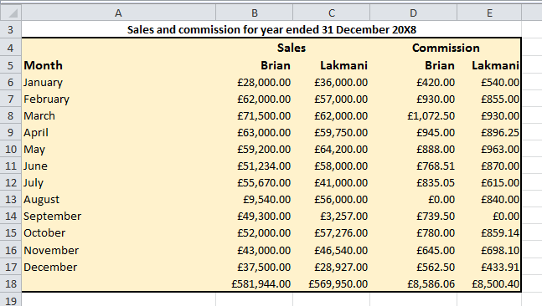
Task 7 (continued)

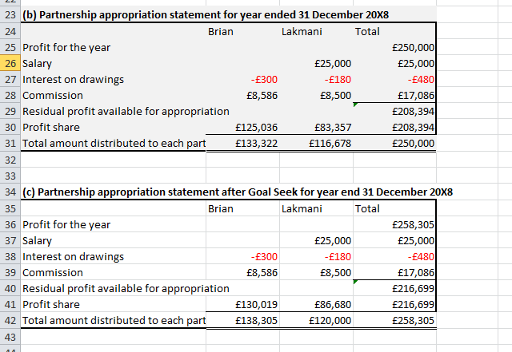

Task 7 (continued)

