
CBT Sample assessment model answers

Management Accounting: Costing (MMAC)
Sample assessment 1
Task 1 (16 marks)

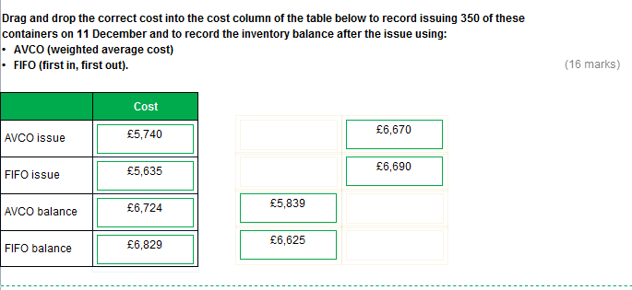

Task 2 (16 marks)

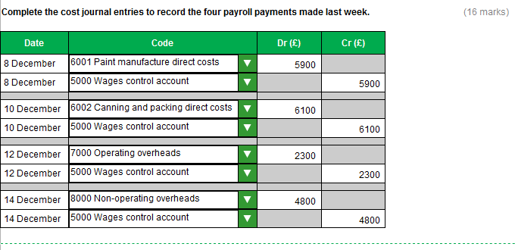
Task 3 (12 marks)

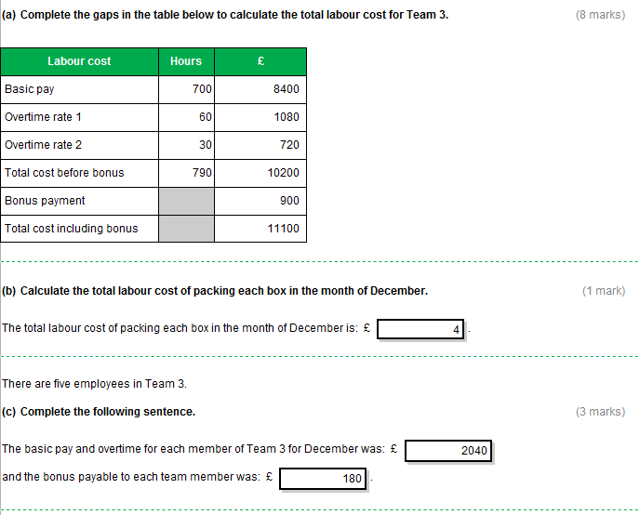
Task 4 (18 marks)

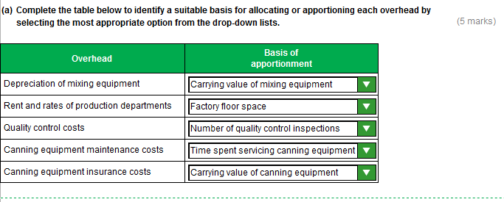

Task 4 (continued)

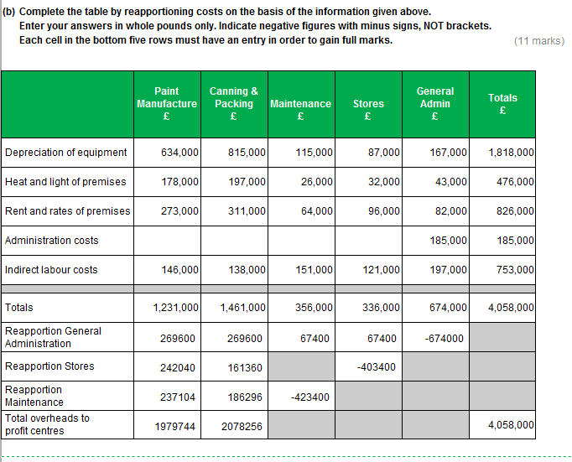
Task 4 (continued)

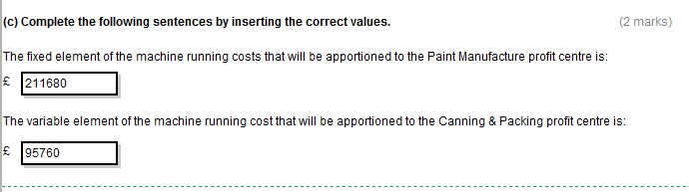

Task 5 (15 marks)

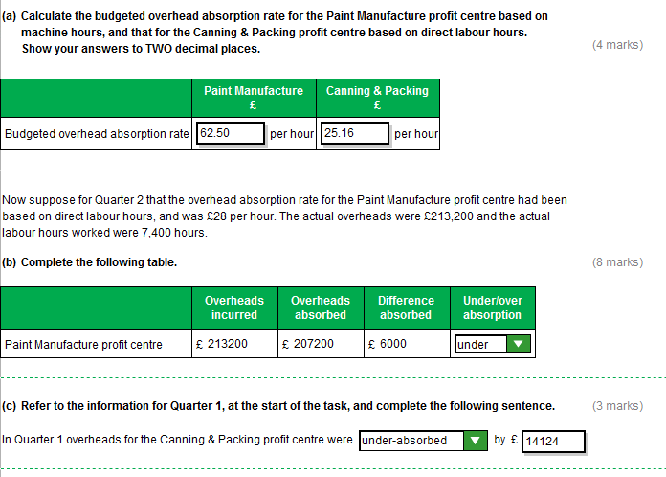
Task 6 (25 marks)

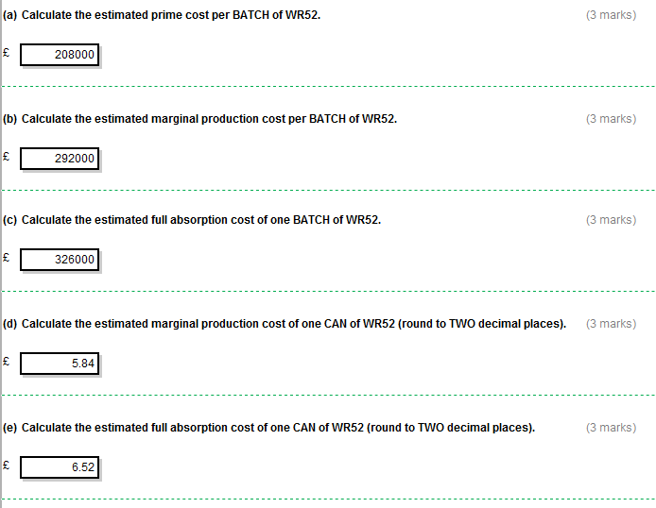
Task 6 (continued)

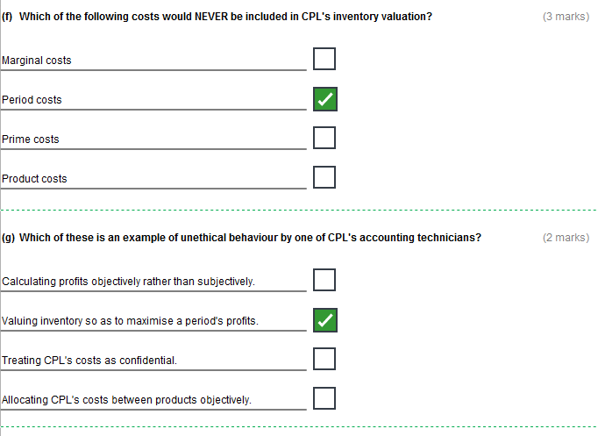

Task 6 (continued)

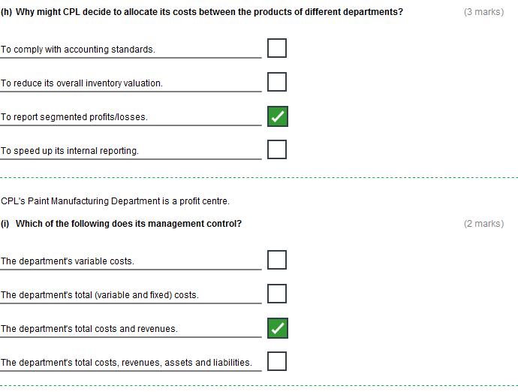
Task 7 (16 marks)

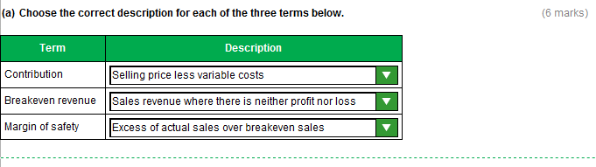

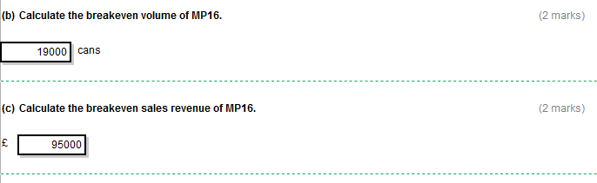
Task 7 (continued)

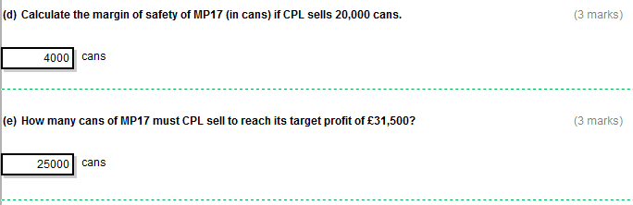

Task 8 (16 marks)

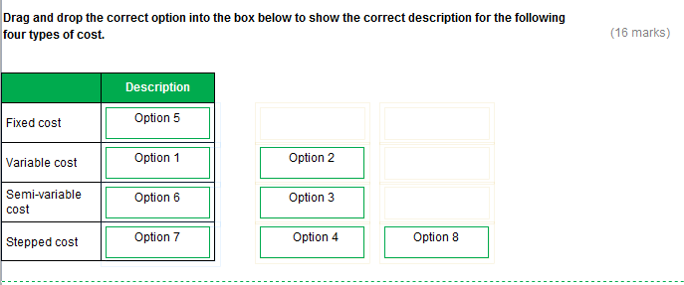

Task 9 (16 marks)

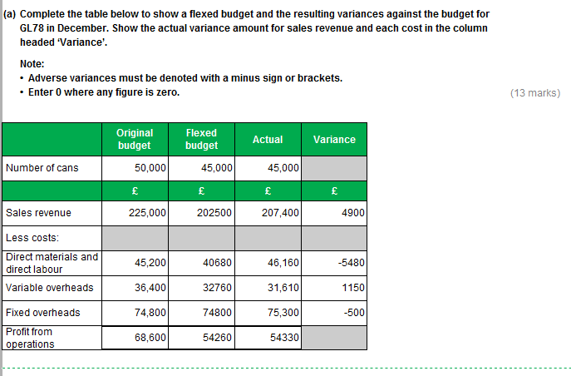
Task 9 (continued)

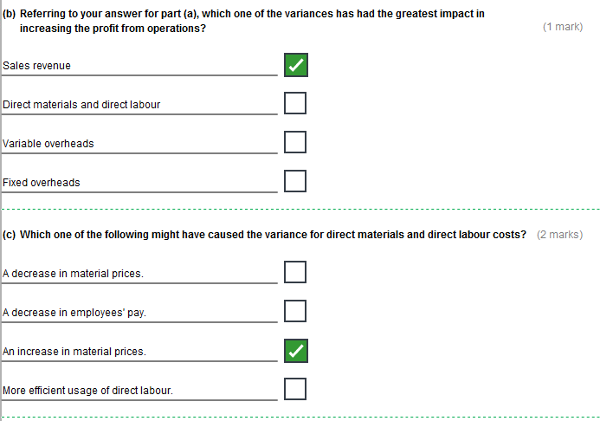
Task 10 (20 marks)

