
CBT Sample assessment model answers

Financial Accounts Preparation (FAPR)
Sample assessment 1
Task 1 (15 marks)

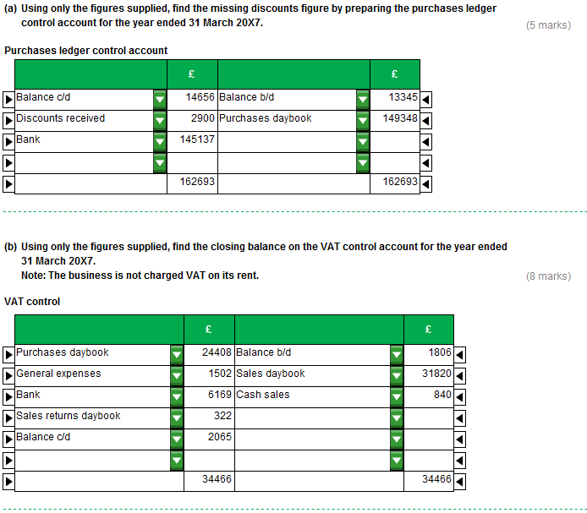
Task 1 (continued)

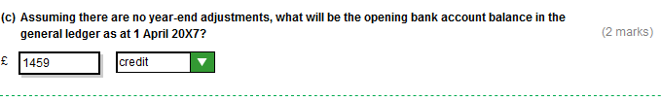
Task 2 (15 marks)

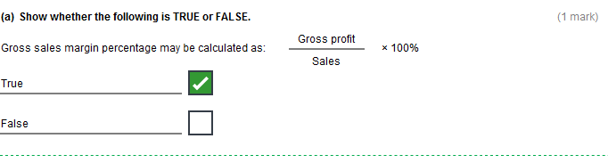

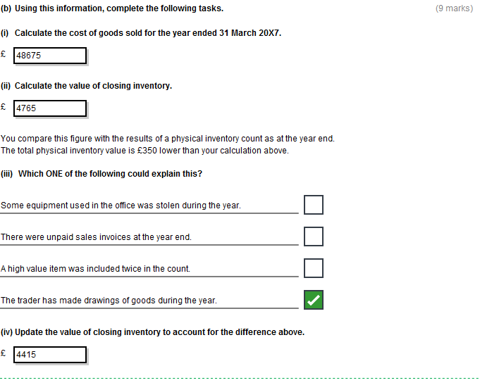
Task 2 (continued)

Task 2 (continued)
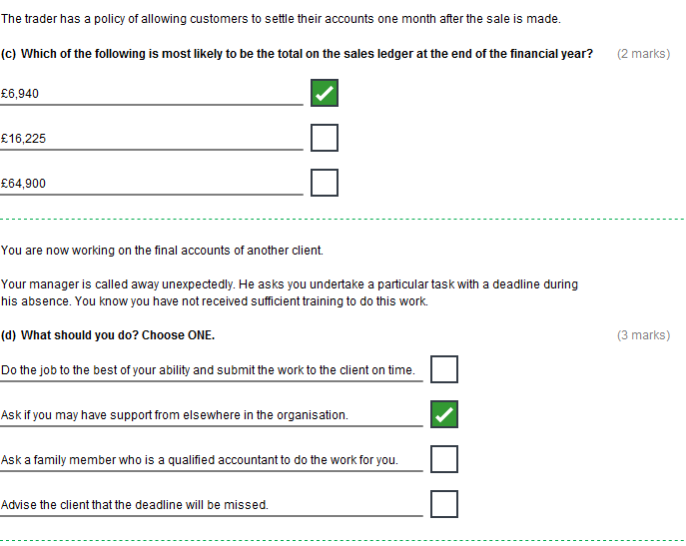
Task 3 (18 marks)

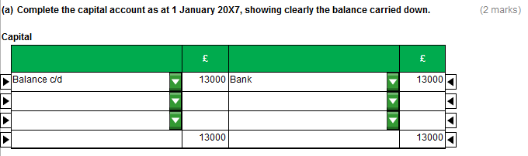

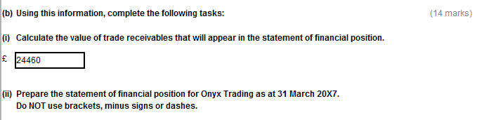
Task 3 (continued)

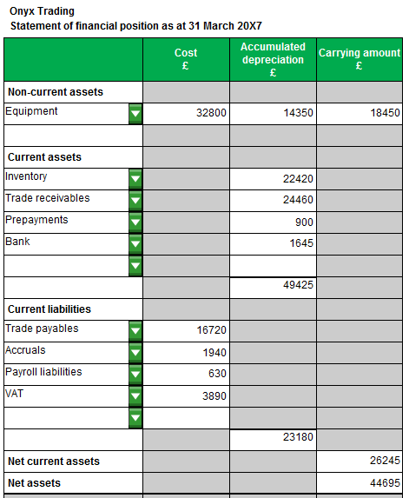
Task 3 (continued)

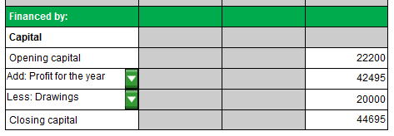

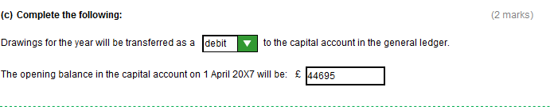

Task 4 (16 marks)

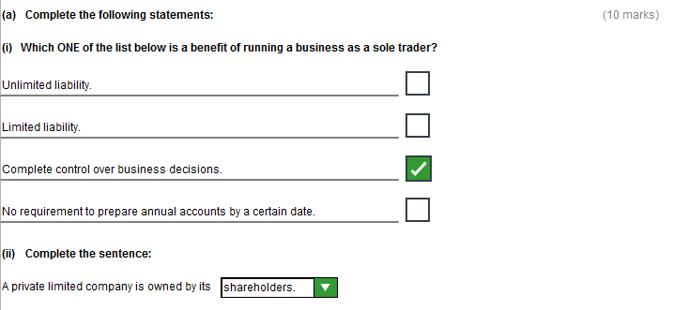
Task 4 (continued)

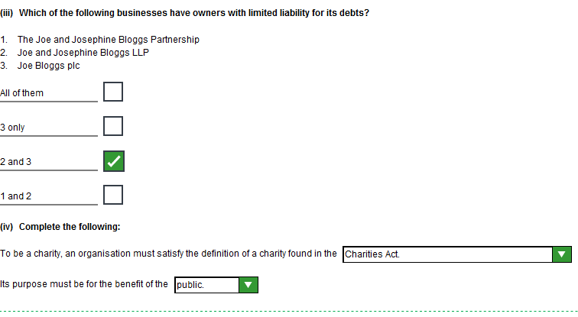

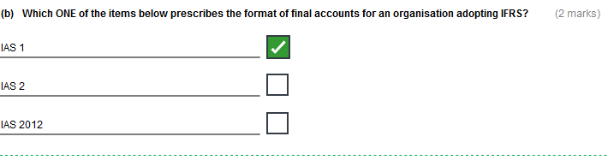
Task 4 (continued)

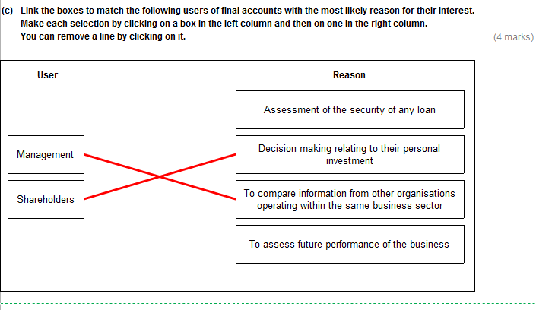
Task 5 (15 marks)

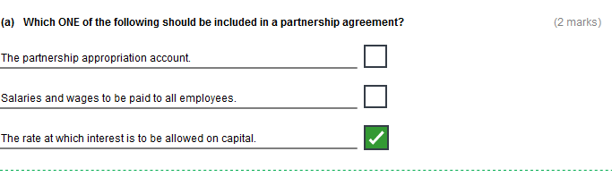

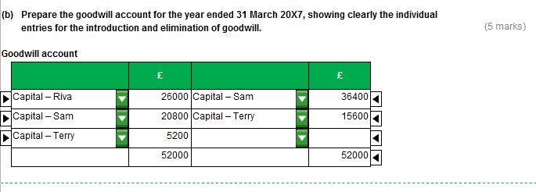
Task 5 (continued)

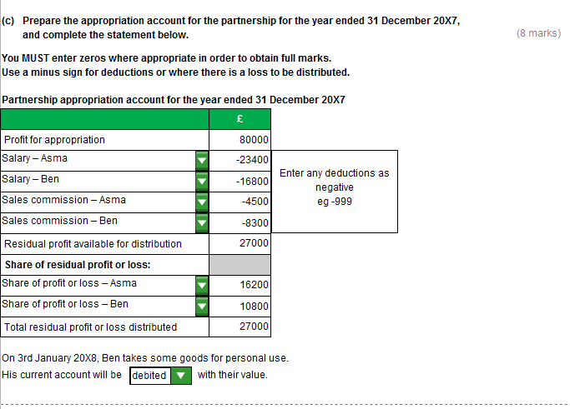

Task 6 (21 marks)
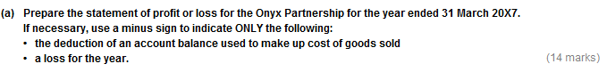
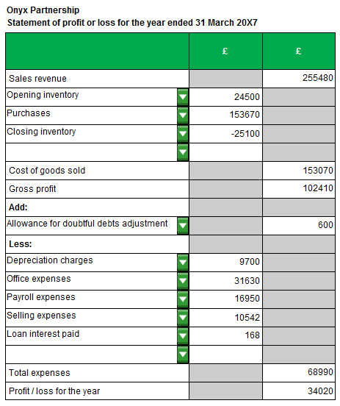
Task 6 (continued)

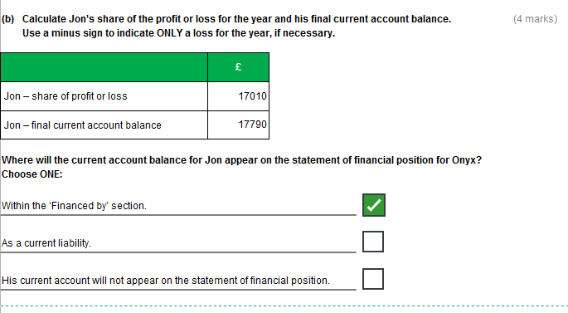
Task 6 (continued)

