
CBT Sample assessment model answers

Advanced Diploma Synoptic Assessment (AVSY)
Sample assessment 2
Task 1.1 (15 marks)

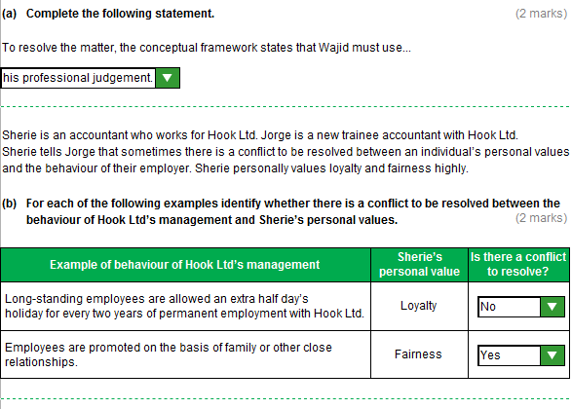
Task 1.1 (continued)

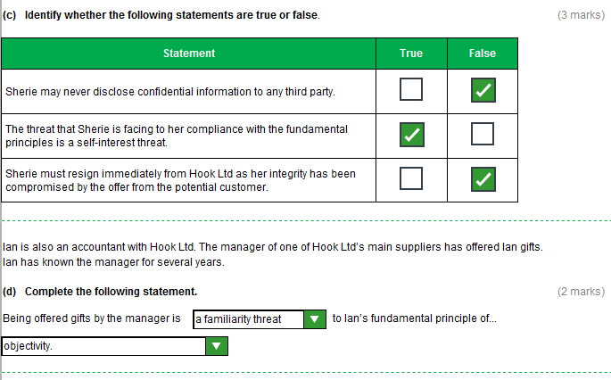

Task 1.1 (continued)

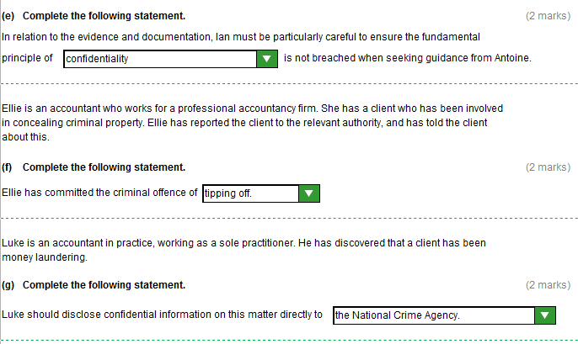
Task 1.2 (16 marks)

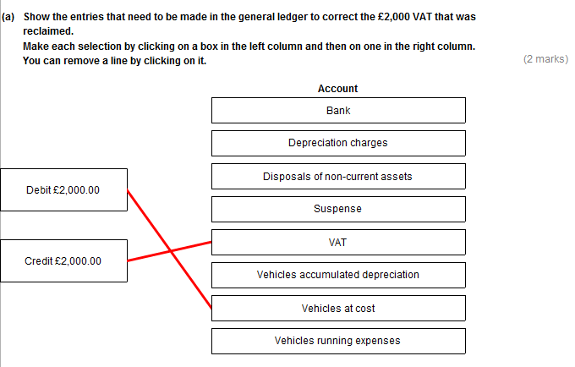
Task 1.2 (continued)

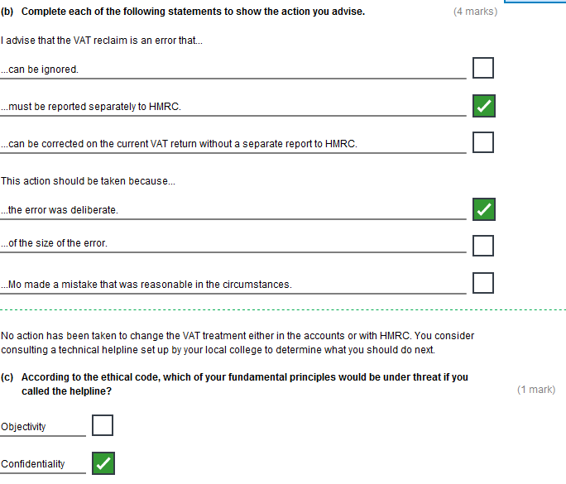
Task 1.2 (continued)

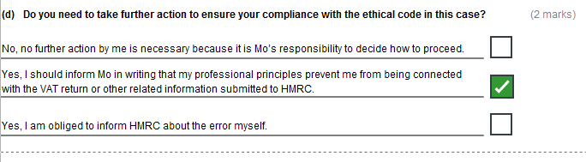

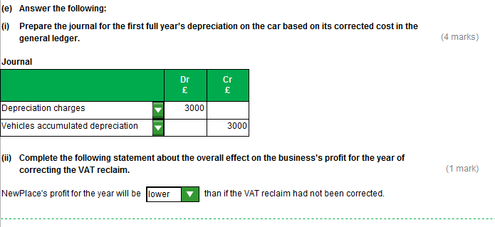

Task 1.2 (continued)

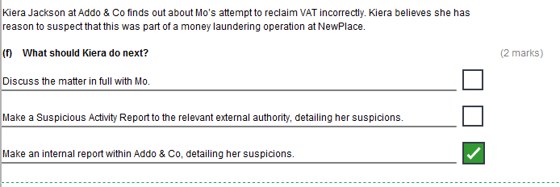
Task 1.3 (14 marks)

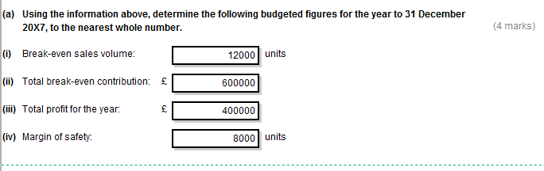

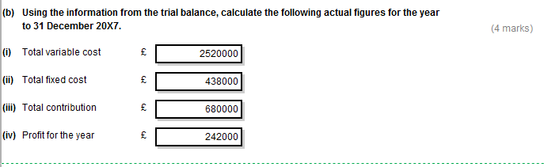
Task 1.3 (continued)

.
To: Mo Hussain <Mo.Hussain@NewPlace.co.uk>
From: Chris Makepeace <Chris.Makepeace@NewPlace.co.uk>
Date: 31/1/X8
Subject: Performance of NewPlace in 20X7
1. The budgeted profit for the year was £400,000, whereas the actual profit achieved was only £242,000 (even though the budgeted volume of 20,000 units was achieved).

2. The revised break-even volume, using the actual figures, is 12,882 units.
Working:
Actual contribution per unit = £680,000/20,000 units = £34 per unit
Actual break-even sales volume = Fixed costs/Contribution per unit: £438,000/£34 = 12,882 units

3. The actual break-even volume of 12,882 units is higher than budgeted at 12,000 units and has been affected by the following changes compared to the budget:
(i) Decreased fixed costs, which have fallen from £600,000 to £438,000, this reduces the break-even volume required.
(ii) Much lower contribution per unit than budgeted, which increases the break-even volume required. Budgeted contribution per unit was £170 - £120 (or £600,000/12,000) or (£600,000 + £400,000)/20,000) = £50 per unit, compared to actual contribution of only £34 per unit.
The reduced contribution per unit compared to the budget has been caused by a reduced average selling price per unit (budget £170, actual £3,200,000/20,000 = £160), plus an increased unit cost (budget £120, actual £2,520,000/20,000 = £126).

Task 1.4 (15 marks)

(a)

Threat 1
Janey’s offer of expensive hospitality is a self-interest threat to my ethical principle of objectivity/integrity/professional behaviour. A self-interest threat occurs when a financial or other interest will inappropriately influence an accountant’s judgement or behaviour. Janey called me several times to press for early payment, then she called me offering expensive hospitality. Clearly she was trying to influence my judgement with the offer.

Threat 2
Janey’s second call is an intimidation threat to my objectivity. An intimidation threat occurs when an accountant may be deterred from acting objectively by threats, whether actual or perceived. The original offer from her was not recorded so she could conceivably claim that I demanded the tickets. Saying that she would lie in this way to my employer was clearly an actual threat to intimidate me into making the payment.

Actions I should take
I should use the Conceptual Framework to apply relevant safeguards to bring the threat to my principles down to an acceptable level OR I should use the ethical conflict resolution process stated in the code.
I should follow any internal procedure for reporting/dealing with such threats.
I should disclose what has happened to a colleague OR my line manager OR Mo OR AAT and seek advice as to what to do next.
I should reject the offer of tickets.
I should continue to arrange payments to DJ as normal.

Task 1.4

(b)

To: Mo Hussain Mo.Hussain@NewPlace.co.uk
From: Chris Makepeace Chris.Makepeace@NewPlace.co.uk
Date: 28/2/X8
Subject: Accounting principles and financial information

Hello Mo,
Thank you for your email of 28/2/X8.
(1) Two key assumptions:
Accrual/matching basis of accounting: we include transactions in the accounting period when they arise, not when they are paid in the form of cash. For instance the 20X7 financial statements will include some items of inventory even though we have not yet paid the invoices from their suppliers.
Going concern assumption: we assume that the business will continue in operation for the foreseeable future, without the need to sell assets and pay liabilities at short notice. If we did not assume this, the amounts we show for non-current assets, for example, would be different (market or ‘fire sale’ value rather than how much they cost when they were bought less depreciation).
(2) EITHER
Relevance: financial information is relevant to the user if it is can make a difference to decisions made by the user. The information might be able to help them make decisions by predicting future outcomes (it has predictive value) or by confirming or changing their previous evaluations (it has confirmatory value).
OR
Faithful (re)presentation: the financial information is complete (it includes all necessary descriptions and explanations), neutral (without bias in how it is selected or presented) and free from error (no errors or omissions).
(3) The statement of financial position (SFP) lists out your business’s assets less its liabilities (including loans), so you can see how much the business is worth (its net asset value). It then shows how the net assets are funded – which is by your capital: the amounts you have introduced into the business plus the profits you have made and kept in the business.
(4) The SFP links with the statement of profit or loss (SOPOL) via the profit figure. In the SOPOL the business’s costs are deducted from its revenue to arrive at the profit for the period. In the SFP this figure is added to the capital you had in the business at the start of the period. Any amounts you have withdrawn in the period for your own use are deducted from this figure to arrive at your total capital.
OR
The SFP links with the statement of profit or loss (SOPOL) via the closing inventory figure. In the SOPOL the cost of closing inventory is deducted from the business’s costs for 20X7. This is because its cost needs to be deducted from the revenue in 20X8, when the inventory is actually sold. Instead the inventory is shown as an asset in the SFP for 20X7, to be carried forward and matched with revenue in 20X8.
Kind regards,
Chris
Task 2.1 (10 marks)

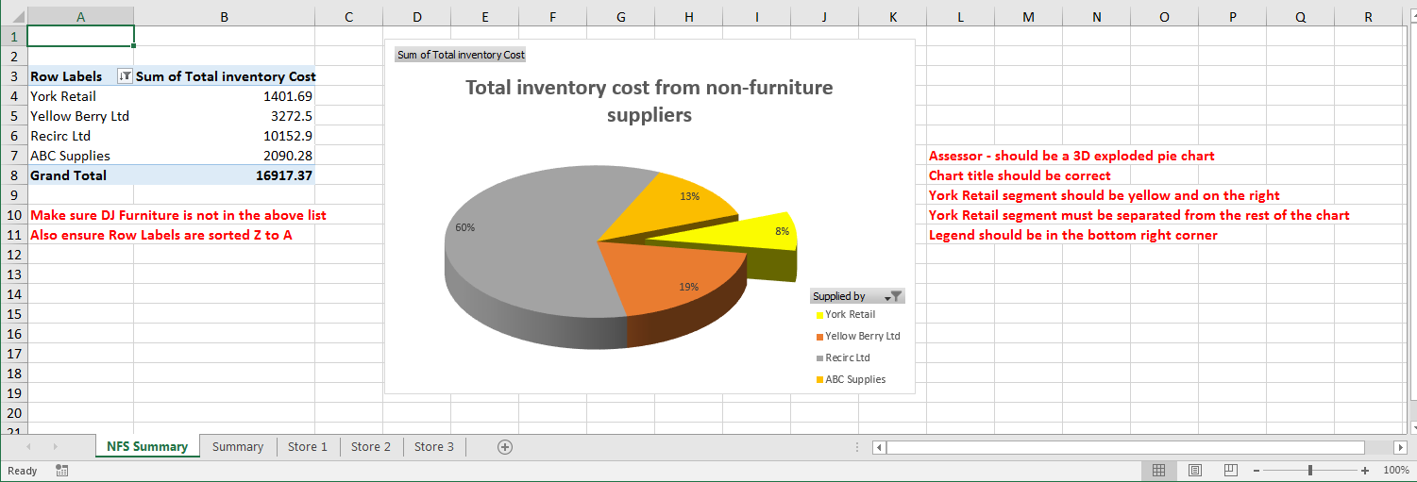
Task 2.1 (continued)

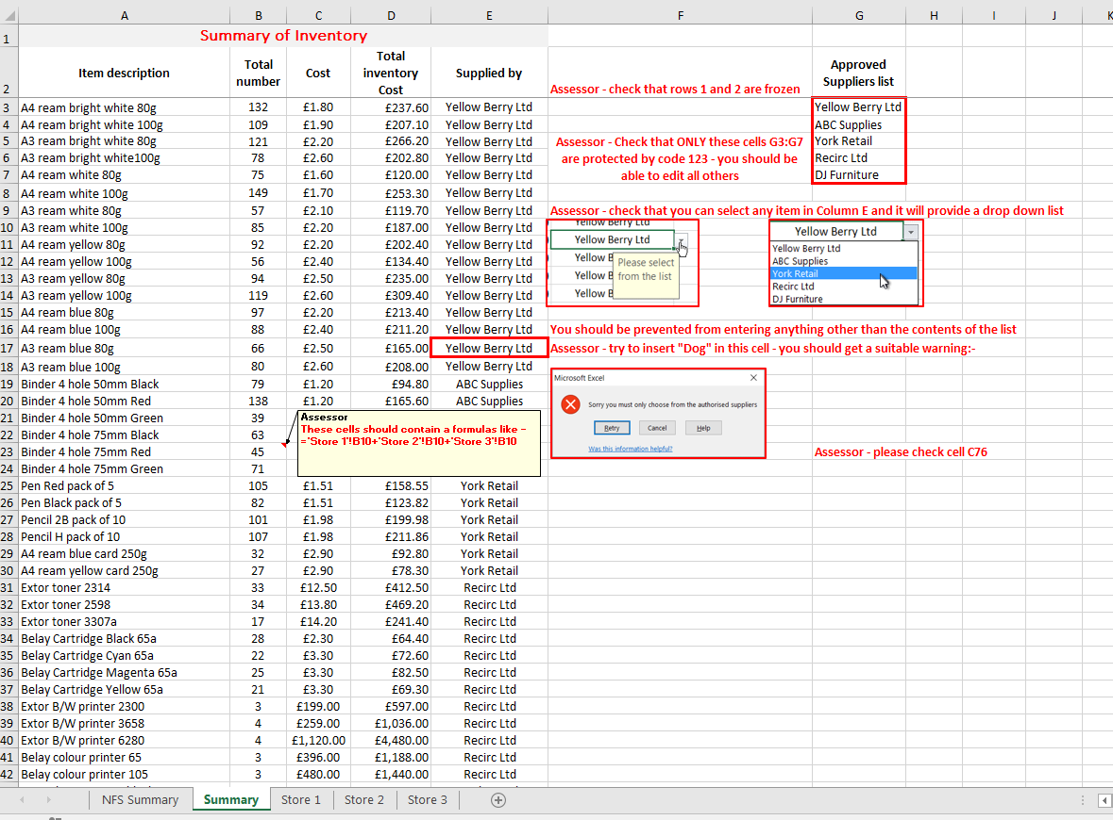
Task 2.1 (continued)

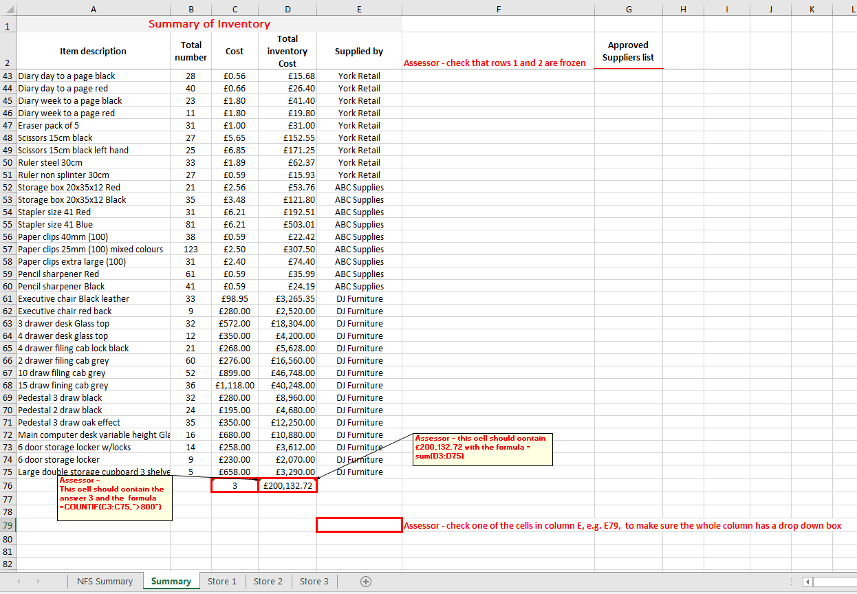
Task 2.2 (16 marks)

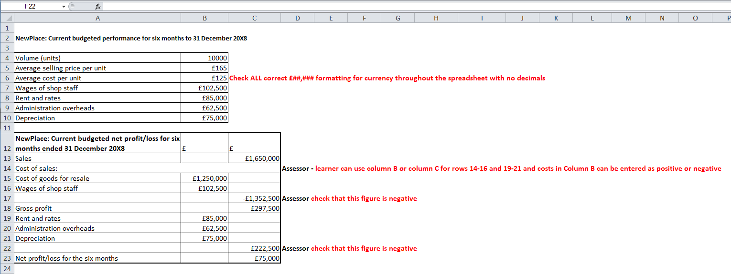

Task 2.2 (continued)

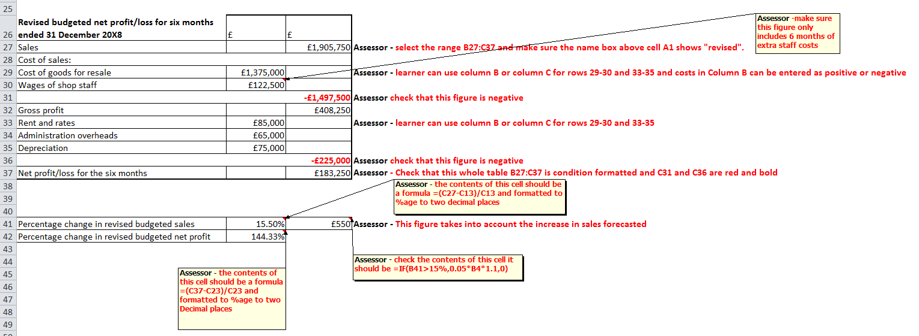
Task 2.2 (continued)

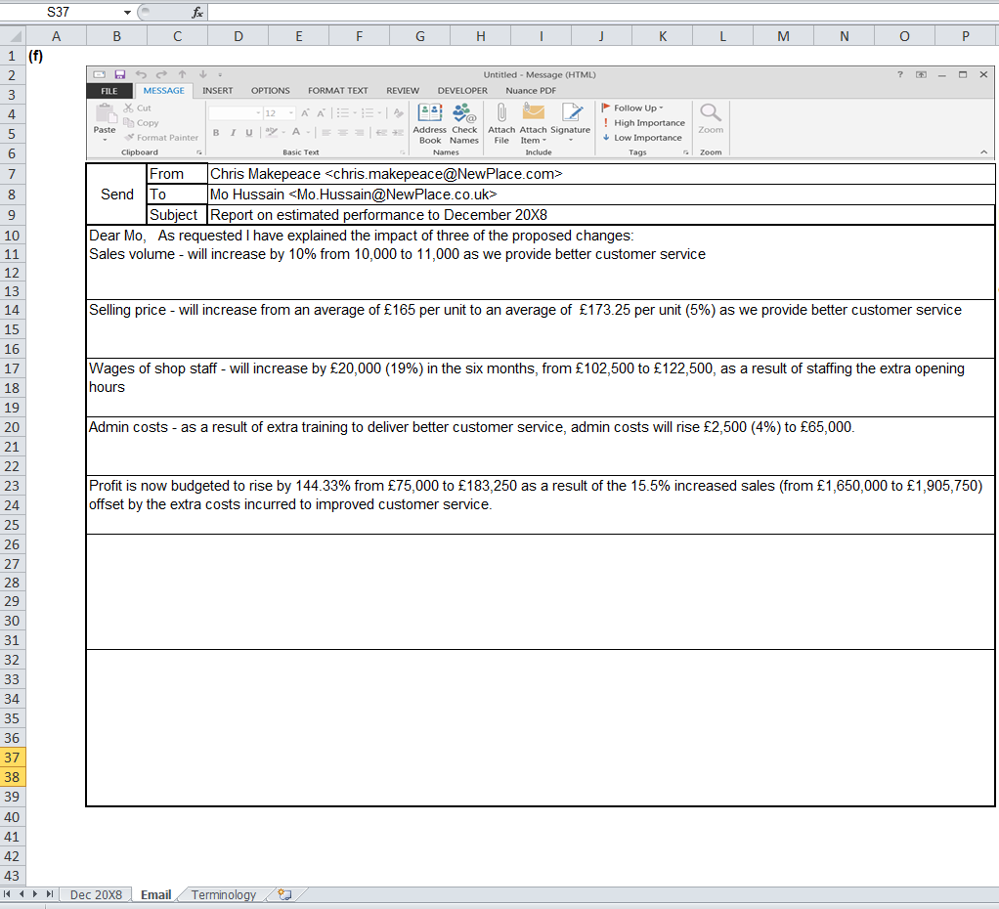
Task 2.2 (continued)

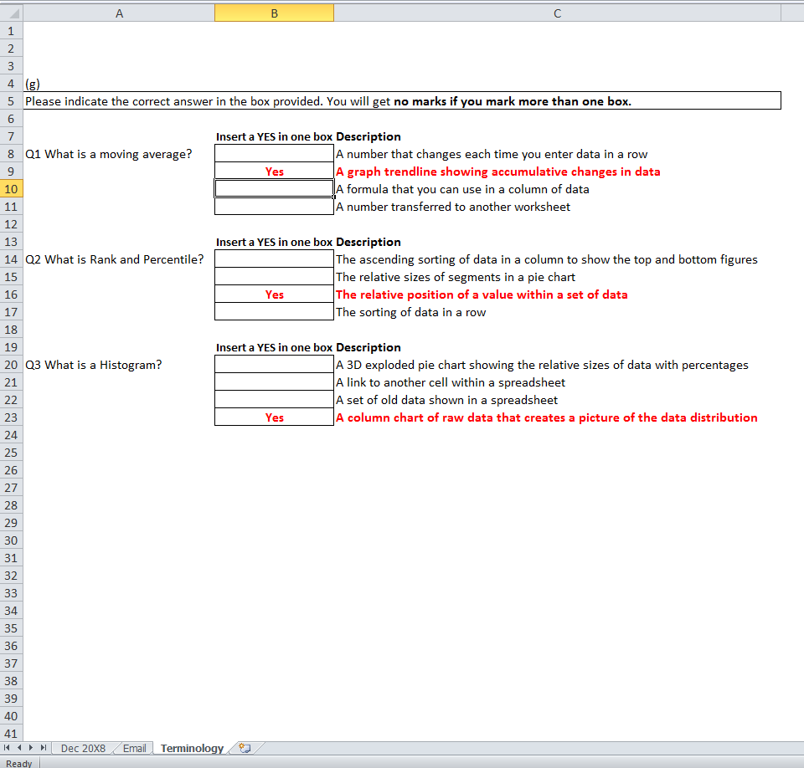
Task 2.3 (14 marks)

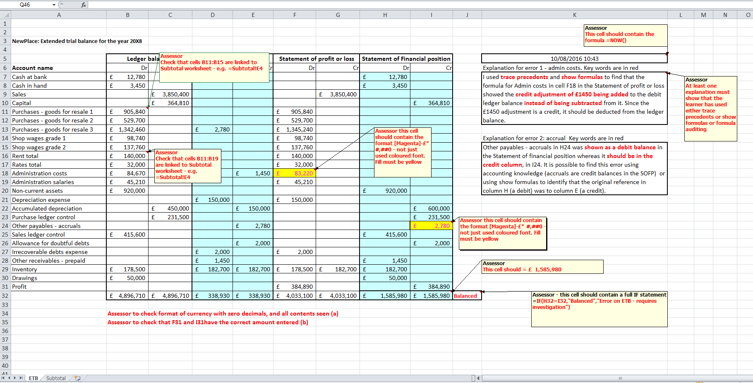

Task 2.3 (continued)

