
CBT Sample assessment model answers

Advanced Diploma Synoptic Assessment (AVSY)
Sample assessment 1
Task 1.1 (15 marks)

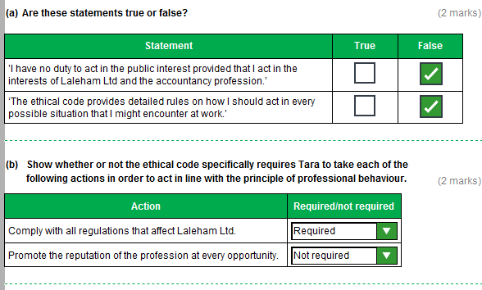

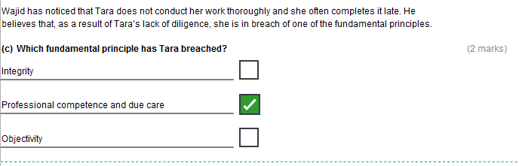
Task 1.1 (continued)

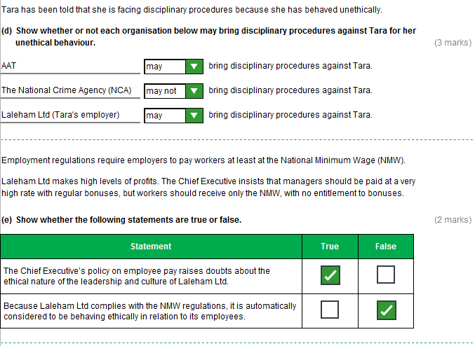
Task 1.1 (continued)

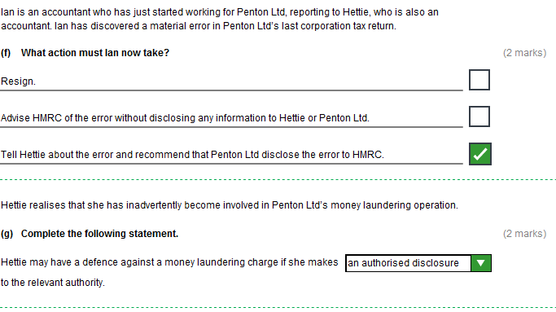
Task 1.2 (16 marks)

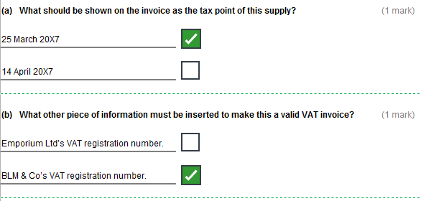

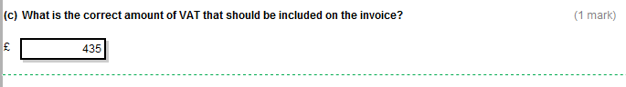
Task 1.2 (continued)

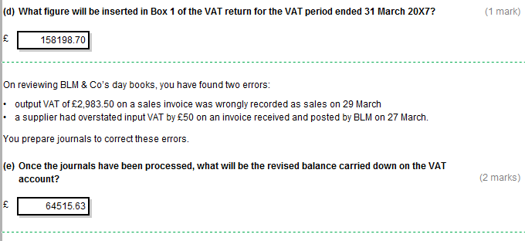
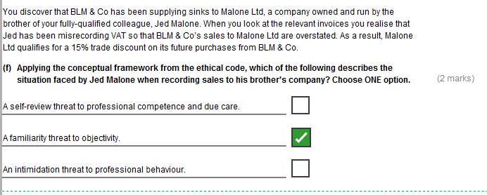
Task 1.2 (continued)

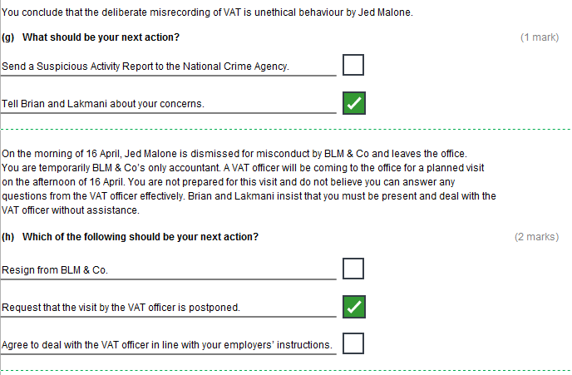
Task 1.2 (continued)

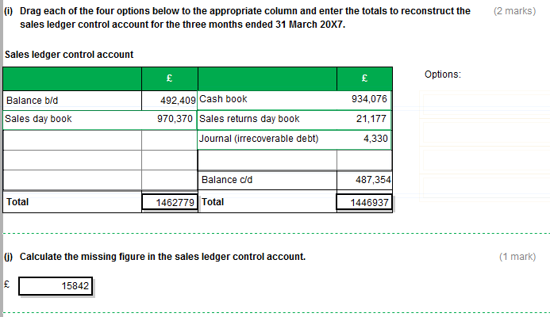

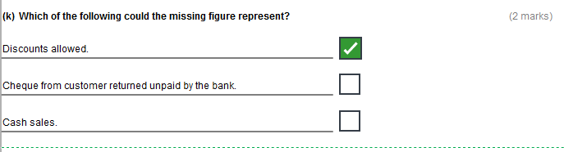
Task 1.3 (14 marks)

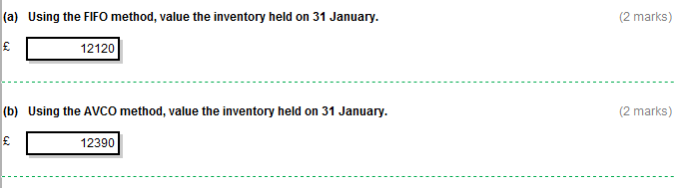

(c)

- When inventory is valued at marginal cost, only the variable costs of producing each item are included in the valuation. This includes the prime cost and the variable production overheads.
For the Jade sink, the marginal cost per unit is £111 ((1980+240)/20) so the 3 sinks held in inventory would be valued together at £333.
When inventory is valued at full absorption cost, a share of fixed production overheads incurred by the business is included in the valuation, so the valuation is higher under absorption costing.
For the Jade sink, the absorption cost per unit is £125 ((1980+240+280)/20) so the 3 sinks held in inventory would be valued together at £375.
Note that, irrespective of method, the non-production overheads are not included in the inventory valuation.
- In the year ended 31 December 20X7, if the partners had valued the Jade sinks at marginal cost rather than full absorption cost, reported profit would have been lower by £42 (375-333), because the share of fixed production overheads was expensed in 20X7, the year of production, rather than being absorbed into inventory, carried forward and expensed in the year of sale.
Task 1.3 (continued)

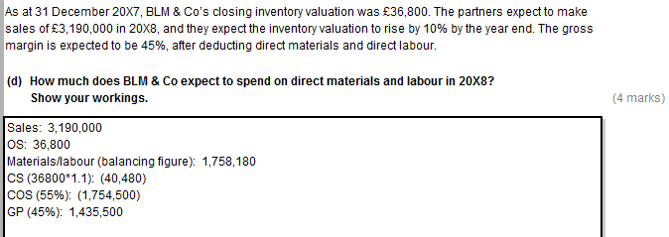
Task 1.4 (15 marks)

(a)

I do not have the experience, expertise (knowledge and skills), or time to complete the tasks properly.
It would be a breach of the principles of professional competence and due care, and integrity, to attempt to do so immediately.
I am facing familiarity, intimidation and self-interest threats because the partners of BLM & Co are trying to appeal to my loyalty to colleagues and fear of losing my job.
I need to apply relevant safeguards to bring the threat to my principles down to an acceptable level.

(b)

I would tell Brian and Lakmani that I can only complete the tasks they have requested if I have additional training/qualified support/supervision to do so (which will take time).

OR

I would tell Brian and Lakmani that I cannot undertake the task competently so it should be given to someone else/Jed Malone (if he has sufficient expertise)/Addo & Co staff.

Task 1.4 (continued)

(c)

To: Lakmani Moore Lakmani.Moore@BLMCo.co.uk
Subject: BLM & Co: change in structure
Hello Lakmani
Thank you for your email of 28/2/X8.
(1) A limited company is a business structure which is a separate legal entity distinct from its owners (known as shareholders). It needs to be registered at Companies House. A company’s accounts and finances are separate from the personal finances of its owners.
(2) A company is owned by shareholders, who have equity shares in the company. Persons acting as directors are responsible for running the company. A company must have at least one shareholder and at least one director. You and Brian can remain as the only owners if you own all the shares in the company between you; your ownership will be diluted if you include more shareholders. You can continue to run the company, acting as its only directors, or you may appoint additional directors.
Directors may be paid a salary by the company from its pre-tax profits. Shareholders may receive dividends paid from its after-tax profits. Any after-tax profits that are not paid out as dividends are reinvested in the company on the shareholders behalf.
(3) The key advantage of operating as a limited company is that of limited liability for the owners. While you as partners in BLM & Co currently have unlimited liability for all the debts of the business, shareholders’ liability for any unpaid debts of the company is limited and they only stand to lose their investment in shares. The company as a separate legal entity remains fully liable for its debts.
The key disadvantage of operating as a limited company is that companies are heavily regulated. There are a number of accounting regulations involved with running a limited company, and the statutory requirements of the Companies Act 2006 apply, as do accounting standards. This means that there is a much greater administrative burden than for a partnership. A company must file accounts each year before a certain date and it must file documents when it is set up. All this extra administration bears a cost.
I hope this is useful to you. Please contact me if you have any questions.
Kind regards
Sam
Task 2.1 (10 marks)

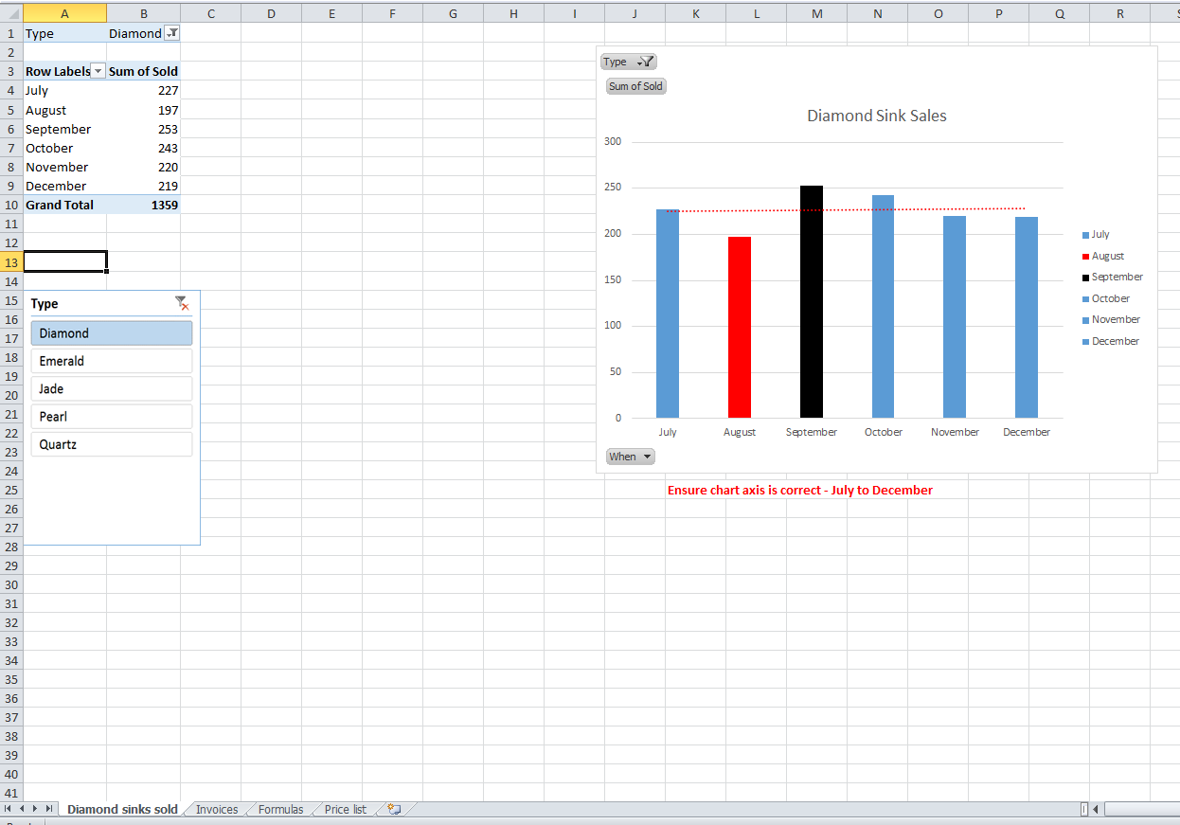
Task 2.1 (continued)

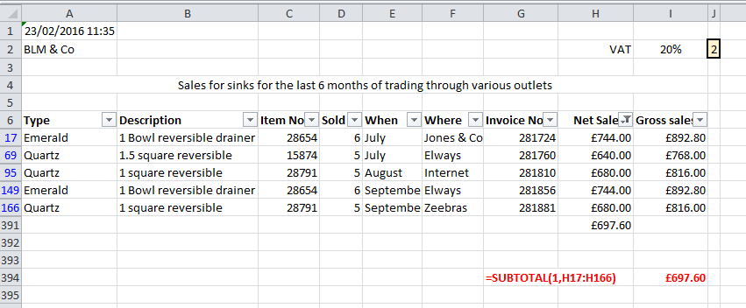

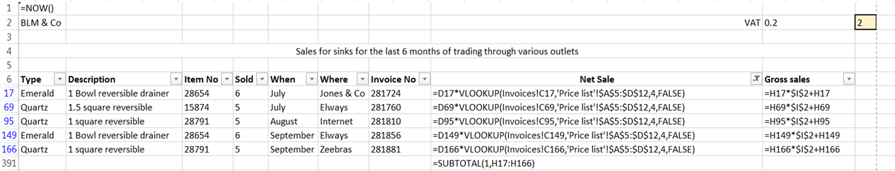

Task 2.1 (continued)

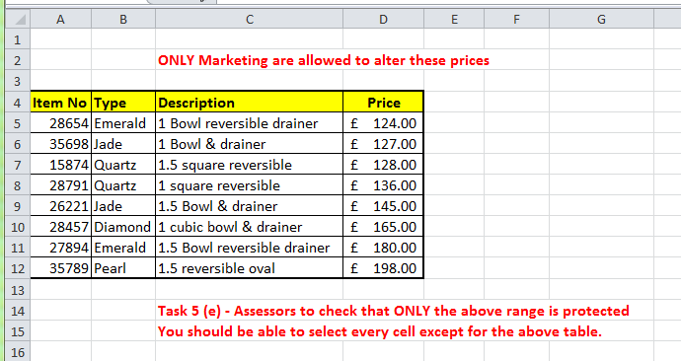
Task 2.2 (16 marks)

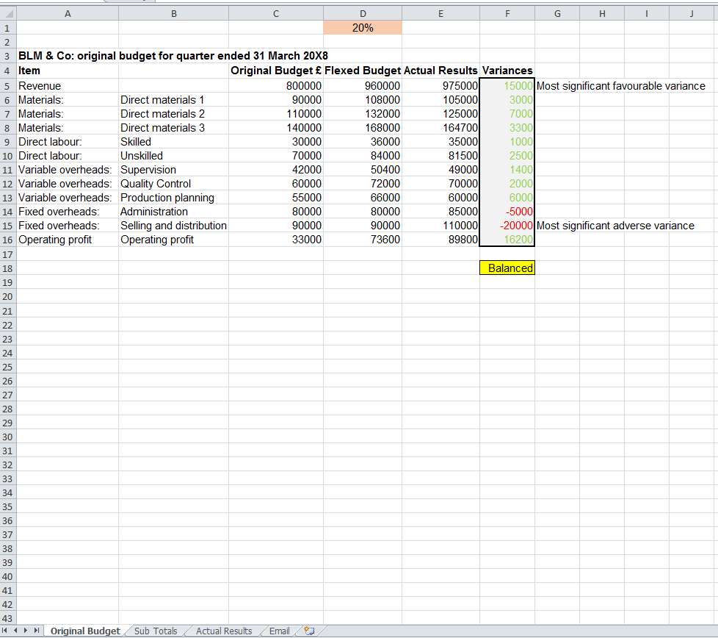
Task 2.2 (continued)

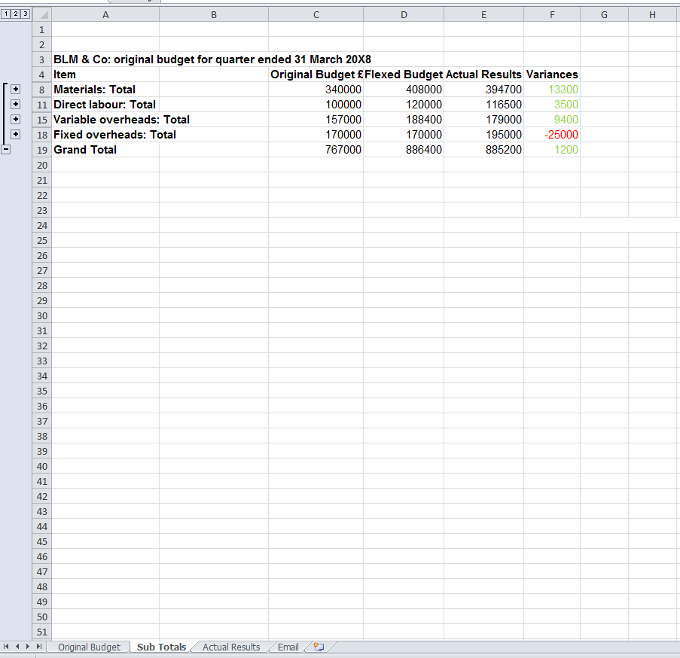
Task 2.2 (continued)

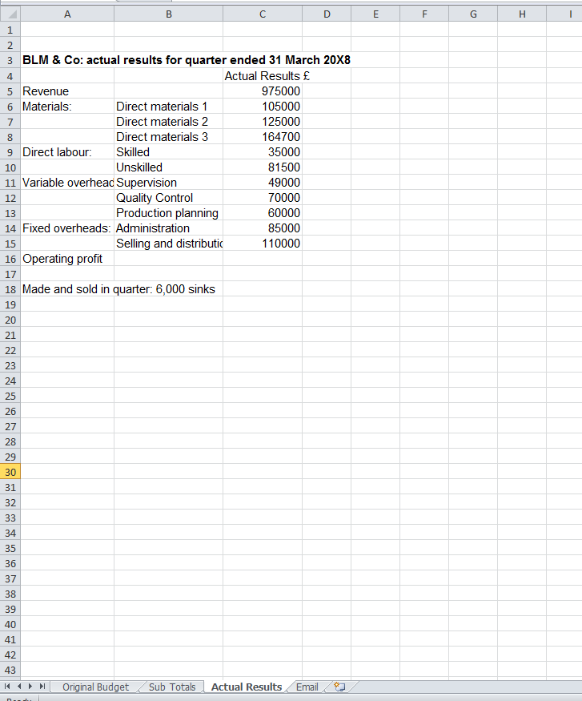
Task 2.2 (continued)

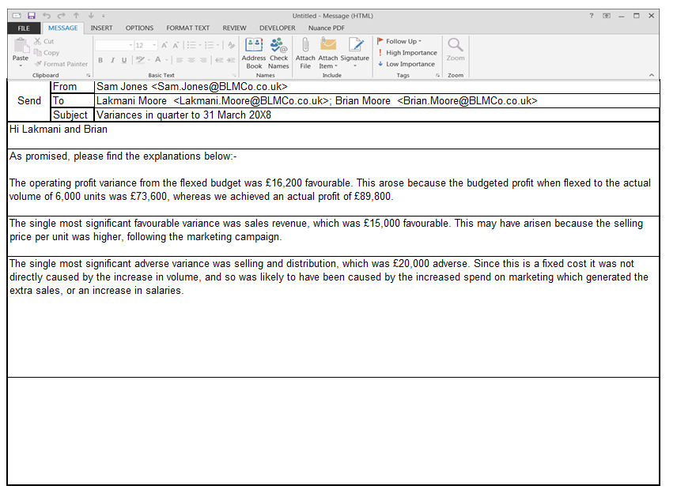
Task 2.3 (14 marks)

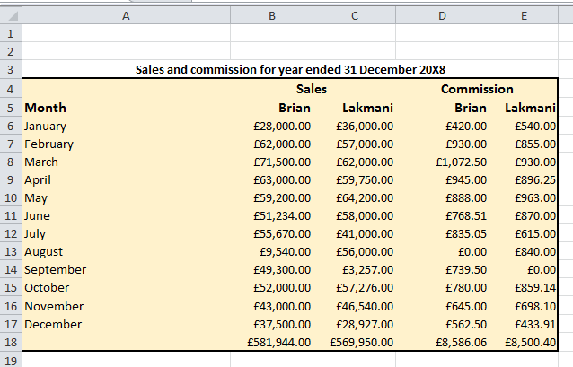

Task 2.3 (continued)

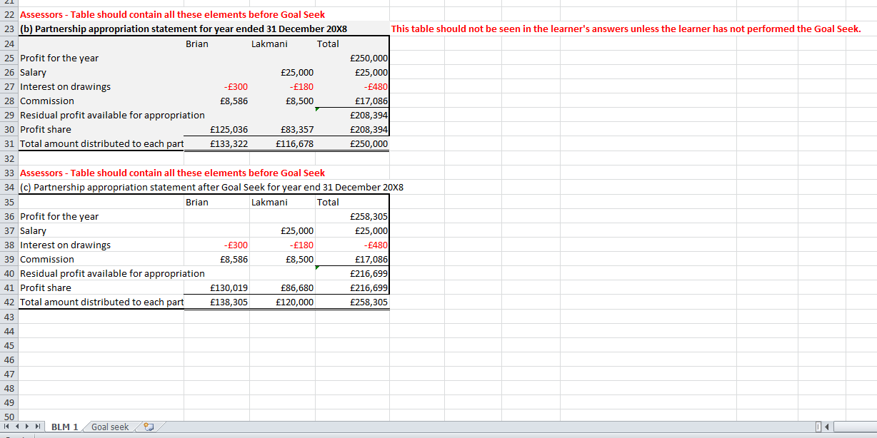

Task 2.3 (continued)

