
CBT Sample assessment model answers

Bookkeeping transactions (BTRN)
Sample assessment 1

Task 1 (12 marks)

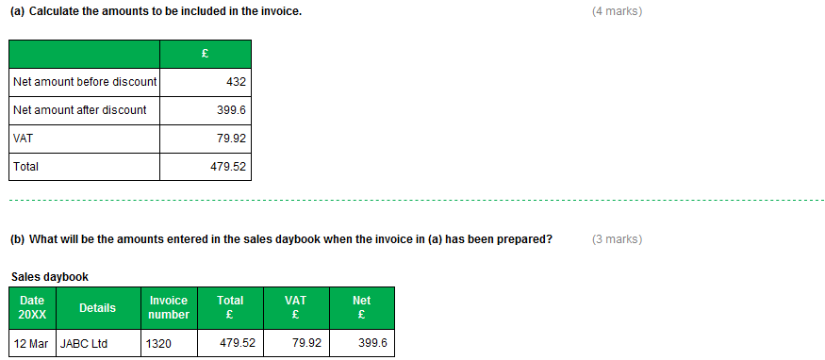

Task 1, continued

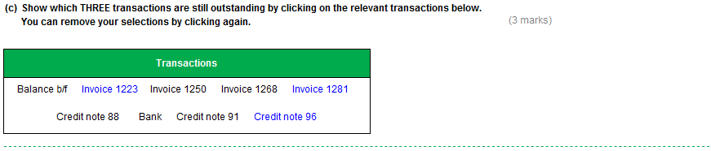

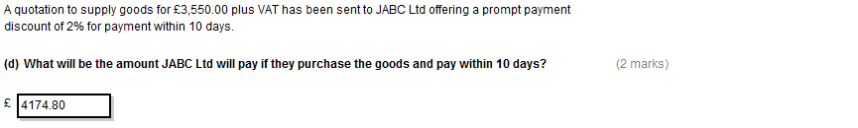
Task 2 (9 marks)

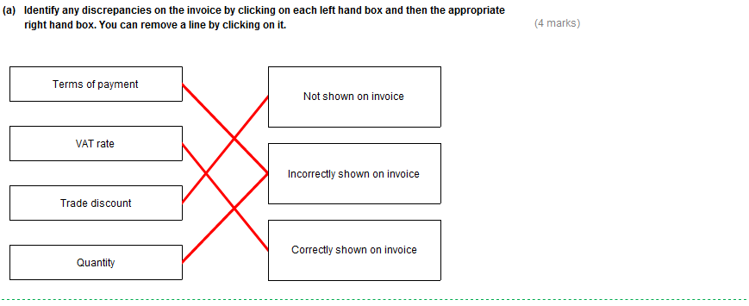

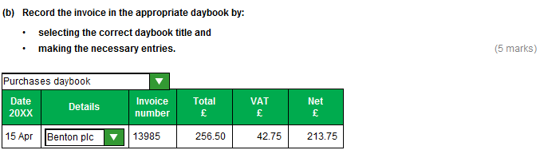

Task 3 (9 marks)

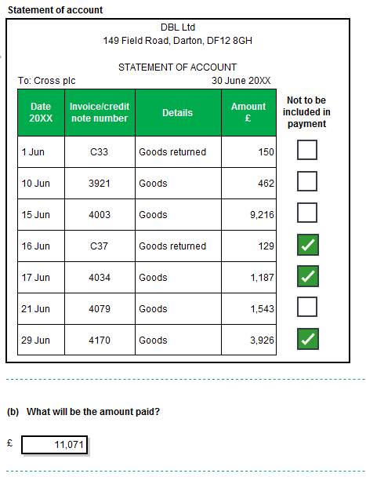

Task 3, continued

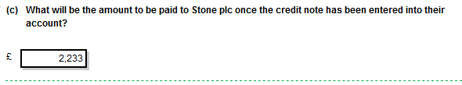

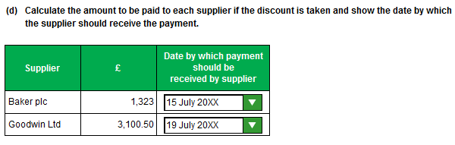
Task 4 (15 marks)

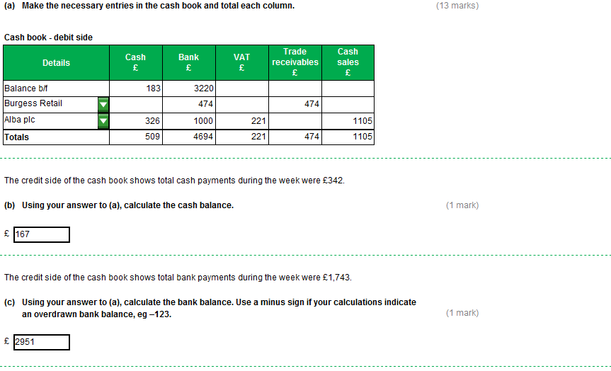

Task 5 (15 marks)

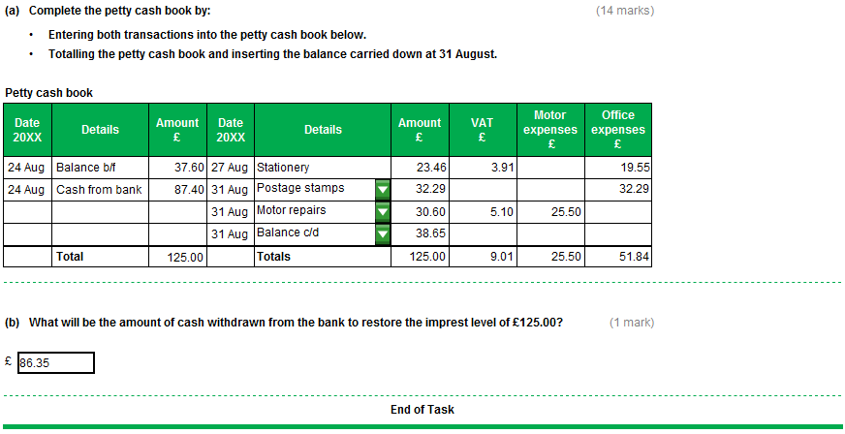
Task 6 (12 marks)

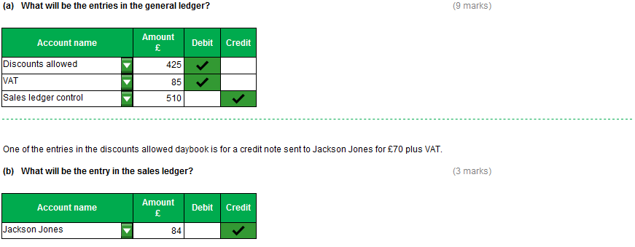
Task 7 (12 marks)

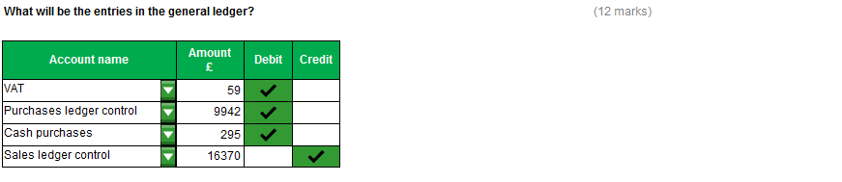

Task 8 (12 marks)

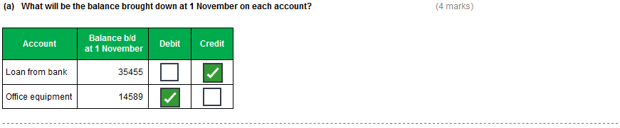
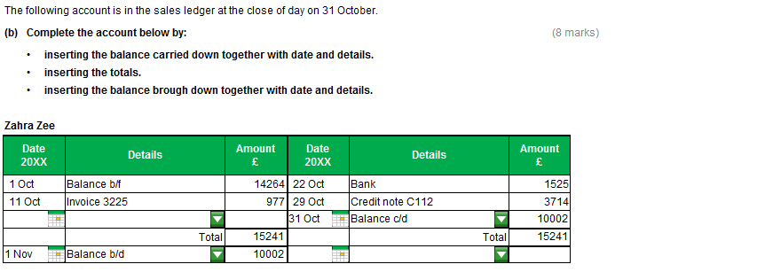

Task 9 (12 marks)

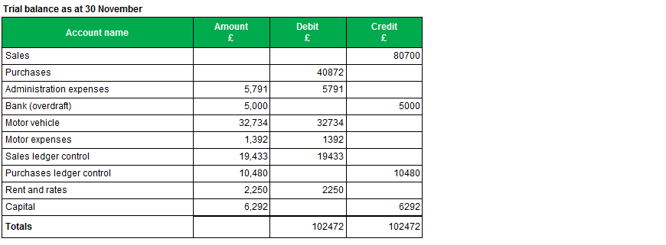

Task 10 (12 marks)

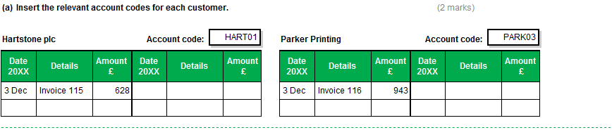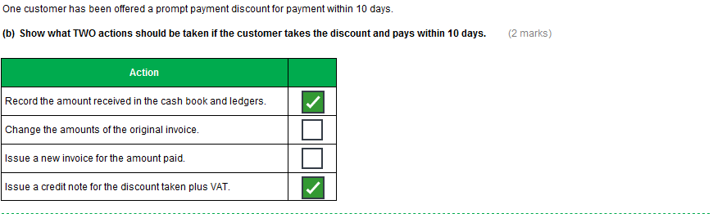
Task 10, continued

