

CBT Sample assessment model answers

**Personal Tax (PLTX) FA2016**

Sample assessment 2

**Task 1** (10 marks)

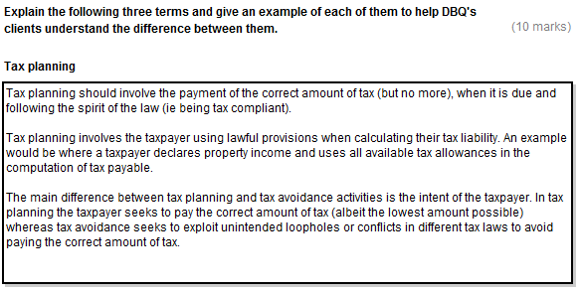

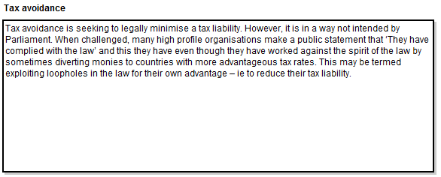

**Task 1, continued**

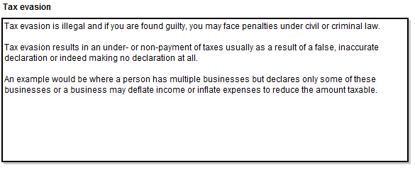

**Task 2** (8 marks)

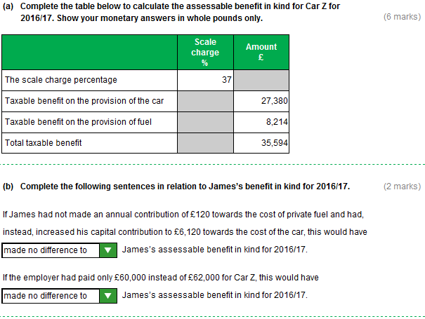

**Task 3** (8 marks)

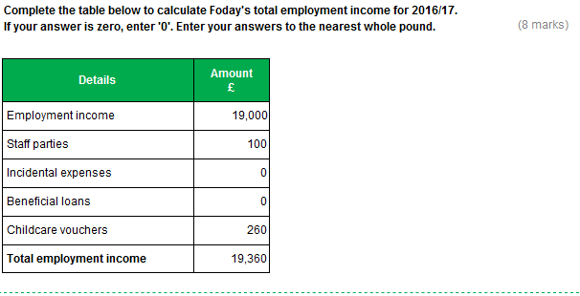

**Task 4** (6 marks)

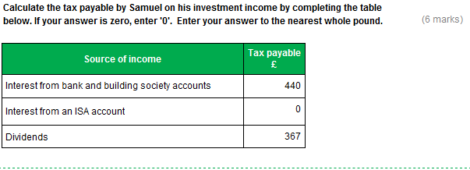

**Rounding – Text box 3**

This model answer shows the figure rounded down. However, figures rounded up are equally valid for the purposes of this assessment.

**Task 5** (6 marks)

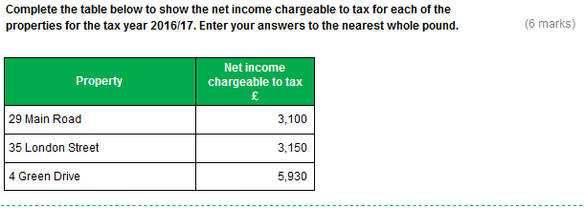

**Task 6** (12 marks)

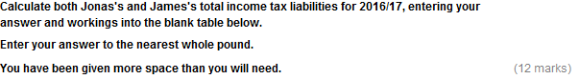

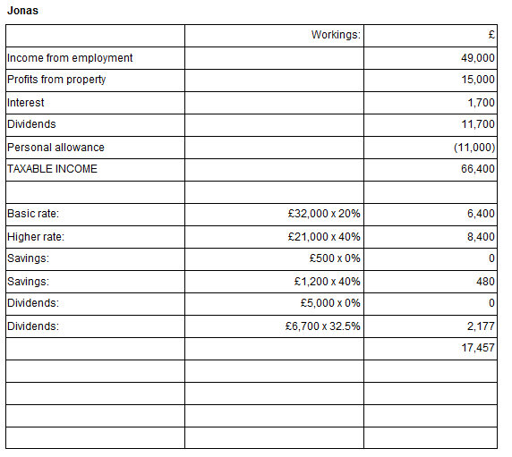

**Rounding**

This model answer shows the figures rounded down, where applicable. However, figures rounded up are equally valid for the purposes of this assessment.

**Task 6, continued**

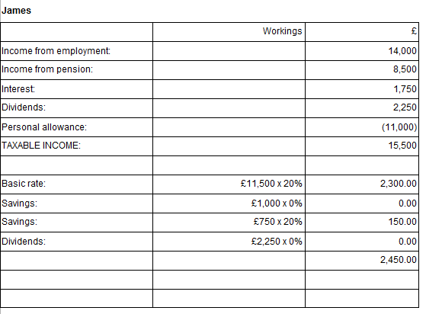

**Task 7** (4 marks)

**Rounding – Text box 1**

This model answer shows the figure rounded down. However, a figure rounded up is equally valid for the purposes of this assessment.

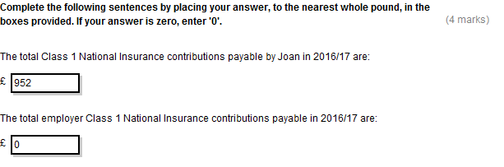

**Task 8** (7 marks)

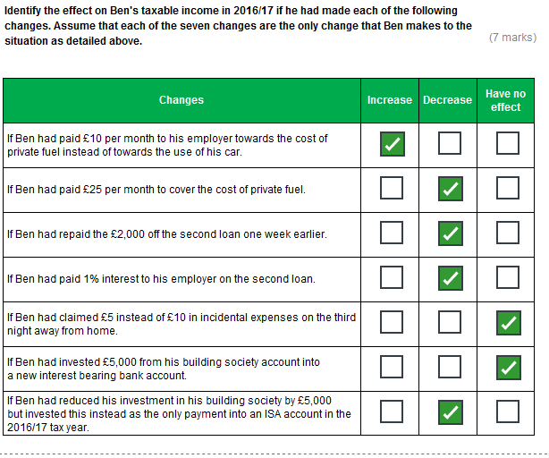

**Task 9** (10 marks)

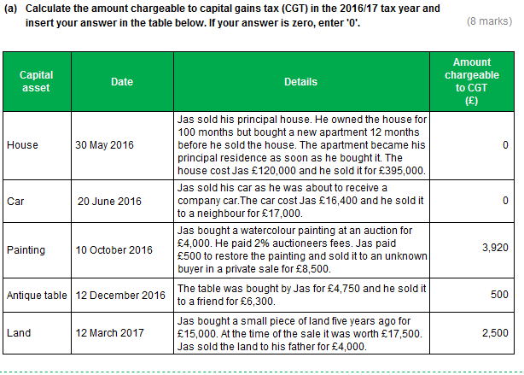

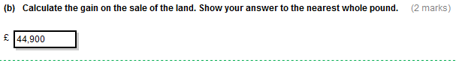**Task 10** (10 marks)

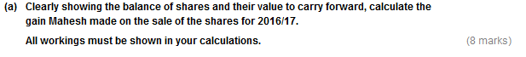

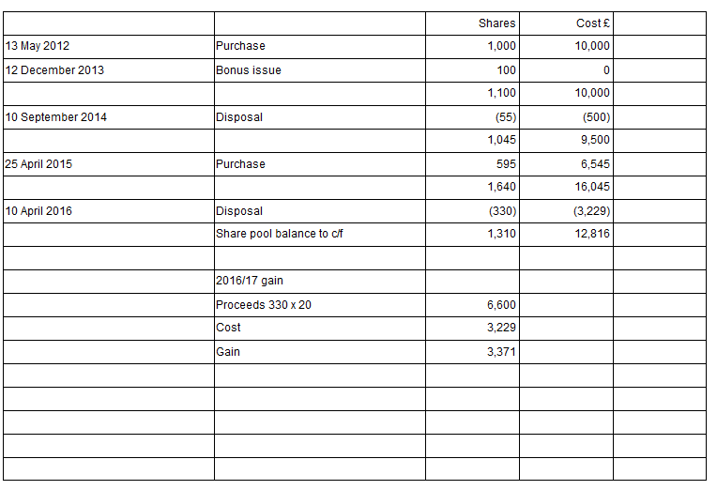

**Task 10, continued**

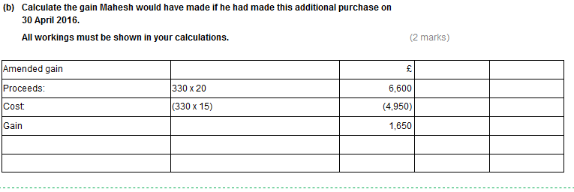

**Task 11** (7 marks)

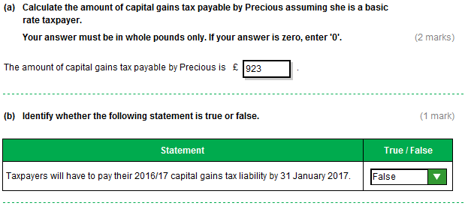

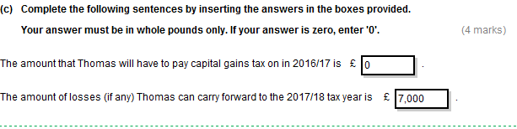

**Task 12** (6 marks)

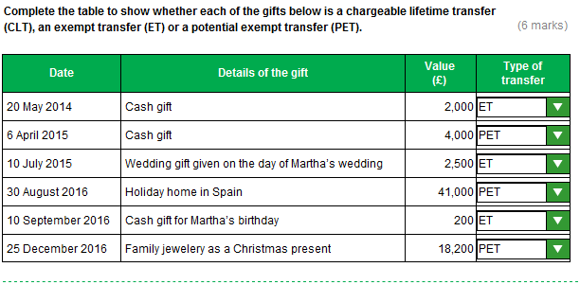

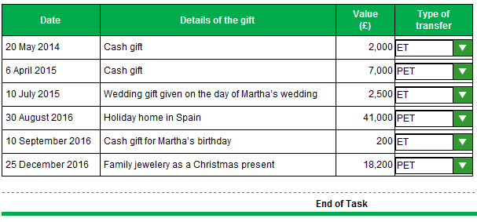

**Task 13** (6 marks)

