

CBT Sample assessment model answers

**Personal Tax (PLTX) FA2016**

Sample assessment 1

**Task 1** (10 marks)

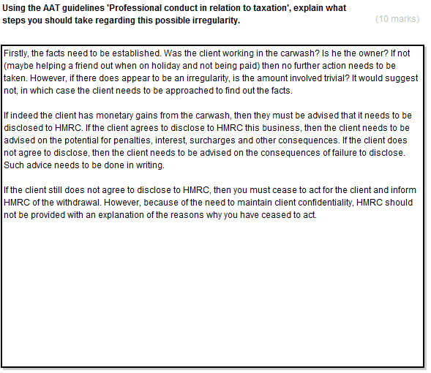

**Task 2** (8 marks)

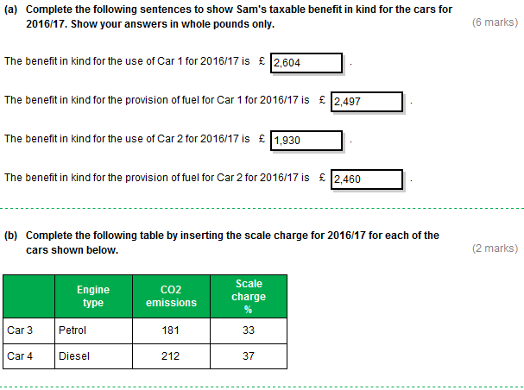

**Rounding – (a) text boxes**

These model answers show the figures rounded down. However, figures rounded up are equally valid for the purposes of this assessment.

**Task 3** (8 marks)

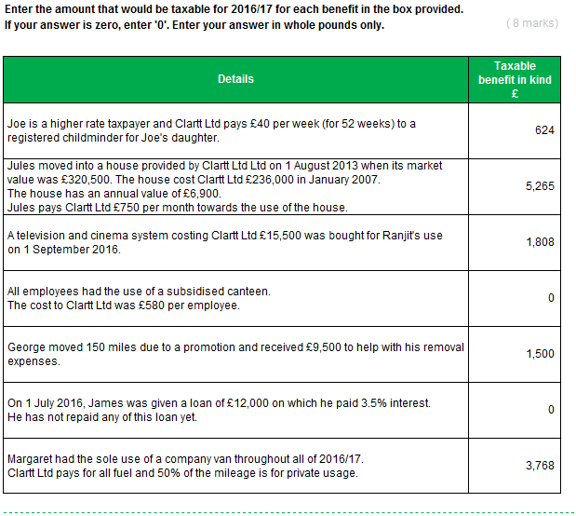

**Rounding – Text box 3**

This model answer shows the figure rounded down. However, figures rounded up are equally valid for the purposes of this assessment.

**Task 4** (6 marks)

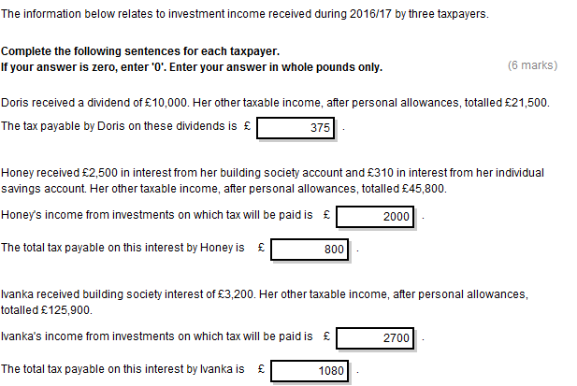

**Task 5** (6 marks)

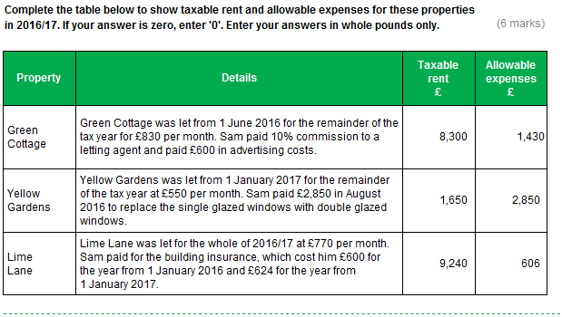

**Task 6** (12 marks)

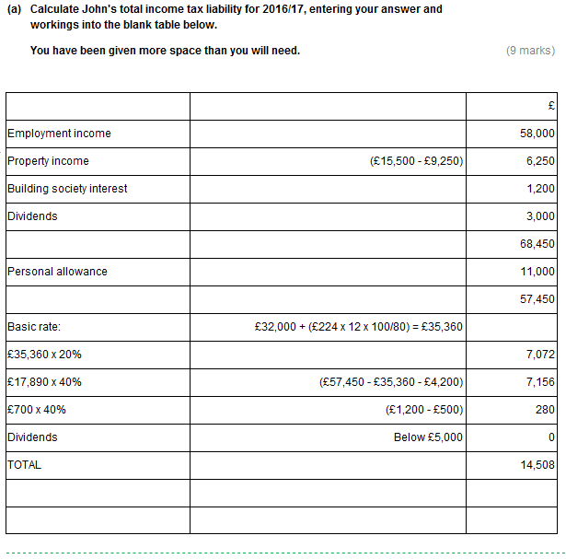

**Task 6, continued**

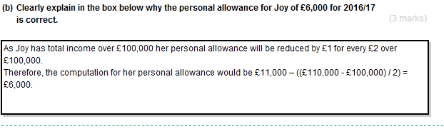

**Task 7** (4 marks)

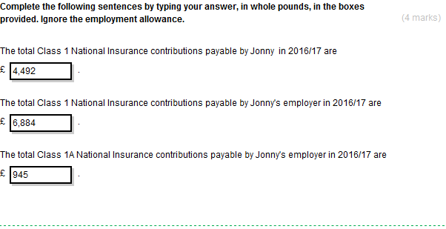

**Rounding – Text boxes**

These model answers show the figures rounded down. However, figures rounded up are equally valid for the purposes of this assessment.

**Task 8** (7 marks)

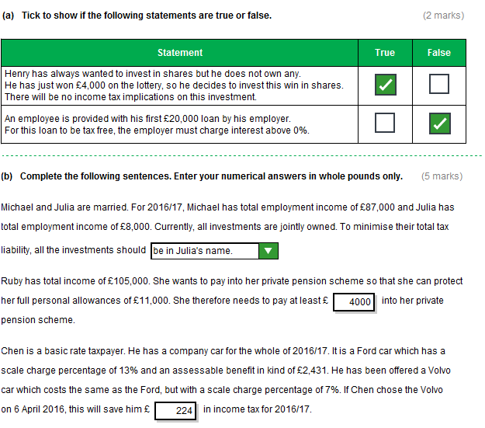

**Rounding – Text box 2**

This model answer shows the figure rounded down. However, figures rounded up are equally valid for the purposes of this assessment.

**Task 9** (10 marks)

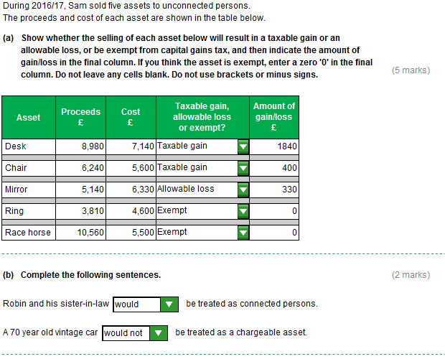

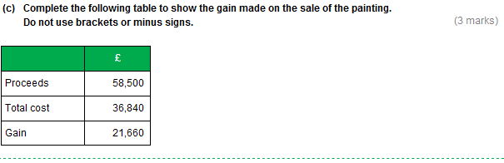

**Task 10** (10 marks)



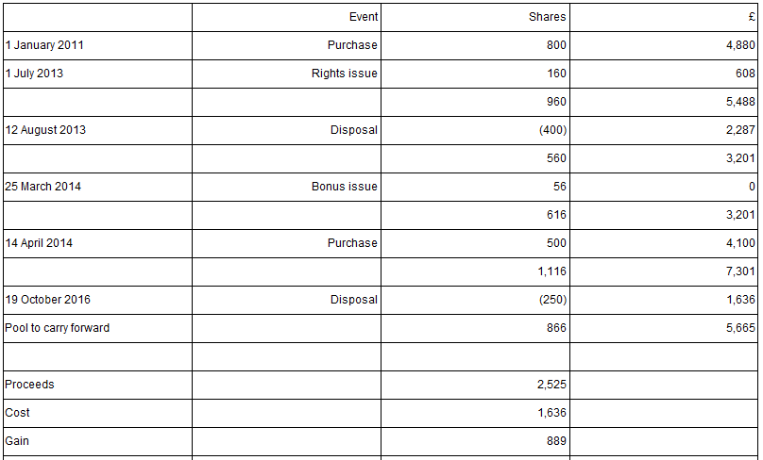

**Task 11** (7 marks)

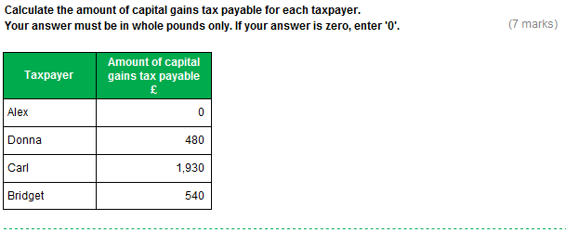

**Task 12** (6 marks)

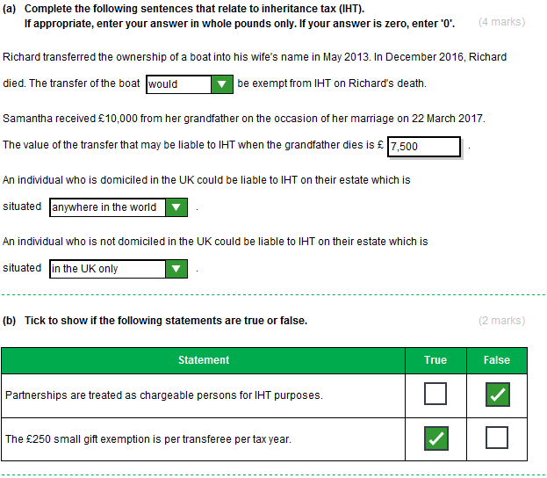

**Task 13** (6 marks)

