

CBT Sample assessment model answers

**Introduction to Payroll (INPY)**

Sample assessment 1

**Task 1** (8 marks)

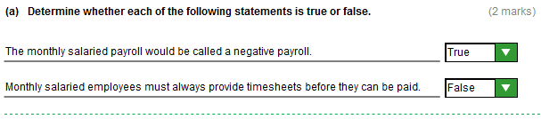

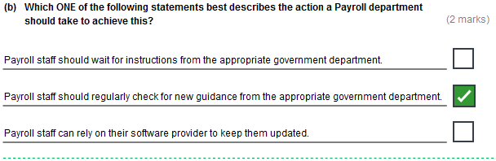

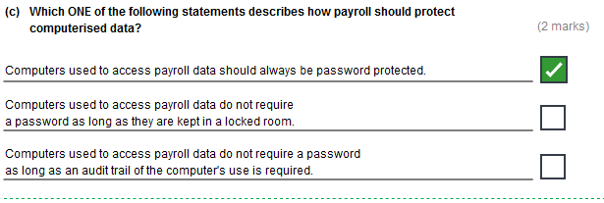

**Task 1, continued**

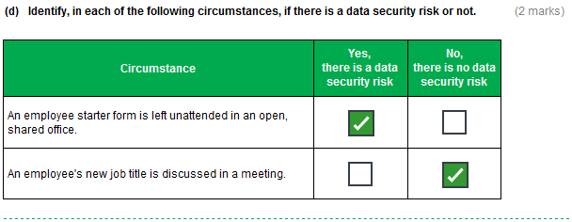**Task 2** (4 marks)

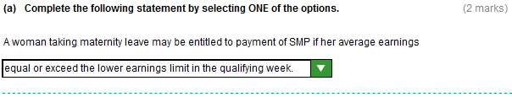

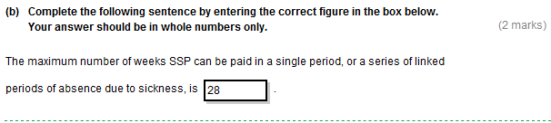

**Task 3** (5 marks)

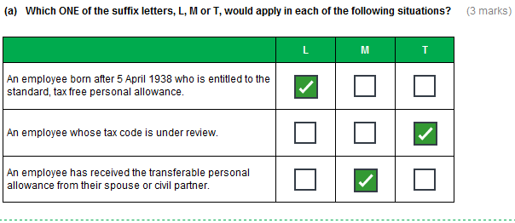

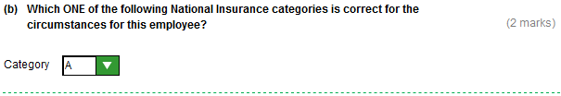 **Task 4** (8 marks)

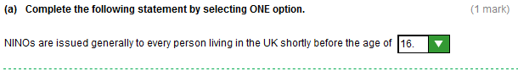

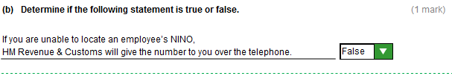

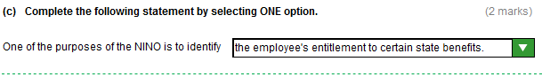

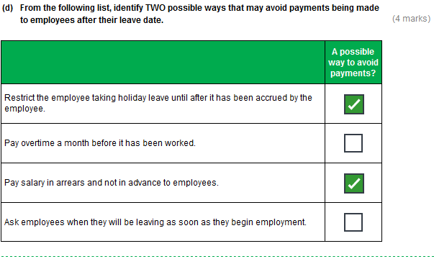

**Task 5** (5 marks)

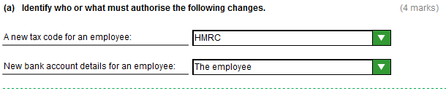

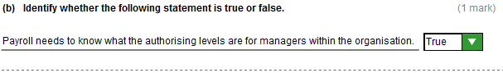

**Task 6** (20 marks)

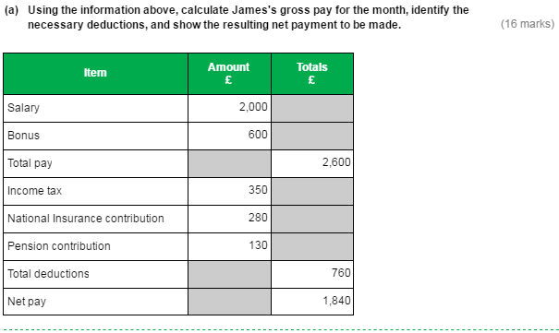

**Task 6, continued**

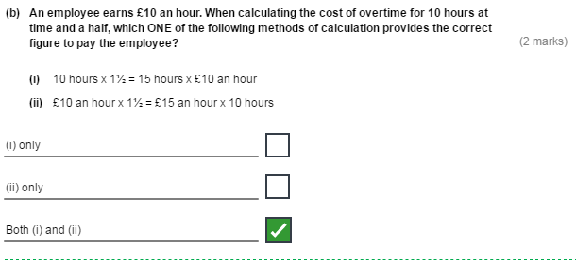

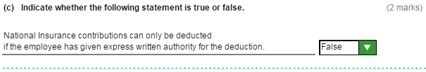**Task 7** (4 marks)

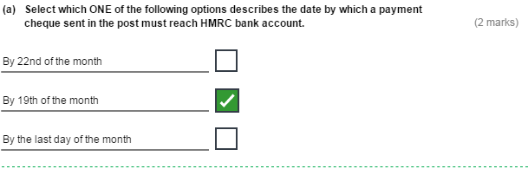

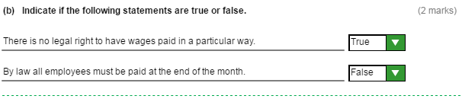

**Task 8** (16 marks)

