

CBT Sample assessment model answers

**Introduction to Business and Company Law (IBLW)**

Sample assessment 2

**Task 1** (5 marks)

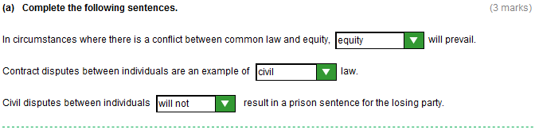

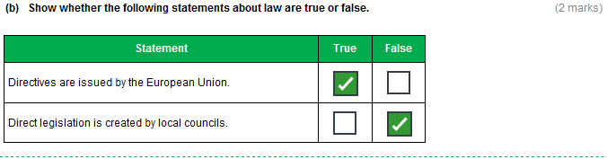**Task 2** (17 marks)

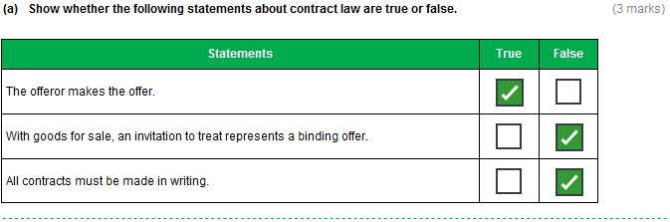

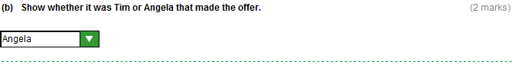

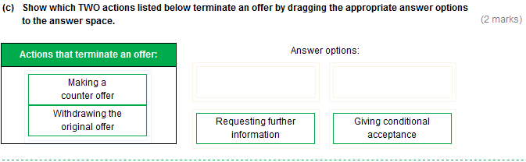

**Task 2 (continued)**

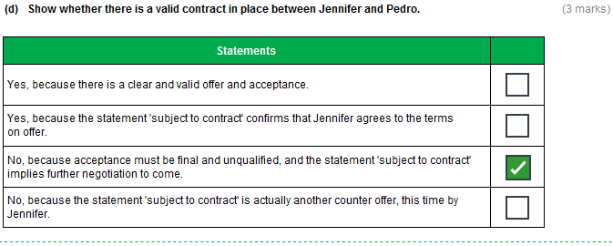

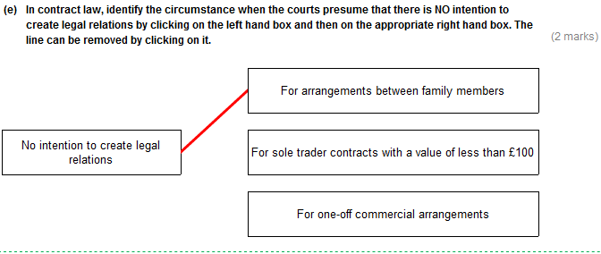

**Task 2 (continued)**

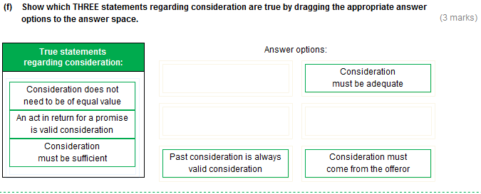

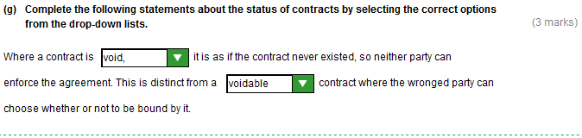

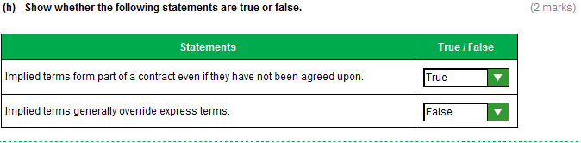

**Task 2 (continued)**

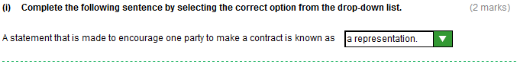

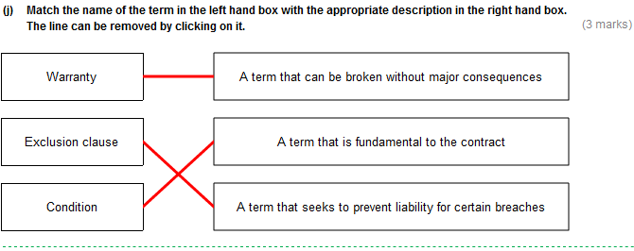

**Task 3** (10 marks)

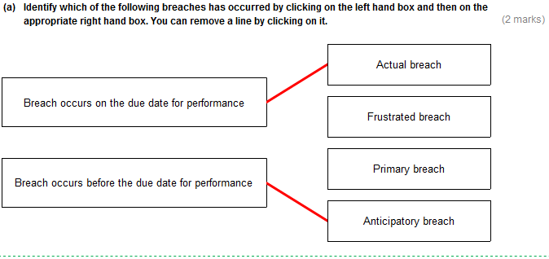

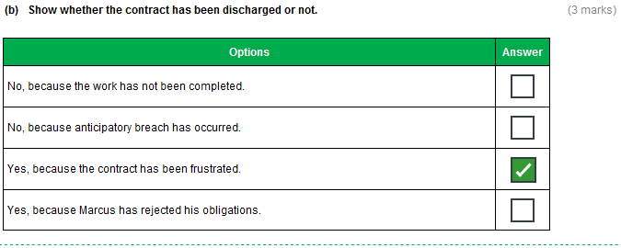

**Task 3 (continued)**

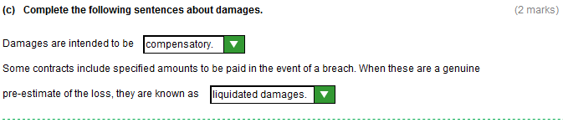

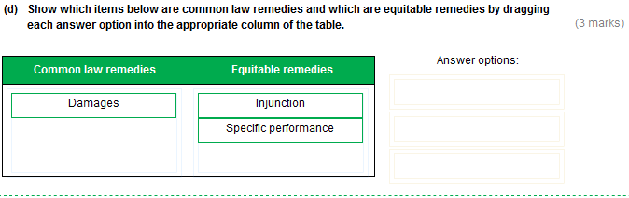**Task 4** (20 marks)

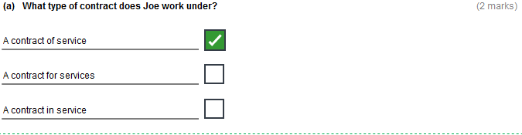

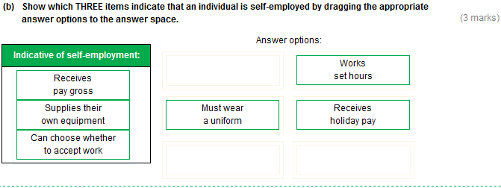

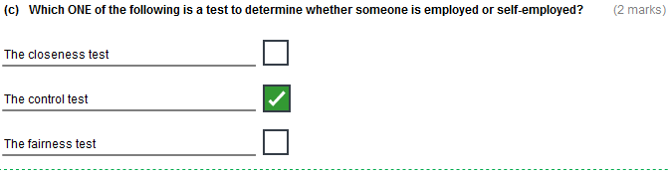

**Task 4 (continued)**

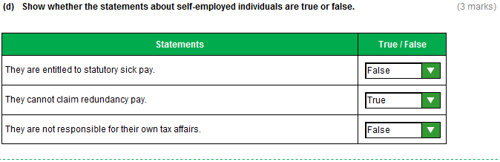

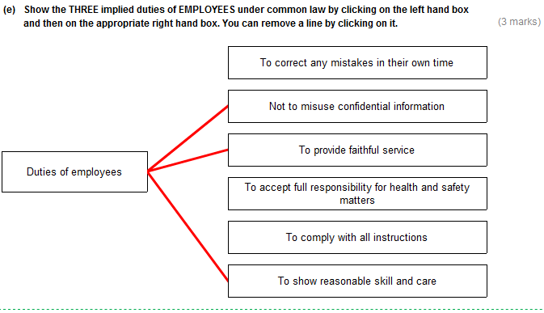

**Task 4 (continued)**

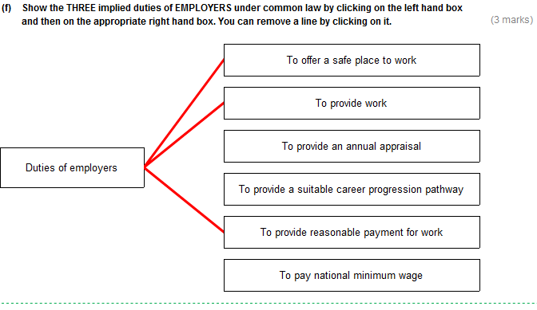

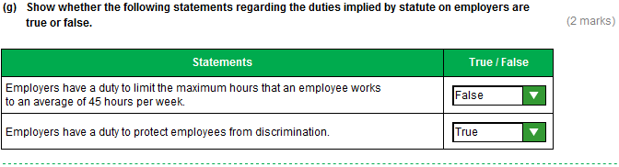

**Task 4 (continued)**

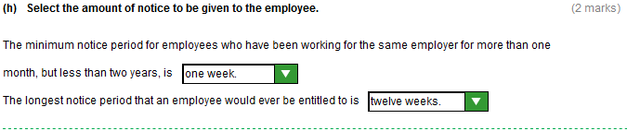

**Task 5** (10 marks)

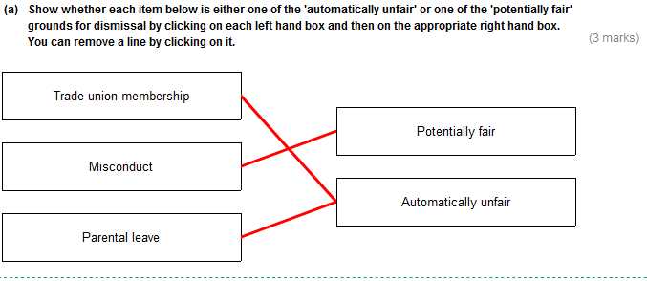

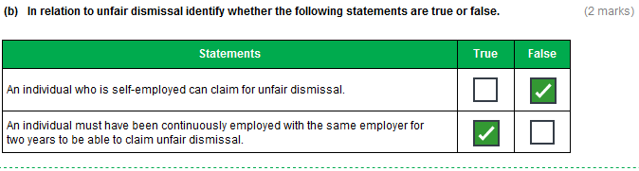

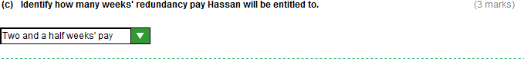

**Task 5 (continued)**

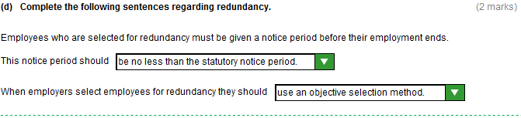

**Task 6** (13 marks)

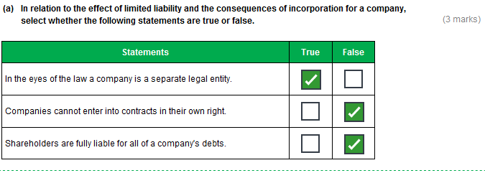

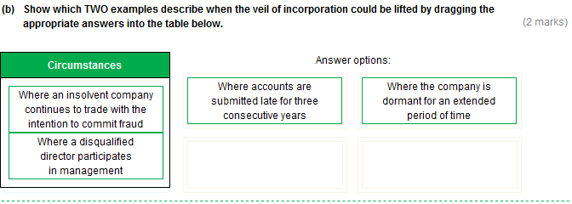

**Task 6 (continued)**

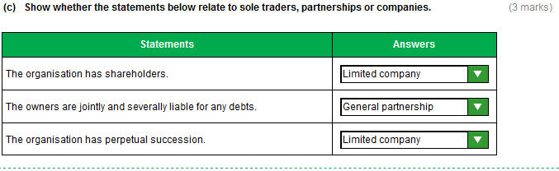

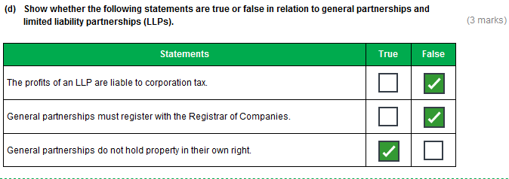

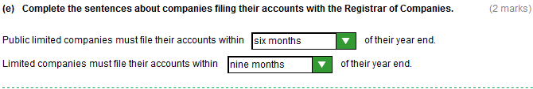

**Task 7** (17 marks)

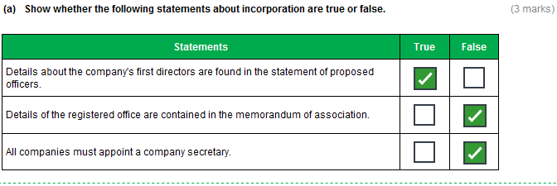

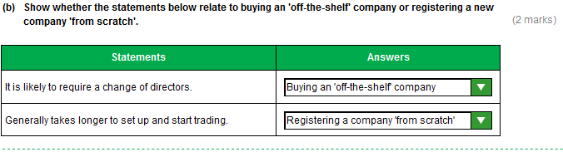

**Task 7 (continued)**

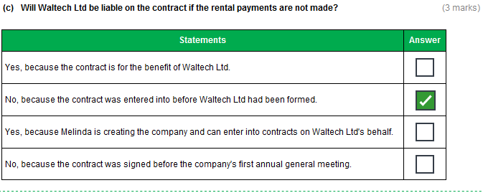

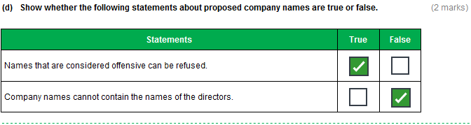

**Task 7 (continued)**

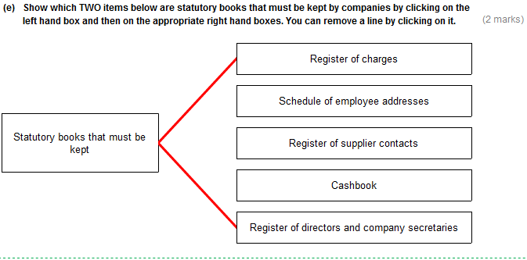

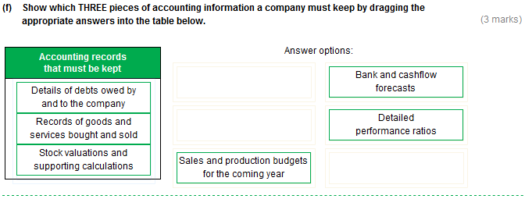

**Task 7 (continued)**

