

Sample assessment 1 model answers

**Level 2 synoptic assessment (AQ2016)**

**Introduction**

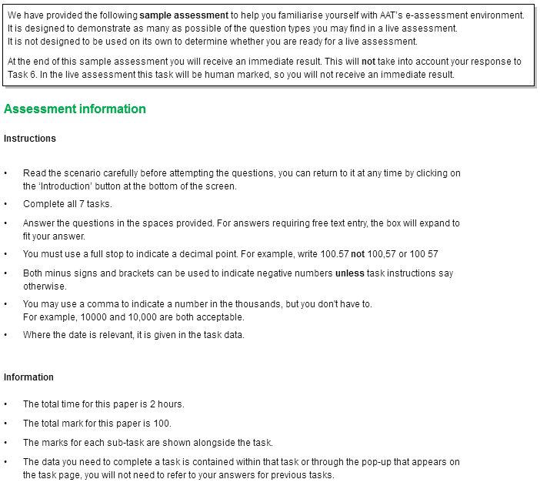



**Introduction, continued**

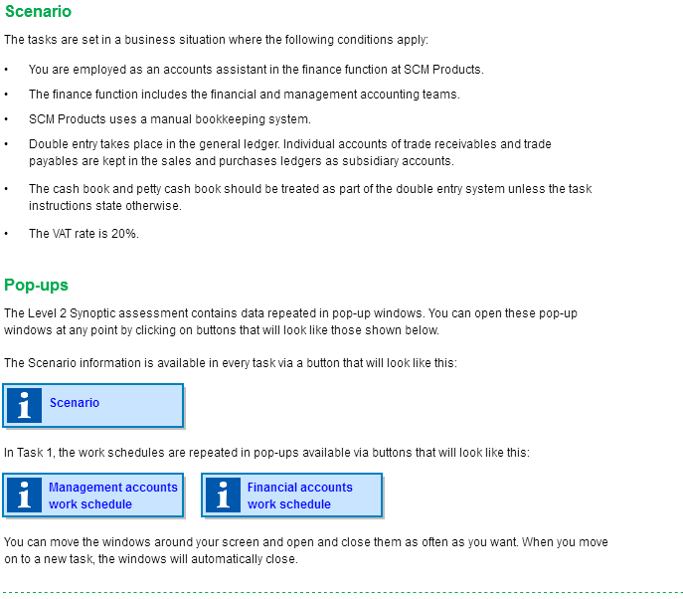



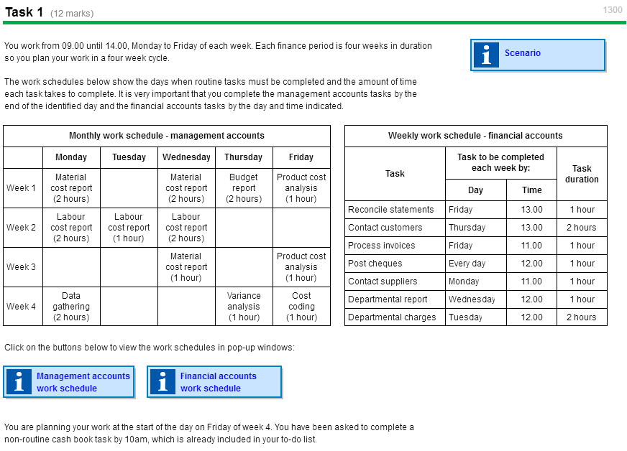

**Task 1, continued**



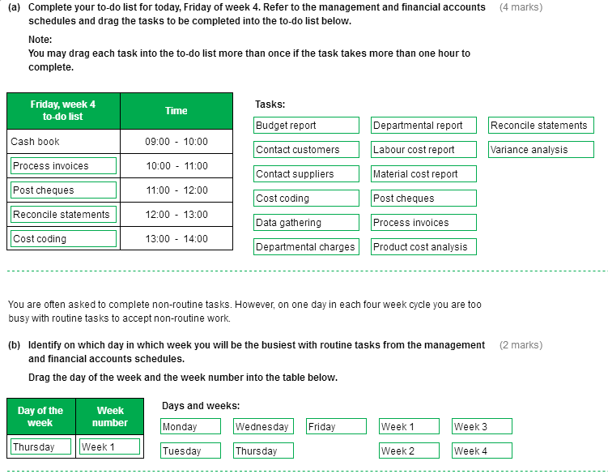

**Task 1, continued**

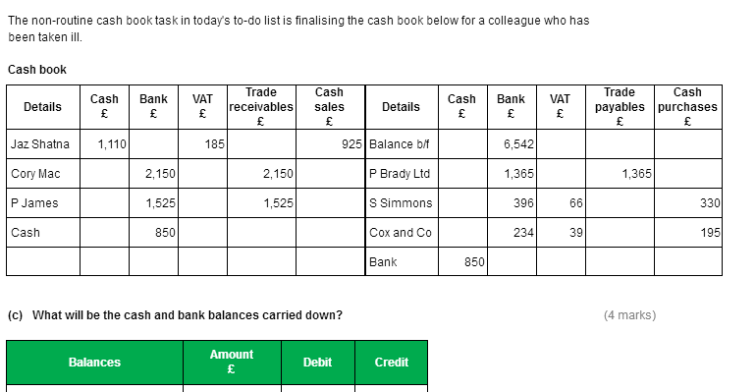

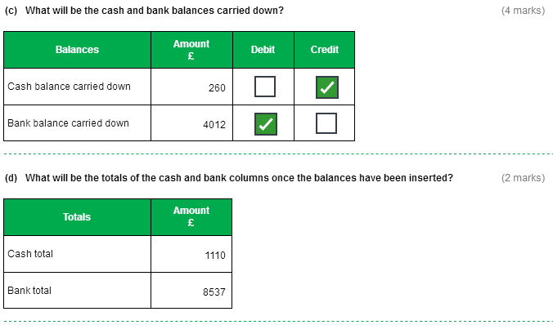



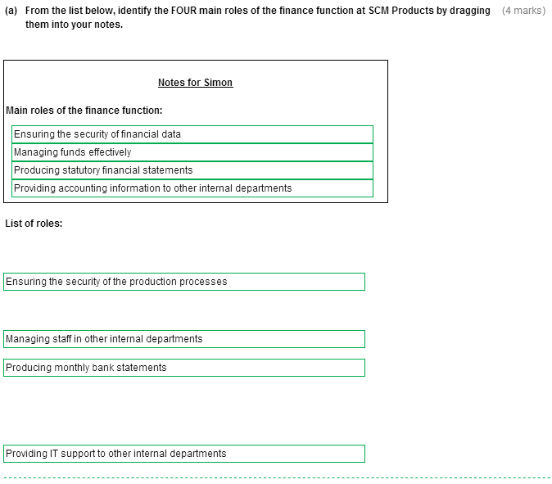







**Task 2, continued**

**  
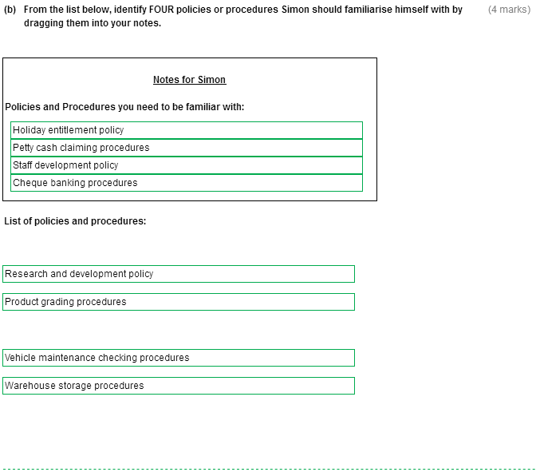**

**Task 2, continued**

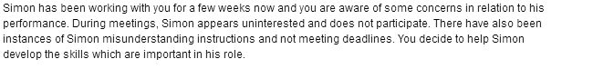

**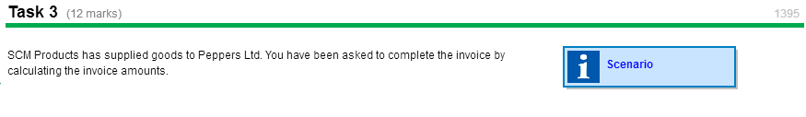  
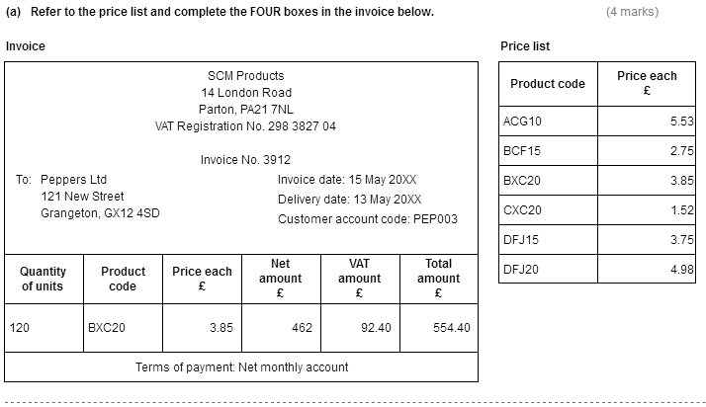**

**Task 3, continued  
  
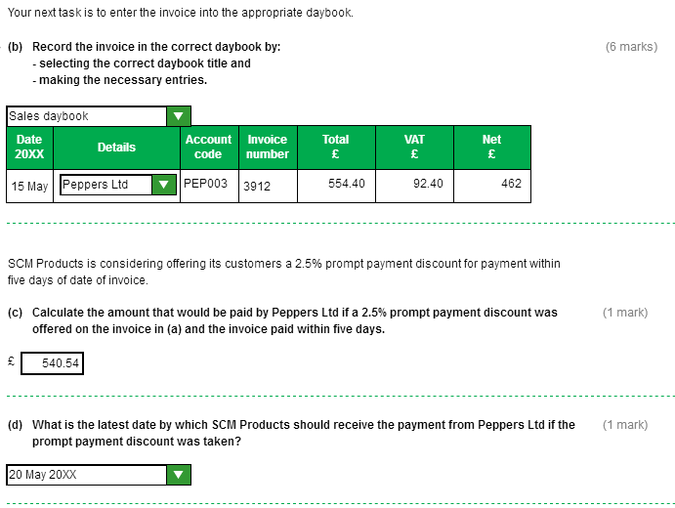**

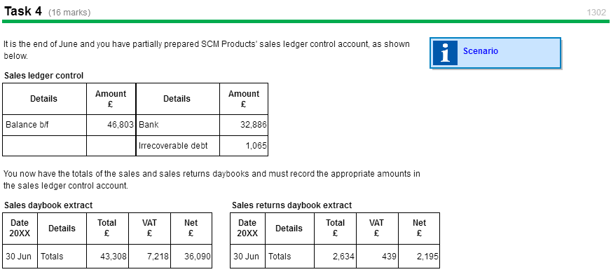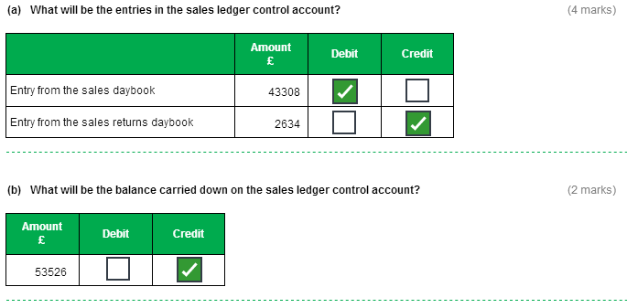

**Task 4, continued**



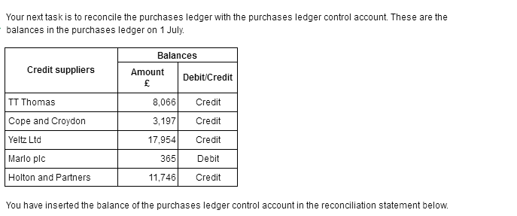



**Task 4, continued**



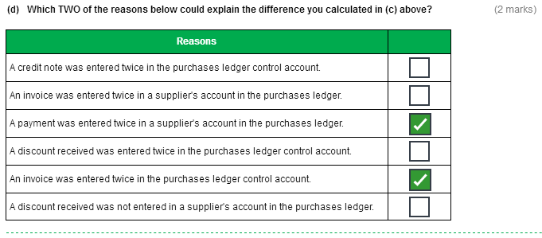

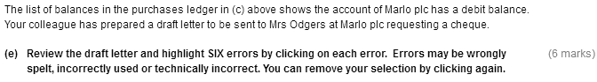

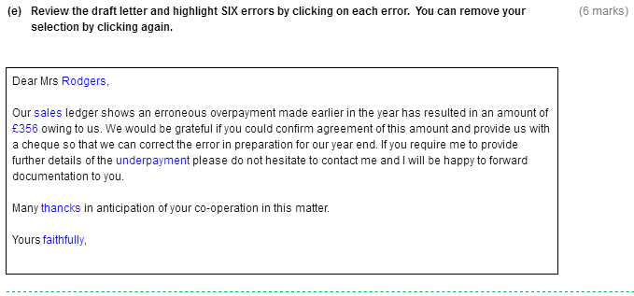



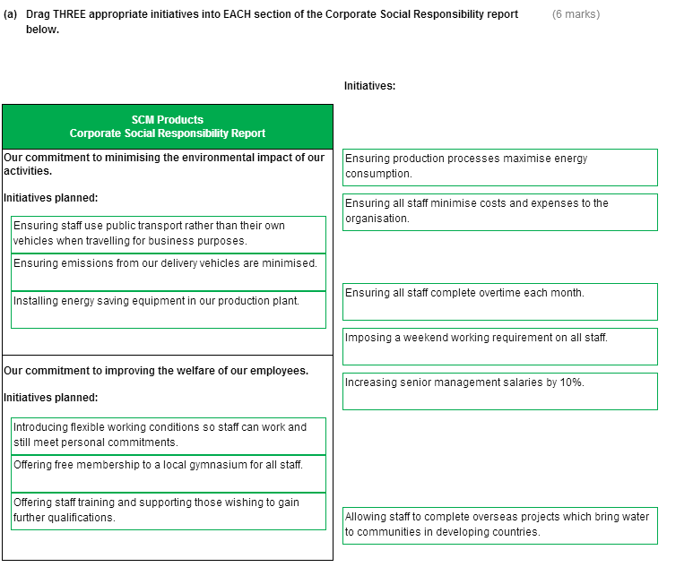



**Task 5, continued**

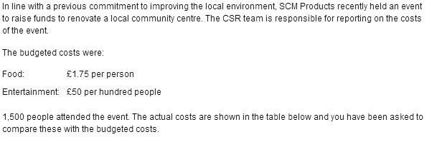

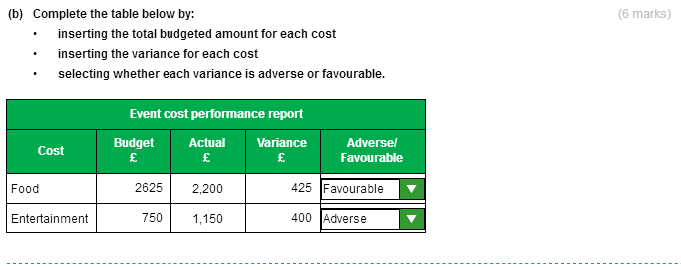

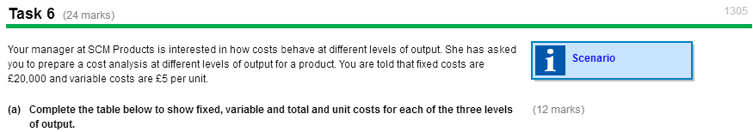

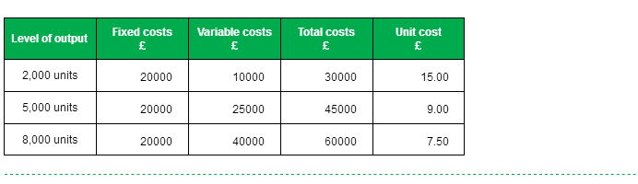

**Task 6, continued  
  
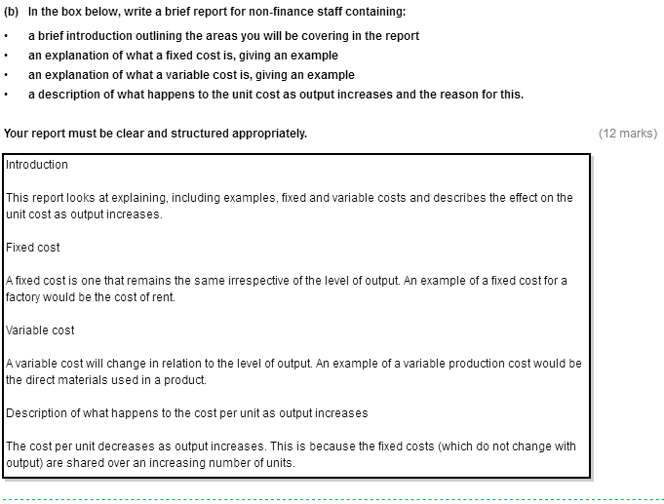**

|  |
| --- |
| **Introduction**  This report:   * explains and gives examples of fixed and variable costs * describes the effect of increased output on unit cost.   **Fixed cost**  A fixed cost is one that remains the same irrespective of the level of output. An example of a fixed cost for a factory would be the cost of rent.  **Variable cost**  A variable cost is one which changes in relation to the level of output. An example of a variable production cost would be the direct materials used in a product.  **Description of what happens to the cost per unit as output increases**  The cost per unit decreases as output increases. This is because fixed costs do not change with output so are shared between an increased number of units when output increases. |

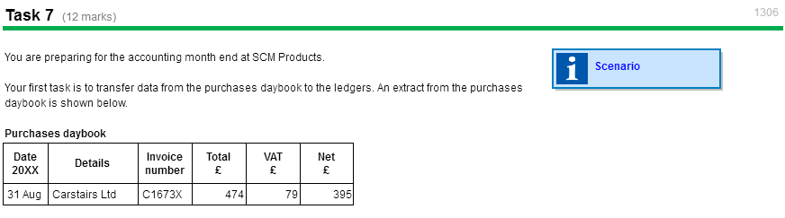

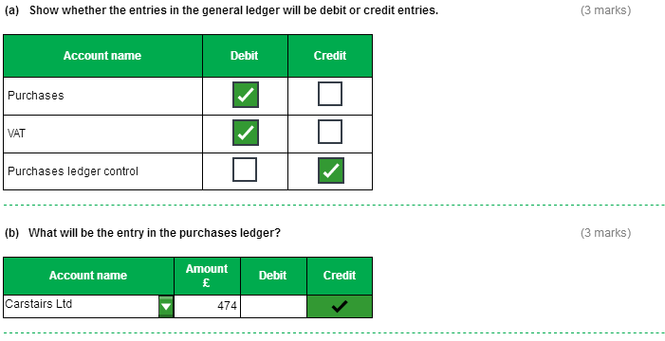

**Task 7, continued**

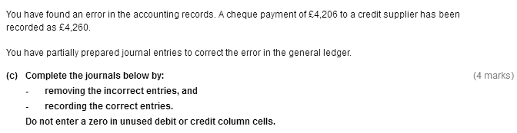

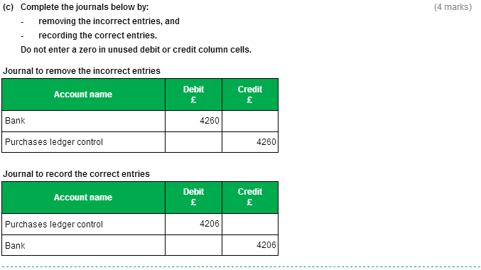

**Task 7, continued**

