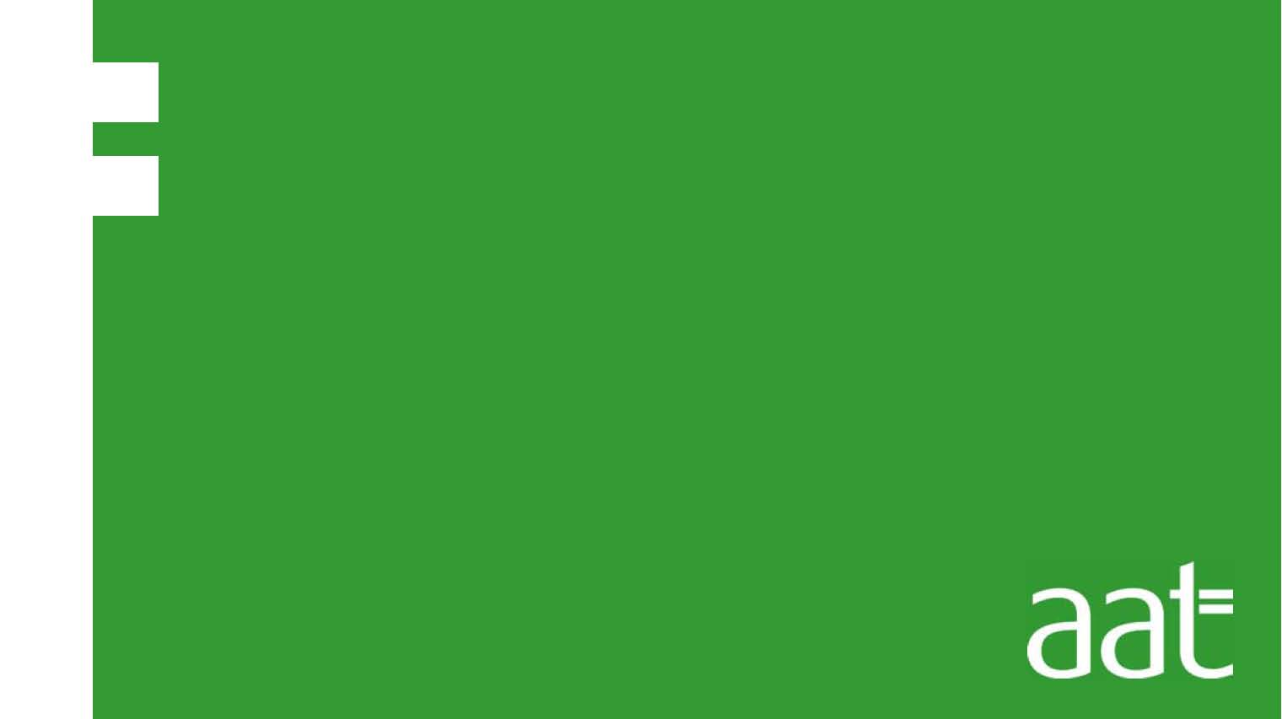
CBT Sample assessment model answers

Foundation synoptic assessment (FSYA)
Sample assessment 2

Task 1 (12 marks)

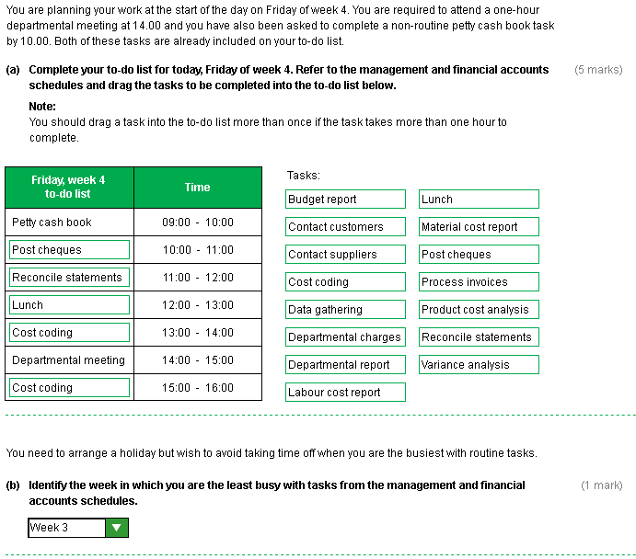
Task 1, continued

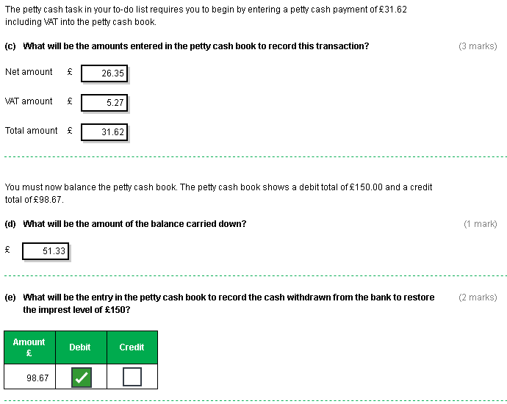

Task 2 (12 marks)

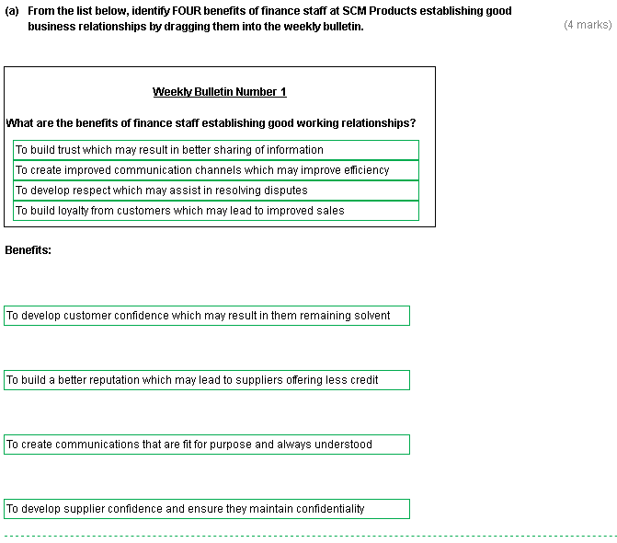

Task 2 (continued)

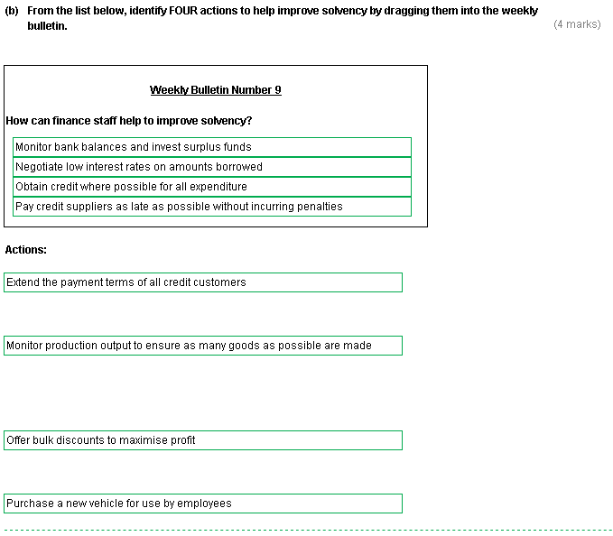

Task 2 (continued)

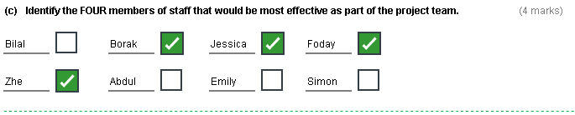

Task 3 (12 marks)

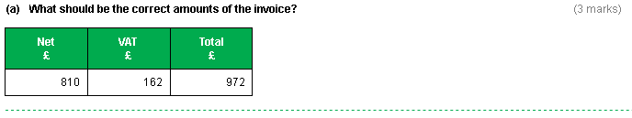
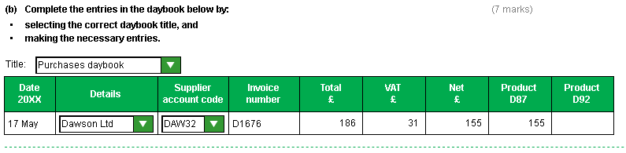
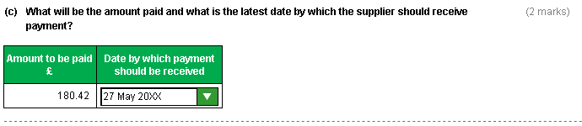

Task 4 (16 marks)

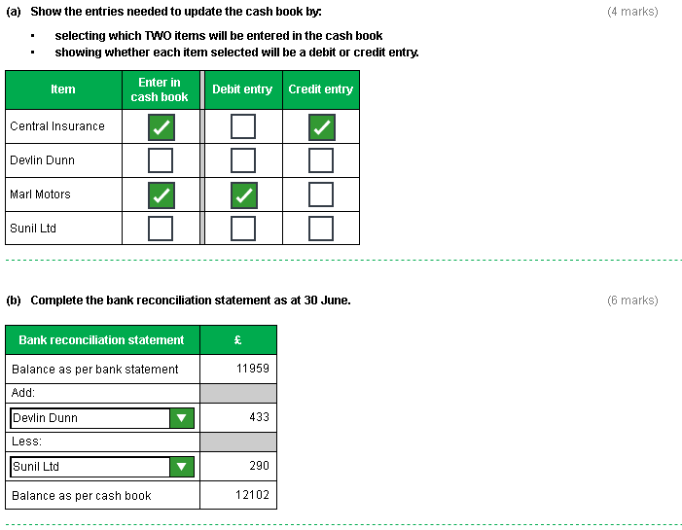

Task 4 (continued)

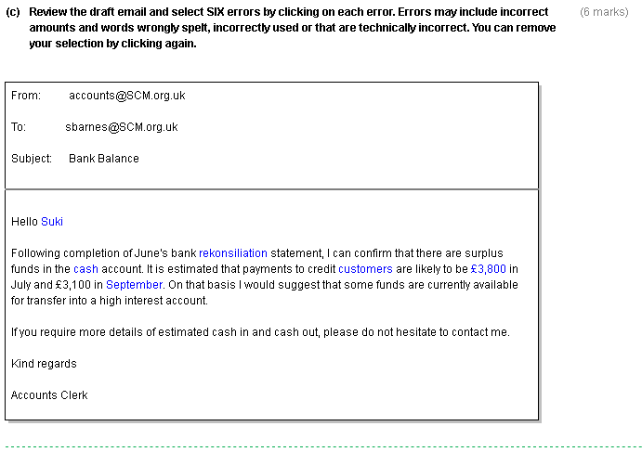

Task 5 (12 marks)

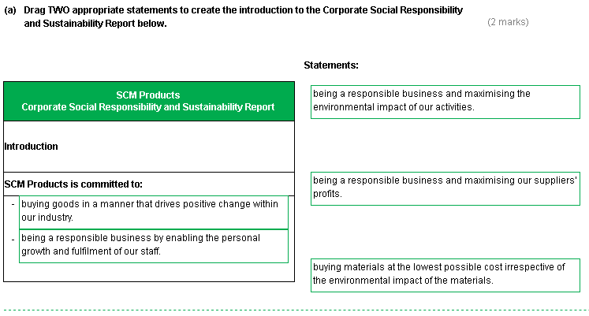
Task 5 (continued)

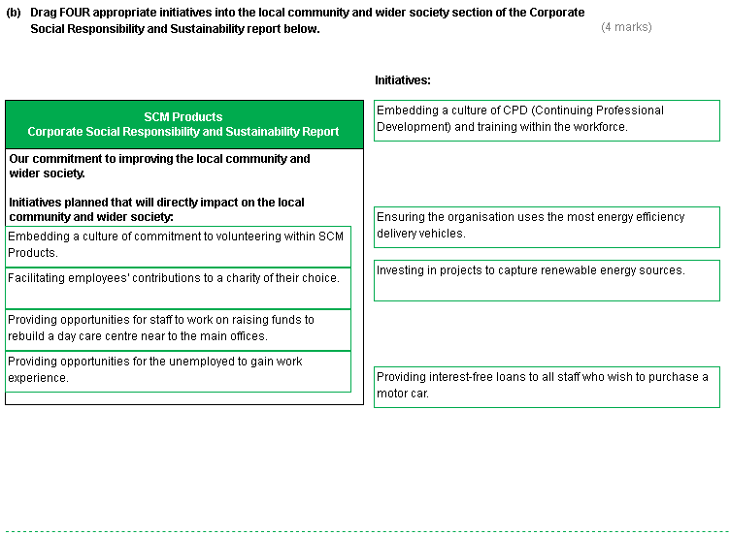

Task 5 (continued)

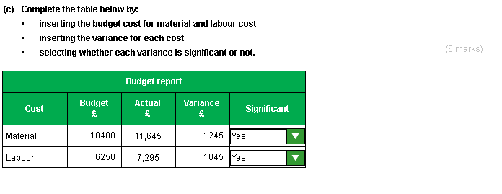

Task 6 (24 marks)

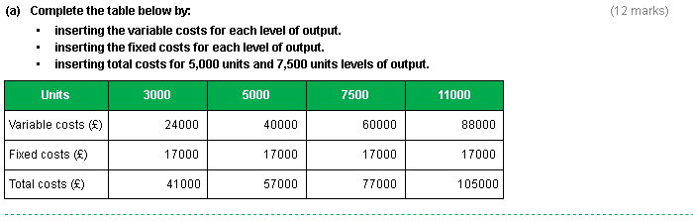

Task 6 (continued)

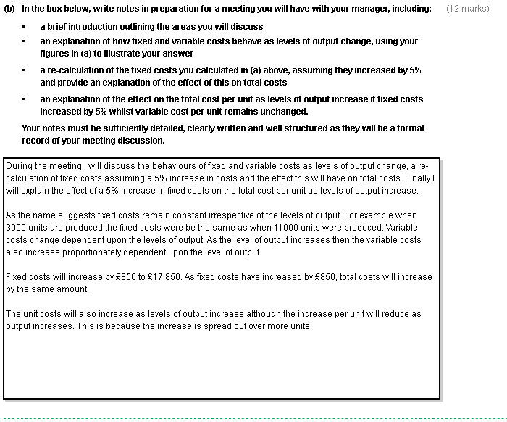
Task 7 (12 marks)

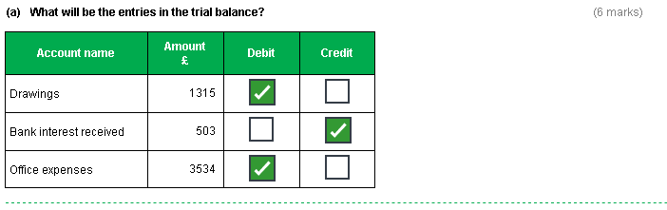
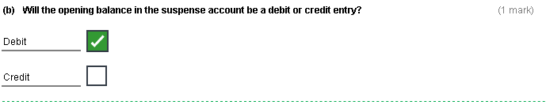

Task 7 (continued)

