

CBT Sample assessment model answers

**Indirect Tax (IDRX) FA2016**

Sample assessment 1

**Task 1** (6 marks)

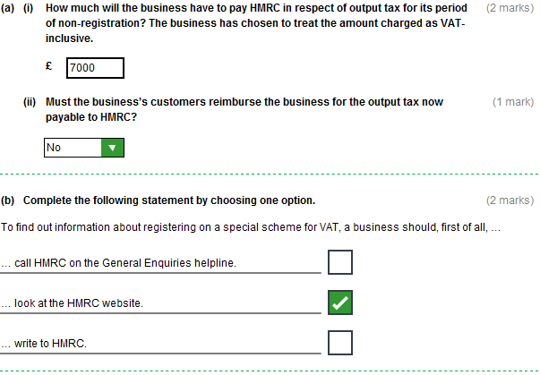

**Task 1 (continued)**

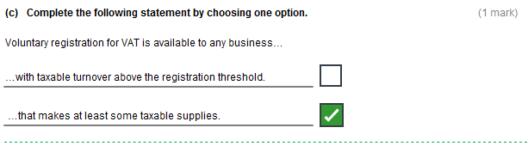

**Task 2** (9 marks)

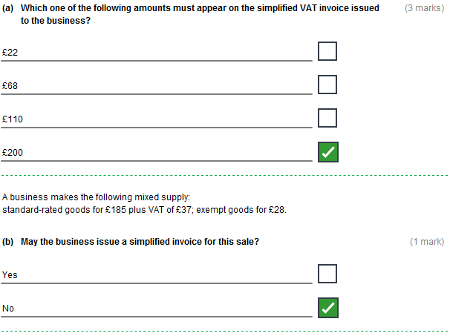

**Task 2 (continued)**

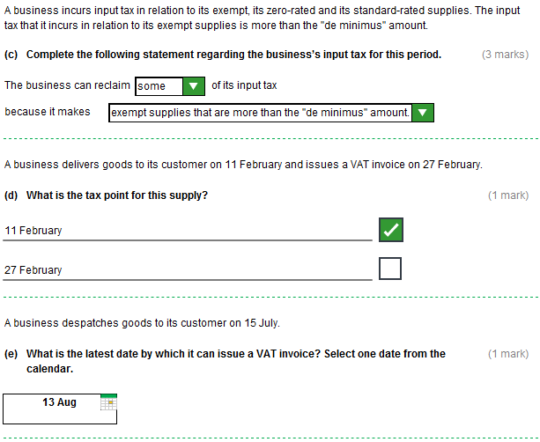

**Task 3** (5 marks)

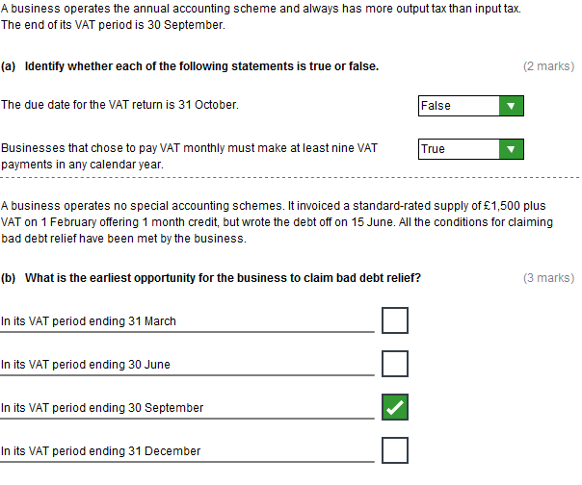

**Task 4** (9 marks)

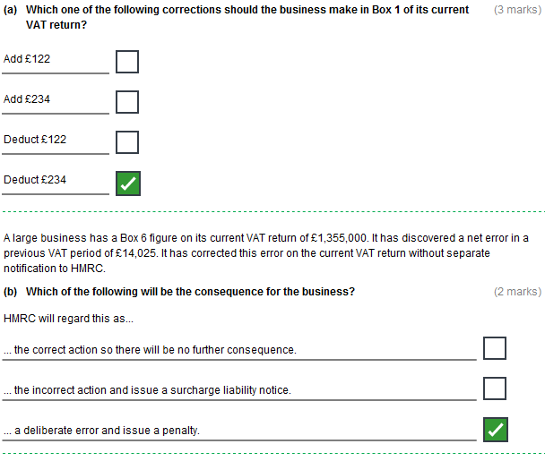

**Task 4 (continued)**

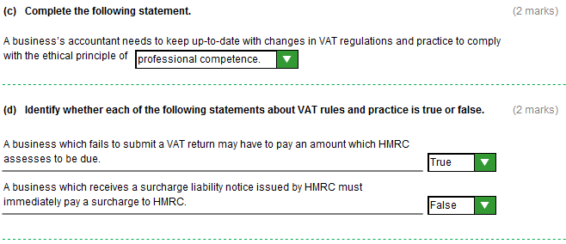

**Task 5** (7 marks)

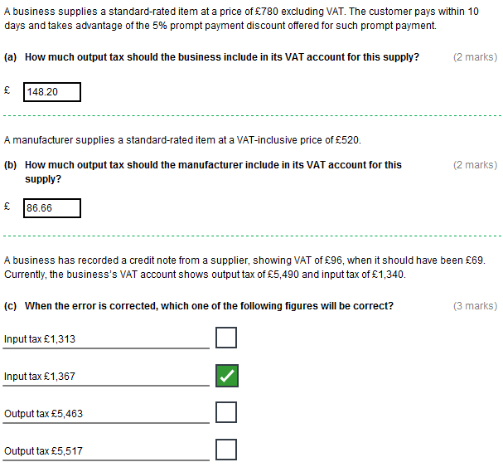

**Task 6** (7 marks)

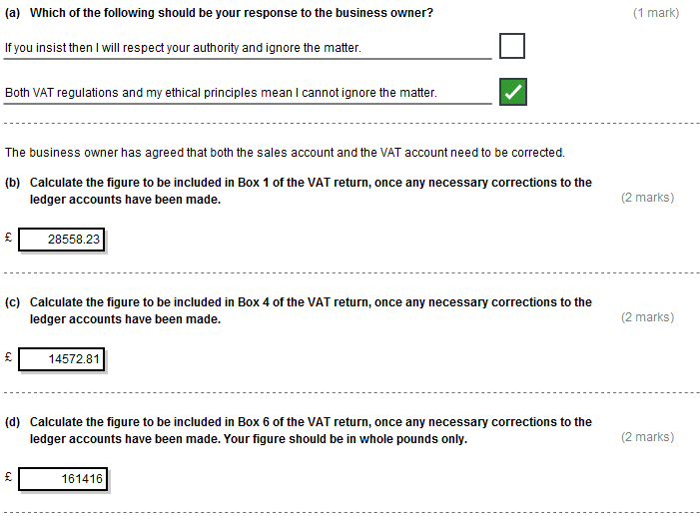

**Task 7** (17 marks)

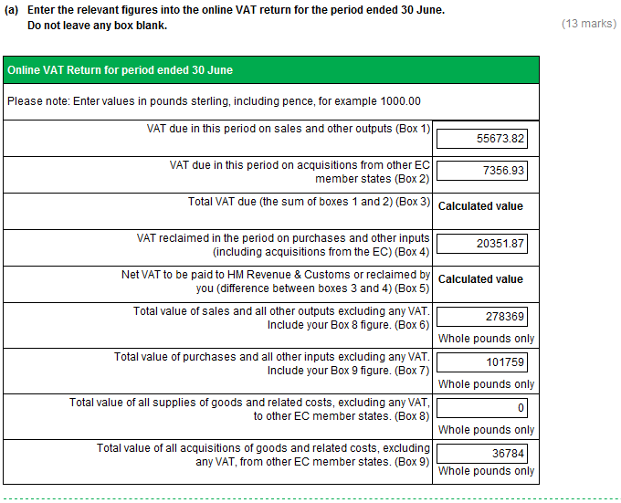

**Task 7 (continued)**

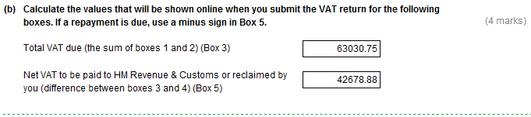

**Task 8** (10 marks)

