
CBT Sample assessment model answers

Indirect Tax (IDRX) FA2016
Sample assessment 1
This is a draft version of the FA2016 sample assessment.
The material has not completed quality assurance.
AAT reserves the right to change the material before actual publication.

Task 1 (6 marks)
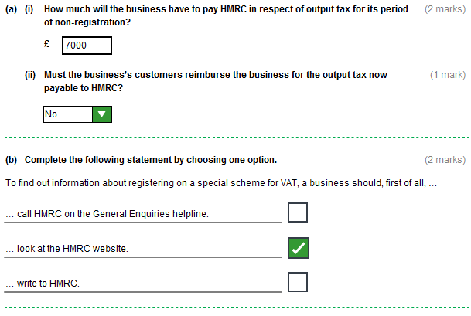

Task 1 (continued)

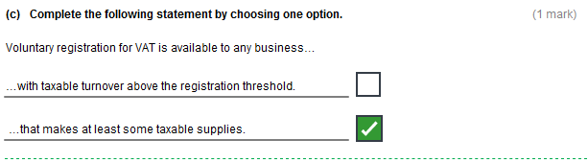
Task 2 (9 marks)

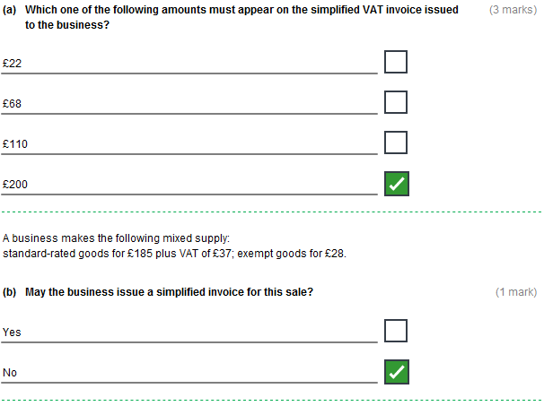

Task 2 (continued)

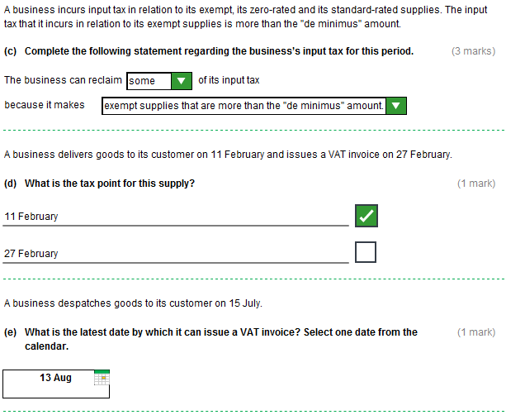

Task 3 (5 marks)

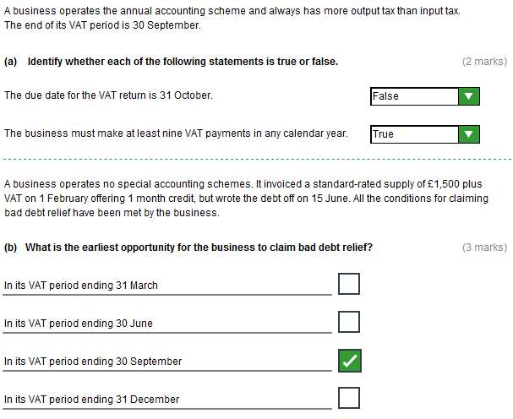

Task 4 (9 marks)

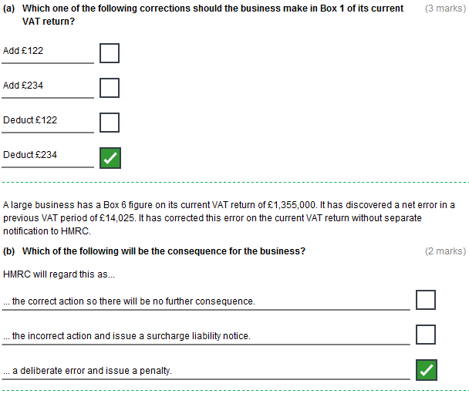

Task 4 (continued)

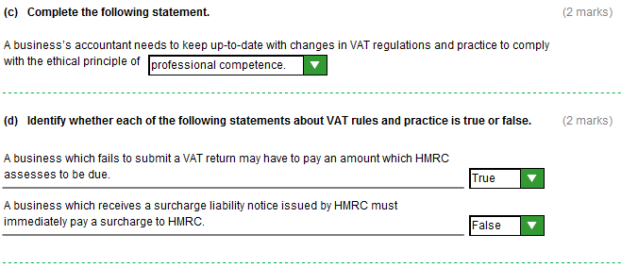

Task 5 (7 marks)

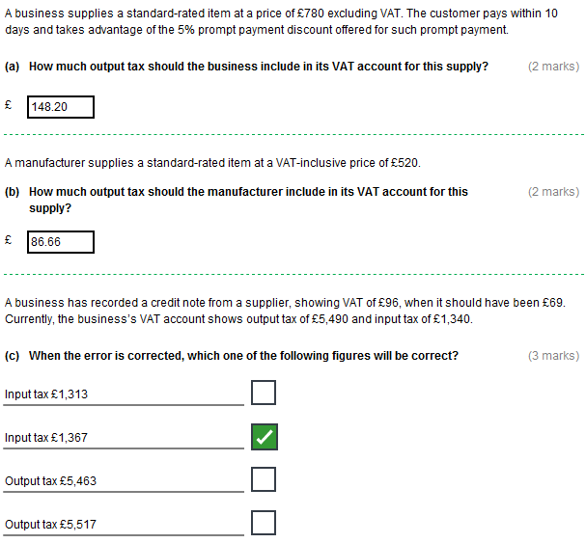

Task 6 (7 marks)

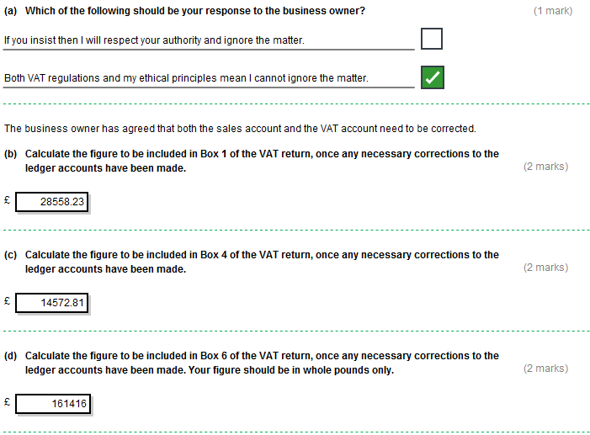

Task 7 (17 marks)

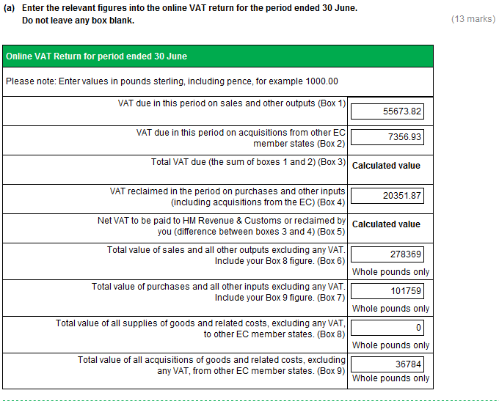

Task 7 (continued)

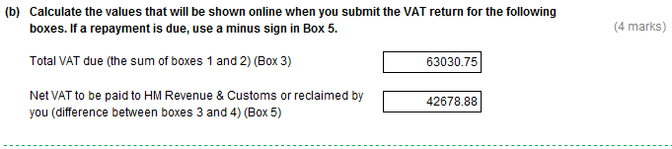

Task 8 (10 marks)

