

CBT Sample assessment model answers

External Auditing (EXTA)
Sample assessment 2

Task 1
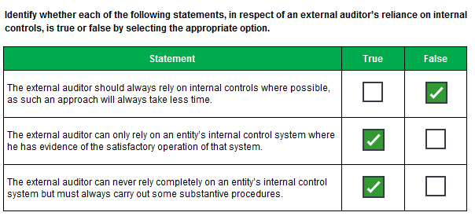
Task 2
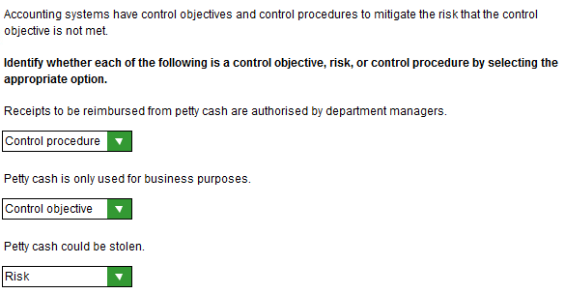

Task 3

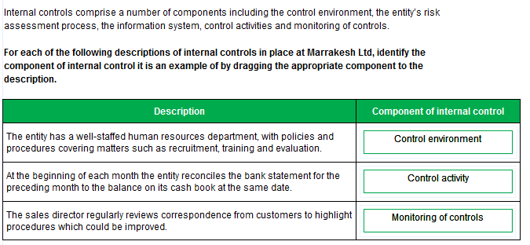

Task 4
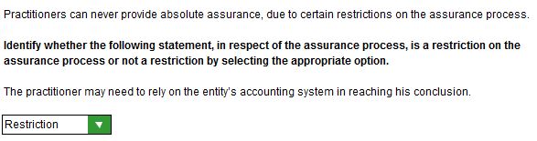

Task 5
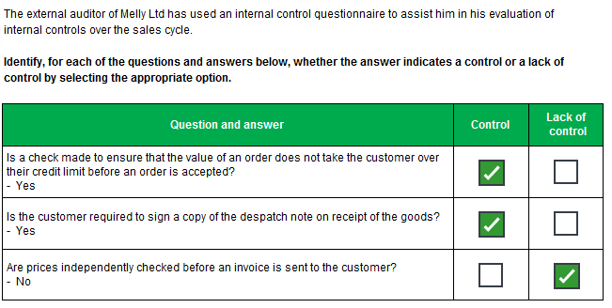

Task 6
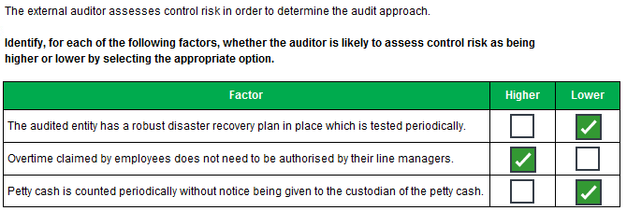

Task 7
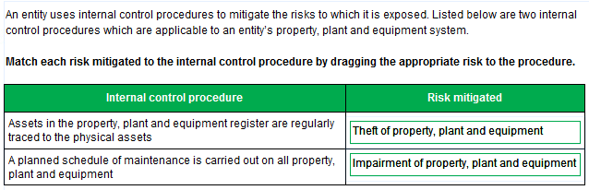

Task 8
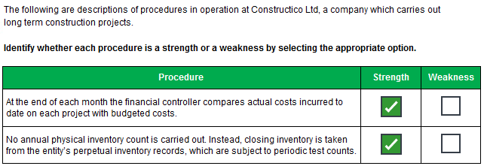

Task 9
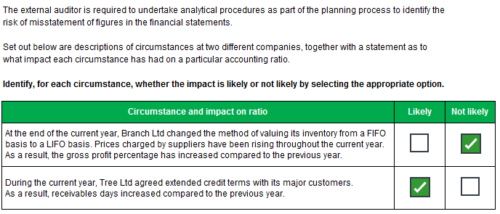

Task 10

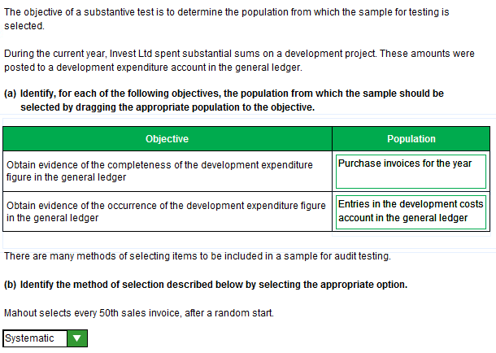

Task 11
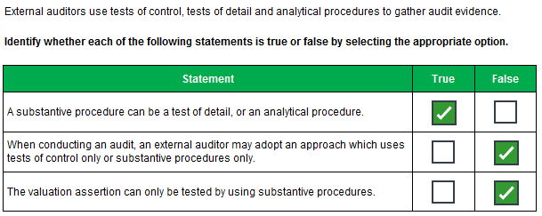

Task 12
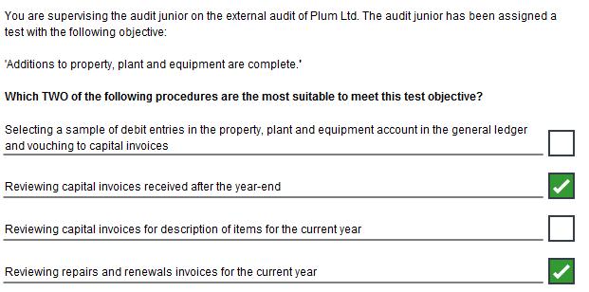

Task 13
Identify and explain the audit risks relating to the external audit of Speedico Ltd. Where possible, your answer should refer to specific items in the financial statements which may be at risk of misstatement.

New client/lack of knowledge and understanding of the business
- increased detection risk
- opening balances may be misstated.

Contract not being renewed next year
- going concern risk if the contract cannot be replaced by other work/new customers
- risk of lack of disclosure in notes to financial statements
- or inappropriate basis of preparation.

Older lorries sold at a loss
- could indicate inappropriate depreciation policy
- such that carrying amounts of similar lorries could be overstated (and depreciation understated)
- “significant” losses may not be correctly disclosed (i.e. “exceptional” item/separately disclosed).

Leased assets
- accounting treatment of leased assets may be incorrect
- lease liabilities may not be correctly disclosed.

Failure of refrigeration units
- provisions could be understated re damages claims
- revenue relating to transportation of these goods needs to be reversed/credit note issued
- may need to disclose/accrue for counter claim
- possible impact on going concern due to loss of reputation.

Task 14
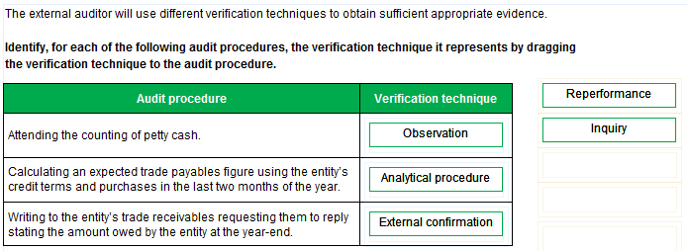

Task 15
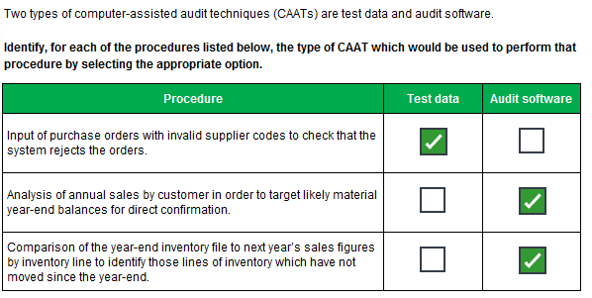

Task 16
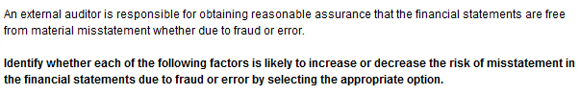
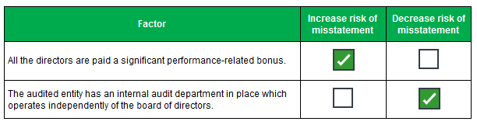

Task 17
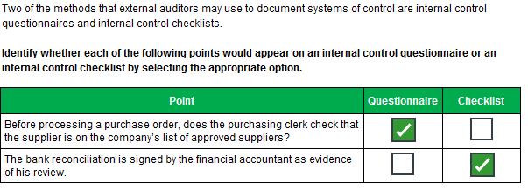

Task 18
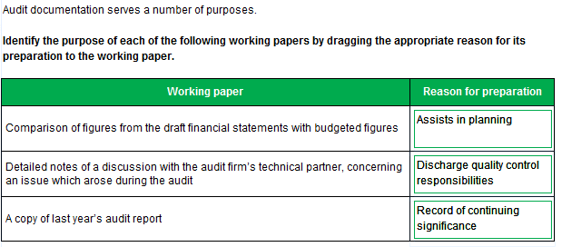

Task 19
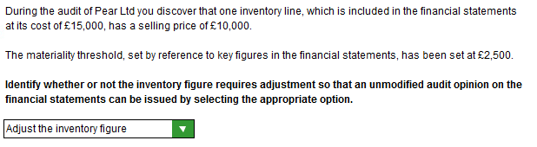

Task 20
Set out, in a manner suitable for inclusion in the audit plan, the audit procedures to be undertaken to ensure that the cash and cash equivalents figure is fairly stated in the financial statements for the year ended 31 March 20X1.
- Obtain a bank letter directly from Doji Ltd’s bank
- Agree the balance per the bank letter to the bank statement
- And bank reconciliation
- Agree cash book balance to bank reconciliation
- Re-perform bank reconciliation/check receipts and payments per cash book to bank statements
- Trace unpresented cheques to April 20X1 bank statement
- If any cheques do not clear this month enquire as to reason why
- Review paying-in books and bank statements to confirm the date uncleared lodgements were paid into the bank
- If any uncleared lodgements do not appear in early April, enquire why
- Ensure the cash book has been adjusted for any pre year-end bank charges/other items not known about by client
- If petty cash is material/if required by client
- Visit client at year-end to observe count/verify year-end balance
- Evaluate internal controls over petty cash.

Task 21
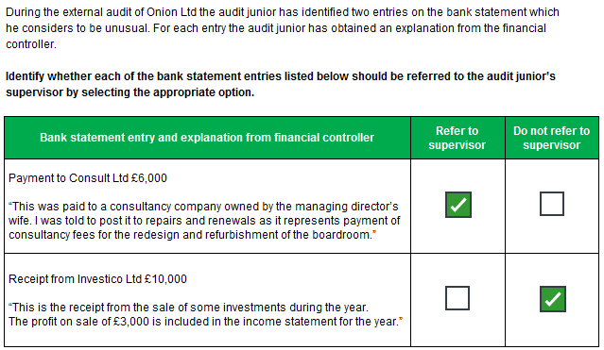

Task 22
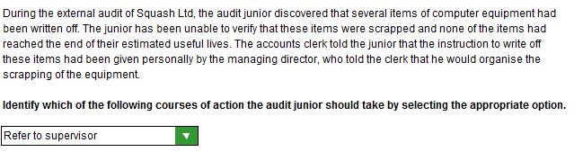
Task 23
Prepare extracts, suitable for inclusion in a report to the management of Venetia Ltd, which set out:
- the possible consequences; and
- the recommendations you would make
in respect of the matter described above.

(i) Consequences
- Loss of profits
- Adverse impact on cash flow
- Fictitious claims
- Unchecked breaches of company policies weakens the control environment
- Lack of receipts/invoices impedes ability to recover VAT.

(ii) Recommendations
- Employees to be reminded of the importance of adhering to company policy
- Expenses not to be reimbursed over the nightly limit unless pre-authorised
- Nor if not supported by receipts
- Monitoring of procedures to ensure compliance
- Breaches to be investigated/staff disciplined.

Task 24

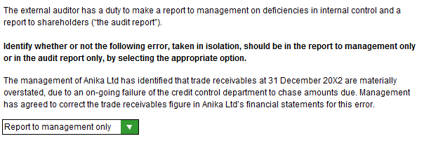

Task 25
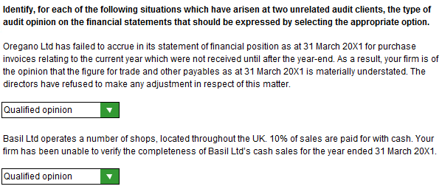

Task 26
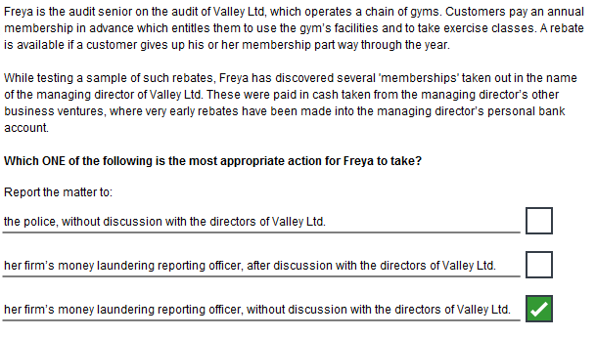

Task 27
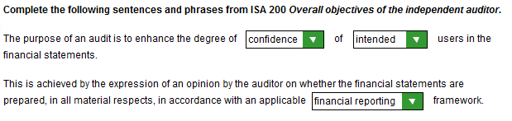

Task 28
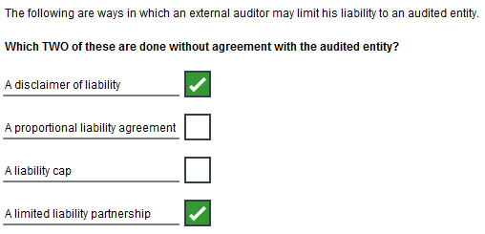
Task 29
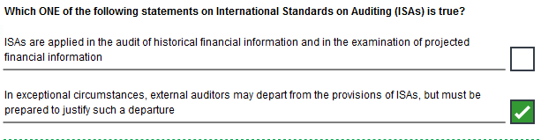
Task 30
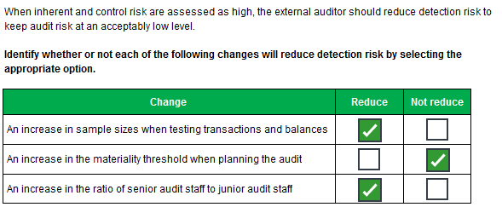

Task 31
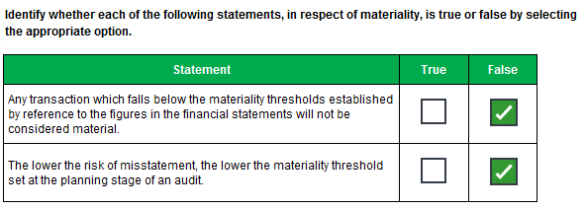

Task 32


